1. Introduction
INTERNATIONAL TELECOMMUNICATION UNION |  |  |  | Focus Group On IPTV
TELECOMMUNICATION  STANDARDIZATION SECTOR  STUDY PERIOD 2006-2008 |  |  | FG IPTV-C-0295
 |  |  | English only
WG(s): 6 |  | 3rd FG IPTV meeting:  Mountain View, USA, 22-26 January 2007
CONTRIBUTION
Source: | China Netcom Group, P.R.China
Title: | Proposal on outline of Service Navigation system
In the 2nd meeting report of WG6, T05-FG.IPTV-R-0013, there is an explanation that “The group resolved and came to an understanding that EPG is an application that displays information that guides the viewer to content. There are many varieties of EPG, such as IPG, ECG, ESG, BCG. There are different ways to realize an EPG as noted in FG IPTV-C-0128”, and the EPG is included in Part B.
Based on the cognizance,a unified EPG system is proposed to include all ECG,IPG,ESG,BCG.
That is Service Navigation System.The present document do my best to put all these xxG into one document,and gives four realization manner based on a general architecture and functional requirements. Also the document presents a basic document structure which can be added/deleted something to it in order to be a output document.
The service navigation system includes generally two parts. The first part is the backstage processing system(service navigation system, is composed by several servers), mainly completes the service discovery and management, as well as collects the metadata and SI information and manage them.The second part is the frontstage navigation system(Portal & page production and the pages presentation), ant it is the man-machine interface of user interacting with the backstage system. service navigation system’s general functional requirements as follows:

1.1 Backstage processing system (service navigation system) general functional requirements:
(1) Service discovery
(2) SP discovery
- Service managements
- Metadata DB
- Live TV channel management
- Value-added service discovery and navigation/redirection(optional)
- ……

1.2 Frontstage navigation system (Portal & page production and the pages presentation) general functional requirements:
(1) Based on browser/middleware/application method
- Based on XML mechanism
- A sole entry Portal
- Permission to integrate Internet Portal and other value-added portal
- Portal & page production. (if Portal & pages are produced in service navigation system, then they are not needed. If Portal & pages are produced in terminal, then they are required)
- Pages presentation(including services and channel list)
- Value-added services list
- …….

2. Four realization manner(if there are other manners, supply/add please.)
  - Based on browser navigation manner(including two methods)
2.1.1 Web Server(Portal & page production) independent to STB
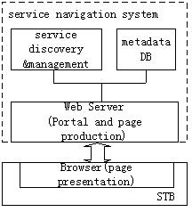

Figure 1 Navigation system based on Browser
The service navigation system is independent to STB.The navigation system includes two parts: backstage service logic processing and frontstage Portal and pages production. The navigation system produces EPG pages and delivers them to STB, and the STB presents them to users by browser. The user’s requests are sent to Web Server, and the Web Server uses the backstage logic to respond user’s request or redirect to other servers. This method has expanded functions besides the service navigation system’s general functions:
(1) User’s self-service
(2) Function of the guardian control
(3) Authentication/authorization proxy (optional, determined by requirements)
(4) The set-top box configuration and monitoring proxy (optional, determined by requirements)
(5) Value-added service discovery and navigation/redirection
(6) Interfaces with other systems
The typical system refers to FG IPTV-ID-0089 and FG IPTV-C-0128. IPG, ESG,BCG,EPG and linkage to Internet are the applications by this manner.
2.1.2 Portal & page production and the pages presentation are accomplished in STB
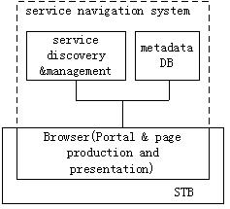
Figure 2 Navigation system based on Browser
The backstage processing of navigation system is independent to STB, and the Portal & page production and the pages presentation are completed in STB Browser. The user’s requests are sent to the backstage service discovery and management server, and they responds user’s request or redirect to other servers.
More detail or other functions can be added…
  - Application/middleware manner(including two methods)

2.2.1 Portal & page production and presentation are fulfilled by the STB application/middleware
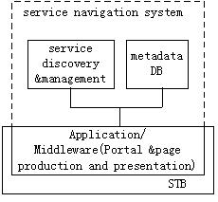
Figure 3 Navigation system based on application/middleware
The backstage processing of navigation system is independent to STB, and the Portal & page production and presentation are completed by the STB application/middleware. The user’s requests are sent to the backstage service discovery and management server, and they responds user’s request or redirect to other servers.
If the service discovery and management system are replaced with DNS and service discovery server(SD&S),then it is the typical DVB navigation system. BCG is the typical application by this manner.
More detail or other functions can be added…

2.2.2 Portal & page production independent to STB
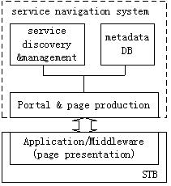
Figure 4 Navigation system based on application/middleware
The service navigation system is independent to STB. The Portal & page production server produces EPG pages and delivers them to STB and the STB present them to users by application/middleware. The user’s requests are sent to Portal & page production server, and the server interacts with the service discovery and management system to respond users’ request or redirect to other servers.
More detail or other functions can be added…

3. Proposal
The present document proposes a outline of service navigation system which includes the Frontstage navigation component and Backstage processing component.Through the two parts, the service navigation system can accomplish all IPG,ECG,ESG and BCG application.

_________________

