1.Introduction
INTERNATIONAL TELECOMMUNICATION UNION |  |  |  | Focus Group On IPTV
TELECOMMUNICATION  STANDARDIZATION SECTOR  STUDY PERIOD 2006-2008 |  |  | FG IPTV-C-0296
 |  |  | English only
WG(s): 1, 6 |  | 3rd FG IPTV meeting:  Mountain View, USA, 22-26 January 2007
CONTRIBUTION
Source: | China Netcom Group, P.R.China
Title: | Proposal on IPTV system middleware architecture and it’s functional requirements
The T05-FG[1].IPTV-DOC-0051 of WG6 has presented a definition of middleware and series of requirements about IPTV middleware. Based on the glossary and the requirements, and according to T05-FG[1].IPTV-C-0261, the present document gives a IPTV system middleware architecture model and it’s functional requirements.
First, the document presents the scope of IPTV system middleware which be confined in the TCP/IP application layer (as far as the application control, session control and streaming control are concerned), transport and access control of the transport layer and below are transparent to the system and we don’t care about it. According to the OSI seven layer model, the IPTV system middleware includes the application,presentation and session layers (see Figure 1), and it is a system software of application layer in the view of TCP/IP four layers model.
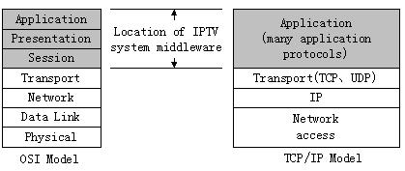

Figure 1 Location of IPTV system middleware in OSI and TCP/IP model

Second,some new requirements of IPTV system middleware are presented besides that of OD-0051:
(1) System middleware should provide interfaces to integrate quickly other systems or third party application.
- Service control of system middleware should be confined to the application control,session control and media streaming control.
- System middleware should be independent to network and OS, and should be extendable and backward compatible.
- System middleware should need Service Profile(the concept of Service Profile is similar to that of User Profile according to NGN Y.2012 draft.)

2. IPTV system middleware architecture and functional requirements model
Goal of IPTV system middleware: The IPTV system middleware is the core software of IPTV service operating, and it is able to integrate quickly other needed systems(including third party systems) such as the BOSS, service management system, CA/DRM, STB upgrade server,STB, VoD server and so on. Via the EPG system, it could provide broadband services such as the VoD,BTV, time-shift TV, value-added services etc. through broadband networks. The IPTV system middleware is open and extendable, can be upgraded or to increase new services and application components according to requirements. IPTV system middleware’s basic functional requirements as follows(see Figure 2):

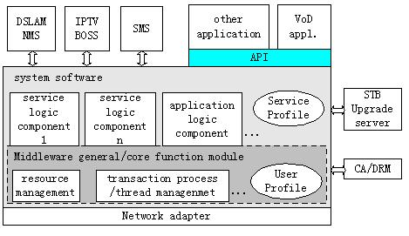
Figure 2 IPTV system middleware architecture and function model
  - Network adapter
Network adapter is mainly to shield each kind of network and resources in the lower layer,and provides the transparent interfaces for upper layer.
  - System software
System software is consist of service/application logic components, database and so on(independent to operating system), mainly dispatch and control resources, manage the transaction and threads as well as service/application logic processing and each kind of strategy processing. It invokes the lower layer network interfaces to control service network resources, and to provide application functions (APIs) for upper layer to be called. At the same time, it also can integrate quickly other systems, such as BOSS, CA/DRM, DSLAM NMS and so on. It includes the following functional entities.

2.2.1 Middleware general/core functional module
It manages the resources of application service system, processes the transaction and threads. Through User Profile, it combines closely the user's general attribute with the network resources, the application threads and control mechanism to form some interfaces to be called by upper service/application logic components.Core functional module can be extended to satisfy the application requirements.

2.2.2 Service/application logic components
By the definition of Service Profile, the service/application logic components use service attribute, invoke lower layer interfaces to fulfill the specific service/application logic, and form application interfaces through which to interact with other systems. Or it encapsulates some logic as APIs to be called by application layer to realize application independent to network and platform.

2.2.3 Service Profile and User Profile
They are the service and user's basic attribute database, for instance the Service No. and User No. (length and category) and so on. The concept of User Profile comes from NGN(Y.2012 draft), and the concept of Service Profile is corresponding with that of User Profile.
  - API layer
The API layer encapsulates the service and application logic for upper layer to provide application interfaces. The number and definition of APIs are closely related with service logic components, and depend on concrete services.
  - Application layer
Application layer includes EPG application, VoD, BTV, time-shift TV, games, videophone as well as other value-added services and so on.
  - Interfaces with other systems(to integrate with other systems)
In order to integrate quickly with other systems(including third party system) and services components, it is needed to provide interfaces to link with other systems. The following example some interfaces but not confined/limited to these interfaces:

2.5.1 DSLAM management interface
The DSLAM network management provides the controllable multicast interface to the system software. System software control multicast and permit validated users receive multicast media flow.

2.5.2 IPTV BOSS interface
IPTV BOSS realizes the user management, the product management, the user service ordered, accounting and billing functions.Through the interfaces, the system software could control the unified operation and accounting platform.

2.5.3 SMS interface
The system software collects service information and metadata to realize the arrangement and life cycle management, and controls the injection and distribution manner of SP/CP’s content through this interface.

2.5.4 STB upgrade server interface
By this interface,system software controls STB upgrade server, detects whether the software in STB is newest software, if not, will push the newest edition of software to STB.

2.5.5 CA/DRM interface
System software interacts with the CA/DRM system, fulfills the authentication/ authorization of user’s service and the content authorization, and sends the unscramble/decipher key to user.

3. Relation with STB middleware
In order to grasp entirely the IPTV system middleware, as well as the relationship with STB middleware, figure 3 presents the corresponding relation model between system middleware and STB middleware. Because the middleware is confined to application layer, the service control also be confined to the application control, session control and streaming control. At the same time, VoD application control is exampled.

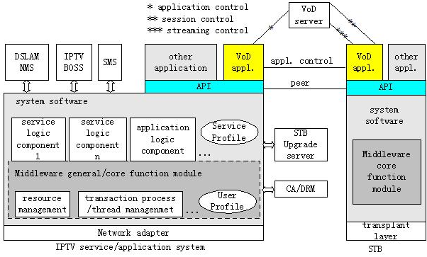

Figure 3 The corresponding relation model between system middleware and STB middleware

4. Proposal
The document proposes a architecture of IPTV system middleware and it’s functional requirements. The IPTV system middleware should be able to integrate quickly other systems(including third party systems) such as the IPTV BOSS, the service management system, STB upgrade server,CA/DRM, the VOD server, STB and so on. Via the EPG application, it should provides broadband services such as the VoD, BTV, time-shift TV, value-added services etc. through broadband networks.

___________________

