INTERNATIONAL TELECOMMUNICATION UNION |  |  |  | Focus Group On IPTV
TELECOMMUNICATION  STANDARDIZATION SECTOR  STUDY PERIOD 2005-2008 |  |  | FG IPTV-C-0337
 |  |  | English only
WG(s): 4 |  | 3rd FG IPTV meeting:  Mountain View, USA, 22-26 January, 2007
CONTRIBUTION
Source: | NEC Corporation
Title: | Bandwidth Allocation Function of Access Network for IPTV Services
1. Introduction
Y.1541 describes the definition of IP-based network QoS class, and it is necessary for all IPTV services to guarantee quality of service. And FGIPTV-C-197 is proposed that access node should implement traffic control for high priority multicast traffic to ensure the QoS of multicast, and is proposed to support the following functions.
- Total Multicast Bandwidth
- Current Available Bandwidth
- Connection Admission Control
However, on the other hand, it is seemed to need to discuss about the function which ensure enough bandwidth and guarantee quality for all IPTV services. Specifically, for reason that some IPTV service traffic is mixed in access network, it is proposed that bandwidth allocation function based on each IPTV service or each IPTV service category is supported in access network.

Table x - Association of IPTV services with Y.1541 QoS classes
(Refer from FG IPTV-DOC-0037)

IPTV service category | IP QoS class | IPTV service examples
Best Effort (BE) service | QoS class 5 | content download service
Best Effort (BE) service | QoS class 5 | regulatory information service
Best Effort (BE) service | QoS class 5 | T-information
Best Effort (BE) service | QoS class 5 | e-mail
Low Loss (LL) service | QoS class 4 | Download VOD, MOD
Low Loss (LL) service | QoS class 4 | T-commerce
Low Loss (LL) service | QoS class 4 | T-learning based on VOD
Interactive (I) service | QoS class 2/3 | messenger
Interactive (I) service | QoS class 2/3 | T-learning based on interactive
Real-Time Interactive (RTI) service | QoS class 0/1 | VOIP, video phone
Real-Time Interactive (RTI) service | QoS class 0/1 | multi player game
Real-Time Multicast & Unicast (RTMU) service | QoS class 6/7 | linear/broadcast
Real-Time Multicast & Unicast (RTMU) service | QoS class 6/7 | multi angle
Real-Time Multicast & Unicast (RTMU) service | QoS class 6/7 | pay per view (PPV)
Real-Time Multicast & Unicast (RTMU) service | QoS class 6/7 | networked personal video record (PVR, time-shift)
Editor Note: The above table is just a starting point. To be updated based on future contributions

2. Bandwidth Allocation Function of Access Network
For reason that some IPTV service traffic is mixed in access network, the QoS class queues for each IPTV service or each IPTV service category and the queues control function should be supported to guarantee quality for all IPTV services in access network. In addition, as shown figure 1, the Bandwidth Allocation Function (BAF) for each IPTV service or for each IPTV service category should be supported in access line, because it is necessary to guarantee its quality of all using IPTV services (except Best Effort service) even if multiple services are used at a customer premise.
For example, the bandwidth allocation function can be operated based on the following information. The information including below ones is for future study.
- Whole bandwidth of access line
- User ID
- Service type ID
- Value of bandwidth
Value of minimum guarantee bandwidth
Value of maximum guarantee bandwidth

Next, the following schemes can be provided for getting the above information of bandwidth allocation. For example, in case of NGN, if using session protocol such as SIP, it is possible for access line to allocate bandwidth dynamically when an end-user selects an IPTV service. Dynamic bandwidth allocation scheme by using session protocol is for further study.
- Case of NGN
- Set from RACF (Resource & Admission Control Functions) to Access line
- Snooping Control Protocol and/or Snooping Streaming protocol and/or Snooping session Protocol at Access line
- Case of Non-NGN
- Set from Resource Control to Access
- Snooping Control Protocol and/or Snooping Streaming protocol at Access

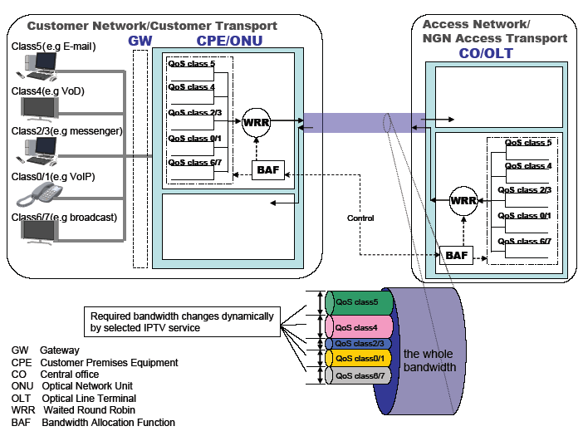

Figure1. Example of bandwidth allocation function of access network for IPTV services

3. Proposal
This contribution proposes the above section 2 is included as a text section of WG4 document.
__________________

