INTERNATIONAL TELECOMMUNICATION UNION |  |  |  | Focus Group On IPTV
TELECOMMUNICATION  STANDARDIZATION SECTOR  STUDY PERIOD 2005-2008 |  |  | FG IPTV-C-0338
 |  |  | English only
WG(s): 2 |  | 3rd FG IPTV meeting:  Mountain View, USA, 22-26 January 2007
CONTRIBUTION
Source: | Pixelmetrix Corporation
Title: | End to End IPTV Monitoring – A Reference View
Introduction: IP networks Monitoring Vs IP “Television” Monitoring
Provisioning video services over IP networks is not about providing data only, it’s about providing a continuous stream of reliable content to a user. The correctness of the network equipment no longer ensures a Quality of Experience for the television viewer. The need is to create multiple monitoring zones by dividing the IP delivery network and establish a plan to engage systems to monitor all efficiently.

The data should enter the system right, should leave the building as intended, should reach the access loop as intended and delivered to the customer as intended for a successful service to operate. A failure at any stage is directly linked to the failure of service, and hence the need to monitor it across the delivery chain.

The contribution is aimed at extending the concept of Perceptual objective video quality measurement, and understanding the implementation of a reduced reference mechanism to monitor quality “end-to-end” in an IPTV network. To brief on the concept of a reduced reference model, features are extracted from the source video and processed video and from an objective comparison of these features, a quality analysis is computed [1].

Also, discussed is how a delta measurement model can be adopted to perform an objective analysis on the source and processed video and the attributes of a “Quality Television Service” that contribute to the content delivery experience of the customer.
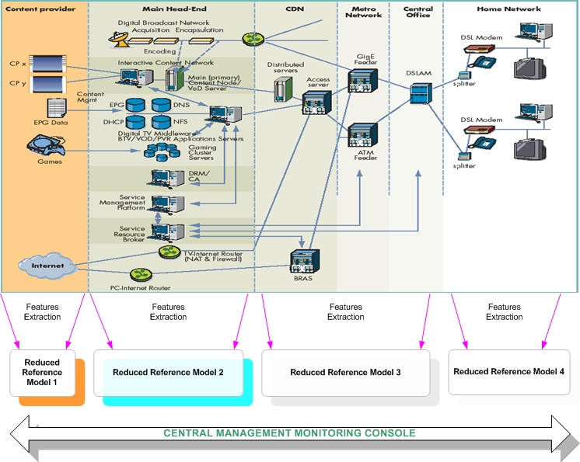
Figure 1: IPTV Delivery chain – Applying reduced reference model

The entire content delivery chain is divided into multiple “monitoring zones” and every zone in the IPTV chain has to be applied with an optimized reduced reference model to analyze the input and output characteristics of content processed for the block. Feature data of the content is extracted at entry and leaving points of each zone and applied a reduced reference objective algorithm to monitor the integrity of flow across the block. A central monitoring engine, maintains and manages extracted feature data and RR analysis data for each macro block in the IPTV delivery cycle. This central engine provides the service provider an elaborate view of data monitored at each stage of the IPTV delivery network. The monitoring engine acts a one-stop telemetry consolidator to understand monitoring information and presenting assimilated information to the service provider. The process of applying RR models to each block ensures accessibility of best possible monitoring data at each stage of the video network to establish integrity of an IPTV service.
A complete end-to-end view of content flow and characteristics can be monitored through the central monitoring engine of the IPTV network. The monitoring engine with seamless integration to the OSS and NMS systems provides the service provider with a snapshot of functioning of the network and the service.
As an extension, to understand how an objective assessment on video can be done, is through a “delta RR model” where the features of source video and processed video are compared for changes, what impact has processing had on the quality of source video.

A possible implementation of this RR delta engine in the IPTV head-end could be:

A/V
IP
SDI
IRD
Encoder
DRM
STB
Input from Satellite Dish

fB
fA

Transfer Channel
RR Algorithm A

Figure 2: A delta RR model in the IPTV head-end
In the above diagram fA and fB refer to features extracted from Original and Processed video.
The features that are extracted from the source and processed video are extremely essential to optimize the functioning of the RR algorithm and produce meaningful results. As examples, multiple features have been defined in the past which can be referred to in [2] and [3].
The holistic integrity of a television service is not only defined by the video picture quality alone. Multiple factors, as mentioned below are equal contributors to any television service, IP or otherwise. Audio presence/ quality, meta data integrity are essential to run a quality television service.
Quality Television Service

Video
Audio
Meta Data

Parental control
EPG
Subtitles

Figure 3: A Quality Television Service
The presence, quality and correctness of each of the elements define a quality television service. The experience is decided by factors that cannot be confined to a single protocol layer or a group of layers, but every single layer plays an equal contribution to deliver a quality experience.
Conclusion:
It is essential that every stage of the IPTV network must pass the eye of the scanner. A clear definition of four things is required to implement a system wide monitoring policy for the IPTV network. The identification of monitoring points of the network, the feature data essential to be monitored for each “monitoring zone” to understand video processing within that zone, an optimized reduced reference objective model to be applied to data collected from each zone and the monitoring engine to establish integrity of the television service for all elements that constitute the service such as video, audio and meta data.
The success of a service lies in the capability of the central monitoring engine and its seamless integration with OSS and NMS systems to show service information as a snapshot of all that matters to the service provider. To conclude, the success of IPTV lies in efficient monitoring.

References:
1. Chul Hee Lee (Yonsei Univ.), 2006. “User requirements for perceptual video quality monitoring of IPTV”. Input document, 1st FG IPTV Meeting, ITU, July2006.
2. S. Wolf and M. Pinson, NTIA Report 02-392, June, 2002. “Video Quality Measurement Techniques,”. Available at http://www.its.bldrdoc.gov/n3/video/documents.htm
3. Sugimoto Osamu, Kawada Ryoichi, Koike Atsushi, Matsumoto Shuichil, Rasmussen Rene, Miyake Yoichi , “Method for remote monitoring of transmitted video quality using very low bitrate data circuit based on the reduced reference method”. Available at http://cat.inist.fr/?aModele=afficheN&cpsidt=17046342 [on order]

____________

