Abstract
INTERNATIONAL TELECOMMUNICATION UNION |  |  |  | Focus Group On IPTV
TELECOMMUNICATION  STANDARDIZATION SECTOR  STUDY PERIOD 2005-2008 |  |  | FG IPTV-C-0344
 |  |  | English only
WG(s): 1 |  | 3rd FG IPTV meeting:  Mountain View, USA, 22–26 January 2007
CONTRIBUTION
Source: | NTT Corporation, CATR, ETRI
Title: | Proposal for document structure of the architecture document
At the second FG-IPTV meeting in Busan in October 2006, the initial draft deliverable of the IPTV architecture was made, and it was then revised at the e-meeting in mid-December. This contribution proposes a new document structure for the IPTV architecture document to accelerate the architectural discussion in WG1.

1. Introduction
At the second FG-IPTV meeting in Busan in October 2006, the initial draft deliverable of the IPTV architecture was made. WG1 agreed to study three architecture approaches: NGN and IMS-based, NGN and non-IMS-based, and non-NGN-based architectures. The current figure 5 where three approaches have converged was made as a result of the discussion. On the other hand, China proposed a high-level functional architecture approach that does not depend on these three architecture groups. WG1 agreed to include both high-level architectures in the IPTV architecture document. The architecture document was discussed and revised at the e-meeting in mid-December. The revised version is included in the input to this FG-IPTV meeting as FG-IPTV-C-261. However, it consists of figures without explanatory text. Considering the study period of FG-IPTV, it is necessary to accelerate the architecture study.
This contribution proposes a new structure for the IPTV architecture document based on FG-IPTV-C-261 to accelerate the study. The key point of the proposed document structure is to divide the description of the architecture in a specific solution from the part that does not depend on functional architecture. It also proposes merging the introductory parts, i.e., “Introduction” and “IPTV relationship,” into one section entitled “IPTV architectural overview.”

2. Discussion
2.1 Beginning of the document
The document should follow the normal format of an ITU-T Recommendation. Therefore, the order of “Definition” and “Abbreviations” should be changed.

2.2 Introductory part
The introductory part should be easy for readers to understand. The current section 5, Introduction, gives only brief explanations of three architectural approaches: NGN and IMS-based, NGN and non-IMS-based, and non-NGN-based architectures. The current section 6, IPTV relationship NGN and other networks, gives only a figure of the NGN architecture with IPTV service component. Figure 1 shows the relationship between NGN architecture and IPTV component. This figure is very helpful in understanding the target architecture of FG-IPTV and the relationship with NGN architecture. Therefore, the introductory part should include the NGN architecture figure with IPTV component.

Note 1: In the last e-meeting, because Figures 6, 7, and 9 were made by FG-IPTV for each architecture approach, there was a proposal that these figures should be referred in current section 5. However, the introductory part should use well-known and simple figures for easy understanding. Figure 6 shows the specific “non”-NGN-based architecture made by FG-IPTV. In general, there are several architectures for non-NGN-based IPTV architecture, so the figure referred to in the introductory part should not be specific and should show only the relationship with NGN architecture.

2.3 General architecture part
The architecture document should have functional architecture descriptions to identify functions for providing IPTV-services. This part should describe general functions that do not depend on specific solutions such as IMS. The current document is not divided between the functional architecture and architectural solution.
A new functional architecture section is needed to describe solution-independent functions. The architectural requirements, such as user control and QoS enablers, should be clarified in a new sub-section. After the requirement description, the reference model is needed as a base for functional architecture study. In the current document, the reference model is shown in section 7. This section should be moved to a sub-section after the architectural requirements sub-section. Then, the high-level architecture that defines the reference points is needed to define functions for providing IPTV services in the next section. After this sub-section, the functional blocks that organize the high-level architecture should be defined with detailed functions. These functions should be aligned with Y.2012, NGN functional architecture, in the case of NGN-based IPTV architectures.

Note 2: The current section 7 shows the reference model. The general aim of the reference model is to clarify the reference points between domains. However, the reference points are defined in the high-level architecture sub-section. The reference model sub-section should be removed in the future if it is not referred to by any parts of the document.

2.4 IPTV service component part
There are three approaches for making IPTV service components: Non-NGN-based, NGN and non-IMS-based, and NGN and IMS-based architectures. The current section 8 shows these three approaches.
The NGN-based approaches are expected to have common functions such as billing and management. A new sub-section, common functions in NGN environments, should be created. After the common part, non-IMS-based and IMS-based approaches should be described.

Note 3: In the case of NGN-based approaches, the new section 7.2, the terminologies used in figures 7, 8, 9, and 11 should be aligned with NGN terminologies defined by SG13, as a result of last e-meeting.

3. Proposal
Based on the above discussion, this contribution proposes a new structure for the IPTV architecture document to accelerate IPTV architecture study. The appendix shows the re-structured architecture document.

IPTV Architecture
- Scope
[Editor’s Note: material is required for the scope.]
- References
The following ITU-T Recommendations and other references contain provisions, which, through reference in this text, constitute provisions of this working document. At the time of publication, the editions indicated were valid. All Recommendations and other references are subject to revision; users of this working document are therefore encouraged to investigate the possibility of applying the most recent edition of the Recommendations and other references listed below. A list of the currently valid ITU-T Recommendations is regularly published.
The reference to a document within this Recommendation does not give it, as a stand-alone document, the status of a Recommendation
[1] ITU-T Recommendation Y.2012 (2006), Architecture and Requirement of the NGN
- Definitions
This working document uses or defines the following terms:

- Abbreviations
This working document uses the following abbreviations.
IPTV Internet Protocol TV
NGN Next Generation Network
IMS

- IPTV architectural overview
[Editor’s Note: introduction text is required here.]
3 approaches were identified for the architecture of IPTV.
(1) “NGN-based” and “IMS-based” architecture
An IPTV service component is drawn on top of the “other NGN service components” in NGN architecture shown in Figure 1. The IPTV service component is achieved by using IMS.
(2) “NGN-based” and “non-IMS-based” architecture
An IPTV service component is drawn on top of the “other NGN service components” in NGN architecture shown in Figure 1. The IPTV service component is achieved without using IMS.
(3) “Non-NGN-based” architecture
The architecture does not depend on NGN architecture [1].

The “NGN-based” architecture means the IPTV architecture in accordance with [1] for providing IPTV services. The NGN components described in [1] are shown in Figure 1.

[Editor’s Note: more text is needed here.]
[Editor’s Note: more text should be added to restate that the NGN Architecture does not exclude legacy networks.]

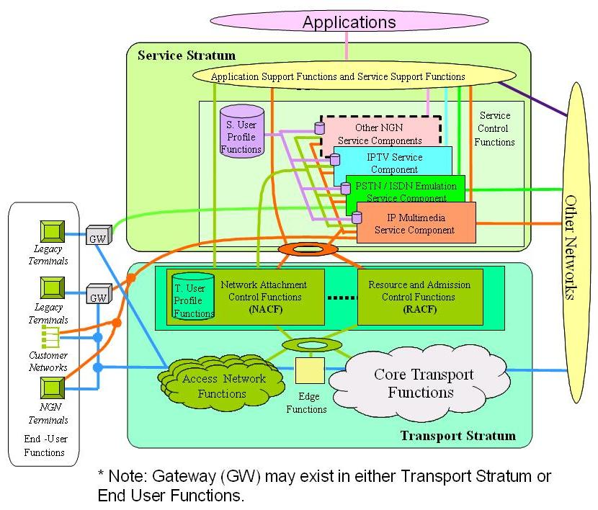
Figure 1 Transport and service configuration of the NGN

- IPTV General Architecture

6.1 Architectural requirements

6.2 IPTV reference model

[Editor’s note: It was suggested during the scenarios that Content Aggregation Entity to be considered.]
Figure 3 Reference Model
[Editor’s note: The table of content is provisional and will include more sections]

[Editor’s Note: There should be a section to describe Service Exchange Points. This note is coming from C-135 and not approved by WG.]

6.3 General functional Architecture of IPTV
[Editor’s Note: the ordering of those sections can be changed. ]

Figure 4 IPTV Functional Architecture
Information cross each reference point is listed as following (not complete),
- A: Content Stream
- B: Content Request, Descriptive Metadata/Content Info etc.
- C: Rights Management Interaction
- G: Conditional Access System
- D: Service Interaction Message
- E: Content Location information, Billing information, Content Control Command, etc.
- F1: Play Control Signal
- F2: Content Stream
[Editor’s Note: The figure and attached text above is taken from FG IPTV-C-0170 with some modification.]

6.4 Functional elements

[Editor’s Note: the list below is picked from FG IPTV-C-0111 Figure 1.]
Service Management Platform Functions:
- Subscribe
- Service
- Account
- STB
- Content
- CP
- Resource
- Portal
- System
- Statistics

Figure 5 Functional Architecture of the Content Delivery Sub-system
[Editor’s Note: The diagram above is taken from FG IPTV-C-0169 with some modifications.]
[Editor’s Note: Need to discuss the difference between the two control boxes labelled “IPTV Control” on top and “Control” at the bottom inside Figure 4.]
[Editor’s Note: the diagram above is not yet approved by WG1.]

- IPTV service component

Figure 6 Converged Applications

[Editor’s Note: the diagram above is coming from Ad-hoc meeting, and not be approved by WG1 yet.]
[Editor’s Note: request further elaboration on the structure of the UE.]
[Editor’s Note: Need more text to illustrate the convergence between the different architectures shown in Figure 5.]

7.1 Non-NGN-based architecture

Figure 7 Non-NGN Based IPTV Architecture

[Editor’s Note: the diagram above is coming from Ad-hoc meeting, and not be approved by WG1 yet.]

7.2 NGN-based IPTV Architecture

7.2.1 Common functions in NGN-based IPTV architectures

7.2.2 Non-IMS-based IPTV Architecture

Figure 8 Non-IMS Based IPTV Architecture

[Editor’s Note: the diagram above is coming from Ad-hoc meeting, and not be approved by WG1 yet.]

Figure-9 Example of non-IMS-based architecture for unicast IPTV services
[Editor’s Note: The terminology may be changed, the terms in Figure 8 need to be aligned with the other diagrams in the document, after the proper definitions have been agreed upon.]

7.2.3 IMS-based IPTV Architecture

[Editor’s Note: The concept of maintenance needs to be introduced and need to be further studied.]

[Editor’s Note: IMS Argumentation need more text.]
IPTV IMS based architecture ensures:
  - SIP protocol dedicated to multimedia
  - Modular architecture
  - Easy integration with old telecommunication networks and exists services
  - Central billing system based on Parley OSA solution.
  - Third-party services
[Editor’s Note: the above text is not yet approved by WG1.]

Figure 10 IMS-Based IPTV Architecture within an NGN Framework
[Editor’s Note: the diagram above is coming from Ad-hoc meeting, and not be approved by WG1 yet.]

Figure 11 IMS-based architecture for IPTV

[Editor’s Note: The figure above is taken from FG IPTV-C-0156er1.]
[Editor’s Note: The entities in light blue in the figure above may require modifications beyond the ITU-T SG13 definition.]
Figure 12 Example of IMS-based architecture for unicast IPTV services
[Editor’s Note: The terminology may be changed, the terms in Figure 11 need to be aligned with the other diagrams in the document, after the proper definitions have been agreed upon.]

