INTERNATIONAL TELECOMMUNICATION UNION |  |  |  | Focus Group On IPTV
TELECOMMUNICATION  STANDARDIZATION SECTOR  STUDY PERIOD 2005-2008 |  |  | FG IPTV-C-0378
 |  |  | English only
WG(s): 2 |  | 3rd FG IPTV meeting:  Mountain View, USA, 22-26 January 2007
CONTRIBUTION
Source: | China Telecom
Title: | Proposal on performance monitor points in IPTV system
Abstract
In the 2nd meeting in Busan, there has be a draft structure for Performance monitoring for IPTV, as shown in FG IPTV-DOC-0039. From services provider perspective, performance monitoring is important for guaranteeing IPTV QoS/QoE. China has successfully deployed 60,000 users in Shanghai city and has done performance monitoring in the real IPTV network.
This contribution proposed a performance monitoring strategy.
Discussion
- According to IPTV general architecture, the content provision layer would provide source live/channel content and relevant metadata to service provider. The source content quality is the key for the IPTV QoE. If the quality loss happened in the source, there would be no possibility to correct. So there shall be a performance monitor reference point where the source contents go into the service provider. This point will be helpfu1 to define the responsibility for QoE between content provision and service provider.
- In the services provider domain, generally called "core office" or "head office", the source contents will be stored, processed and streamed. When the streaming contents are exported into the network, there should be a reference point for monitoring the original streamed audiovisual quality.
- For the IP network layer, there naturally are reference points for monitoring IP network performance. The performance parameters would be IP related, such as IP packet loss ratio, jitter etc.
- For the IP edge network, generally there would deploy edge vod servers and multicast replication points as a part of content delivery network for good performance. Because these servers are located nearest user and provide the actual services streaming functions, there should be performance monitoring points in the export of IP Edge Network.
- For the end system, subscribes are the IPTV end users, so they are naturally the ultimate judge of IPTV QoE. From end user perspective, the audiovisual quality and services attribute are perceptive. There shall be reference points for monitoring QoE of end user in end system.

Proposal
From above discussion, we can draft out diagram of IPTV performance monitoring as following figure.
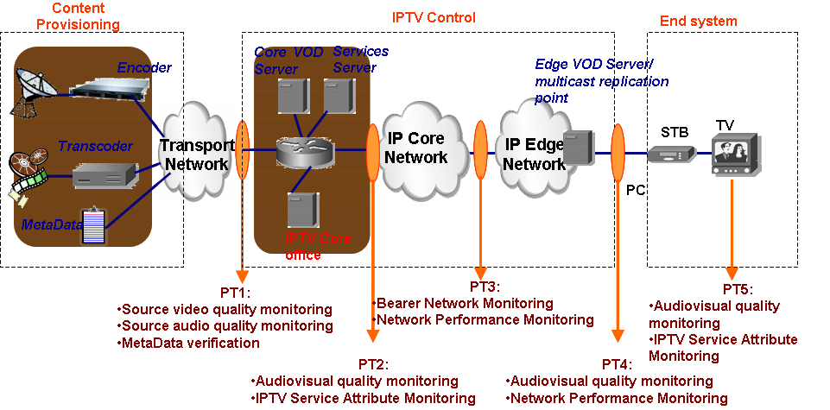
- PT1: this point define the quality borderline between content provision and IPTV control. It should aims for Source video quality monitoring, Source audio quality monitoring, MetaData verification.
- PT2: this point aims for original streaming quality monitoring, such as Audiovisual quality monitoring, IPTV Service Attribute Monitoring.
- PT3: this point aims for IP-related performance parameters monitoring, such as Bearer Network Monitoring, Network Performance Monitoring.
- PT4: this point aims for monitoring quality of streaming Closest to user quality Audiovisual quality monitoring,IPTV Service Attribute Monitoring.
- PT5: this point aims for monitoring end users QoE,specially Audiovisual quality monitoring and IPTV Service Attribute Monitoring.

We think the above strategy should be very helpful for IPTV service provider to monitoring performance of IPTV services in end-to-end environment. It is proposed that the above diagram would be discussed in WG2 and the PT1~PT5 would be basic performance monitor points in IPTV and be added into the section 6 in working document of WG2, “FG IPTV-DOC-0039”.

Contributor List
Name | Company | Tel. | Email
Siqing Luo | China Telecom | +86 21 58755452 | luosq@sttri.com.cn
Haining Yan | China Telecom | +86 21 28970207 | yanhn@sttri.com.cn
Jianting Meng | China Telecom | +86 21 58755057 | mengjt@sttri.com.cn
Li Jiang | China Telecom | +86 21 58750441 | jiangli@sttri.com.cn

____________

