Summary:
INTERNATIONAL TELECOMMUNICATION UNION |  |  |  | Focus Group On IPTV
TELECOMMUNICATION  STANDARDIZATION SECTOR  STUDY PERIOD 2005-2008 |  |  | FG IPTV-C-0392
 |  |  | English only
WG(s): 4 |  | 3rd FG IPTV meeting:  Mountain View, USA, 22 – 26 January 2007
CONTRIBUTION
Source: | ETRI, Republic of Korea
Title: | Proposed Working Document: IPTV Multicast Requirements
This contribution proposes initial draft of Working Document for identifying IPTV Multicast requirements. The contents of his contribution based on the living lists, parts of, not all of them, on IPTV multicast which developed at the last FG IPTV meeting in Busan Korea, October 2006.
Draft Working Document
IPTV Multicast Requirements

CONTENTS
1 Scope 3
2 References 3
3 Definitions 3
4 Abbreviations 3
5 Conventions 4
6 Overall Requirements of IPTV Multicast 4
6.1 Functional Requirements of IPTV Multicast Access Node 4
6.2 Functional requirements for Replication Point 5
6.3 Functional requirements for load balancing 5
6.4 Functional requirements for multicast availability 5
6.5 Functional requirements for multicast QoS 6
6.6 Functional requirements for multicast security 6
6.7 Functional Requirements for Multicast Address Management 7
6.7.1 IP Multicast Address Transition 7
6.7.2 The Control of Users’ Multicast Address 8
6.8 Functional Requirements for overlay IPTV Multicast 8
6.9 Interoperability Requirement 10
6.9.1 Requirement of IPTV Service Exchange Point 10
6.9.2 Requirement of IPTV Information Registry 11
6.9.3 Interoperability Requirements amongst IPTV multicast service providers 12
7 IPTV Multicast Transport Stratum Requirements 12
7.1 IPTV Multicast Control Function at the Transport Stratum 13
8 IPTV Multicast Service Stratum Requirements 13
8.1 Functional Requirements for IPTV Service Level Multicast 13
8.2 Control Framework for IPTV Service Level Multicast 14
8.2.1 IPTV Session Manager (ISM) 14
8.2.2 IPTV Multicast Agent ( IMA ) 15
9 Requirements of Overlay IPTV Multicast 16
9.1 Requirements of Overlay IPTV Multicast Control 16
10 Procedure of IPTV multicast user authentication and authorization 17
11 Multicast scenarios 17
12 Other aspects 18

IPTV Multicast Requirements

Scope
This draft working document describes functional requirements and architecture models of supporting multicast capabilities in terms of IPTV network control.

References
The following ITU-T Recommendations and other references contain provisions, which, through reference in this text, constitute provisions of this working document. At the time of publication, the editions indicated were valid. All Recommendations and other references are subject to revision; all users of this working document are therefore encouraged to investigate the possibility of applying the most recent edition of the Recommendations and other references listed below. A list of the currently valid ITU-T Recommendations is regularly published.
The reference to a document within this working document does not give it, as a stand-alone document, the status of a Recommendation.
TBD

Definitions
This working document uses and defines the following terms:
IPTV Service Exchange Point (SEP)
IPTV SEP identifies as a reference point for handling the service brokering function between IPTV SPs enabling the optimal contract between IPTV SPs and providing the stable IPTV services amongst IPTV service providers.
Multicast Domain Management
A multicast domain is a set of multicast routing and forwarding instances than can send multicast traffic to each other. These multicast routing and forwarding instances are referred to as IPTV multicast domain. Thus, multicast domains map all of a customer’s multicast groups that exist in particular IPTV service members to a single unique global multicast group. This is achieved by existing or specific group routing and forwarding capability in the network.
Others: TBD
[Editor’s note] Terms and definitions in this section should be confirmed through the meeting considering other relevant terms and definitions as appropriate for using in IPTV multicast. And special care should be needed to avoid any confusion with other terms and definitions. Further study should be carried out.

Abbreviations
This working document uses the following abbreviations.
DRM Digital Rights Management
IP Internet Protocol
QoE Quality of Experience
QoS Quality of Service
SEP Service Exchange Point

Conventions
TBD
Following sections are based on WD of IPTV Network Control aspects.

Overall Requirements of IPTV Multicast
Multicast functionality is required to make efficient use of network bandwidth resources when delivering broadcast content. IPTV multicast and its control function are important in network to support stable IPTV services, therefore IPTV multicast network should support stable and robust multicast network architecture which should equipped with following functional requirements.

Functional Requirements of IPTV Multicast Access Node
Following sections are based on document FGIPTV-C-197 (LL#7)
Multicast functionality is required to make efficient use of network bandwidth resources when delivering broadcast content. Video traffic encapsulated in IP multicast packets will probably be flooded within VLAN in a non- optimized L2 network. The target in IPTV multicast traffic delivery is to support multicast optimization by controlling the flooding of Ethernet multicast frames by using IGMP proxy in intermediate (L2) devices especially Access Node which is the closest (First Mile) to the end user.
To support multicast optimization by controlling the flooding of Ethernet multicast frames should be use of IGMP protocol.
IGMP proxy function in access node (or other network node in bearer network where multicast replicated to users) should be supported. Access node performs the router portion of the IGMP protocol on its user interfaces and the host portion of the IGMP protocol on its network interfaces. Thus, access node (or other network node in bearer network where multicast replicated to users) can:
- Reduce the number of messages from numerous users to network
- Improve bandwidth efficiency in multicast traffic
- Secure multicast delivery to undesired end users
- Ensure availability of multicast video service to end users by reduce message loss. Specifically, for example, some messages are lost due to the packet loss of bearer network, or load of service router, or other possible reasons.
One of the concerns is that doing IGMP proxy in access node (or other network node in bearer network where multicast replicated to users) instead of snooping is that IGMP proxy solution may lead to an issue that subscriber information is terminated in access node and does not go to service edge. But in multi-service multi-edge architecture, the access node, which is the access point of multiple services, will be the best point to collect multicast service detail information instead of upper network devices.
As video service need much bandwidth and also should be a service with high service quality. Access node should implement traffic control for high priority multicast traffic to ensure the QOS of multicast. Specifically, following functions should be supported in access node:
- Total Multicast Bandwidth: access node should be able to control on total bandwidth of a user port that can be used for multicast service;
- Current Available Bandwidth: the access node should be able to aware of current available bandwidth that can be used for multicast service, specifically, can be total multicast bandwidth – consumed multicast bandwidth;
- Connection Admission Control: It is required that Connection Admission Control supported in Access network based on available resources. When end user subscribes to a multicast stream, access network will perform CAC: check if current available resources are enough for the new service subscription. The resources can be bandwidth, connection number and user service privilege profile.
- Network Attachment Control: The attachment control should be supported by the multicast control function and multicast replication function. The multicast control function should build the privilege table for multicast users, and the multicast replication function should forward multicast media content to users which have the privilege of IPTV multicast services.

Following sections are based on document FGIPTV-C-0137 (LL#2).

Functional requirements for Replication Point
Location of Replication Point (RP) is not only affects IPTV service delay, but also network burden. Following requirements should be taken care.
- Optimal RP Positioning: Optimal RP positioning depends upon Service Providers’ network topology and their multicast traffic path which taken consideration of followings:
- Loop free, Delay/Jitter independent, stability guarantee topology
- Optimal position to exchange SA information amongst multicast service provider
- RP redundancy mechanism: IPTV network should be guaranteed optimized RP redundancy to improve IPTV service stability in case of RP failure. IPTV network should be designed their RP mechanism not only to maximize service stability, but also to minimize service recovery time during RP failure.
Following sections are based on document FGIPTV-C-0137 (LL#2).

Functional requirements for load balancing
When multicast routers receive a join message, multicast routing protocol normally send its join message to one of the multicast interfaces. If some groups have the same source, among multiple multicast interfaces, only one of them is selected and sends the join. In an ECMP environment, all multicast interfaces cannot be used to distribute multicast traffic; instead only single interface is used. To load sharing the traffic, multicast source should be distributed for different groups, and service provider should be considered of this load sharing requirements.
Following sections are based on document FGIPTV-C-0137 (LL#2).

Functional requirements for multicast availability
<need explanatory text about availability in here>
Followings should be taken care as functional requirements for guaranteeing of multicast services:
- Multicast Service failure recovery: IPTV network should support a time for non stop forwarding of multicast traffic with fully redundant system architecture and topology.
- Link/Node failure recovery: IPTV network should support a time for non stop forwarding of multicast traffic with fully redundant system architecture and topology.
- By ISSU feature, multicast service should not be affected even in a maintenance period such as software upgrade.
- Multicast Traffic should be in ready condition for whole PIM links for IPTV service.
- IPTV network should robust against Any DoS attacks
Following sections are based on document FGIPTV-C-0137 (LL#2).

Functional requirements for multicast QoS
<need explanatory text about multicast QoS in here>
Followings should be taken care as functional requirements for supporting multicast QoS:
- IPTV network should support mean(s) for multicast traffic monitoring (including performance monitoring) and analysis for each service group.
- IPTV network should support differentiated handling of multicast traffic which requested QoS treatment.
Following sections are based on document FGIPTV-C-0137 (LL#2).

Functional requirements for multicast security
<need explanatory text about multicast security in here>
Security is one of the most critical issues for multicast network deployment. Followings should be taken care as functional requirements for supporting multicast security:
- Security in RP: <need explanatory text about security in RP here>
- Group range address filtering: When configuring RP to avoid RP overload, IPTV network should support of filtering group addresses designate to a specific group so prevent unwanted groups from sending join messages.
- PIM register message filtering: PIM register message filtering should be supported by IPTV network only for approved source can register in RP which needs to apply PIM register message filter, so as to prevent unwanted sources from sending by bogus sources.
- MSDP SA filtering: MSDP SA messages contain source and group information for RPs in PIM-SM domains, and they exchange SA messages without filtering them for specific source or group addresses by default. IPTV network should be support of MSDP SA filtering to prevent bogus (S, G) from sending.
- PIM Router Security: <need explanatory text about PIM Router security in here>
- Multicast route should be limited to protect against any kind of worm attack via multicast routing update.
- BSR message filtering: If RP selection is selected by a static way, IPTV network should support to block bootstrap messages to prevent RP from overriding the information. If Service Provider’s domain does not use bootstrap messages to select RP, IPTV network should support to block bootstrap messages in multicast routers.
- PIM authentication among each neighbor: IPTV network should support to block PIM neighbor-ship facing customer interfaces to prevent unwanted information from spreading out.
- Security on Last mile PIM router: In the last mile, it is necessary to apply filtering to block spoofed customer IP, multicast sources sent from customer side, and PIM neighbour-ship with customer facing interface.
- IPTV network should support of protection against multicast source spoofing

Functional Requirements for Multicast Address Management
Related Following sections are based on document FGIPTV-C-157 (LL#8)
According to IANA rule, the addresses ranging from 224.0.0.0 to 239.255.255.255 belong to IP multicast address. As the addresses from 224.0.0.1 to 224.0.1.255 are distributed to the specific protocols and implementations, the addresses from 239.0.0.0 to239.255.255.255 can only be used in the private areas. Therefore, several hundred millions of multicast addresses from 224.0.2.0 to 238.255.255.255 can be used in the internet. As one of important resources, these multicast addresses, should be managed effectively.
IPTV multicast functions should be support of interactive control aspects.

IP Multicast Address Transition
When deploying IPTV broadcasting services, carriers often use one multicast group address representing an IPTV channel. Unlike the unicast addresses, multicast addresses are not distributed depending on different countries, areas and carries all over the world. Therefore, during the operating of IPTV broadcasting service, the corresponding relationship between IPTV channel and multicast address can be overlapping or conflicting among different carriers or different service areas of one carrier. As Fig. 1 shows, carrier A and carrier B want to interconnect their IPTV direct broadcasting services; or Carrier B created local IPTV broadcasting service platform in service areas C and D , where the local carriers should interconnect some broadcasting service sources. With regard to these IPTV service traffic which cross multiple multicast bearer domains, IPTV MST (multicast service stream transition) needs to be deployed at the edge of each bearer network domain to check the multicast service traffic from other domains. If the multicast address of IPTV service stream is conflicting to the multicast address planning of local domain, the multicast address of IPTV stream coming from other domains should be changed before entering local domain.
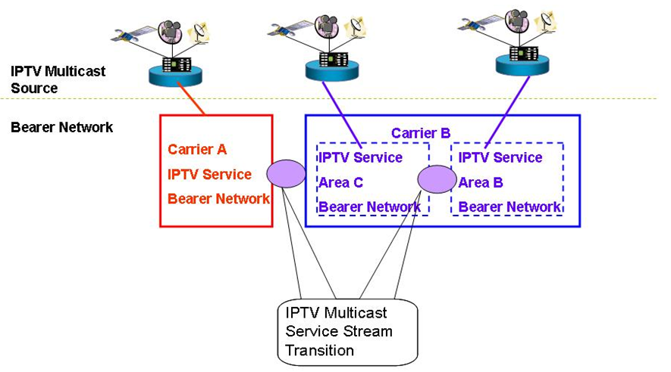
Fig. 1 IPTV Multicast Address Transition

The Control of Users’ Multicast Address
In order to control the development of these multicast services on carrier’s network and avoid impact on carriers’ IPTV broadcasting services, carriers can deploy multicast service controller to manage the distribution of multicast address uniformly. However, as for the multicast application without registration, carriers will restrict the usage of these multicast addresses at the access point of IPTV network. The procedures of applying for multicast service and multicast address are as follows and shown as Fig. 2.
1. In order to carry out services based upon multicast address users should arrange the inquiry and registration on the PORTAL of carrier-provided Multicast Address and Service Control Platform.
2. The self-service system check the situation of this multicast address from multicast address policy controller
3. If this multicast address is available, users will be told that they are allowed to use it.
4. At the same time, multicast address policy controller sends policies to the access point to allow the multicast services get access.
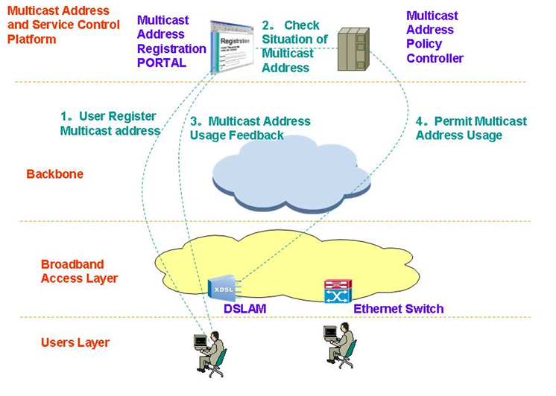
Fig. 2 Control Procedure of Multicast Address

Functional Requirements for overlay IPTV Multicast
Following sections are based on document FGIPTV-C-0221 (LL#3)
To deliver IPTV media, native IP multicast mechanism is the best solution. Because IP multicast router copies IPTV media data and then forwards them to destined group, native IP multicast mechanism shows high performance by reserving resources of network’s as well as media sender’s. But native IP multicast highly depends on the condition of underlying network, which means to make native IP multicast possible, all the routers must be changed into multicast-enabled; and that means ISP must pay for the expense. Not alone the matter of cost, several problems prevent native IP multicast mechanism from being fully deployed in the Internet.
Therefore some well-known alternative multicast mechanisms are emerged; which are CDN, P2P, and overlay multicast mechanism.
In an overlay multicast mechanism, each node constructs multicast data delivery path from sender to group dynamically as native IP multicast router does. Along the constructed path, each node forwards media, which arrives from its upstream node, to its downstream nodes. The size of group is not logically bounded, and it is adequate to distribute contemporary media.
Following sections are based on document FGIPTV-C-228 (LL#9).
An overlay network for IPTV service control has a feature interaction capability to analyze, tradeoff and generate option for IPTV application services. In addition, few service control nodes will perform policy management, configuration and monitoring service components. And the overlay processing entities will perform service processing for user’s requirements and information with dynamic.
Fig. 3 shows an example of IPTV service control structure with overlay control framework.

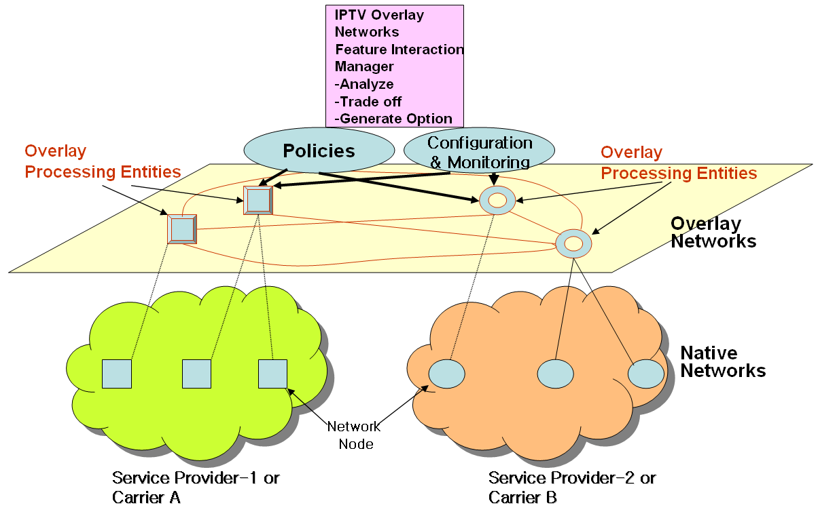
Fig. 3 Overlay Network Framework for IPTV Service Control
As an alternative IPTV multicast control scheme, overlay IPTV multicast control mechanism which makes good use of existing unicast, multicast and/or multicast tunneling schemes should be considered. In addition, service level multicast is designed as several separate forms to support any kinds of group service type well.
Fig. 4 shows architecture for overlay IPTV Service Control Functions which performs an IPTV session control to provide multicast capability for diverse IPTV services.
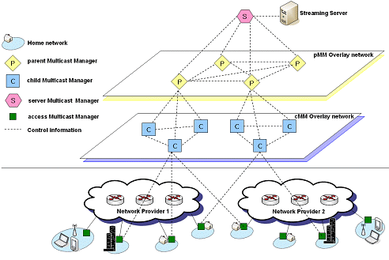
Fig. 4 Hierarchical Architecture for Overlay IPTV Service Multicast Control

Interoperability Requirement

Requirement of IPTV Service Exchange Point
Following sections are based on document FGIPTV-C-0135 (LL#5)
To make the optimal contract and to provide the stable IPTV services amongst IPTV multicast service providers, IPTV SEP (service exchange point) to handle the service brokering function amongst IPTV SPs and its reference model as interoperability perspective should be identified.
IPTV SEP is identified as a reference point for handling the service brokering function between IPTV SPs enabling the optimal contract between IPTV SPs and providing the stable IPTV services amongst IPTV service providers. Location of IPTV SEP: IPTV SEP can be located in any peering point, and can be implemented as router line card, like SBC (Session Border Controller) type. Reference model example of IPTV SEP is shown in Fig. 5.
Fig. 5 Reference Model of IPTV SEP
IPTV SEP should support of following functions.
- Access Privileges and authentication function
- Resource Usage and CAC
- QoS and Quality monitoring function
- Inter-domain address translation and Control of multicast injection
- VoD Admission Control Support
- Security Support function
- Policing of Multicast and Unicast traffic
- Policy exchange feature

Requirement of IPTV Information Registry
Following sections are based on document FGIPTV-C-0135 (LL#5)
For IPTV service interoperability, the fundamental information for each IPTV service provider should be announced. The purpose of the IPTV information Registry is to define the IPTV source information from all IPTV providers. This information can be summarized as following information registry.
      - ID of content aggregator or video provider (BGP AS number is preferred)
      - source IP address block
      - multicast IP address block (applied for only multicast stream) block
      - Descriptor
      - Transport protocol(UDP or TCP)
      - Port number
      - Authentication key
      - URL for session announcement (https:// )
Additionally, the session announcement should be defined for the multicast transmission. The session announcement URL is defined also in the IPTV information Registry. Each IPTV provider should announce the session announcement information for all multicast streams. Session announcement information includes following fields.
- ID of the content aggregator
- Descriptor
- Start time
- End Time
- Multicast address
- Authentication key

Interoperability Requirements amongst IPTV multicast service providers
Related Document: FGIPTV-C-0136 (LL#6): Need further discussion and study. But if meeting agreed the contents of the document, then the contents should be incorporated in this section.

IPTV Multicast Transport Stratum Requirements
Following sections are based on document FGIPTV-C-227 (LL#10).
In order to enhance and optimize service capability of IPTV, multicast function should be required to perform at transport stratum, service stratum or both.
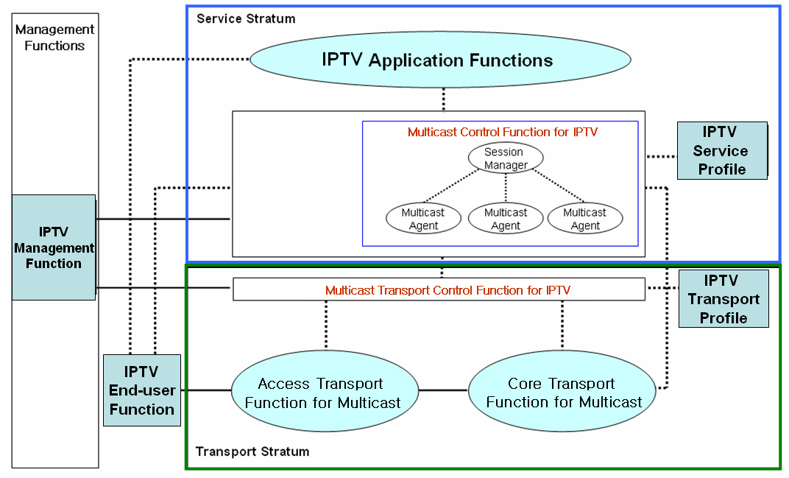
Fig. 6 IPTV Multicast Function Framework

IPTV Multicast Control Function at the Transport Stratum
An IPTV multicast group and service should be identified by the relevant mapping mechanisms with physical or logical identifiers of IPTV users.
The multicast transport control function for IPTV services manages the multicast session information including multicast tree information, which includes the number of multicast IPTV users, multicast domain, the QoS levels per multicast group, and accounting information per user, etc. It supports a multicast tree configuration for a specific multicast group. The multicast tree can be dynamically updated when joining and leaving IPTV customers. Depending on network topology and physical media, multicast tree path can be constructed by physical media (e.g., FTTH/PON and wireless LAN).

IPTV Multicast Service Stratum Requirements
Following sections are based on document FGIPTV-C-227 (LL#10).
Service level multicast aims to support various kinds of group applications for IPTV service, some of which are categorized in the according to the ways of communication and the characteristics of data delivery. In order to provide IPTV multicast at the service stratum in the network (e.g., NGN), two major functional entities, ISM (IPTV Session Manager) and IMA (IPTV Multicast Agent) are introduced to perform multicast function at the service stratum in the network.

Functional Requirements for IPTV Service Level Multicast
Service level IPTV multicast includes service control functions (including IPTV Session Manager and IPTV Multicast Agents) and IPTV application functions, IPTV service user Profiles.
IPTV Service control functions include session control, session membership management and service user profile management at the service level. They can also include functions for controlling media resources -- i.e., specialized resources and gateways at the service-signaling level.
IPTV application function includes a lot of functions for various IPTV multicast services. Therefore, they could be implemented specific functions dependent on the each service and could provide an interface to user to notice the IPTV service information and accept the service request of user. IPTV Application function support functions include functions such as the gateway, registration, authentication, and authorization functions at the service level. And IPTV Application Function support functions work in conjunction with the Service Control Functions to provide users with the value added services they request.
IPTV Service User Profile functions are based on the user subscription data and network data. It is a database based on a service user and shall be provided in support of:
- IPTV Multicast user authentication and authorization
- IPTV Multicast service subscription information
For IPTV service level multicast over converged network platforms (e.g., wired, wireless and broadcast networks), each multiple IMAs will handle their functionalities of multicast functions at each IMA.

Control Framework for IPTV Service Level Multicast
Service Level Multicast constructs and manages relayed multicast functions to support internet group application services over the unicast-based network. After control messages of a service level multicast are exchanged, a multicast data delivery path is constructed by using multiple end hosts even such as personal desktop computer. Along the delivery path, real-time or reliable data transport channels are inter-connected between upstream and downstream IMAs. Only after the data delivery path and data channel are established, group applications can work as if they were in a native IPTV multicast network.
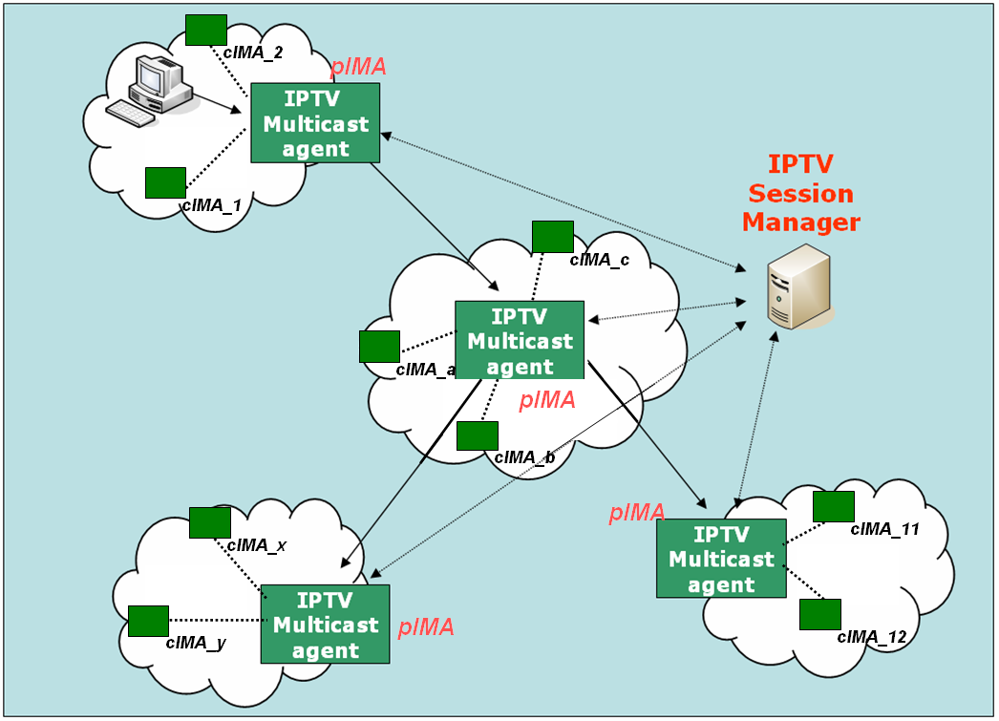
Fig. 7 Functional Architecture for Service Level Multicast Capabilities for IPTV

IPTV Session Manager (ISM)
ISM is involved in session configuration and maintenance for IPTV service flows. A single ISM can handle one or multiple sessions simultaneously, and it can provide the following functionalities:
- Session initialization: ISM allocates ISID (IPTV Session ID) for new session.
- Session release: Session can be released as needed.
- Session membership management
- Session status monitoring:
- report the status of data channel
- data throughput
- multicast protocol topology information gathering
- multicast protocol membership management

IPTV Multicast Agent ( IMA )
IMA constructs relayed multicast delivery path and forwards data along the constructed path from pIMA ( parent IPTV Multicast Agent ) and to cIMA ( child IPTV Multicast Agent). An MA consists of control module and data transport module. The main function of former is to establish relayed data delivery path and that of latter to setup data channel along the path constructed by control module and relay data through the channel. IMA performs the control functions to exchange control messages with other entity. Its major functions are as follows.
- Session join: each IMA contacts with Session Manager.
- Session leave: when an IMA wants leave the session, it gives notice to pIMAs and cIMAs
- Session maintenance: relay request and its response will be exchanged between the two IMAs periodically.
- Loop detection & avoidance
- Partitioning detection & recovering
- Parent switching
- IPTV Session status reporting
In order to perform service level multicast of streaming application for IPTV service, the functional box of service control can be described into few functional blocks in detail as shown in Fig. 8.
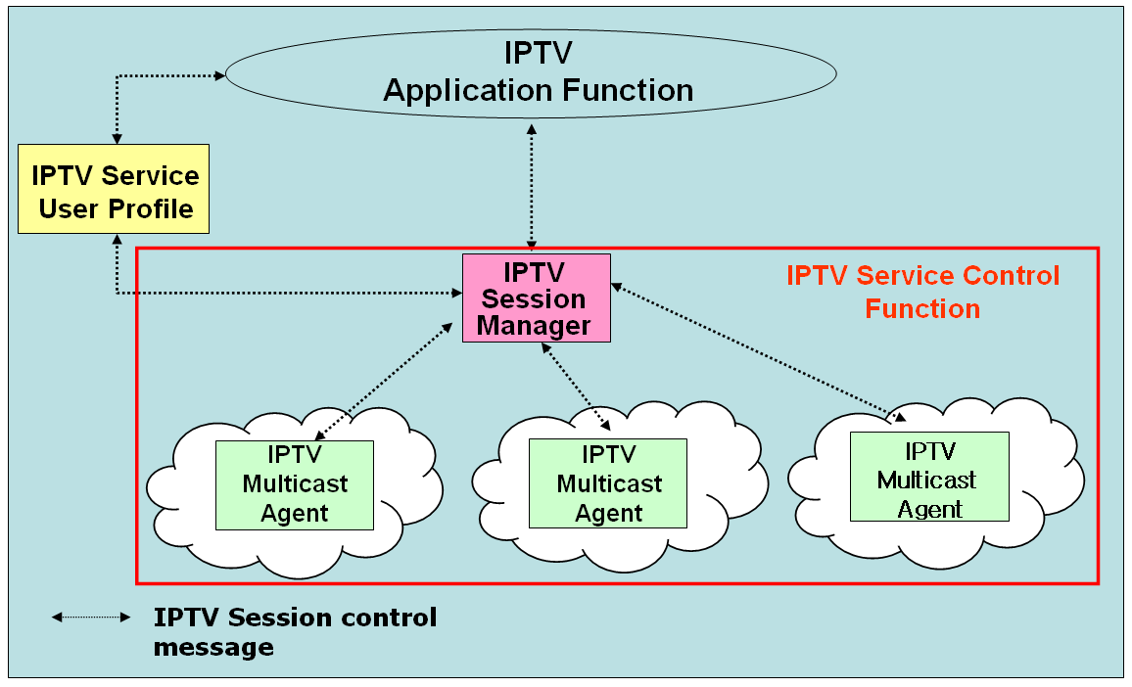
Fig. 8 Functional Blocks of IPTV Session Control for IPTV Application Services

Requirements of Overlay IPTV Multicast

Requirements of Overlay IPTV Multicast Control
Following sections are based on document FGIPTV-C-227 (LL#10).
Current reliable multicast transport mechanisms have unresolved problems including scalability, flow control, congestion control and etc. Until the related reliable multicast transport mechanism settles down, group communications requiring reliable data transfer are actually clinging to replicate unicast method based on servers. Although IP multicast has not deployed globally, a lot of local networks have already been equipped with IP multicast transport. For example, Ethernet-based LANs and private networks such as corporate and campus networks substantially provide the multicast transport capability within their local subnet or administrative domains.
Recognizing these observations, there is a crucial need to develop an alternative multicast delivery scheme, service level multicast approach. It makes good use of existing unicast, multicast and/or multicast tunneling schemes. In addition, service level multicast is designed as several separate forms to support any kinds of group service type well. Service level multicast is expected to provide a substantial solution for group applications for IPTV service.
Fig. 9 shows architecture for “Overlay IPTV Service Multicast Functions” for IPTV service. The overlay service control function performs a IPTV session control to provide multicast capability for diverse IPTV service capabilities.
Fig. 9 Overlay IPTV Service Multicast Control

Procedure of IPTV multicast user authentication and authorization
Following sections are based on document FGIPTV-C-168 (LL#11).
As the current multicast protocol (i.e. IGMP) does not consider Multicast user authentication and authorization, it is requested a further development these issues to support IPTV services efficiently.
Multicast User authentication function controls the authority for users to receive multicast flows. And through authentication of multicast users, the network can distinguish legal multicast users from the illegal ones and then distribute the multicast traffic to the reasonable receivers. Following procedures should be supported.
- When a user initiates a multicast “join” request to join a certain multicast group with an account, the duplication point should not accept the request and make him join the group at once, it should be sent the request to the authentication point.
- The authentication point inquires the account information database and returns the result to multicast duplication point. The value of the user’s multicast property in the account should be set by the service layer system.
- According to the authentication result returned from the authentication point, the Multicast duplication Point should decide whether it allow the user to join the group or not. If allow the user to join the group, the duplication will add it to distribution table. Whereas it will refuse the user to join the group.
Fig. 10 Functional components for Multicast user management

Multicast scenarios
Following sections are based on document FGIPTV-C-165 (LL#1).
The multicast service traffic comes from multicast service source. Its deployments are dependent on their business model such as in backbone network or access network areas. The multicast capability which the IPTV network supports has great effect to the development of IPTV services. It is requested to take into consideration that how to develop multicast features on the bearer network with various multicast capabilities supporting IPTV services.
Following two scenarios would be taken consideration as supporting multicast features:
  - Scenario 1 (IPTV bearer network which has weak capability of supporting multicast protocol): As for the carrier whose bearer network has weak capability of supporting multicast protocol, he should construct the multicast service distribution tree in the backbone network from multicast service source to backbone network edge in order to deploy his IPTV services rapidly. Generally, the location of IPTV multicast source and the number of multicast channel are fixed, however, because the backbone network with weak multicast routing capability, the following optimization proposal can be adopted. The equipment on IPTV bearer network should support the static configuration of multicast distribution tree. The multicast distribution tree from multicast source to backbone network edge can be configured manually.
- Scenario 2 (Reduce dynamic multicast protocol effect to IPTV service): Normally, multicast distribution tree is created via multicast routing protocol, which running should be adaptive to the changes of backbone network unicast routing. However, when IPTV service is delivered by the multicast routing table which is created by dynamic multicast protocol, the multicast distribution tree will shrink to multicast source if one channel does not have audiences for a long time. In the other words, IPTV broadcasting service can not reach the subscribers when new audiences join in, because users’ IPTV channel application will be sent to IPTV broadcasting source hop-by-hop, then the IPTV broadcasting service traffic will be transferred to the edge of backbone network, which delays the IPTV channels switching time greatly. Hereby, the following optimization proposal can be used to solve this problem. To some popular channels, no matter the terminal users want to watch this channel or not, the edge node of backbone network sends IPTV service demands within a time scale, so that we can guarantee the service traffic of this channel can be delivered to the edge of backbone network and shorten the deferral of users’ channel switching.

Other aspects
[Editor’s note]: This section is for inviting future contributions, which could be addressed to IPTV Multicast aspects.

__________

