INTERNATIONAL TELECOMMUNICATION UNION |  |  |  | Focus Group On IPTV
TELECOMMUNICATION  STANDARDIZATION SECTOR  STUDY PERIOD 2005-2008 |  |  | FG IPTV-C-0525
 |  |  | English only
WG(s):1,2 |  | 4th FG IPTV meeting:  Bled, Slovenia, 7-11 May 07
CONTRIBUTION
Source: | Cisco
Title: | Nomenclature of IPTV Architecture Alternatives and Editorial Clarifications
Abstract
This contribution proposes a nomenclature for the IPTV architecture options based on their descriptions, rather than on what they are not. In addition, this contribution proposes a number of editorial clarifications to the existing text to further enhance the material.

Introduction
Over the last few IPTV FG meetings there has been general agreement that three approaches for the IPTV functional architecture will be adopted to enable various network deployment scenarios to be accommodated for both NGN and non-NGN based approaches. So far the terminology used to describe these three options uses negatives (e.g. Non-NGN) to label the resulting functional architectures, which is highly undesirable.
This contribution proposes to change this nomenclature to label the approaches positively in terms of “what they are”, rather than in terms of “what they are not”.

Discussion
In order to allow for the possibility of deploying IPTV services over networks based on existing technologies, NGN based technologies or IMS technologies, it has been agreed to accommodate three possible approaches to describing IPTV functional architecture. As defined in FGIPTV Doc-0062 from the Mountain View meeting these are generally referred to as:

- Non-NGN based IPTV Architecture
- Non -IMS based IPTV Architecture
- IMS based Architecture

Apart from the IMS case, it seems this type of naming of the architectural approaches is based on describing them in terms of what they are “not”, rather than what they “are”
Considering the fundamental importance of the IPTV functional architecture in the overall standardization of IPTV, this type of negative naming is absurd.
It is important to describe the three approaches selected in positive terms, using simple terminology which can be easily used by all. We therefore propose to use the following titles for the three approaches listed above, instead of the existing labels in Doc-0062 from the Mountain View meeting:

- Core IPTV Architecture
- NGN-IPTV Architecture
- IMS-IPTV Architecture

The attached document provides an edited version of FGIPTV Doc-0062 with the required changes in terminology. It also provides some additional text proposals intended as editorial clarification for some of the editor notes included.

Proposal

It is proposed that the names of the three IPTV architectural approaches be changed to reflect what they are and remove the “non- X” nomenclature used so far.
It is proposed that the edited text proposals shown as “change marked” in the attached document be adopted by the IPTV FG as the new baseline text for this meeting.

____________________________

INTERNATIONAL TELECOMMUNICATION UNION |  |  |  | Focus Group On IPTV
TELECOMMUNICATION  STANDARDIZATION SECTOR  STUDY PERIOD 2005-2008 |  |  | FG IPTV-DOC-0062
 |  |  | English only
WG(s): 1 |  | 3rd FG IPTV meeting:  Mountain View, USA, 22-26 January 2007
OUTPUT DOCUMENT
Source: | Editor
Title: | Working Document: IPTV Architecture

This Working Document is the draft output of the FG IPTV Mountain View meeting,
22-26 January 2007. It was prepared starting from the output document of the
WG1 e-meeting held from 18-21 December 2006, otherwise called C-261.

Content
1. Scope 6
2. References 6
3. Definitions 6
4. Abbreviations 6
5. IPTV Architectural Overview 7
6. IPTV Relationship with NGN and other networks 7
7. IPTV Reference Model 9
7.1. IPTV Service Types 9
7.1.1. Linear IPTV with Local PVR 9
7.1.2. Content on Demand 10
7.1.3. Hybrid: Online and Off-air TV Delivery 10
7.2. IPTV Definitions 10
8. IPTV Architecture 11
8.1 High Level Architecture of IPTV 11
8.1.1 High Level Architecture 1 11
8.1.2 Architecture Framework for IPTV 16
High-Level Functions 16
High-Level Functional Groups 17
Mid-Level Architectural of IPTV 17
Key to Figures 18
Non NGN based Architecture 18
NGN based Architecture – Common Components 19
NGN based Architecture - Non-IMS session control 20
NGN based Architecture - IMS based session control 21
NGN based Architecture - Coexistent IMS and non-IMS session control 22
NGN based Architecture including Content Provider and OSS/BSS 23
8.3 Functional illustrations of use cases 24
Alternative approaches to IPTV session control 25
Common Functional Components for Content on Demand 25
Non-IMS based Content on Demand 26
IMS for Application and Content Sessions 28
IMS for Content Sessions 29
Common Functional Components for Multicast 30
Non-IMS for Multicast IPTV 30
IMS for Applications and Multicast Sessions 31
IMS Based Multicast IPTV Delivery 32
NGN Interconnection 34
8.1.2 High Level Architecture 2 35
8.2 Non-NGN-based architecture 35
8.3 NGN-based IPTV Architecture 35
8.3.1 Non-IMS-based IPTV Architecture 36
8.3.2 IMS-based IPTV Architecture 36

IPTV Architecture

Scope
[Editor’s Note: material is required for the scope.]

This document describes the IPTV functional architecture intended to support all types of IPTV services based on the requirements and definitions provided in the related IPTV Focus Group documents. Starting from a basic description of IPTV roles and services, a high level IPTV functional model is outlined. This model is then developed into more detailed functional architecture. Specific cases are also described in more detail.
The IPTV functional architecture may be based on using existing network components and technologies, as well as on NGN architectures. This leads to three possible options for the architectural representations:
- IPTV functional architecture for existing network components
- IPTV functional architecture based on NGN functional architecture
- IPTV functional architecture based on IMS component
The common elements between these alternatives as well as the differences are described in this document.

References
The following ITU-T Recommendations and other references contain provisions, which, through reference in this text, constitute provisions of this working document. At the time of publication, the editions indicated were valid. All Recommendations and other references are subject to revision; users of this working document are therefore encouraged to investigate the possibility of applying the most recent edition of the Recommendations and other references listed below. A list of the currently valid ITU-T Recommendations is regularly published.
The reference to a document within this Recommendation does not give it, as a stand-alone document, the status of a Recommendation
[Y.2012] ITU-T Recommendation Y.2012 (2006), Architecture and Requirement of the NGN

Definitions
This working document uses or defines the following terms:
TBD

Abbreviations
This working document uses the following abbreviations.
IPTV Internet Protocol TV
NGN Next Generation Network
IMS IP Multimedia Subsystem

IPTV Architectural Overview
[Editor’s Note: introduction text is required here.]
Three general approaches have been identified for describing IPTV Functional Architectures, to enable service providers to deliver IPTV services depending on the type of network architecture and evolutionary choices they select..
- “Core IPTV functional Architecture” (Core IPTV)
The Core IPTV architecture is based on using existing IPTV network components and protocols/interfaces the technology components and protocol interfaces used in this IPTV architecture are already in widespread use and hence this model is a representation of typical existing. IPTV networks and services. It is intended to provide the basis for evolution towards the other IPTV architectures listed below.
(2) “NGN-based IPTV Functional Architecture” (NGN-IPTV)
The NGN IPTV functional architecture utilises the components of the NGN framework reference architecture as identified in Recommendation Y.2012 to support the provision of IPTV services, in conjunction with other NGN services if required..
(3) “IMS-based IPTV Functional Architecture” ((IMS-IPTV)
The IMS based IPTV functional architecture utilises the IMS component to support the provision of IPTV services, in conjunction with other IMS services if required.
Although the above three architectural approaches to describing IPTV have been selected it is recognised that there are several common functional entities and similarities between these alternative approaches. This aspect simplifies interworking between these approaches, as well as evolution path to be described to maximise similarities. The use of common elements is a key feature of the representations used in this document to describe these three approaches.

IPTV Relationship with NGN and other networks
It is useful to relate the IPTV architecture to the general NGN framework architecture and other networks to clarify the similarities and differences, as well as provide a reference for the more detailed description of IPTV specific components. The “NGN-based” architecture means the IPTV architecture in accordance with [Y.2012] for providing IPTV services. The NGN components described in [Y.2012] are shown in Figure 6-1.

As the Core IPTV functional architecture outlined above does not necessarily require NGN components, and uses conventional and/or legacy technology networks for delivery of IPTV services, Figure 6.1 should not be construed as the only basis for IPTV services.

[Editor’s Note: more text is needed here.]
[Editor’s Note: more text should be added to restate that the NGN Architecture does not exclude legacy networks.]

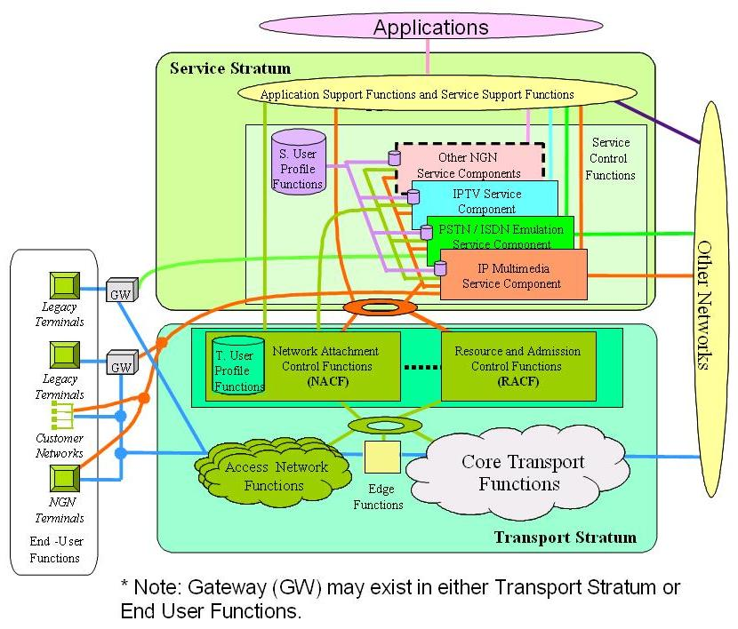
Figure 6-1: Transport and service configuration of the NGN

Reference Model for IPTV Roles
The following figure shows the main roles that are involved in the provision of an IPTV Service.
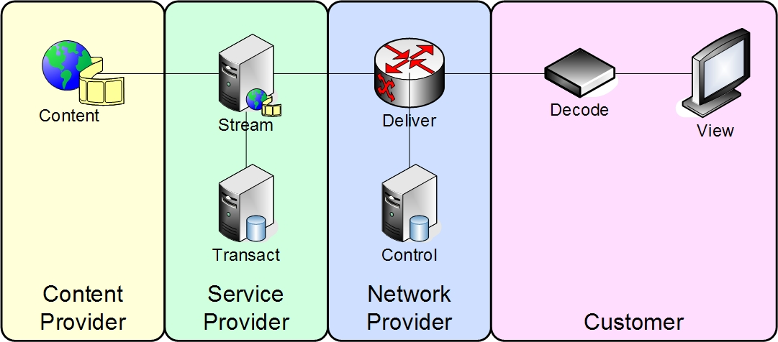
Figure 7-1: Reference Model for IPTV Roles
The four roles are as described below:
Content Provider: The entity that owns or is licensed to sell content or content assets.
Service Provider: The entity that providing the IPTV Service to the Customer.
Typically, the Service Provider acquires or licenses content from Content Providers and packages this into a service that is sold to the Customer.
Network Provider: The entity providing that connects the Customers and the Service Providers.
Customer: The entity that consumes and pays for the IPTV Service.

IPTV Service Types
These roles are useful for the description of the basic IPTV Service types.

Linear IPTV with Local PVR
A key part of a typical IPTV Service is the delivery of Linear TV. This is received, from the existing broadcast transmission from a Content Provider, trans-coded and multicast by the Service Provider. The multicast streams are delivered by the Network Provider, via the Consumer’s Network to the Customer’s IPTV device.
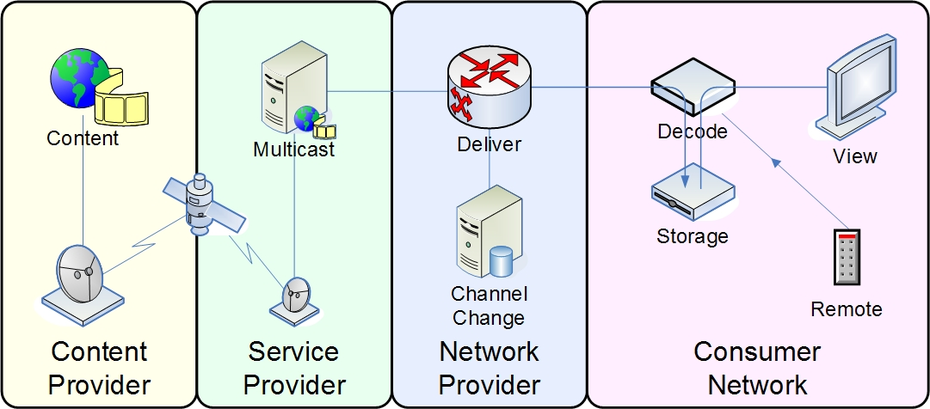
Figure 7-2: Linear IPTV with Local PVR

Content on Demand
The second part of a typical IPTV Service is the delivery of On-Demand Content. The content is normally received from a Content Provider in the form of physical media, such as a digital video-tape. This trans-coded and stored by the Service Provider and made available as unicast streams. The unicast streams are delivered by the Network Provider, via the Consumer’s Network to the Customer’s IPTV device.
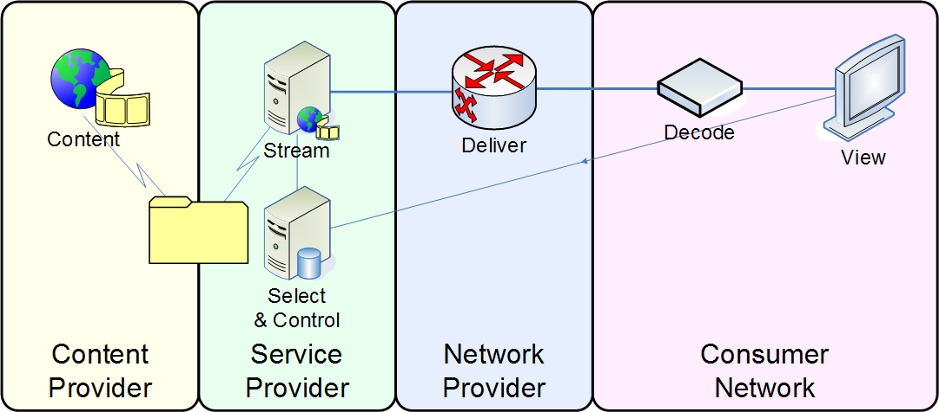
Figure 7-3: Content on Demand Reference Model

Hybrid: Online and Off-air TV Delivery
An alternative approach for the delivery of Liner TV is to enable the customers IPTV device to directly receive the broadcast signal from the Content Provider. This will then be combined with On-Demand content delivered over the network from the Network Provider.
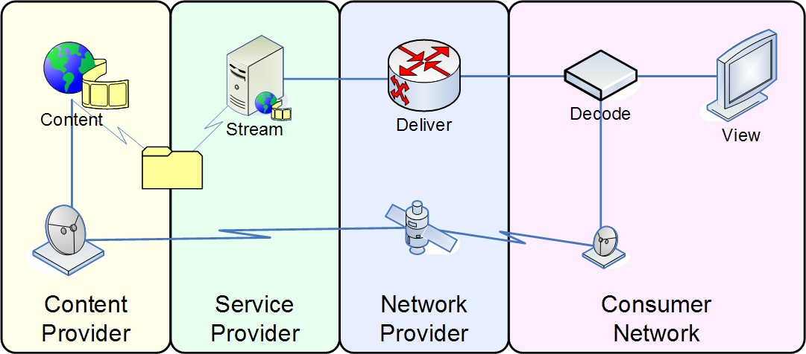
Figure 7-4: Hybrid: Online and Off-air TV Delivery Reference Model

IPTV Definitions
In the description of IPTV Services a number of different terms, such as service, application, and component are often used. For consistency the following definitions are to be used
The IPTV Service is the total proposition offered to the customer, it offers a set of
Applications that provide different Service features to the customer
Live TV
On Demand Video
Communications
Games
These make use of a set of underlying support services that provide common facilities these include.
Unicast Video Delivery
Multicast Video Delivery
An IPTV component provides part of a service, examples are
Video streamer

[Editor’s note: Whether the definitions of the IPTV service and Application is consistent with NGN document needs to be checked.]
[Editor’s note: It was suggested during the scenarios that Content Aggregation Entity to be considered.]
[Editor’s note: The table of content is provisional and will include more sections]

IPTV Architecture
[Editor’s Note: There should be a section to describe Service Exchange Points. This note is coming from C-135 and not approved by WG.]

8.1 Relationship of IPTV and Content Delivery (Video on Demand) Architecture
[Editor’s Note: the ordering of those sections can be changed. ]

8.1.1 High Level Architecture 1

Figure 8-1: Relationship between IPTV and Content Delivery Functional Architecture
Information cross each reference point is listed as following (not complete),
- A: Content Stream
- B: Content Request, Descriptive Metadata/Content Info etc.
- C: Rights Management Interaction ( e.g. DRM and CAS)
- C1：Rights Management
- G: Authentication and AuthorizationConditional Access System
- D: Service Interaction Message
- E: Content Location information, Billing information, Content Control Command, etc.
- F1: Play Control Signal
- F2: Content Stream

[Editor’s Note: The figure and attached text above is taken from FG IPTV-C-0170 with some modification.]

[Editor’s Note: the list below is picked from FG IPTV-C-0111 Figure 1.]
Service Management Platform Functions:
- Subscribe
- Service
- Account
- STB
- Content
- CP
- Resource
- Portal
- System
- Statistics
Figure 8-2: Detailed relationship between IPTV and Content Delivery Architecture

- Content Provision: IPTV contents, including the VoD programs, TV channel streams, including their related metadata, are prepared by the Content Provision functions through some adapting processes before or during the service offering. First the contents are ingested from content sources into the Content Provision, then converted into the designated format when necessary, and encrypted for digital right management (DRM) by the Content Provision Functions. Meanwhile, some simple editing work upon the contents can be done within the Content Provision if it is permitted, e.g. Ad inserting, subtitle or logo superposing etc. After the adapting process aforementioned, then contents are transferred to the Content Delivery functions. The Content Provision functions also act as the root authority of the contents’ right management to empower the IPTV Control functions to issue the right description and keys to the end users before content is to be consumed.

- IPTV Control: IPTV Control functions are responsible to IPTV service preparation control as well as service offering control. During the service preparation process, IPTV Control may request contents from Content Provision, and pack the contents into services, generate content distribution policy, and then publish these deliverable services through navigating / EPG components. In the service offering process, IPTV Control will delivery the service information (e.g. in the form of EPG) to IPTV users, therefore the users can select specific service/program. With the empowerment of Content Provision, IPTV Control can also responsible to issue the content licence to the users according to their subscription. In order to support the service control functions, at least three kinds of information base should be maintained by IPTV Control functions, that is content profile, service profile and user profile.

- Content Delivery: Contents which are packed in IPTV media streams are delivered to End System by the Content Delivery functions. The content data is injected to the Content Delivery functions from Content Provision before or during the service offering process. In order to support the services like VoD and PVR, and for the sake of transport efficiency, contents shall be stored /cached within the Content Delivery. When the end user requests for a piece of content, it will be directed by the IPTV Control functions to the Content Delivery functions to obtain content data. Content Delivery functions also provide capability to facilitate interaction between the users and programs such as playback control. Physically, Content Delivery sub-system employs the resources of IP bear networks for the content conveying.
[Editor’s note: The position of the Content Delivery Component against the NGN architecture needs to be reviewed”].
- End System: Functionally End System is composed of a set of service execution functions of IPTV system in custom premise. End System is responsible to collect control command from user, and interact with IPTV Control functions to get service information (e.g. EPG), content license and key for decryption. End System also provides the capability for content acquisition, content decrypting and decoding.

- IPTV System Management & Security: System Management & Security functions is in charge of system overall status monitoring, configuration, and security aspects. This set of functions may be deployed in a centralized manner, or otherwise in a distributed manner.
[Editor’s Note: Terminology for PVR should be aligned with the rest of the document (particularly network PVR).]
[Editor’s Note: Definitions should be aligned with other definitions in the architecture document.]
IPTV Control
- Service Provisioning Control: This function element can be regard as the core of IPTV Control. On the one hand, Service Provisioning Control acquires (through reference point B, shown in figure 1) content metadata from Content Provision, and produce IPTV services according to the policy by the SP or the request from users. Then the information about the produced service will be put into Service Profile. On the other hand, it generates policy and control signal for Content Delivery functions to control (through reference point E, shown in figure 1) the delivery and distribution of the service related content. Usually this control is service interrelated.
When the service is running, Service Provisioning Control bridges the service control enforcement functions, Right Management Proxy, Service Navigation and Authentication & Authorization, together with the control support functions, Content Profile, Service Profile and User Profile. Logically speaking, Service Provisioning Control act as a reader for the enforcement functions, while as a writer for the support functions.
- Service Navigation: Service Navigation is the entrance point of IPTV service using, it publish service information, for example, in the form of EPG pages, and response to the inquiries from the users. The basic information about the service comes from the User Profile function and need to be rearranged before delivered to the end users. Rearrangement of this kind of information is under the control of Service Provisioning Control. Users interact with Service Navigation (through reference point D, shown in figure 1) to get service information and select service they wanted. The User will gain a pointer to specific content, and turn to Content Delivery for media data acquisition.
- Authentication and Authorization：to validate the user’s right based on the user profile. Only the right of the user is proved then he can be granted to use the subscribed services.
- Right Management Proxy: provide the function to manage the digital right of content as a delegate of right management function within Content Provision, such as issuing the license and key to the end users (through reference point C, shown in figure 1) according to their subscription.
- Content Profile: Content profile function maintains the metadata of content packed in the service for the use of service preparing.
- Service Profile: Service profile maintains the information of deliverable service (e.g. material for produce EPG page).
- User Profile User profile function is responsible to maintain the basic user information，and service specific information such as subscription, interesting, bookmark etc.
[Editor’s Note: RMProxy need clarification.]
End System
- Service Interaction exchanges information with system side functions to get admission to use service, and then accomplish the service navigation and selection. Information about content location as well as decryption key and license is obtained during the service interaction process.
- With the location information (logical or physical) of content data, Media Processing element will turn to Content Delivery to acquire the media data, and then decrypt and decode the media data. Playback control is also performed by Media Processing as a client of content serving.
Content Delivery
- Delivery Control: It is responsible to control the distribution of content according to the policy from IPTV Control Functions, and it also can be the receiver of playback control commands (e.g. via RTSP) from End System. The physical location of specific content also resolved by the functional element.
- Storage/Cache: It not only stores and caches the content from Content Provision Functions, but also transfer the content data among peers for the efficiency of delivering. In some cases such as linear TV without track mode, content stream does not unnecessary to pass through the “Cache/Storage” (shown as broken line in figure 1).
- Content Serving: Content Serving is the immediate functional element to delivery (e.g. via RTP over UDP, unicast or multicast) content stream to the End System.
Content Provision:

- Content Aggregating:
  - It aggregates contents such as TV channels, movies, metadata etc from content owner.
- Content Adaption:
  - When authorized, this module should do content and metadata adapting, that means that before going to the IPTV services network, the content should be processed for meeting the service requirements. For example, it may need to encode the content from raw format into more efficient format, such as mpeg4/avc for saving bandwidth, to extract content index or labels for future content searching and to re-edit the metadata for different application scenarios.
- Content Right Management:
  - This module functions for content right protection according to requirements of content owners. For example, it should produce and manage the content encryption key, produce and delivery content right objects according to content consuming requirement and so on.
- Content Provision Control:
  - It is core module of content provision and responsible for any functions necessary for content-oriented business and control.

8.1.2 General Architecture Framework for IPTV
The Figure 8-3 Architecture Framework for IPTV shows the principal functional component of an IPTV Service as the rectangles and their main groups and the coloured areas.
Figure 8-3: General Architecture Framework for IPTV
The figure only shows the end-to-end interfaces between the service clients in the IPTV Terminal and their corresponding server. Many other interfaces will exist and are detailed in later sections.

High-Level Functions
The high-level functions are either sufficiently described by their name or covered in the mid-level descriptions in section 8.2.2 below.

High-Level Functional Groups
The high-level functional groups provide a more detailed breakdown of the IPTV roles that are defined in section 7. The roles of Content Provider and Customer remain the same. The roles of Service Provider and Network provider are dropped as the commercial and operational boundaries that this implies are not appropriate to an architectural decomposition. The layers in the architecture are derived by grouping related functions, how these layers are allocated across operational boundaries will vary between implementations.
Customer: The entity that consumes and pays for the IPTV Service.
IPTV Device: The physical device that the customer uses that hosts the functions (software clients) that form the IPTV Service. For fixed-line IPTV this is often called an IPTV Set Top Box.
Customer Transport: The network equipment used by the customer to provide connectivity between the IPTV Device and the Access Network termination.
Application Components: The functional components of the IPTV Application. The main role of this layer is to enable the use of the IPTV terminal to select, and purchase if necessary, and item of content. It will also contain support for content protection
Service Components: The functional components that support the origination of the media content stream the functional components for the management of the network to ensure the successful delivery of the media content from it source to the IPTV Terminal
Network: The combination of network transport and control functions
Network Control Functions: The set of functions required to control the network transport layer to provide the Security and Quality of Service needed for the successful operation of the IPTV Service.
Network Transport Functions: The set of function that provide the IP layer connectivity between the IPTV Service Components and the Customers Transport. These component are normally shared across all service delivered by IP to a customer.
OSS / BSS: The Operational Support Systems, OSS, and Business Support Systems, BSS, required for the successful operation and management of the Applications Service and Network.
Content Provider: The entity that owns or is licensed to sell content or content assets.

[Editor’s note: Contributions are invited to extend and refine this framework to ensure that it fully aligns with subsequent architecture diagrams.]

Mid-Level Architectural of IPTV
The following figures provide a mid-level decomposition of the IPTV Architecture. In these figures the high-level functional elements introduced in the preceding section are expanded.
The Core IPTV Architecture (Core IPTV), the NGN based IPTV (NGN-IPTV) and the IMS based (IMS-IPTV) architectures are shown separately. However, a common representation of the functional blocks is used to highlight similarities and differences in these diagrams .
The focus of these figures is on the essential functional components for the service and the relationship between the service components and the network components.

Key to Figures
The rectangular blocks represent functional components in the control planes of the NGN and service architectures.
The rounded rectangular areas represent the main groupings of functionality by provider and the dashed areas the layers in the NGN architecture.
The solid lines represent IP connectivity between the functional components.
The dotted lines represent end-to-end connectivity between functional components.
The solid blue line represents the transport path of the media streams
The components and paths shown in black will exist for all IPTV services irrespective of the approach used for session management and control.
The components and paths shown in red will exist for an IPTV service that uses IMS for session management and control.
The components and paths shown in green will exist for an IPTV service that uses non-IMS based session management and control.

Core IPTV Architecture
The Figure 8-4 non-NGN based IPTV Architecture provides a more detailed view showing common components and their interface when providing an IPTV Service over a generalise non-NGN IP network.
Figure 8-4: Core IPTV Architecture
The functionality of the components is common for an IPTV Service deployed over both a Core IPTV and an NGN-IPTV architecture. This is described in 8.2.2 below.

Network Functions
Access Network Functions
Edge Functions
Core Transport Functions
Authentication and IP Allocation Functions
Resource Control Functions

IPTV Device Functions
Control Client– Provides the functions required to communicate to the IPTV Control to identify and prepare for the connection to the content delivery server to be used.

Service Component Functions
IPTV Control - Provides the functions to establish and maintain the network and system resources required to support the delivery of the media streams.

NGN based IPTV Architecture – Common Components
For the architecture of an IPTV Service that operates based on a Next Generation Network (NGN), there are five main layers in the decomposition. For this case, two approaches to session control may be selected:
- Conventional session control (NGN-IPTV Architecture)
- IMS based session control..(IMS-IPTV Architecture)
The Application component layer - this contains the functional components of the IPTV Application. The main role of this layer is to enable the use of the IPTV terminal to select, and purchase if necessary, and item of content. It will also contain support for content protection.
NGN Service Stratum – divided into Service Support Functions and Service Control Functions (Note: these are NGN terms and are network not IPTV focused).
Service Support Functions - this contains the functional components that support the delivery of the media content from it source to the IPTV.
Service Control Functions - this contains the functional components for the management of the network to ensure the delivery of the media content from it source to the IPTV Terminal.
NGN Transport Stratum – divided into Transport Functions and Control Functions
The Network Transport and Control functions are as defined in NGN standards.

Network Functions
The Network Transport and Control functions are as defined in NGN standards documents such as ITU-T Y.2012

Customer Transport Functions
The Delivery Network Gateway Functions provide the customer domain network that provides connectivity between the external network and the IPTV Device.
In general, these functions will manage the IP connectivity, obtaining IP address(s) and configuration for the home and IPTV Device. These functions are normally contained within the Deliver Network Gateway, DNG.

IPTV Device Functions
Application Client - Provides the client side function that support the User Interface and the non-streaming parts of the IPTV Service.
Media Client – Provides the functions to receive and control the delivery of the media from its source.

Application Component Functions
IPTV Application - Provides the server side functions of the IPTV Application. In general, this supports selection of IPTV service and the browsing and selection of content with the service.
For example, it could deliver the URL of the Delivery service for the content selected. It may communicate with the service functions if resources need to be checked or reserved before the URL is released.
IPTV subscriber Management – Provides the functions for the application level management of the customer’s details.

Service Component Functions
Distribution & Delivery Broadcast & VoD – Provides the functions for the distribution and delivery of content for Broadcast and On-Demand services.
For example, for On-Demand it could receive a content item, e.g. a digital video file, and distribute this to a set of video servers. The distribution can be rule based and or usage based and the servers may be geographical distributed. It could also provide for the mapping between the Content identifier provided by the IPTV Application to the actual video server and content instance to be allocated to the Media Client.
For example, for Linear TV it could receive one or more digital video streams (IP or otherwise) and output these as IP multicast streams. The reception and streaming may be geographically distributed. It could also provide for the mapping between the Logical Channel Number to the Multicast Address that the IPTV terminal can receive.

NGN based IPTV Architecture (NGN-IPTV).
The Figure 8-5 provides a more detailed view showing the NGN-IPTV architecturS with the interfaces to common components and other NGN supporting functions.
The common components are described above; the IPTV control specific components are described below.
Figure 8-5: NGN based IPTV Architecture (NGN-IPTV)

IPTV Device Functions
IPTV Control Client– Provides the functions required to communicate to the IPTV Control to identify and prepare for the connection to the content delivery server to be used.
For example, it could pass the URL of the server and content instance received from the IPTV application.

Service Component Functions
IPTV Control - Provides the functions to establish and maintain the network and system resources required to support the required IPTV Terminal functionality.
User Profile Functions – Provides for the storage and management of the user profiles required to support the network service functions.

IMS based IPTV Architecture (IMS-IPTV).
The figure 8-6 NGN based Architecture - IMS session control provides a more detailed view showing IMS based IPTV service with the interfaces to common components and other NGN supporting functions where the Core IMS is used for session control.
The common components are described above; the IMS specific components are described below.
Figure 8-6: IMS based IPTV Architecture (IMS-IPTV)

IPTV Device Functions
IPTV Session client – Provides the functions required to communicate to Core-IMS to establish the SIP-based session to the content delivery server
For example, it could use the SIP address of the server and content from the IPTV application.

Service Component Functions
Core IMS - Provides the session control to deliver SIP-based services to the IPTV Terminal.
User Profile Functions – Provides for the storage and management of the user profiles required to support the network service functions. In the IMS-based implementation, this includes the full HSS capability as defined by 3GPP.

Interworking between– NGN-IPTV and IMS-IPTV Network Domains.
Both the NGN-IPTV and IMS-IPTV services can interwork within coexisting deployments, thereby enabling reuse of the interfaces to common components and other common NGN related functions. This is shown in Figure 8.2.6 below.
The IPTV Control component and the Core IMS components can function as described above, with interworking between them by means of a gateway function.

A hybrid approach may also exist where Core IMS is used to manage and control the network resources and a gateway function is used to translate these protocols for the IPTV client.

Relationship between the IPTV Architecture Approaches including Content Provider and OSS/BSS Capabilities.
The figure 8-7 below superimposes the two NGN related approaches described above and includes the functional components that relate to Content and to Operational Support Systems, OSS, and Business Support Systems, BSS. It also shows the details for the interworking between the NGN-IPTV and the IMS- IPTV approaches.
This representation also show the common functional components, and the differences between these approaches.
Figure 8-7: Combination of NGN-IPTV and IMS-IPTV based Architecture including Content Provider and OSS/BSS
Editor’s note2: the 3rd party network should be removed from the above diagram for the time being.
The additional components included in this figure are:
DRM Client, DRM Server and DRM & Rights Source – These functional components provide for the description and protection of a content item’s rights. In general, the Content Provider will be the source of the content for the IPTV service and define the usage rights for a content item. The DRM Server protects the content and provides the DRM client with the key to enable it to access the content.
IPG Client, IPG Server and IPG Data Source – These functional components provide for the delivery and presentation of the metadata that describes the IPTV services and their content.
OSS/BSS – These are the Operational and Business Support Systems for the different layers in the architecture. In general, these will be common to all services provided by an entity at that layer in the architecture, e.g. a Network Provider.

[Editor’s note: Align 3rd party with other boxes in NGN architecture.]

[Editor’s note: the relationship between MDDCF from 316, the MRBF from 390 and the Distribution & Delivery Broadcast & VoD is for further study.]
<Source from 316 end>
The MDDCF function entity is marked in purple in the above Figure, which has the following functions:
- Manage the content distribution from the content source to the media servers throughout the network based on the business policies of the operator. The MDDCF is aware of the content distribution info among the media servers.
- Collect the status information of all the available media servers, e.g. online or offline, media processing capability, available resource capability etc. The MDDCF is aware of all media servers’ status info.
- Select the most suitable media server for the user’s IPTV service request based on the information above, and transfer the service request to media server.
The functionality of CMF (Content Management Function) is as follows:
- Serve as the contact point with the Content Provider;
- Get and manage the content related information, i.e. content metadata, from the Content Provider, including identifier of the content, the time duration, the brief introduction etc.
Editor’s note: This text needs additional clarification, contributions are encouraged.
[Editor’s note: the relationship between the SGF and the IPG is for further study. Terminology needs to be aligned.]
The functionality of SGF (Service Guide Function) is as follows:
- Generate the Electronic Program Guide based on the necessary information, e.g. metadata information, some service related information and user profile etc;
- Provide the produced EPG to the user through interactions with the user.

8.3 Functional illustrations of use cases
In the following figures the relationships between the layers is hierarchal and driven by user interaction with the IPTV Applications, both immediate e.g. VoD play and time based e.g. PVR record.
Wherever possible, the higher levels need to be as agnostic of the lower levels as possible and treat these as services to be called upon to perform functions.
The IPTV Applications functions, VoD play or a PVR record, will call upon the content delivery services as and when required. It is the content delivery services that deal with finding the content, allocating the server resources.
The content delivery services call upon the service control functions to authenticate the end device, allocate network resources and to manage these over the duration of the consumption, i.e. the session.
The service operation is based upon a 'pull' model where the Client starts media consumption, even if this is driven by a notification from a server side component

Alternative approaches to IPTV session control
A session is an end-to-end relationship between a pair of functional components. A session may require intermediate components to be involved through out its duration. The key IPTV sessions are the session associated IPTV Application and the session associated with the delivery of the Content, the Application and Content sessions respectively. These sessions may be independent sessions, nested session or a single shared session.
In the detail decompositions below three alternatives are considered for the control of the IPTV sessions.
- NGN-IPTV Architecture case
Uses IPTV Control to request the allocation of network resources between the IPTV terminal and the Delivery server and manages them during the life-time of the content session.
- IMS-IPTV Architectue applications case
Uses Core IMS – (As defined by NGN) to request the allocation of network resources between the IPTV terminal and the Delivery server and manages them to during the life-time of the application and content sessions.
- IMS -IPTV Architecture content sessions case
Uses Core IMS – (As defined by NGN) to request the allocation of network resources between the IPTV terminal and the Delivery server and manages them to during the life-time of the content sessions.

Common Functional Components for Content on Demand
Content Distribution and Delivery is as defined in the mid level decomposition, is further decomposed into:
Content Location – Translates a logical content reference into a reference to the physical server and content instance that is allocated to the Content Session.
Content Distribution – Receives a content item and distributes it to the physical servers according to rules and usage.
Content Delivery – The server that is the source of the media stream to the client.
Content Preparation – Ensures that the content is in the format that is required by the IPTV terminal. Usually provides trans-coding between video encoding formats.
Content Control – Manages the content session associated with the content stream.
For VoD the content session normally exists for the delivery of a single content item.
User Profile – Stores the device profile details required for authentication and for the management of the network and content sessions.
[Editor’s note: the definition and relationship between the MRBF (C390) and Content Control and Content Location are to be unified.(C326)]
“The Media Resource Broker Functional Entity (MRB-FE) does the following:
- It assigns specific media server resources (i.e., MRC-FE and MRP-FE) to incoming calls at the request of service applications (i.e., an AS-FE); this happens in real time as calls come into the network.
- It acquires knowledge of media server resource utilization that it can use to help decide which media server resources to assign to resource requests from applications.
- It employs methods/algorithms to determine media server resource assignment.
- It acquires knowledge of media server resources status related to in-service and out-of-service status and reservations via an operational type of reference point.

Content on Demand based on NGN-IPTV Architecture
The following figure shows the detailed functional decomposition for Content on demand using non-IMS based session control.
Figure 8-8: Content on Demand based on NGN-IPTV Architecture

Video on Demand (VoD) for the case of NGN-IPTV Architecture:
The following sequence represents one of a number of possible operational models for IPTV. It assumes that all provisioning and initial connection activities have been completed.
- Customer’s network gateway obtains an IP Address and configuration details, via DHCP or PPP, from network
- IPTV Terminal obtains IP Address and configuration details, via DHCP, from the Gateway
- IPTV Terminal runs IPTV Application and obtains a logical URL for the content that the customer wishes to receive
IPTV Terminal resolves the logical URL of content into the physical URL of content using the IPTV server
  - IPTV server determines the URL of the best server to deliver the content by passing IPTV Terminal’s IP address and content reference to the Content Location service
    - Content Location service uses the IPTV Terminal’s IP address to determine its geographical location
    - Content Location service uses information about the distribution of content in the network to find a server that has the requested content and free resources to deliver it
    - Content Location service uses sever and terminal information to reserve delivery capacity on physical server
    - Content Location service returns URL of physical server and content to the IPTV server
  - IPTV server sets up network resources for path from server to network core
  - IPTV server sets up network resources for path from network core to client
  - IPTV server returns URL of physical server and content to IPTV Terminal
- IPTV Terminal uses its Media Client to connect to and control the delivery of the Content
- Media Client receives Content

[Editor’s note: This user case is just for information and needed to be refined.]

Application and Content Sessions for the case of IMS-IPTV Architecture
The following figure shows the detailed functional decomposition for Content on demand using IMS-IPTV based control for application and content sessions.
Figure 8-9: Application and Content Sessions for the IMS-IPTV Architecture

Content Sessions for the case of IMS-IPTV Architecture
The following figure shows the detailed functional decomposition for Content on demand for the case of IMS-IPTV Architecture based control for content streaming.

Figure 8-10: Content Sessions for the case of IMS-IPTV Architecture

Common Functional Components for Multicast
Content Distribution and Delivery is as defined in the mid level decomposition, is further decomposed into:
Content Location – Provides for the mapping between a logical channel number and the multicast address that the IPTV device can receive it on.
Multicast Source – Provider the source of the Multicast content stream
Content Session – Manages the content session associated with the content stream.
For Multicast the content session supports the viewing of multiple channels over a continuous time period, the session is maintained across channel change events.

Multicast IPTV for the case of NGN-IPTV Architecture
The following figure shows the detailed functional decomposition for Multicast IPTV using non-IMS based application and content session control.

Figure 8-11: Multicast TV for the case of NGN-IPTV Architecture

Applications and Multicast Sessions for the case of IMS-IPTV Architecture Option.
The following figure shows the detailed functional decomposition for Multicast IPTV using IMS based control for application and multicast content sessions.

Figure 8-12: Application and Multicast sessions for the case of IMS-IPTV Architecture

Multicast IPTV Delivery for the case of IMS-IPTV Architecture Option.
The following figure shows the detailed functional decomposition for Multicast IPTV using IMS based control for multicast sessions.
Figure 8-13: Multicast Content Sessions for the case of IMS-IPTV Architecture option

[Editor’s note: These user cases are just for information.]
[Editor’s note: FigA: top “IPTV control” box should be called called “content control”.]
[Editor’s note: Title of 8.3.9 should be IMS and non non-IMS.]
[Editor’s note: Remove IMS charging function.]
[Editor’s note: Terminal Profile Function (as per C190) needs to be added in this diagram]
[Editor’s note: The position of Content Delivery function in the NGN architecture needs for further studied.]
IPTV Terminal: The IPTV Terminal initiates the IPTV service request, receives and handles the corresponding service response, and displays the corresponding information to the user via interaction with the user.
Customer Transport: The home network part through the IPTV transport path.

Application layer: The IPTV application, together with the Application support functions and service support functions specific to IPTV services provides all kinds of IPTV services.
IPTV application: The IPTV application performs IPTV service control function based on specific service logic and provides all kinds of IPTV services to user,
Application support functions and service support functions: The Application support functions and service support functions include some common functions used to support the provision of IPTV services, e.g. content management function, service guide function etc.
NGN service orientated Components: The NGN service orientated components perform necessary IPTV control functions, such as the, registration, authentication of the end user, the service provision for the IPTV service, the content distribution and delivery control for the media content etc.
IMS core: It provides functions for authentication, authorization of the end user, for the setup of the provision of the IPTV services and the content delivery; it routes or triggers the signalling messages to the appropriate IPTV application; it interacts with RACS for resource reservation and admission control function.
User profile: Provides user profile functions as defined in Rec. Y.2012.
IPTV subscriber management: the IPTV subscriber management manages the user subscription information and provides the information to relevant functions entities.
NGN IP control Components: i.e. the transport control functions in Rec. Y.2012, which include resource and admission control functions and network attachment control functions.
NGN transport functions: The transport functions provide the connectivity for all components and physically separated functions within the NGN. These functions provide support for the transfer of media information, as well as the transfer of control and management information.
Transport functions include access network functions, edge functions, core transport functions, and gateway functions.
NGN core transport: the core network part of the NGN transport functions, consistent with the corresponding description in Rec. Y.2012.
Edge functions: the aggregation part of the NGN transport functions, consistent with the corresponding description in Rec. Y.2012.
NGN access transport: the access network part of the NGN transport functions, consistent with the corresponding description in Rec. Y.2012..
Streaming for broadcast & VoD: The Streaming for broadcast & VoD is the media resource function in IPTV services, which includes media resource control function and media resource processing function.
[Editor’s note: harmonize the text with BT’s contribution .]

NGN Interconnection
Figure 8-14 illustrates the assumed network configuration to be discussed in this document.
This diagram assumes that the IPTV terminal (Set-Top Box: STB) that is connected to the Network-B receives IPTV services that are delivered from the IPTV server belonging to Network-A. In this case, resource control and admission control are required to be consistent between both Network-A and Network-B.
In this example, the STB firstly issues a request to the IPTV server in order to initiate a video distribution session. In accordance with the request, the server instructs the resource and admission controller (RACF) to obtain permission for distribution and to reserve the required resources. The RACF is typically responsible only for the network to which it belongs (Network-A in Figure 8-14). In addition, the same network control policy must be applied to all other networks where video distribution packets flow (Network-B in Figure 8-14).
Based on the conventional concept, the internetwork resource control can be realized by the proprietary protocols defined among the IPTV operators in alliance. However, for the flexible interconnectivity of future IPTV networks, it is very important to standardize protocols for interconnection between the resource controllers.
Figure 8-14: Assumed network configuration (IPTV over interconnected networks)
Figure 8-15: IPTV over a single network

[Editor’s Note: contribution on the Content Broker Function in 390 for Korea are welcome in the future .
The CB-FE is responsible for brokering content between domains.
]

8.1.2 High Level Architecture 2

[Editor’s Note: the diagram above is coming from Ad-hoc meeting, and not be approved by WG1 yet.]
[Editor’s Note: request further elaboration on the structure of the UE.]
[Editor’s Note: Need more text to illustrate the convergence between the different architectures shown in Figure 5.]

8.2 Core IPTV Architecture
[Editor’s Note: the diagram above is coming from Ad-hoc meeting, and not be approved by WG1 yet.]

8.3 NGN-IPTV Architecture

8.3.1 NGN-IPTV Architecture

[Editor’s Note: the diagram above is coming from Ad-hoc meeting, and not be approved by WG1 yet.]

Figure-8-16: Example of NGN-IPTV Architecture for unicast IPTV services
[Editor’s Note: The terminology may be changed, the terms in Figure 8 need to be aligned with the other diagrams in the document, after the proper definitions have been agreed upon.]

8.3.2 IMS- IPTV Architecture

[Editor’s Note: The concept of maintenance needs to be introduced and need to be further studied.]

[Editor’s Note: IMS Argumentation need more text.]
IPTV IMS based architecture ensures:
  - SIP protocol dedicated to multimedia
  - Modular architecture
  - Easy integration with old telecommunication networks and exists services
  - Central billing system based on Parley OSA solution.
  - Third-party services
[Editor’s Note: the above text is not yet approved by WG1.]

Figure 1 IMS- IPTV Architecture
[Editor’s Note: the diagram above is coming from Ad-hoc meeting, and not be approved by WG1 yet.]

Figure 8-17: Details of IMS and its relationship to IMS-IPTV Architecture
[Editor’s note1: ????.]

[Editor’s Note: The figure above is taken from FG IPTV-C-0156er1.]
[Editor’s Note: The entities in light blue in the figure above may require modifications beyond the ITU-T SG13 definition.]
Figure8-18: Example of IMS-IPTV Architecture for unicast IPTV services
[Editor’s Note: The terminology may be changed, the terms in Figure 11 need to be aligned with the other diagrams in the document, after the proper definitions have been agreed upon.]

8.4 Functional architecture for management and monitoring
Configuration module
Security manager
Terminal manager
Alerts manager
Logs manager
Modules of monitoring and management IPTV system
Figure 8-19: Diagram of monitoring and management IPTV system

[Editor’s Note: Contributions are encouraged.]

[Editor’s Note: Already covered, Role of UE should be clarified.]

[Editor’s Note1: add the following text as a new subsection in IMS-Based IPTV architecture titled as “Benefits of IMS- IPTV Architecture”.]
[put in 8.3.2 to replace IMS advocacy paragraph, check title]
IMS- IPTV implies that the system will use SIP for session control, and the IMS could be used for authentication and authorization of subscribers, as well as admission control and resource reservation.
IMS as a control mechanism can provide a number of functions that will be required by the IPTV architecture. For the IMS-IPTV architecture these IMS functions must be evaluated to determine if/how they can provide required IPTV functionality. The functions that will be considered in this context include: s:
- Service integration: integration of IPTV services with IMS communication services, such as multimedia telephony, messaging etc. can use IMS capabilities..
- Security: this could be provided by making use of the IMS built-in identity management, authentication, authorization, and service access protection functions.
- QoS: IMS mechanisms could be used to support the delivery of multiple services over the common managed transport with a controllable Quality of Service (QoS).
- User preferences: IMS mechanisms could be used to support interactivity and personalization of IPTV services.
- Charging: IMS standardized charging capabilities, both off-line and on-line could be re-used within the context of an IMS based IPTV solution
- Roaming: IMS mechanisms to support roaming could be used to provide roaming for IPTV.

_______________________________

Based on the definitions in the ATIS IIF Architecture Requirements document ATIS-0800002
Recommendation Y.2012 (formerly Y.NGN-FRA) "Functional requirements and architecture of the NGN"

