INTERNATIONAL TELECOMMUNICATION UNION |  |  |  | Focus Group On IPTV
TELECOMMUNICATION  STANDARDIZATION SECTOR  STUDY PERIOD 2005-2008 |  |  | FG IPTV-C-0573
 |  |  | English only
WG(s): 2 |  | 4th FG IPTV meeting:  Bled, Slovenia, 7-11 May 2007
CONTRIBUTION
Source: | China Telecom
Title: | Proposal on IPTV performance metrics for typical monitoring points

1. Introduction
Monitoring and Assessing the performance and reliability of service streams is a vital task for any operator when deploying an IPTV system. In FG IPTV-DOC-0066, an example topology with domain boundaries has been proposed and it’s shown as below.
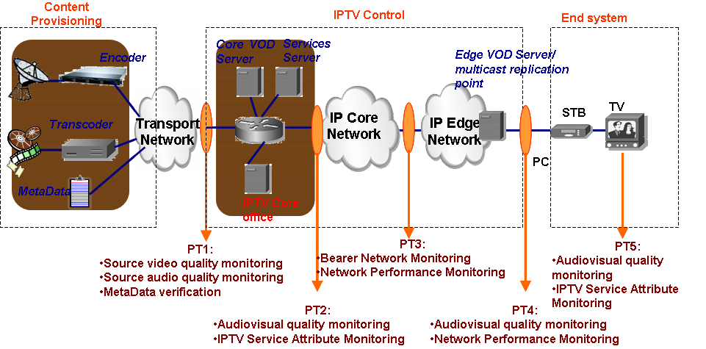
In above figure, it is proposed that 5 typical performance monitoring points can be considered in an IPTV end-to-end system.
This document farther proposed some important performance metrics that should be considered in every monitoring point.

2. Discussion
The proposed metrics and relevant notes are listed below:
- Metadata Validty （MV）
Metadata Validity is for checking whether the metadata files from content provision meet or comply with the language used, syntax and semantics which has been specified in advance. For example, the IPTV control domain should check if the file used XML as the description language if XML is the normative description language for IPTV metadata file.
- Metadata Integrity（MI）
Metadata Integrity is for checking whether the metadata files from content provision has contain all the necessary information and comply with the metadata specification. For example, the IPTV control domain should check all the attributes such as information about director, actor and so on when it received a metadata file of a movie for VOD purpose.
- Source Video Quality Assessment (SVQA)
Source Video Quality Assessment represents the source video quality grade by assessing according to the quality assessment parameter sets or subjective assessment. For example, regarding the MPEG2 TS as the source, IPTV control domain should outcome video quality score after synthesising video bitrate, resolution, PCR jitter and so on.
- Source Audio Quality Assessment (SAQA)
Source Audio Quality Assessment represents the source audio quality grade. For example, according to the tone, volume, sampling rate and so on, IPTV control domain should outcome the quality grade score.
- Connection Success Rate (CSR)
The Connection Success Rate is the number of connection which was successfully established with the streaming server as a percentage of total attempted connection in a unit time. The CSR is a good viewpoint from users’ experience when using IPTV service.
- Streaming Jitter (SJ)
The SJ represents the maximum and minimal bit rate of the streaming server output streaming. The SJ is a from network’s viewpoint and it is a vital metric when monitoring the performance.
- Connection Time(CT)
Connect time measures the amount of time elapsed between the initial request by the media player or STB and the start of buffering. This time may includes Domain Name System (DNS) lookup and resolution, metafile actions, RTSP handshakes and the transport of the first byte of data to the player. The CT is also a good viewpoint from IPTV users’ experience.
- Network Performance (NP)
The NP represents the quality of network. It covers the bearer network and access network. The parameter sets for monitoring include packet delay, packet loss, network jitter and other traditional 3-layer quality parameter. This aspect should comply with existing ITU standard.
- AAA Success Rate (AAASR)
The success rate about service related request from end users should reflect the users’ experience. So authentication, authorization, and accounting success rate should be monitored.
- End Video Quality Assessment (EVQA)
End Video Quality Assessment represents the final impression by the end user. End video quality grade should be obtained by subjective and objective assessment. Regarding objective assessment, the metrics should cover perceptual metrics, such jerkiness, blockiness, blurring, noise, colourfulness. When original video is available, the fidelity metrics, such as PSNR is referenced.
- End Audio Quality Assessment (EAQA)
End Audio Quality Assessment represents the final hearing feeling by the end user. End audio quality grade also should be obtained by subjective and objective assessment.

For every PT in above figure, the proposed metrics which should be monitored are listed below:
PT1: MV，MI，SVQA，SAQA；
PT2: AAASR
PT3: CSR，SJ，CT，NP
PT4: CSR，SJ，CT，NP
PT5: EVQA，EAQA

3. Proposal

It is proposed that the above metrics for PT1~PT5 would be discussed in WG2 and be added into the section 7 in working document of WG2, “FG IPTV-DOC-0066”.

Contributor List
Name | Company | Tel. | Email
Siqing Luo | China Telecom | +86 21 58755452 | luosq@sttri.com.cn
Jianting Meng | China Telecom | +86 21 58755057 | mengjt@sttri.com.cn
Haining Yan | China Telecom | +86 21 28970207 | yanhn@sttri.com.cn
Mingjie Zhang | China Telecom | +86 21 58757591 | zhangmj@sttri.com.cn
Li Jiang | China Telecom | +86 21 58750441 | jiangli@sttri.com.cn

____________

