INTERNATIONAL TELECOMMUNICATION UNION |  |  |  | Focus Group On IPTV
TELECOMMUNICATION  STANDARDIZATION SECTOR  STUDY PERIOD 2005-2008 |  |  | FG IPTV-C-0581
 |  |  | English only
WG(s): 4 |  | 4th FG IPTV meeting:  Bled Slovenia, 7-11 May, 2007
CONTRIBUTION
Source: | NEC Corporation
Title: | Proposal for Resource Control Function of Access Network for IPTV Services
1. Introduction
ITU-T Rec.Y.2111 describes the definition of “QoS resource control scenarios” and the following two flow diagrams as examples. It is preferable that ITU-T Rec.Y.2111 specification is applied for NGN network of IPTV services. However, these scenarios do not supply a sufficient quality service. Because the access lines of NGN between each CPE and central office have various types of physical line and various types of topology, and the available bandwidth of the access line differs from. So it is proposed that some parameters should be add to the parameters of Rw reference point (between RACF and Transport Functions) of “QoS resource control scenarios” for IPTV services.

Service Control Functions
RACF
Transport Functions
CPE
NACF
(1)
(2)
(3)
Figure 1/Y.RACF: The flow diagram for Scenario 1

Service Control Functions
RACF
Transport Functions
CPE
NACF
(4)
(6)
(5)
(1)
(2)
(3)
Figure 2/Y.RACF: The flow diagram for Scenario 2
2. Resource Control Function of Access Network for IPTV Services
ITU-T Rec.Y.2111 describes the definition of “QoS resource control scenarios” between CPE, SCF (Service Control Functions), RACF and Transport functions in case of using NGN based contorol. And also ITU-T Rec.Y.2111 defines information components at the reference points. If these scenarios and information components were applied to IPTV services as it is, it doesn’t supply a sufficient quality service. Because the available bandwidth between CPE and central office, which can be occupied by IPTV service, differs from each case by “a type of access line*” or “a type of topology”. So, “information components” considering effect of a IPTV service quality is necessary.
* Access line : The line between CPE and Access Node
The below is an example of “a type of access line” and “a type of topology”.
Example 1 type of access line (e.g. xDSL)
For example, if xDSL is used for the access line, the available bandwidth differs by the distance
from CPE to central office.
Example 2 a type of topology (e.g. PON, FTTN(Optical + xDSL or Ethernet))
For example, if share topology such as PON or FTTN (Optical + xDSL or Ethernet) is
used, the available bandwidth differs by the figure of connected user simultaneously or
occupied bandwidth by each user.
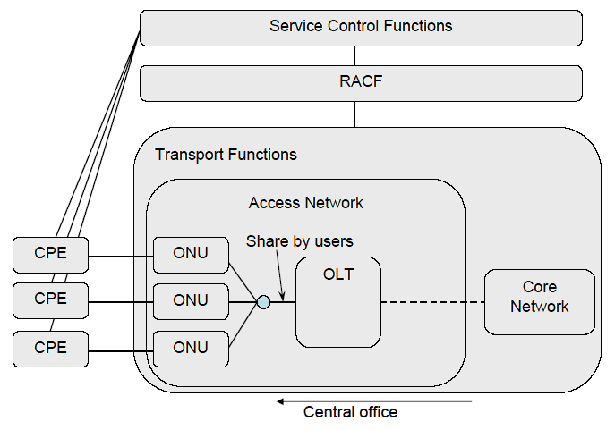 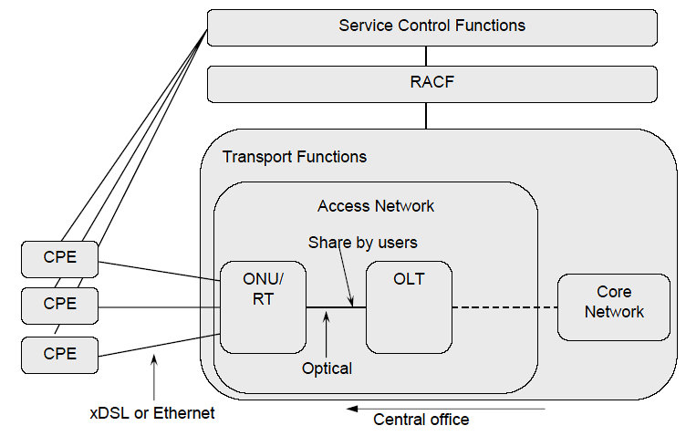
Figure 3 example of share topology (PON) Figure 4 example of share topology (Optical + xDSL or Ethernet)
The information components which might be able to change the value by conditions of each user should be managed. In addition, in case of “share topology”, it’s necessary to manage the bandwidth not only of each user or session, but also all users or sessions which share the same physical line as a group.
The information components of the reference point named Rw is defined in ITU-T Rec. Y.2111. Rw is the reference point between PE-FE of Transport Functions and PE-FE of RACF.
The following parameters should be added to the components of Rw reference point.
The information components including below are for future study.
- type of access line (e.g xDSL, FTTN etc.)
- maximum bandwidth which can be occupied
3. Proposal
This contribution proposes the above section 2 is included as a text section of WG4 document (IPTV Network Control Aspects).
-----------------------------------------

