Abstract
INTERNATIONAL TELECOMMUNICATION UNION |  |  |  | Focus Group On IPTV
TELECOMMUNICATION  STANDARDIZATION SECTOR  STUDY PERIOD 2005-2008 |  |  | FG IPTV-C-0585
 |  |  | English only
WG(s): 6 |  | 4th FG IPTV meeting:  Bled, Slovenia, 7-11 May 2007
CONTRIBUTION
Source: | France Telecom (France)
Title: | Comments on STB Middleware for Browser solution
This contribution provides a view of the IPTV terminal external interfaces.
Background
At the last conf call on navigation system, a discussion took place on the STB interfaces with the Navigation front-end. This contribution addresses this issue further.
Proposal
It is proposed to consider the following navigation architecture coming from DVB CM-IPTV comercial requirements for IPTV Services as a basic architecture for the browser case.
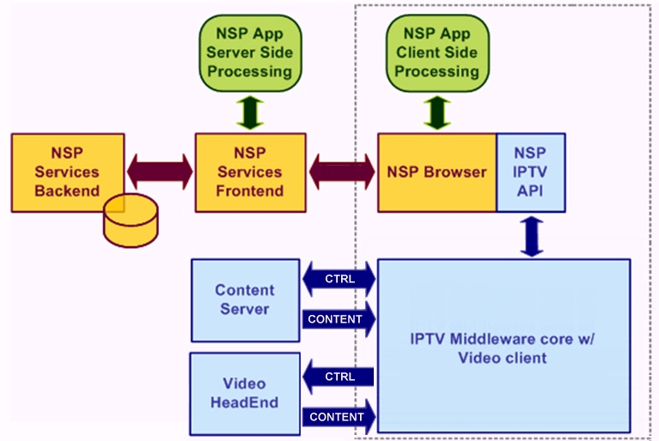
Figure 1. NSP application conceptual model
NSP: Network Service provider
If we want to consider metadata flows more precisely, we can update the previous figure as following:
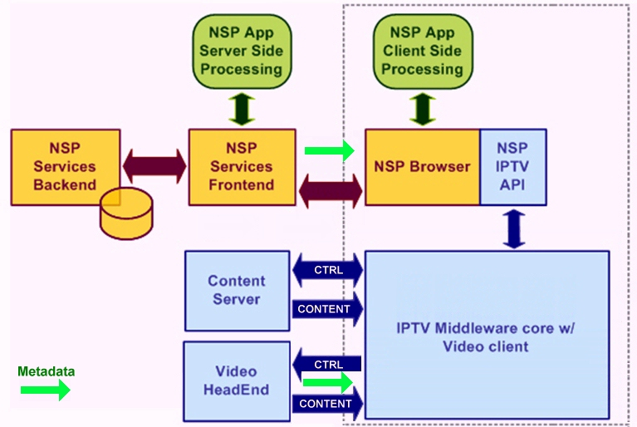
Figure 2. NSP application conceptual model with metadata flows

So we think that the architecture included in the output of the WG6 conf call on Service & content navigation system should be revisited concerning the metadata flow.
We consider that the metadata flow is not unique.
We consider that the existing metadata flow shown on the figure is not between the middleware and the front-end but between the front-end and the browser.

