INTERNATIONAL TELECOMMUNICATION UNION |  |  |  | Focus Group On IPTV
TELECOMMUNICATION  STANDARDIZATION SECTOR  STUDY PERIOD 2005-2008 |  |  | FG IPTV-C-0588
 |  |  | English only
WG(s): 2 |  | 4th FG IPTV meeting:  Bled, Slovenia, 7-11 May 2007
CONTRIBUTION
Source: | IEEE Broadcast Technology Society (BTS) / Communications Research Centre Canada (CRC)
Title: | Considerations on restructuring the working document: quality of experience requirements for IPTV (FG IPTV-DOC-0063)

1 Introduction
In ATIS-0800004 [1], four quality layers were identified for IPTV QoS and/or QoE measurements. These include, as illustrated in figure 1, content quality, media stream quality, transmission quality and transaction quality.
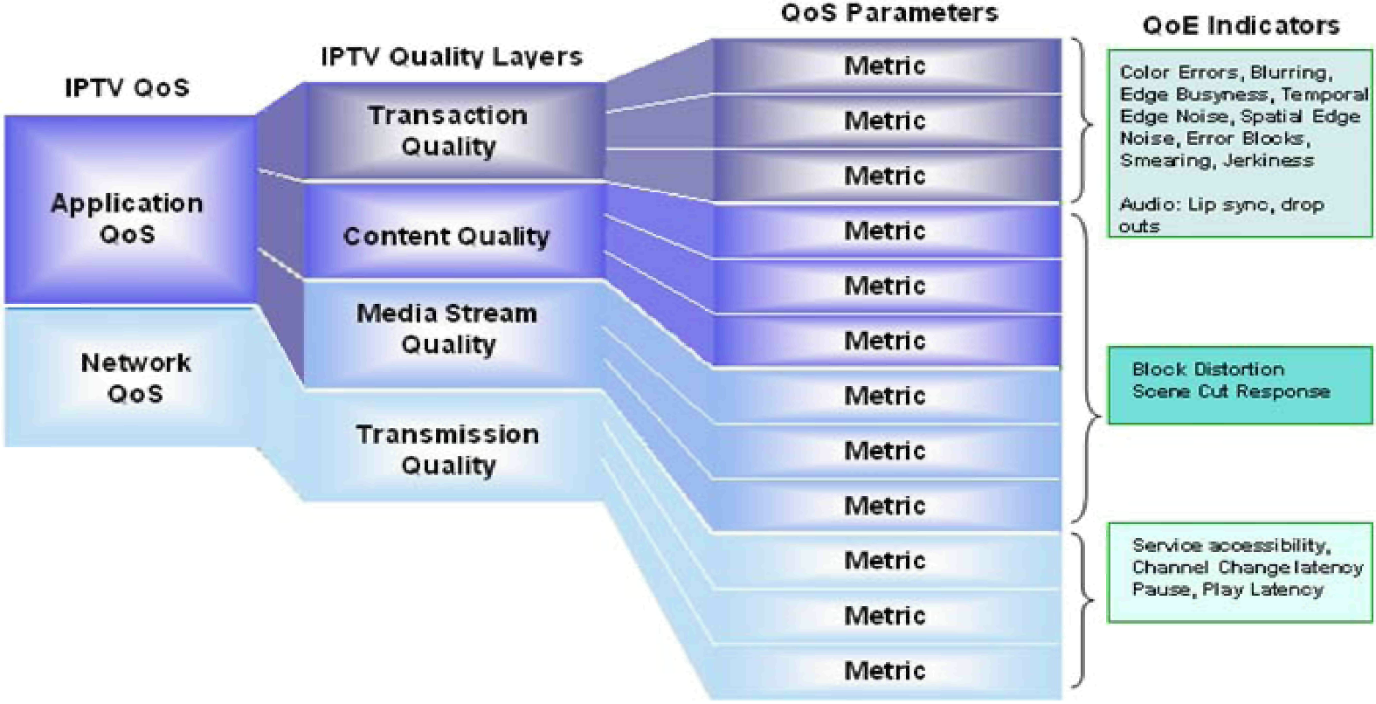
Figure 1. Quality layers, QoS parameters, and QoE indicators [1].

IPTV content includes encoded video/audio flows as well as additional information such as text, graphics, sub-titles, closed captioning, EPG, etc. Content quality refers to the quality of these streams. It’s the layer where QoS/QoE are affected by the IPTV terminal function or head end encoding system.

The media stream quality measures the quality of transporting streams. These include the IPTV content described above encapsulated within a MPEG-2 Transport Stream (TS) and/or RTP stream.

The transmission quality is the collective quality of IP streams which are delivered over the IPTV network using a stack of IP protocols such as UDP/IP, TCP/IP, etc.

The transaction quality denotes user experiences in requesting of a service. This can include the purchase and control of a content stream, channel changing, session tearing down, etc.

These quality layers are closely related. Quality degradation of one layer may cause negative impacts to other layers.

2 Discussion
The working document “Quality of experience requirements for IPTV (FG IPTV-DOC-0063)” defines general QoE requirements for IPTV services from users’ perspectives. It describes various QoE aspects in a simple listed manner. When a new QoE requirement item is identified and introduced, the descriptive texts are added towards the end of the document with a new item inserted at the end of the Table of Contents. We find that this is not a well organized approach for the document’s layout.

3 Proposal
Based on the quality layers described in the introduction section, it is proposed to reorganize this working document. The proposed new Table of Contents is reformatted in the Appendix. The contents of this working document remain unchanged.

References:
[1] ATIS-0800004, “A framework for QoS metrics and measurements supporting IPTV services”, Nov. 2006.

Appendix
Table of Contents
1 Scope Error! Bookmark not defined.
2 References Error! Bookmark not defined.
3 Definitions Error! Bookmark not defined.
4 Abbreviations Error! Bookmark not defined.
5 Conventions 3
6 Introduction to QoE 3
7 QoE for Content Quality 3
7.1 QoE for video 3
7.2 QoE for audio 3
7.3 QoE for combined audio/video/text/graphics (e.g. lip sync, sub-titles, closed captioning, descriptive audio) 3
7.4 QoE requirements for EPG 3
7.5 QoE requirements for Metadata 3
7.6 QoE requirements for Browser 3
7.7 Accessibility requirements 3
8 QoE for Media Stream Quality 3
9 QoE for Transmission Quality 3
9.1 Transport Impairments 3
9.1.1 IP Packet Transfer Delay 3
9.1.2 IP Packet Loss Ratio (PLR) 3
10 QoE for Transaction Quality 3
10.1 QoE requirements for channel switching 3
10.2 QoE requirements VOD trick mode 3
10.3 Service billing and its impact on end-users’ expectation for a service quality 3
10.4 Proposed QoE requirements with service billing for IPTV service: End-users’ Utility 3
Appendix I Bibliography 3

_____________

