INTERNATIONAL TELECOMMUNICATION UNION |  |  |  | Focus Group On IPTV
TELECOMMUNICATION  STANDARDIZATION SECTOR  STUDY PERIOD 2005-2008 |  |  | FG IPTV-C-0601
 |  |  | English only
WG(s):WG6 |  | 4th FG IPTV meeting:  Bled, Slovenia, 07 – 11 May 2007
CONTRIBUTION
Source: | ETRI
Title: | The requirements for supporting legacy channels in IPTV

- Introduction

This contribution is about supporting legacy channels in IPTV. This is related to the previous input document FG IPTV-C-0226 discussed at the second meeting of the FG IPTV Busan, Republic of Korea in October last year. The input document only described reference architecture to support legacy channels based on ACAP, OCAP, and MHP between IPTV head-end system and terminals.
The legacy channels mean pre-made linear broadcasting services provided from terrestrial, satellite, and cable network providers. IPTV service providers retransmit those services with some modifications. Traditionally, the linear broadcasting services are multiplexed by several components like AV, SI, and applications as Xlets based on MPEG-2 TS, and de-multiplexed on their legacy STB and shown to users after all components are composed together according to their own standards. In IPTV, the legacy channels should be retransmitted to IPTV STBs and be shown to users as same as legacy STBs. Therefore, this document describes detailed requirements for seamless support of legacy channels in IPTV.

- Requirements

Figure 1 shows the architecture of IPTV middleware to support legacy channels. It is composed of two main modules, the first one is GEM based execution environment and the other is PSI/SI Manager.

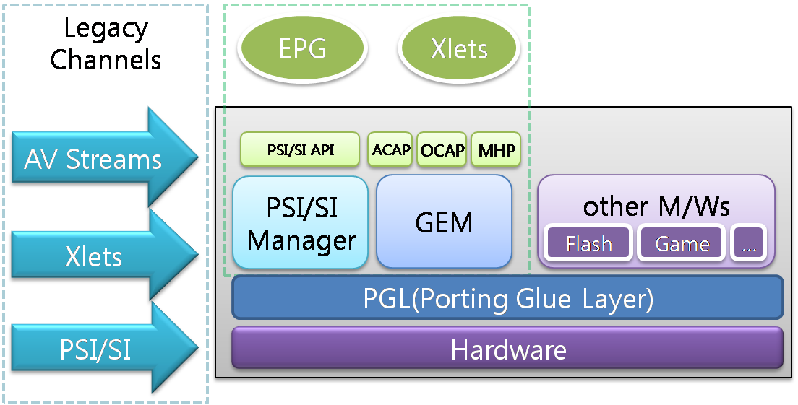
<Figure 1> the architecture of middleware to support legacy channels

The important things what we should consider are how to deliver legacy channel’s components to IPTV terminals and how to display them in the same manner as their legacy STBs.
Therefore, IPTV terminals should contain the middleware to manage PSI/SI information and to launch xlets as well as AV streams together with optimized IP protocols. The requirements for supporting legacy channels are as follows.

- Legacy channels should be retransmitted to be shown to users on IPTV STB as same as their legacy STBs
- Additional IP address spaces for accommodating legacy channels should be allocated to the network
- Logical channel numbers should be allocated according to IPTV service provider’s channel map tables
- AV should be retransmitted without modifying their contents, but MPEG-2 can be transcoded to H.264/AVC because of network bandwidth.
- PSI and SI (DVB-SI or PSIP) should be retransmitted to IPTV terminals. They can be transmitted included in each MPEG-2 TS or transmitted through multicast protocol as a kind of an EPG document generated using PSI and SI tables filtered from each legacy channels
- Applications (Xlets or HTML documents) included in legacy channels should be retransmitted based on MPEG-2 TS or with other optimized IP transport protocols.
- SI monitoring should be provided for each legacy channels to update SI data
- Application signaling should be provided for each legacy channels to control the lifecycle of their applications
- AV, SI, and applications should be synchronized when they are replayed on IPTV terminals

- Conclusion

IPTV middleware architecture should be designed to accommodate various kinds of services. Therefore, the requirements for supporting legacy channels in IPTV should be reflected when IPTV middleware architecture is defined because legacy channels can be considered as good content sources in IPTV. Besides, it is necessary to describe the scenarios and mechanism how to support legacy channels in IPTV in the chapter 9 of WG6’s working document.

