INTERNATIONAL TELECOMMUNICATION UNION |  |  |  | Focus Group On IPTV
TELECOMMUNICATION  STANDARDIZATION SECTOR  STUDY PERIOD 2005-2008 |  |  | FG IPTV-C-0623
 |  |  | English only
WG(s): 1 |  | 5th FG IPTV meeting:  Geneva, 23 – 31 July 2007
CONTRIBUTION
Source: | Nortel Networks (Canada)
Title: | Proposal for addition of a clause to FG IPTV-DOC-0083
Abstract
This contribution proposes text for a new clause to be added to “FG IPTV-DOC-0083 (7-11 May 2007), Working Document: IPTV Services Requirements” in order to help reader understand the requirements.
Background and discussion
At the most recent FG IPTV meeting, i.e. 7-11 May 2007, significant progress was made on the IPTV Services Requirements document. Throughout the working document there are numerous references to four IPTV domains, viz. “content provider”, “service provider”, network provider” and the “end-user”. To facilitate understanding of the requirements, it is essential that the reader of the document have a visual concept about these domains. It is for this reason that the following is proposed. It is also proposed that Figure 1 at the end of sub-clause 6.7.3 be removed. Please note that for the sake of alignment with IPTV functional architecture document, the text as presented in FG IPTV-DOC-0084 is re-used changing “customer” to now read as “end-user”.
Reference
FG IPTV-DOC-0083 (7-11 May 2007), working document: IPTV Services Requirements
Proposals
Proposal 1
It is proposed that the following text be adopted so that there is clear text that identifies what is meant by different IPTV domains. It is also proposed to remove Figure 1 at the end of sub-clause 6.7.3.

X IPTV functional Domains
The following figure shows the main functional domains that are involved in the provision of an IPTV service. It is provided in this document to help understanding of requirements which in some way relates to these domains. Full description of all domains is provided in other document addressing IPTV functional architecture. These functional domains do not define a business model. Also, one provider may play several functional domains in an actual service.

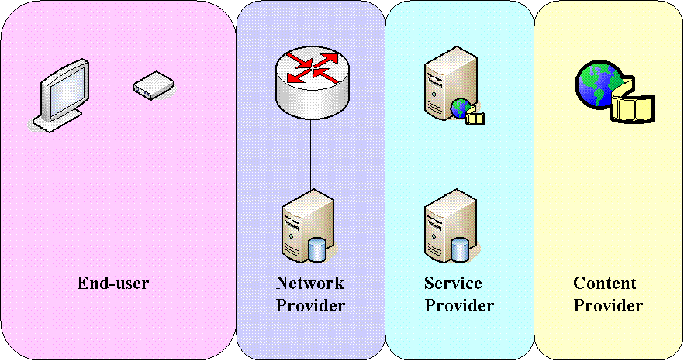

Figure X-1: IPTV Domains
The four functional domains are as described below.
Content provider: The entity that owns or is licensed to sell content or content assets.
Service provider: The entity that provides the IPTV services to the end-user.
Note: Typically, the service provider acquires or licenses content from Content Providers and packages this into a service that is sold to the Customer.
Network provider: The entity providing that connects the end-users and the service providers.
Note: The Service Provider and the network provider may be one entity. For simplicity, the two are shown as functionally separate entities in the included figures.
End-user: The entity that consumes and pays for the IPTV Service.
Note: The functional elements shown in each of the four functional domains above will be described in more detail in the document dealing with IPTV functional architecture.
Proposal 2
It is proposed that Figure 1 at the end of sub-clause 6.7.3 be removed.

_______________________

