1 Introduction
INTERNATIONAL TELECOMMUNICATION UNION |  |  |  | Focus Group On IPTV
TELECOMMUNICATION  STANDARDIZATION SECTOR  STUDY PERIOD 2005-2008 |  |  | FG IPTV-C-0644
 |  |  | English only
WG(s): 6 |  | 5th FG IPTV meeting:  Geneva, 23-31 July 2007
CONTRIBUTION
Source: | China Netcom Group, P.R.China
Title: | Proposal on the chapter 6 of the DOC-0098e
On the 4th meeting of FG IPTV held on Bled, Slovenia,we have a working document: Service Navigation System.As to the chapter 6,we present Figure 6-1: Browser-based service navigation system architecture,and give a typical realization system(referring to FG IPTV-ID-0089) as well as some explanation.

This document will give a more detail structure and further explanation of the structure. Let’s redraw the figure 6-1/DOC-0098e as following:

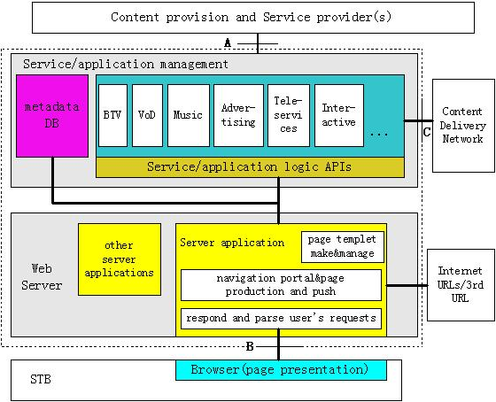

Figure 1 Browser-based service navigation system architecture
- Proposal
It is proposed to replace the figure 6-1/DOC-0098e with here figure 1.
Before we continue the work further,we think it is necessary to make some clarification and
explain some of the idea of our work,because it is the basis to understanding the architecture.Here we explain three functional module of figure 1.They are optional added to the chapter 6 of DOC-0098e for the convenience of understanding.
  - “page templet make&manage”
Here give an example to explain the “page templet” only for understanding:
For instance,a operator could provide the following services and programs as:3 channels(BTV),3 programs(VoD),a game and advertising.
Services and programs | Channel 1(BTV) | Channel 2(BTV) | Channel 3(BTV) | Star War  (VoD) | Spiderman 3  (VoD) | Solar Strike  (VoD) | Game | Adver-  tising
statue
Navigation system provider could write a navigation page based on XML.How to array all the services and programs on the page as well as embellishing the page is decided by the providers. Usually,providers make some fixed format as templets.How to use these page templet is decided by what kind of products user have purchased.

  - “navigation portal&page production and push”
The operators will combine and group these services and programs by the user’s purchase and operating convenience, and decide to provide three set of “meal” for users to choose.Each kind of “meal” is corresponding to a page templet and a cost,as following:
- 30RMB/month
Services and programs | Channel 1 | Channel 2 | Channel 3 | Star War  (VoD) | Spiderman 3  (VoD) | Solar Strike  (VoD) | Game | Adver-  tising
statue | free | free | free | free | free | free | free | free
- 20RMB/month
Services and programs | Channel 1 | Channel 2 | Channel 3 | Star War  (VoD) | Spiderman 3  (VoD) | Solar Strike  (VoD) | Game | Adver-  tising
statue | free | free | charged | free | free | charged | charged | free
- 10RMB/month
Services and programs | Channel 1 | Channel 2 | Channel 3 | Star War  (VoD) | Spiderman 3  (VoD) | Solar Strike  (VoD) | Game | Adver-  tising
statue | free | charged | charged | free | charged | charged | charged | free
Operator will use the page templet and make some modification/limitation,add other 3rd party free services and Internet URLs to provide a user individuation page (based on HTML/XML),and push to STB before the consumer use services. For example,as to the second “meal”, when an user press on the button of Channel 3,then a page presents to tell user it costs or pay it before watch it.If the multicast flow is duplicated and controlled at DSLAM,then each port of DSLAM control a channel,when the port is open,the user could watch the program, as following:
DSLAM Port No. | Port 1(open) | Port 2(open) | Port 3(closed)
 | Channel 1 | Channel 2 | Channel 3
In fact, an operator may have many kind of page style in order to satisfy users’ individuation requirements.
  - “service/application logic”
In order to explain what the “service/application logic” is,we present two services logic which is very simple,and they are only used for illuminating the service logic.In fact,each kind of service has it’s fixed service logic,and the service management server need to interact with other systems to realize the logic.
The first case is BTV,and we give the very simple process as following:
Figure 2 BTV channel request and respond process
- Channel request
- Web server application invoke service and application logic APIs(from Navigation application server)
- Logical process include:Authentication and Authorization of the user, IP address and DSLAM port,Channel ID,etc.So,the navigation application server will interact with other systems such as NMS,service management system,etc.to realize the service logic.
- Send application information
- Return application information
- STB match corresponding DSLAM port
- Send program
The second case is VoD,and we give the simple process as following:
Figure 3 VoD request and respond process
- VoD request
(2) Web server application invoke service and application logic APIs(from Navigation application server)
(3) Logical process include:Authentication and Authorization of user,IP address and port of VoD server,etc. So,the navigation application server will interact with other systems such as CDN,service management system,etc. to realize the service logic.
(4) Send application information
(5) Return application information
(6) STB interact with VoD server
(7) Send media flow

It is proposed to put the following structure into the chapter 6 of DOC-0098e:
    - The function of Service/application management
- To receive service and content metadata and account/bill data from other systems and manage them.
- To interact with related systems and realize&manage each kind of service logic.
- To provide APIs to Web server
    - The function of Web server application
- page templet make and manage
- navigation portal&page produce and push
- integrate the Internet page and other 3rd party page
- respond and parse user’s request
    - Interface A,B,C
- Interface A.
An interface between CP(s)/SP(s) and service navigation system, through which service information, service metadata, content metadata etc. are sent to the service navigation system.
- Interface B.

- Interface C.

_________________

