Abstract
INTERNATIONAL TELECOMMUNICATION UNION |  |  |  | Focus Group On IPTV
TELECOMMUNICATION  STANDARDIZATION SECTOR  STUDY PERIOD 2005-2008 |  |  | FG IPTV-C-0662
 |  |  | English only
WG(s): 1 |  | 5th FG IPTV meeting:  Geneva, 23 – 31 July, 2007
CONTRIBUTION
Source: | NTT Corporation
Title: | Proposal for clarification of Content Delivery Functions in IPTV Architecture document
This contribution proposes clarification of functions of Content Delivery Functions and some modifications of relevant text and figures of clause 7 and clause 8 in the IPTV Architecture document.

1. Introduction
The IPTV Architecture document that was developed at the 4th FG-IPTV meeting (7-11 May, Bled, Slovenia) as FG-IPTV-doc-0084 defines Content Delivery Functions. However, the IPTV Architecture document only mentions information flows and instantiated functions; essential functions are not clearly described. As a result, the relationship with Service Control Functions is also vague. Therefore we cannot proceed with the work on concrete reference model and protocols. Hence, clarification of Content Delivery Functions is required.

2. Discussion
2.1 Overview based on instance of processing
IPTV services can be roughly classified into Linear broadcast TV services and VoD services. Considering current discussion, the following operations are encouraged to be performed for providing these services.
- IP level multicast => Network Transport Functions*
- Establishment and release of session => Service Control Functions
- Manipulation of content => Content Delivery Functions
- Application level operation => Application Functions
(* operation => corresponding function)
In terms of functions defined in the IPTV architecture document, the above four operations should be provided by the functions written after the “=>” mark.
These operations and corresponding functions should be deployed from lower layer to upper layer or from End-User Functions side to Content Provider side in order of listed above.
However, in the current document, the Content Delivery Functions is located nearer to End-User Functions than Service Control Functions. That also differs from the order of functional domains of clause 5, and should be modified in line with the above-mentioned order. Thus, figure of the functional overview should be the following.

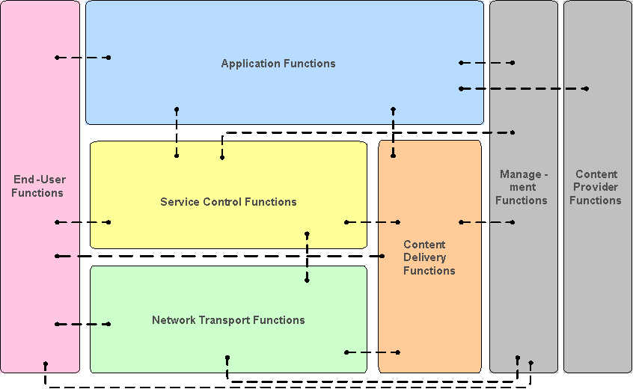
Figure 7-1 IPTV Functional Architecture Framework

2.2 Definition of Content Delivery Functions
Current description of Content Delivery Functions in clause 7 does not explicitly explain these functions and should be modified as follows.
The Content Delivery Functions deliver IPTV content accrding to the request of the End-User Functions. Triggered by the request (except in specific push modes), the Content Delivery Functions establish the transport and service arrangement and inject the content. The Content Delivery Functions obtain the content and associated data from the Application Functions, before or during the service offering process. In order to support the services like VOD and Network PVR, and for the sake of transport efficiency, content may be stored/cached in the Content Delivery Functions. When the End-User Functions issues a request for a piece of content, it will be directed by the Service Control Functions to the Content Delivery Functions to obtain content data. The Content Delivery Function then streams the requested piece of content to the End-User Functions via the Network Transport Functions. Content Delivery Functions also provide the capability to facilitate interaction between the End-User Functions and selected content, such as playback control (trick play functionality with VOD and Network PVR). Physically, the Content Delivery Functions employs the resources of Transport network Functions for the content delivery.

2.3 High-Level Architecture
This sub section examines the high level architecture of clause 8 based on the above overview and definition of Content Delivery Functions. There are three kinds of elementary functions in Content Delivery Functions.
- Content Delivery Control Function: receives service requests from End-User Functions via Service Control Functions, then establishes session for delivery of content
- Content Delivery Control Function: receives content control requests such as playback control from End-User Functions and controls Content Delivery & Storage Function
- Content Delivery & Storage Function: stores or caches content and deliveries that to End-User Functions
In addition, we should consider that there are three functions in IPTV Terminal Functions of End-User Functions that corresponding to the above three in Content Delivery Functions. In the case of broadcast services, the function having multicast capability for content delivery is encouraged in Network Transport Functions.
These functions should be allocated like the figure below in the high-level architecture.

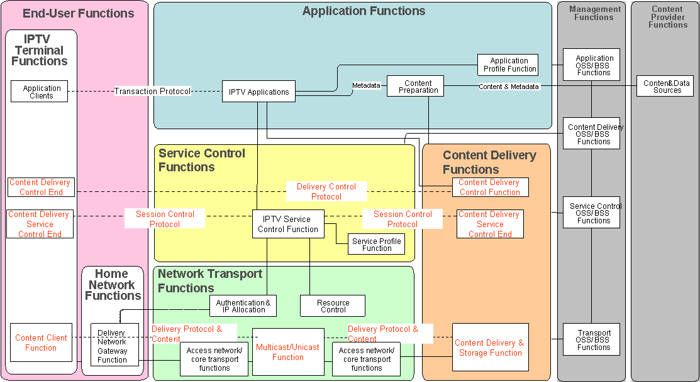
Figure 8-1 Functional Architecture for IPTV

3. Proposal
This contribution proposes modifications of text and figures of clause 7 and clause 8 in IPTV Architecture document (FG IPTV-DOC-0084) as stated above.

_____________

