INTERNATIONAL TELECOMMUNICATION UNION |  |  |  | Focus Group On IPTV
TELECOMMUNICATION  STANDARDIZATION SECTOR  STUDY PERIOD 2005-2008 |  |  | FG IPTV-C-0680
 |  |  | English only
WG(s): 2 |  | 5th FG IPTV meeting:  Geneva, 23-31 July 2007
CONTRIBUTION
Source: | Pixelmetrix Corporation
Title: | Suggested additions to FG-IPTV-DOC-0089 “Performance monitoring for IPTV”
Introduction: This contribution presents several suggested changes to the document FG-IPTV-DOC-0089 “performance monitoring for IPTV”. To make additions in section 7 “Monitoring parameters” by replacing specific subsections with the following:

Proposal 1: Replace the monitoring points and parameters “Table 1” in section 7 of the document with the following table
The new table is restructured to align the monitoring parameters with the protocol delivery stack:
Also, some parameters are added and deleted from the existing table:
- New parameters added to the table include: IP Flow List (IP layer parameter) and VOD Request Accuracy (Correctness Rate)
- Deleted parameters from the table include: AAA Success rate, Connection Success rate as it is a VOD performance metric, Connection time as it is a part of the zap time and streaming jitter as it is covered under both the IP and transport stream layer parameters.

Monitoring Parameters | Domain A | Domain B  (PT1- PT2) | Domain C  (PT2- PT3) | Domain D  (PT3- PT4) | Domain E  (PT4- PT5)
Physical Layer Parameters
RF Integrity | Yes
Available Bandwidth | Yes | Yes | Yes | Yes | Yes
IP Layer Parameters
Packet Loss Metrics | Yes (Only for content over IP contribution) |  | Yes | Yes | Yes
Jitter | Yes (Only for content over IP contribution) |  | Yes | Yes | Yes
IGMP join/ leave time |  |  |  | Yes | Yes
IP Flow List | Yes | Yes | Yes | Yes | Yes
Transport Layer Parameters
Packet Loss Metrics | Yes |  | Yes | Yes | Yes
Jitter | Yes |  | Yes | Yes | Yes
TR 101 290 | Yes  Priority 1, 2 & 3 | Yes  Priority 1 and 2 | Yes  Priority 1 | Yes  Priority 1 | Yes  Priority 1
Service Line-up Parameters
Meta Data Verification (parental control/ EPG/ Subtitles) | Yes | Yes |  |  | Yes
Metadata Validity | Yes | Yes |  |  | Yes
Metadata Integrity | Yes | Yes |  |  | Yes
Channel Zap time |  |  |  |  | Yes
Channel Line Up Verification |  | Yes |  |  | Yes
Channel Attribute Parameters
Video/ Audio Bandwidth | Yes | Yes | Yes | Yes | Yes
Video Quality | Yes | Yes |  |  | Yes
Audio Quality | Yes | Yes |  |  | Yes
Blackout Detection | Yes | Yes |  |  | Yes
Freeze Frame Detection | Yes | Yes |  |  | Yes
Audio Loss/ Presence | Yes | Yes |  |  | Yes
VOD Parameters
VOD Request Performance |  |  |  |  | Yes
VOD Request Accuracy (Correctness Rate) |  |  |  |  | Yes
Table 1 - Monitoring points and parameters

Proposal 2: Replace figure 2 in section 7.1 “Service parameters” with the following figure and text.

7.1 Service parameters

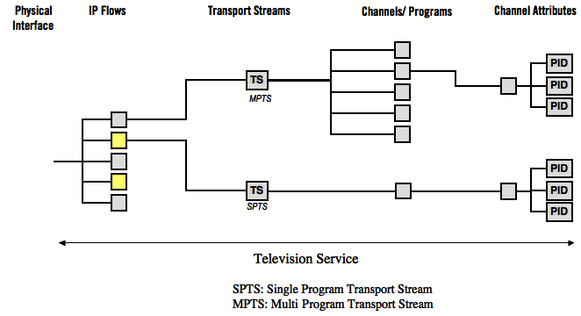
Figure 2 - Television Service
There is a hierarchical relationship within an IP television service, where a physical interface (e.g. Ethernet) can carry one or many IP flows, those IP flows in turn carry single or multiple program transport streams, each channel/program within, having multiple attributes defining the content.

Proposal 3: Subsection 7.1.1 in section 7.1 to be replaced by the following:

7.1.1 Channel line up
It is essential to monitor the parameters applicable to the entire channels/ programs offering of the IPTV Service. Monitoring these parameters is essential as it details the presence and correctness of channels intended to be delivered over the service.
Some of the parameters that need to be monitored are:
- Number of channels on the service
- Channel Identity (ID) Number
- The names of the services
- Source of content for the services (content provider/ aggregator)
- Number of interactive channels
- Number of free to air/ pay channels
- Genre of channel content and number in each genre

Proposal 4: Sub-Section 7.1.3 in section 7.1 to add the following:

7.1.3 Channel zap time
Channel zap time is typically measured in milliseconds (ms).

Proposal 5: Add subsection 7.1.5 to section 7.1 to include the following:
7.1.5 Content on Demand (VOD/KOD) request correctness
Correctness Rate (CR): The correctness rate is the number of times the “correct” content expected by the user is played as a percentage of total number of requests attempted by users in a pre-defined time interval. The CR can be treated as an important parameter to measure the overall users’ experience of the IPTV service.

Proposal 6: Section 7.2 (Including sections 7.2.1, 7.2.2 and 7.2.3) to be replaced by the following:

7.2 Channel parameters
As described in figure 2, each channel has specific attributes attached to it. They are embedded as part of the transport stream carrying the channels. The PID (program ID) defines the identity of the program being carried by the transport stream (TS).
7.2.1 Channel attributes
Multiple attributes of each channel have to be monitored to ensure the performance of the service.

PID (Program ID)

Type: Audio/ Video/ Data

Aspect Ratio
- Conditional Access Enabled/ Disabled
- Age rating

Encoding Format of the channel

Bit-rate of the channel

Bit-rate of each component of the channel in case it carries more than one type of information (eg. Audio and Video)

7.2.2 Video quality
Video quality assessment represents the video quality grade by assessing according to the quality assessment parameter sets, subjective assessment, or objective assessment.
When the original video is available, fidelity metrics, such as PSNR can be used. Video Quality cannot be measured objectively, but can be approximated using objective estimation models and represented as an MOS (Mean Opinion Score).

7.2.3 Audio quality
Audio quality assessment represents the audio quality grade by assessing according to the quality assessment parameter sets, subjective assessment, or objective assessment.
Audio quality cannot be measured objectively, but can be approximated using objective estimation model and represented as an MOS (Mean Opinion Score).
____________

