INTERNATIONAL TELECOMMUNICATION UNION |  |  |  | Focus Group On IPTV
TELECOMMUNICATION  STANDARDIZATION SECTOR  STUDY PERIOD 2005-2008 |  |  | FG IPTV-C-0681
 |  |  | English only
WG(s): 2 |  | 5th FG IPTV meeting:  Geneva, 23-31 July 2007
CONTRIBUTION
Source: | Pixelmetrix Corporation
Title: | Suggested additions to FG-IPTV-DOC-0089 “Performance monitoring for IPTV”
Introduction: This contribution presents a suggested change to the document FG-IPTV-DOC-0089 “performance monitoring for IPTV”
Proposal 1: To replace figure 1. The following figure presents a clear definition of the domains and monitoring points within an IPTV delivery chain.

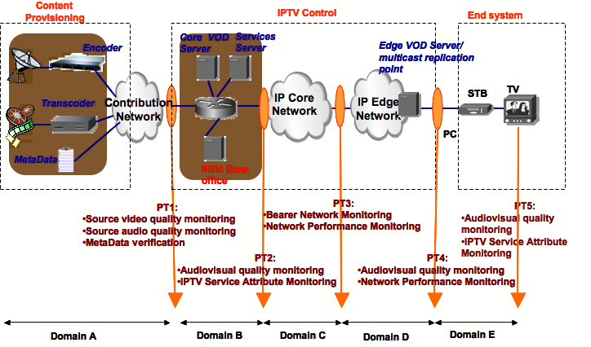
Figure 1: Monitoring Points and Domains
Domains are sections of an IPTV network between a pair of monitoring points. The complete IPTV network can be seen as a series of domains.

