INTERNATIONAL TELECOMMUNICATION UNION |  |  |  | Focus Group On IPTV
TELECOMMUNICATION  STANDARDIZATION SECTOR  STUDY PERIOD 2005-2008 |  |  | FG IPTV-C-0687
 |  |  | English only
WG(s): 4 |  | 5th FG IPTV meeting:  Geneva, 23-31 July 2007
CONTRIBUTION
Source: | ETRI, Republic of Korea
Title: | Proposed modifications to figure 18 and 19 of FG IPTV-DOC-0092
1. Introduction
At the previous meeting, Figure 18 and 19 in FG IPTV-DOC-0092 were accepted by WG4 ‘IPTV Multicast Frameworks’. This contribution proposes some amendments to figures and the related text as well.

2. Discussion
In the section ‘9.5.2 QoS Control at Overlay Multicast Network for IPTV Services’ of the document ‘FG IPTV-DOC-0092’, resource control architecture has been proposed as Figure 18 of the document. Resource control function for IPTV overlay network is located between IPTV overlay network and physical transport network, and In Figure 18 and 19 in IPTV-DOC-0092 RCF (Resource Control Functions) performs collection and management of transport network resource (e.g., DiffServ, RSVP) via specified interface (e.g., SNMP, COPS). Overlay network nodes create tree topology and route optimization to support QoS requirements for IPTV users through the information collected by Resource Control function.
It is necessary to consider the two interfaces, COPS and SNMP between RCF and transport network to provide policy installing/uninstalling and SNMP capability respectively.

3. Proposal
This contribution proposes to replace the figure 18 and 19 in FG IPTV-DOC-0092 by the modified figure 18 and 19 in this contribution, which incorporates some amendments to the former figure and text (italic format) according to the discussions above.

Revised Text of 9.5.2.1 of FG IPTV-DOC-0092 is as follows.

9.5.2.1 Functional Position of Resource Control
If the information on IPTV transport networks is directly collected and managed by IPTV overlay nodes to establish overlay transport route and configuration trees, it will be serious burden to handle overheads in IPTV overlay networks. It is assumed that resource control functions for IPTV overlay network is located between IPTV overlay network and physical transport network, and it performs collection of information about network resource and provides QoS control to transport network.

As shown in Figure 18, it is necessary that resource control function is introduced to provide interface function for IPTV overlay multicast QoS control between physical transport and IPTV overlay network. This function performs collection and management of transport network resource (e.g., DiffServ, RSVP) via specified interface (e.g. SNMP. COPS). And overlay network nodes create tree topology and optimized route to support QoS requirements of IPTV users through information collected by Resource Control function.. And RCF can have the interfaces such as COPS, Diameter and H.248 to install/uninstall the policy decision for transport network The interface between overlay network and RCF will be further study. The interface may be proprietary of IPTV service providers.

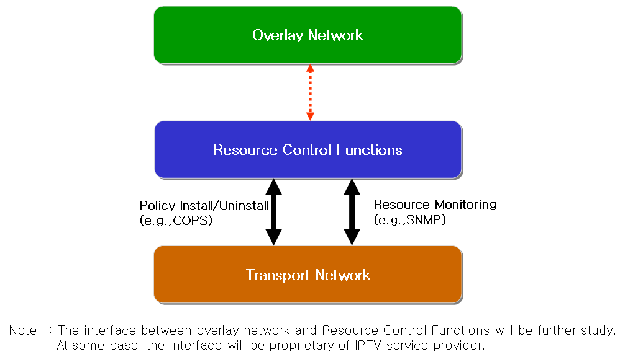
Fig. 18 Resource Control Architecture in IPTV Overlay Network
      - Resource Control Function for Overlay QoS Control in Heterogeneous Networks.
The Session Manager configures routes among IPTV overlay network nodes and optimizes tree topology for multicast sessions according to information of Resource Control Function. RCF has resource information from transport network such as link state information, routing information, multicast traffic information and so on. Session manager requests the resource information in transport network to RCF. RCF verifies the resource status based on gathered information, and makes the policy decision for the request. Session manager confirms the received message from RCF, and compares with service information. Then session manager sends the policy installing request message to RCF. After receiving the policy request message, RCF sends the policy installing request message to transport network through the configured path for overlay network.
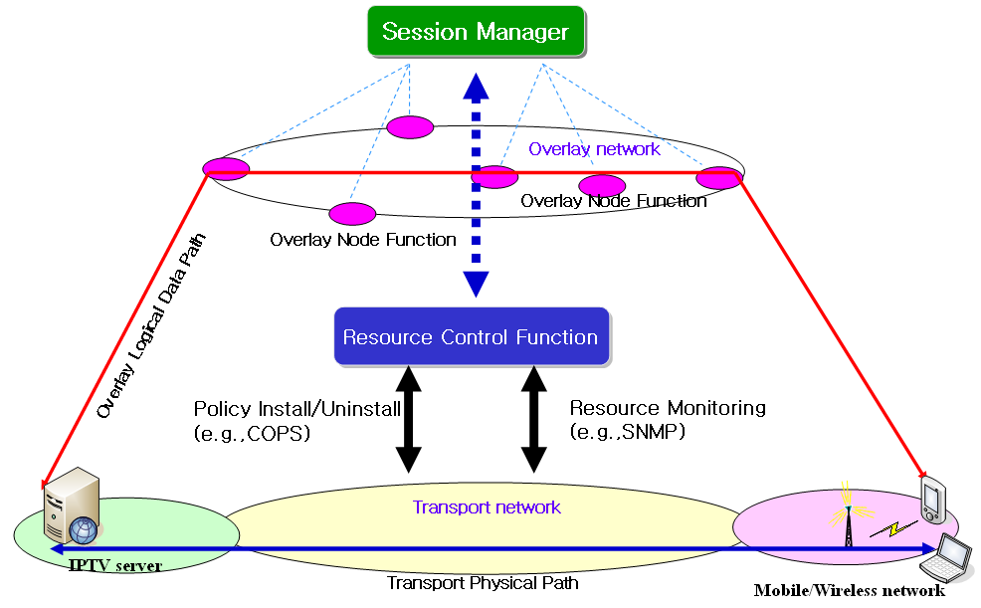
Fig. 19 Application of Resource Control Function in Heterogeneous Networks for Overlay
QoS Control

------------------------------------------

