INTERNATIONAL TELECOMMUNICATION UNION |  |  |  | Focus Group On IPTV
TELECOMMUNICATION  STANDARDIZATION SECTOR  STUDY PERIOD 2005-2008 |  |  | FG IPTV-C-0690
 |  |  | English only
WG(s): 2 |  | 5th FG IPTV meeting:  Geneva, 23-31 July 2007
CONTRIBUTION
Source: | China Telecom
Title: | Proposal on adding centralized platform for IPTV monitoring points

1. Discussion
It is vital for IPTV operators to have a performance monitoring system with functionality to pinpoint where errors are occurring and to evaluate the end user’s QoE. The working document of IPTV FG WG2(FG IPTV-DOC-0089) has outlined an example topology with domain boundaries placed monitoring points.
But after deploying this points, the operators need a centralized platform to manage monitoring task, to collect parameter value, to do performance analysis and to generate report. The platform does make sense of all the monitoring points.
So this contribution proposes there should be a centralized platform or system to do monitoring management and performance analysis and the altered figure describing IPTV monitoring points is diagrammatized as below.

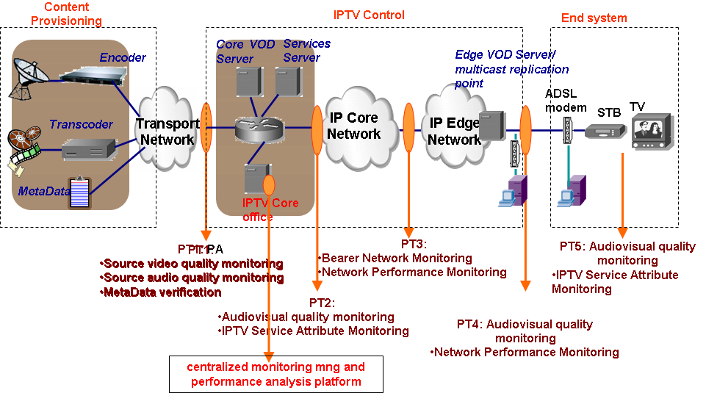

Figure1 altered IPTV monitoring points for FG IPTV-DOC-0089

2. Proposal

It is proposed that the modification for IPTV monitoring points in FG IPTV-DOC-0089

would be discussed in WG2 and the altered figure would be accepted as one part of working document of WG2.

Contributor List
Name | Company | Tel. | Email
Siqing Luo | China Telecom | +86 21 58755452 | luosq@sttri.com.cn
Baohua Lei | China Telecom | +86 10 58552305 | leibh@ctbri.com.cn
Jianting Meng | China Telecom | +86 21 58755057 | mengjt@sttri.com.cn
Haining Yan | China Telecom | +86 21 28970207 | yanhn@sttri.com.cn

____________

