Abstract
INTERNATIONAL TELECOMMUNICATION UNION |  |  |  | Focus Group On IPTV
TELECOMMUNICATION  STANDARDIZATION SECTOR  STUDY PERIOD 2005-2008 |  |  | FG IPTV-C-0710
 |  |  | English only
WG(s): 1 |  | 5th FG IPTV meeting:  Geneva, 23-31 July 2007
CONTRIBUTION
Source: | ZTE Corporation
Title: | Review Comments on IPTV Architecture
This contribution provides review comments on IPTV Architecture “FG IPTV-DOC-0084 (7-11 May 2007), Working Document: IPTV Architecture”.

Proposal
It is proposed to modify the IPTV Architecture of the Working Document as below.
No. | Current Working Document | Review Comments, Proposed Changes
1 | - End-User Functions  The End-User functions include those functions normally provided by the IPTV Terminal and the End-User Network.  The Terminal Functions are responsible for collecting control commands from the user, and interacting with the Application Functions to get service information (e.g. EPG), content licenses, and keys for decryption. The Terminal Functions interacts with the Content and Service Control functions to receive the streaming parts of the IPTV Service. The Terminal Functions provides the capability for content reception, decryption and decoding. | - End-User Functions  The End-User functions include those functions normally provided by the IPTV Terminal and the End-User Network.  The Terminal Functions are responsible for collecting control commands from the user, and interacting with the Application Functions to get service information (e.g. EPG), content licenses, and keys for decryption. The Terminal Functions interacts with the Content Delivery functions and Service Control functions to receive the streaming parts of the IPTV Service. The Terminal Functions provides the capability for content reception, decryption, decoding and playback.
2 | 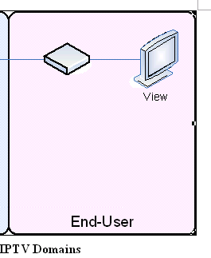  Customer: The entity that consumes and pays for the IPTV Service. | End-User: The entity that consumes and pays for the IPTV Service.

________________

