INTERNATIONAL TELECOMMUNICATION UNION |  |  |  | Focus Group On IPTV
TELECOMMUNICATION  STANDARDIZATION SECTOR  STUDY PERIOD 2005-2008 |  |  | FG IPTV-C-0741
 |  |  | English only
WG(s): 6 |  | 5th FG IPTV meeting:  Geneva, 23-31 July 2007
CONTRIBUTION
Source: | ETRI, Republic of Korea
Title: | Proposal of metadata syndication capability on figure 5.3 in Service Navigation Systems ( FG IPTV-DOC-0098 )
Summary
In this contribution, syndication capability for metadata is newly proposed to be added on the figure 5.3, “Metadata flows in Service Navigation System” in service navigation system of WG6 WD (FGIPTV-DOC-0098).

Discussion
Metadata service is overviewed in IPTV metadata to support IPTV service (FG IPTV-DOC-0099). And metadata based service navigation is also described on service navigation system, FG IPTV-DOC-0098. Metadata is necessary for interactive IPTV data service. Below are related texts with metadata in WG6.
- In FG IPTV-DOC-0099 WD (IPTV metadata), metadata server and metadata client are described for metadata service. On section 2, it describes that metadata is necessary to support for user preference or context. And on section 7, metadata elements are described for service and content metadata.
- In FG IPTV-DOC-0098 WD (Service Navigation System), metadata is based on XML mechanism to support Navigation Functional Entity on section 5.2.2.

As well, EPG metadata capabilities are listed for retrieval and customization in FG IPTV-DOC-0095. Customization includes on-demand feeding, filtering and gathering with metadata. To support such services, metadata syndication capability is necessary. Syndication, for example RSS ("Really Simple Syndication") in Web, is a family of web feed formats used to publish frequently updated content. An RSS document contains either a summary of content from an associated web site or the full text. RSS formats are specified using XML, a generic specification for the creation of data formats.
- In FG IPTV-DOC-0095 WD (IPTV middleware, Application and Content Platforms), some guidelines about EPG capabilities are described on section 13. Among them, some features listed on EPG metadata capabilities for retrieval and customization. Retrieval includes fast search, semantic search. Customization includes on-demand feeding, filtering and gathering for metadata.
In this document, metadata syndication capability is proposed on Browser-based service navigation system.

References
- Working Document: IPTV Middleware, Application and Content Platforms, FG IPTV-DOC-0095
- Working Document: Service Navigation System, FG IPTV-DOC-0098
- Working Document: IPTV metadata, FG IPTV-DOC-0099
- http://en.wikipedia.org/wiki/RSS
_______________

Proposed texts and modified figure for Metadata Syndication in figure 5.3

5.2.2 Navigation Functional Entity (navigation front stage) general functional requirements:
(1) Based on browser or middleware/application method
- Based on XML mechanism
- A sole(unified) entry Portal
- Permission to integrate Internet Portal and other value-added portal
- Pages presentation(including services and channel list)
- Value-added services list
- …….

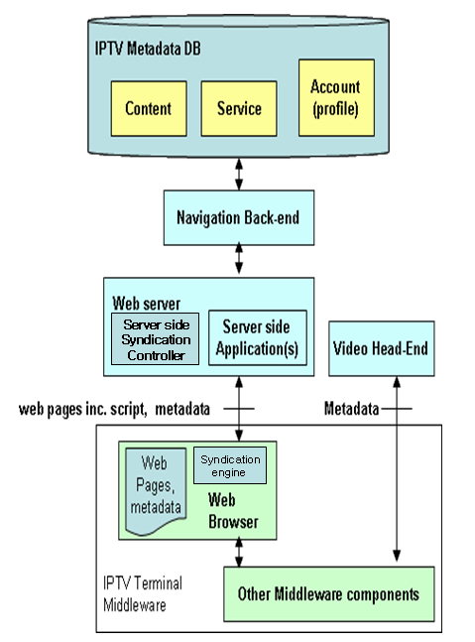

Figure 5.3: Metadata flows in Service Navigation Systems

Browser is IPTV client module that loads and renders web pages encoded in a mark-up language mostly based on HTML/XML, and a scripting language.
Navigation front-end serves navigation information (e.g. metadata) and client side scripts on requests from client side application in IPTV client.
Metadata can also be received from a video head-end and cached or processed in middleware.
Client side application is executed locally to control the navigation user interface. Client side application can retrieve metadata directly from the front-end or through middleware from local cache.
Syndication controller provides metadata adaptation function with metadata DB and manages metadata with browser syndication engine. It classifies and customizes metadata from IPTV metadata DB for web browser in IPTV terminal. The data format between syndication controller and syndication engine could be standardized syndication format such as RSS/Atom.
Syndication engine in browser manages the metadata information from server side and it can provide the aggregated feeding and customized retrieval of metadata information.

_______________

