INTERNATIONAL TELECOMMUNICATION UNION |  |  |  | Focus Group On IPTV
TELECOMMUNICATION  STANDARDIZATION SECTOR  STUDY PERIOD 2005-2008 |  |  | FG IPTV-C-0750
 |  |  | English only
WG(s): 6 |  | 5th FG IPTV meeting:  Geneva, 23-32 July 2007
CONTRIBUTION
Source: | Coding Technologies
Title: | Audio Codec according to MPEG D: MPEG Surround
Abstract
MPEG Surround is a new, flexible and highly efficient technology for coding and transmitting multi-channel audio in the form of a 1 or 2-channel downmix plus a low overhead data stream specifying the upmix to the multi-channel audio. It is an open standard defined by the International Standardization Organization (ISO) and it has been tested by MPEG as verification test and by the EBU with regard to its efficiency and quality.
By using MPEG Surround, any existing service such as broadcasting, streaming or downloading can easily be upgraded to provide surround sound. While a legacy stereo decoder ignores the MPEG Surround data and plays back the stereo downmix without any quality degradation, an MPEG Surround enabled decoder will deliver high-quality multi-channel audio.

Introduction
With the ongoing quest for an improved consumer experience in the audio world, multi-channel sound (e.g. SA-CD, DVD-Audio etc.) is gaining more and more attention. In this context, many of today’s consumer audio applications would benefit significantly from extending their traditional two-channel stereophonic capability towards surround sound rendering.
Legacy discrete multi-channel (5.1) audio coding techniques typically require 2-3 times the bit rate of stereo coding, and have no inherent embedded stereo or mono signal. If a stereo output is desired from a legacy multi-channel coded signal, the decoder needs to decode all 5.1 channels and subsequently do a stereo downmix. The only legacy systems available that can provide a backwards compatible stereo downmix and that claim to deliver a surround sound experience are matrix based systems. However, these kinds of technologies are severely limited in quality, and rarely provide a multi-channel output signal that even closely resembles the original signal. Furthermore, the matrix encoded downmix hampers the quality of the stereo signal significantly.
MPEG Surround is a new open standard for compressing multi-channel audio, defined in ISO/IEC 23003-1 that resolves these problems. As such it reaches compression ratios previously unattainable for multi-channel audio coding, while being inherently mono and stereo backwards compatible, since the multi-channel signal is described by surround parameters in relation to the mono or stereo downmix signal.

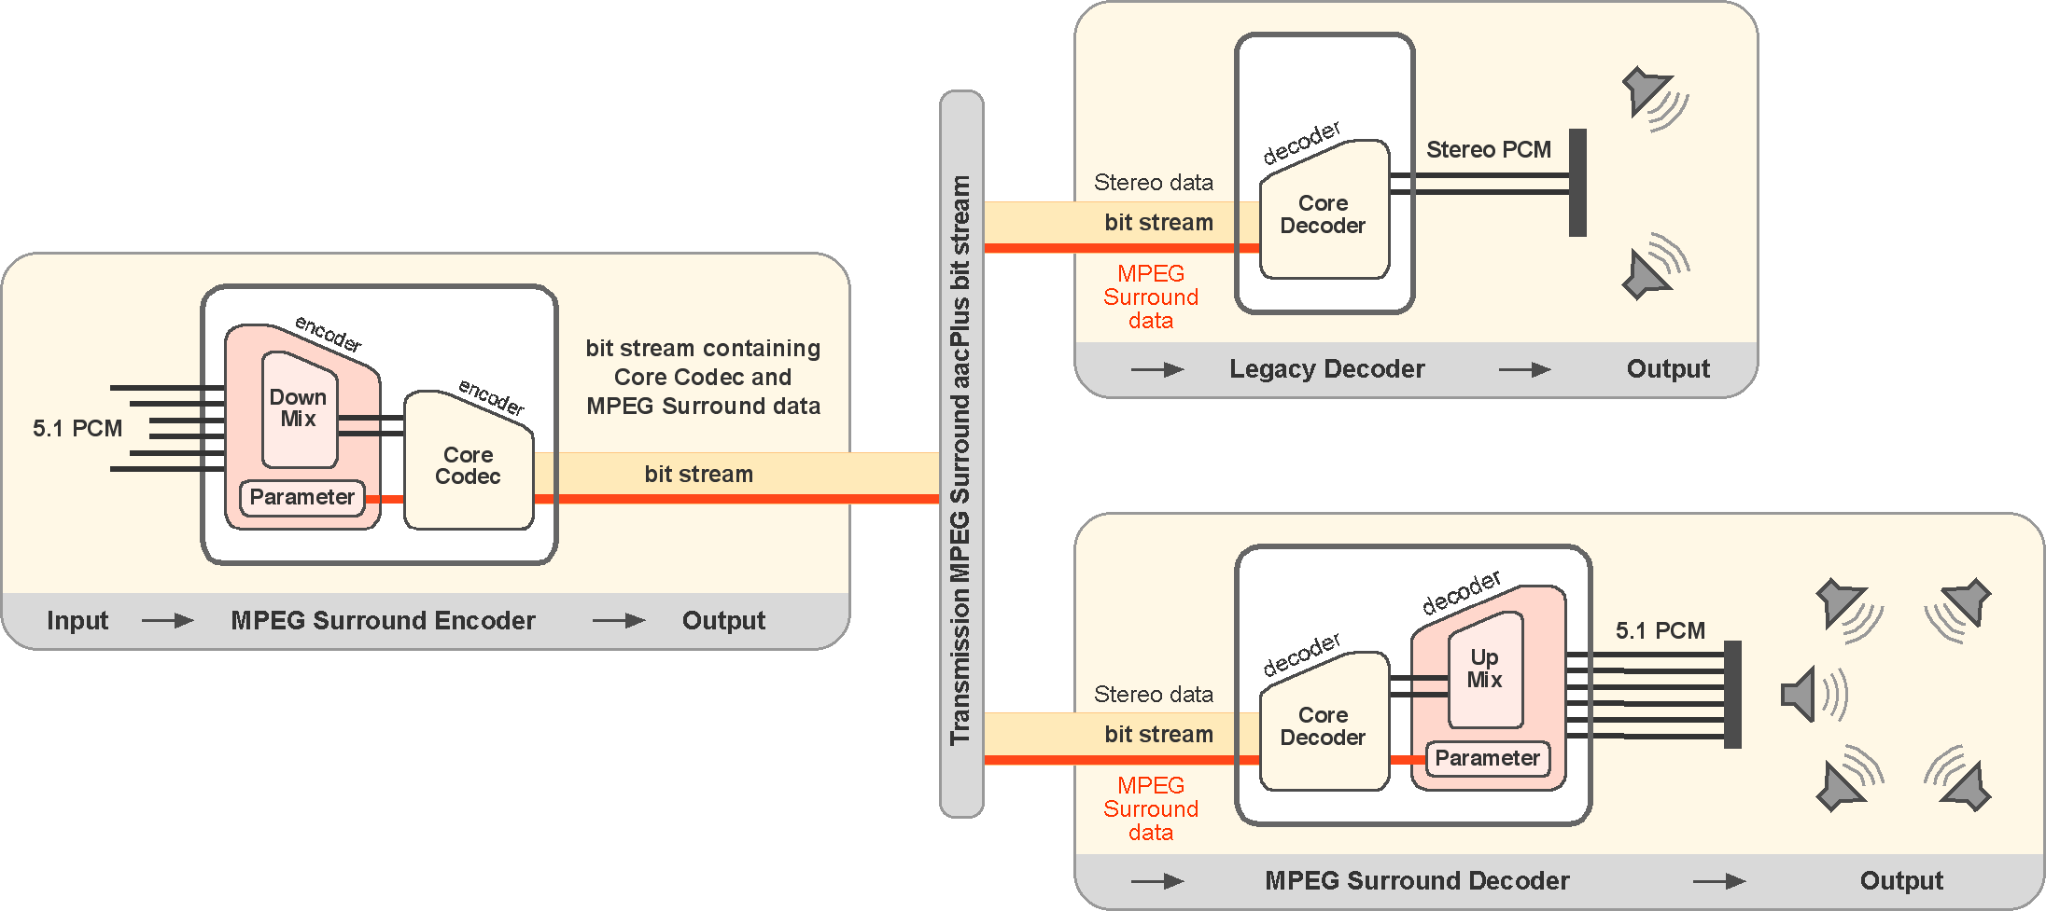
Figure 1 - The basic principle of MPEG Surround illustrated in combination with the HE-AAC codec
MPEG Surround can be used in combination with any core codec, e.g. MPEG-1 Layer II, AAC LC, HE-AAC etc.
MPEG Surround is not limited to 5.1 output channels, but supports a wide range of channel configurations with up to 32 output channels.

Basic Principle
The efficient coding of multi-channel signals, and the inherent mono/stereo backwards compatibility is achieved by, at the encoder side, creating a mono or stereo audio downmix from the original multi-channel signal and by simultaneously extracting a small amount of additional side information. The downmix audio signal can be encoded using any audio codec e.g. HE-AAC, AAC or mp3, and the additional side information is added to the downmix signal bitstream in a fully backwards compatible manner. At the decoder side upmix from the mono or stereo downmix signal to the output multi-channel signal is controlled by the transmitted side information. A decoder which is not aware of MPEG Surround will decode and play the downmix while ignoring the MPEG Surround side information.
If no coding of the downmix is performed, the additional side information describing the multi-channel signal can be included in the PCM signal by utilizing a technology called buried data, which allows the incorporation of the surround parameterization without affecting the sound quality of the legacy stereo PCM signal.
In general, the MPEG Surround system utilizes a flexible parametric/wave-form representation of the multi-channel signal enabling the system to scale from lowest bit rate up to transparent quality. Hence, even though the surround sound signal can be described by additional information as low as a few kbps, there is no limit in quality if the bit rate is increased, as is commonly the case for coding systems relying solely on parametric methods.

MPEG Surround tools and features
Given the low overhead of the MPEG Surround data, a MPEG Surround bit stream can be put on a storage constrained device without penalty for the legacy stereo output quality, and with very little loss in storage capacity. This enables surround sound to "boldly go where no surround has gone before", namely portable devices. The additional enabler for this is the Binaural Decoding Mode available in MPEG Surround that allows for a high quality, low complexity surround sound experience on stereo headphones and portable devices with small scale loudspeakers.

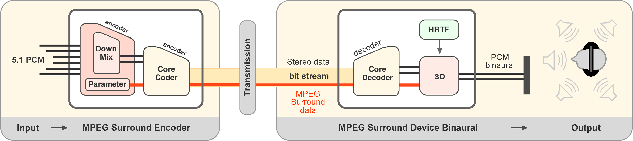
Figure 2 - MPEG Surround in Binaural Decoding Mode.
For cases where no additional side-information can be conveyed, the MPEG Surround decoder can be operated in an Enhanced Matrix Mode that recreates the multi-channel signal solely by analyzing the downmix signal. This tool enables the usage of the MPEG Surround decoder as a general stereo to 5.1 upmix tool creating multi-channel content from stereo content.
It is clear from today’s consumer media which deliver multi-channel audio (e.g. DVD-Video/Audio, SA-CD) that it has become common practice to deliver both dedicated multi-channel and stereo mixes that are stored as separate data on the media. The stereo mix data may contain a ‘manual’ mix of the recorded sound sources into two-channel stereo created by a sound engineer using hand-optimized mixing parameters, and thus preserving a maximum amount of artistic freedom. MPEG Surround therefore includes an External Downmix Mode that enables the use of an artistic downmix in combination with MPEG Surround.

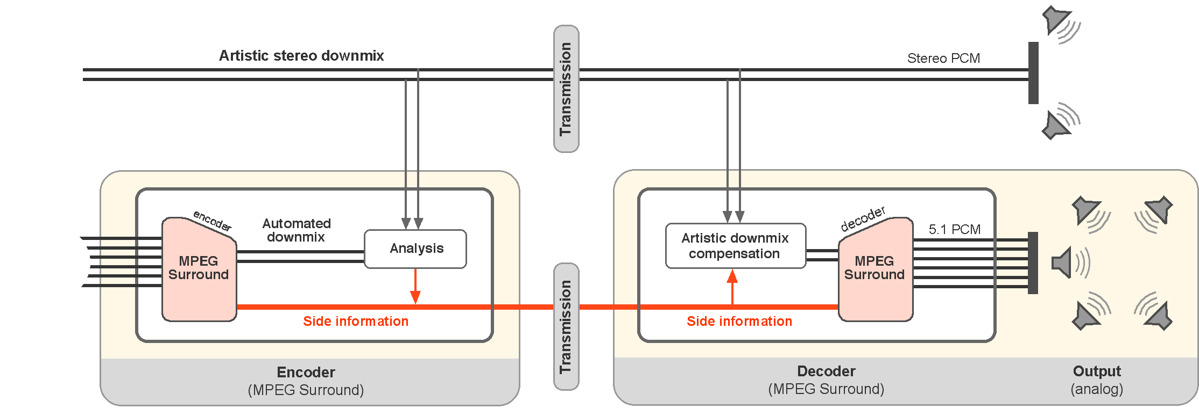
Figure 3 -MPEG Surround operated in External Downmix Mode.
Furthermore, striving to provide maximum compatibility with existing infrastructure it is recognized that all AV receivers in consumer homes incorporate a matrix decoder. Therefore, the stereo downmix produced by the MPEG Surround encoder, can be constructed in a Matrix Compatible Mode. This provides the legacy devices with a matrix enabled downmix, thus enabling the legacy device to recreate a multi-channel signal as well as the legacy matrix technology allows, while the MPEG Surround enabled device recreates a true multi-channel signal based on the downmix and the MPEG Surround data.

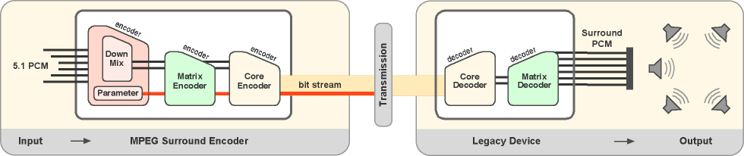
Figure 4 - MPEG Surround operated in Matrix Compatible Mode.
Applications
MPEG Surround enables a wide range of applications and scenarios offering numerous opportunities to expand existing business models. To provide a high level overview of the potential of MPEG Surround, its system and content aspects are listed below.
MPEG Surround system aspects:
- MPEG Surround enables surround transmissions without multicast even in a mixed receiver base, which can consist of everything from portable mono receivers to 5.1 home receivers.
- MPEG Surround provides multi-channel coding at very low overhead compared to stereo.
- MPEG Surround provides 100% stereo compatibility (including matrixed systems).
- MPEG Surround can be used with any perceptual audio core codec or even PCM.
- MPEG Surround supports two decoding methods:
  - Standard decoding for multi-channel playback.
  - Binaural decoding for headphone playback.
MPEG Surround content aspects:
- MPEG Surround supports automatic stereo or artistic downmix of surround original to guarantee optimum listening experience for users with traditional stereo setups.
- MPEG Surround provides an Enhanced Matrix Mode in case MPEG Surround data is not available.
- MPEG Surround supports a wide range of input/output channel configurations (2.0, 5.1, 7.1, …28.4).
- MPEG Surround supports a wide range of downmix configurations, e.g. mono, stereo, matrix stereo and 5.1 downmix channels.

Profiles and Levels
MPEG Surround has an inherent bit stream compatibility between levels, which allows for decoders of level 1, 2, 3, or 4 to decode any bit stream of all of the afore mention levels, though at a slightly reduced quality due to decoder implementations.
The proposed profile is called "MPEG Surround Baseline Profile", which is defined in [1] together with the different levels. In this profile the distinguishing factor between the different levels 1 to 4 is the number of output channels and the use of the coding tool residual coding, which if used allows for higher audio quality but adds computational complexity, hence the bit stream is such that lower level decoders can ignore the residual data. In the table below is a summary of the different levels defined in [1].

Decoder level | Number of output channels | Residual data
1 | 2, Stereo and Binaural | Ignores residual data
2 | 5.1 | Ignores residual data
3 | 5.1 | Utilizes residual data
4 | 7.1 | Utilizes residual data
Figure 6 – Summary of the MPEG Surround Baseline Profile
Hence it is proposed that dependant on how many output channels the receiving device has it shall be one of the following levels:
- MPEG Surround Baseline Profile @ Level 1
- MPEG Surround Baseline Profile @ Level 2
- MPEG Surround Baseline Profile @ Level 3
- MPEG Surround Baseline Profile @ Level 4

Transport and Signaling
Since the proposed audio coding technology is an MPEG standard it is fully compatible with both LATM/LOAS and ADTS transport. It should be known though that, when using LATM/LAOS it is possible to signal the presence of MPEG Surround on a high level within MPEG-2 systems hence this is the proposed way.
The transport of MPEG Surround will follow the transport and signaling requirements for MPEG Surround in an MPEG-4 Audio/Systems Environment as specified in [1].

The Codec Entry Criteria
The standard is published as ISO/IEC 23003-1 [1].
Tests have been conducted by MPEG [2] (extensive verification tests) and EBU [3] (critical item tests).
There is market demand, currently with specific emphasis from broadcasters e.g. HD Radio. Additionally, the DVB entry criteria of at least five members from two different constituencies have been met.

Proposal
MPEG Surround is added to the WG 6 document “Requirements and tool box for content coding” (formerly FG-IPTV C-0430).

Reference
[1] “ISO/IEC 23003-1, Information technology – MPEG audio technologies – Part 1: MPEG Surround” as part of the MPEG-D standard
[2] MPEG Surround verification test report with results from several listening tests: http://www.chiariglione.org/mpeg/working_documents/mpeg-d/sac/VT-report.zip
[3] Preliminary report: EBU B/MAE 023 rev 1 of June 2007

______________

