INTERNATIONAL TELECOMMUNICATION UNION |  |  |  | Focus Group On IPTV
TELECOMMUNICATION  STANDARDIZATION SECTOR  STUDY PERIOD 2005-2008 |  |  | FG IPTV-C-0751
 |  |  | English only
WG(s): 5, 6 |  | 5th FG IPTV meeting:  Geneva, 23-31 July 2007
CONTRIBUTION
Source: | Coding Technologies
Title: | Multi-channel Audio Transcoding
Abstract
IPTV operators opting for latest generation audio codecs for multi-channel transmissions face the legacy of deployed home theatres which neither allow for an interface to transmit uncompressed 5.1 channels not for decoding these newer codecs like Dolby Digital Plus or HE-AAC, also known as aacPlus.

To overcome this legacy issue, transcoding in the terminal from the transmission codec like HE-AAC or Dolby Digital Plus into DTS Surround or Dolby Digital is the solution which is defined in several specifications and found already major support from the decoder chip industry.

The Issue
For IPTV, to compete successfully with other distribution networks like satellite and cable, the need to offer high quality audio in combination with the video becomes an increasing and demand driven necessity. Today, prime content like movies and sports events is difficult to imagine without multi-channel audio, in other words surround sound is set to become a basic feature of any competitive IPTV service.

At the consumers´ premises the home theatre equipment, ranging from the expensive high end High Fidelity device to HTIBs (home theatre in a box), handles the surround sound representation. By the end of 2006 approximately 1/3 of Western European TV households owned a home theatre, whereas in the US, the percentage was even higher at approx. 42%. Almost all of these home theatre devices feature a Dolby Digital and a DTS decoder and have a S/PDIF interface. Newer models of A/V receivers provide HDMI connectivity.

IPTV operators intending to use state-of-the-art audio codecs face the challenge to deliver surround sound to the home at high quality, high efficiency and access the home theatre devices at the same time. The currently used “pass through” solution, where the compressed surround sound signal is simply passed through the set-top-box and only decoded in the home theatre device restricts the choices to these codecs which are implemented in the home theatre devices.

With this restrictions, the benefits of newer generation codecs would be lost. Whereas the ratio between bit rate for video and multi-channel audio may for some years to come remain acceptable for HDTV services, the same is certainly not true for SDTV transmissions using MPEG-4 AVC, e.g. at 2 Mbps for video, and 640 kbps for simulcasting stereo (MPEG-1 Layer II at 192 kbps) and multi-channel 5.1 (AC-3 at 448 kbps).

The Proposal
Without a sufficiently high population of home theatre devices with HDMI which will be capable to pass an uncompressed surround sound signal from the IPTV terminal to the A/V receiver, transcoding the transmitted audio stream in the IPTV terminal is a valid option.

Transcoding solutions have been developed for both enhanced audio codecs for surround sound broadcast, i.e. HE-AAC and Dolby Digital Plus.

HE-AAC, which according to recent EBU tests (Mushra score) received “Excellent” ratings for 5.1 transmissions at 160-192 kbps, respectively “Good” ratings at 128 kbps, transcodes to DTS and passes a DTS Surround encoded bit stream at 1,5 Mbps to the home theatre via the S/PDIF. For a schematic description please see figure 1.
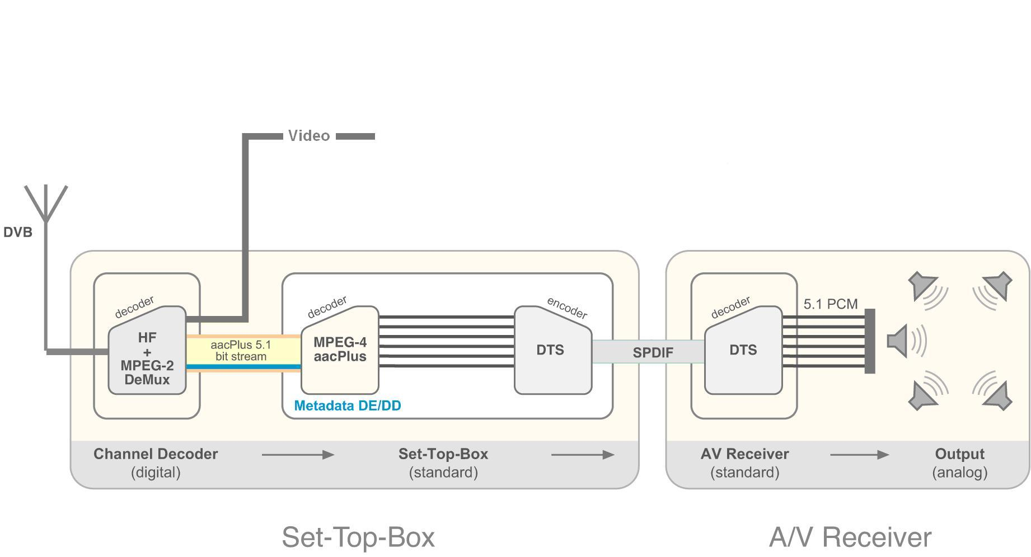

Figure 1 (source Coding Technologies)

Dolby Digital Plus, which has been tested (Mushra Score) “Good” at 200 and 256 kbps and “Excellent” at 448 kbps by the EBU, transcodes to Dolby Digital and passes an AC-3 encoded bit stream at 640 kbps to the home theatre via the S/PDIF. For a schematic description please see figure 2.
Dolby Digital Plus to Dolby Digital Converter
Dolby Digital Plus / Dolby Digital Decoder
Home Cinema
Dolby Digital
Decoder
1-5.1 ch
2 ch
Set top Box
5.1 ch
Dolby Digital
1 - 5.1 ch
Dolby Digital Plus
96-640 kbps
32-640 kbps
S/PDIF Dolby Digital

Figure 2 (source Dolby)

DTS Surround is specified in ETSI TS 102 114 v1.2.1, Dolby Digital (AC-3) is specified in ETSI TS 101 154 and other standards.

The process of transcoding implies the implementation of the respective decoder (if a single codec is used) or decoders (if two codecs are requested) in the IPTV terminal. This gives IPTV operators the possibility to avoid simulcasting stereo and multi-channel streams. With the decoder in place, the terminal may easily feature a downmix from multi-channel to stereo for either all devices or at least those which are not offering the transcoding feature, respectively S/PDIF interface.

An additional option is the application of audio metadata (i.e. most prominently DRC Dynamic Range Control, DN Dialogue Normalisation (acc. to Dolby) = Programme Reference Level (acc. to MPEG), and Downmix coefficients) in the decoder and prior to the re-encoding. If the IPTV operator specifies terminals, he will have control over such features and establish a homogeneous feature set. Even if this is not the case, the terminals are connected to a bidirectional network and it may be possible to offer such feature set for download; this is not the case for home theatre devices which do not provide connectivity other than unidirectional audio stream input.

The Requirements
- For multi-channel audio transmissions, the IPTV terminal is required to implement the transcoding feature, e.g. from HE-AAC to DTS Surround or Dolby Digital Plus to Dolby Digital, if it is a multi-channel capable terminal; such multi-channel terminals are required to have a S/PDIF interface.
- IPTV terminals without multi-channel capabilities are required to implement multi-channel decoders and downmix from multi-channel to stereo.
- Multi-channel capable IPTV terminals are recommended to apply audio metadata, i.e. Dynamic Range Control, Programme Reference Level or Dialogue Normalisation and Downmix in the audio decoder.
- DTS Surround according to ETSI TS 102 114 v1.2.1 is added to the list of audio codecs for IPTV

______________

