Abstract
INTERNATIONAL TELECOMMUNICATION UNION |  |  |  | Focus Group On IPTV
TELECOMMUNICATION  STANDARDIZATION SECTOR  STUDY PERIOD 2005-2008 |  |  | FG IPTV-C-0771
 |  |  | English only
WG(s): 5 |  | 5th FG IPTV meeting:  Geneva, 23-31 July 2007
CONTRIBUTION
Source: | Cisco
Title: | Modifications/Clarifications to General Functional Architecture of the Terminal Device (DOC 93)
This contribution proposes slight modifications and clarifications to the general functional architecture of the Terminal Device defined in current sections 7.1.1 – 7.1.5 of “Aspects of IPTV End System – Terminal Device” [DOC 0093]. The proposed figures and textual descriptions attempt to further clarify and define the general functional architecture and to incorporate the contents of the living list documents relating to the “IPTV Terminal Device Attachment and Initialization process” (Cisco Contributions 527-529 from the Bled Meeting – accepted into WG5 Living List) into an appropriate location in the document.

Introduction
At the IPTV FG Meeting in Bled, Slovenia, it was decided that clarification was needed with regard to the section relating to the general functional architecture. This proposal attempts to further clarify and define that section as well as to incorporate the “IPTV Terminal Device Attachment and Initialization process”.

Discussion
The IPTV Terminal Device General Functional Architecture should enable a clear understanding of the functional entities, interfaces, and connections. The previous diagram, while providing a good first step to understanding the direction that the Working Party wishes to pursue, was not fully aligned with much of the rest of the document (particularly the interfaces section that follows). The proposed figures are intended to clarify and provide an aligned view of the general functional architecture of the terminal device.
The Working Party also discussed the integration of the Cisco contributions (527-529) entitled “IPTV Terminal Device Attachment and Initialization process”, which were placed in the living list for a decision on location to be made at a later date. This contribution proposes a location for incorporating the Cisco Contributions relating to Terminal Device Attachment. Some more decisions may have to be made regarding how to divide this section up amongst Working Party 4 documents and Working Party 5 documents relating to the Terminal Device and Home Network.

Proposal
It is proposed to replace the contents of current sections 7.1.1 – 7.1.5 with the following sections 7.1.1 – 7.1.2.

7.1.1 General functional architecture block diagram

Figure 7-1: Functional Architecture Block diagram of IPTV Terminal Device

A brief explanation of each component/functional entity in Figure 7-1 is presented below:
Network Interface:
The Network Interface functional entity includes the following functions:
- Send and Receive signals.
- Processing of Layer 2 functions.
- Processing of IP Packets.
- Processing of TCP/UDP Packets.
- Handling of the control flows
- IPTV Terminal Device Attachment and Initialization process described in section 7.1.2.

- Management and reception of content over the BC-TD interface described in section 7.4.1, “BC-TD”, for the connection to a Broadcast Network (i.e. Satellite, Terrestrial, Cable).
- Management and the reception of content over the NW-TD interface described in section 7.4.2, “NW-TD”, for the connection to the Outside Network (i.e. NGN)

CAS/DRM:
The CAS/DRM functional entity includes the following functions:
1) Handling of authentication mechanisms (CAS) including key exchange and processing.
- Processing of DRM entitlement issues.
3) Descrambling of input stream.
4) Encryption and Decryption of Content Streams for storage and display.
5) Transferring applicable DRM rights/privileges throughout the Home Network.
Demux/Mux:
The Demux/Mux functional entity is responsible for the following functions:
1) De-multiplexing of video, audio, and data streams.
2) May include Re-multiplexing functionality.
Decode:
The Decode functional entity is responsible for:
1) Decoding the compressed video and audio streams.
2) Decoding textual data, i.e. closed caption.
Display Interface:
- The Display Interface functional entity is responsible for the TD-DD interface which is described in Section 7.4.3, “TD-DD”.
- If the IPTV Terminal Device includes display functionality, the interface for an external display device is optional.

HN Interface:
- The HN Interface entity is responsible for the TD-HN interface described in Section 7.4.4, “TD-HN”.
- The HN Interface is optional.
Storage Device:
- The Storage Device is responsible for the storage of content. [[Editor’s Note: Further Contributions are needed]]
- The Storage Device is optional.
Applications:
- Applications include the software components capable of enabling functional and observable behavior, such as the GUI, EPG, VOD, and other service related applications.
- Some Applications are responsible for basic management of the IPTV Terminal Device, such as power management and event management.
- Some Applications are responsible for supporting services, including but not limited to DRM applications, plug-in applications, browser applications, media player applications, and graphical user interface (GUI) applications

User Input:
- The User Input, as a functional entity is responsible for interaction between the user and the appropriate Applications.
User Interface:
- A User interface is a combination of software and hardware components through which a user can interact with the User Input functional entity [ITU-T Recommendation F.902]. It can manifest itself in such forms as:
- A remote control (e.g. for TV)
- A keyboard
Connection/Session Management:
1) The Connection/Session Management functional entity is responsible for authentication, communication, and management of the connection to the IPTV Server through the Outside Network (i.e. NGN).
2) The Connection/Session Management functional entity is also responsible for managing the protocols necessary to stream and control the flow of media and other contents arriving at the terminal device, using protocols such as IGMP and RTSP.
3) Aid the Network Interface functional entity in the IPTV Terminal Device Attachment and Initialization process described in section 7.1.2.
FEC Decode:
1) The Forward Error Correction Decode functional entity is responsible for decoding a received signal using the redundant data sent by the sender, without the need for the Terminal Device to request more information from the sender.
2) The FEC Decode functional entity is an optional entity.
Removable Security:
- The Removable Security functional entity may be used in a system where removable security is required or desired.
- Removable Security is an optional component.
- The Removable Security functionality is described in more detail in Section 7.4.5, “TD-SM”.
Peripheral Device:
- The Peripheral Device functional entity may be used by the user to interact with Applications.
- The Peripheral Device is an optional component.
- The Peripheral Device functionality is described in more detail in Section 7.4.6, “TD-PD”.

<Contributor’s Note: The old sub-sections 7.1.2-7.1.5 have been incorporated into the above descriptions of each functional entity>

<Editor’s Note: New Section 7.1.2 incorporates the Cisco Contributions 527-529 (TD Attachment) that was accepted into the living list at the Bled Meeting. The DNG and more network oriented sections here may need to be incorporated into the Home Network document or WG4 documents and cross-referenced instead.>

7.1.2 IPTV Terminal Device Attachment and Initialization process
The IPTV Terminal Device (including the DNG device) attachment and initialization process can be broken down into the following steps (see Figure 7-5):
- Setup & Configuration
- Network Attachment
- Service Provider Discovery
- Services discovery and Service attachment

7.1.2.1 Setup and Configuration
Delivery Network Gateway (DNG)
In some network deployments the DNG and TD devices are preconfigured with all or part of the network attachment information. For example, a DNG or an TD device could use the procedure described below to get its own IP address, and then proceed directly to communicate with a remote configuration server based on some hard-coded addressing information, or based on some plug-in methods, such as smart card.
In lack of such pre-configuration information, the device needs to follow the procedures listed in this document.
IPTV Terminal Device (TD)
The activities associated with ‘TD Setup and Configuration’ are those related to acquiring and configuring a physical TD device. The initial device configuration may be hard-coded or manually entered by the user. Functions performed during this step are prerequisites for other stages in the process.
For a TD to properly function in different environments, its setup and configuration should provide means for specifying the following:
- The identity and authentication credentials to be established for the TD. Identity credentials are data elements maintained on the TD that are used to identity the device and/or its associated subscriber(s) to a service provider.
- Service provider(s) identities and any additional information for establishing a service account with one or more service providers.
- Other device and service options.
Note that while the mechanisms for implementing the ‘TD Setup and Configuration’ procedure are outside the scope this document, the specific types and formats used to contain the required information are in scope.

7.1.2.2 Network Attachment
Delivery Network Gateway (DNG)
The term ‘Network Attachment’ refers to the activities associated with the DNG establishing Layer-3 connectivity to an IP-network. Once the network attachment activities have been completed, the DNG will be capable of transmitting and receiving IP packets, and establishing a management session with a remote configuration server. Subsequently the remote configuration server, such as an auto-configuration server (ACS) defined in TR-69, can be used to provision the DNG with access-network specific parameters.

DHCP
The most prevalent automatic method currently used to attach to the network is the DHCP protocol. Using this protocol, the DNG acquires its WAN IP address, and can also learn the address of the remote configuration server.
Figure 7-2 below shows the sequence of events that take place when the DNG is powered up or initialized.
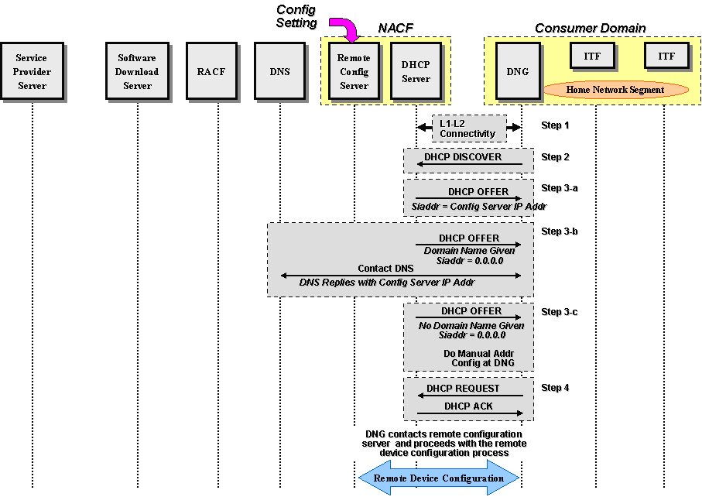
Figure 7-2: DNG Network Attachment

Specifically, the following procedure takes place:
- The DNG establishes L1 and L2 connectivity with the network. The specific steps depend on the type of the access network (DSL, PON, HFC Wireless) and are beyond the scope of this document.
- The DNG issues a DHCP DISCOVER message toward the network that must include all the mandatory DHCP options, per RFC 2131.
If the DNG device were to support the Container option, it would request it in option 55 (parameter request list). This would be performed in step 2 in the figure above.
- The network provider DHCP server replies to the DNG with a DHCP OFFER message that must include all the DHCP mandatory options, per RFC 2131. The DHCP server must provide the following information to the DNG:
  - DNG WAN IP address
  - DNG network mask
  - DNS Server IP address(es)
  - the Container option requested in step 2 above, if configured, to convey other options to the TD.
  - the remote configuration server addressing information (see possibilities below), if configured.
There are three possibilities related to the siaddr at this point, reflected in the content of the DHCP OFFER message:
      - If the DHCP server is provisioned with the remote configuration server IP address, then it must include it in the siaddr field of the OFFER message. This is shown as step 3-a in the figure above.
      - If the DHCP server is provisioned with the remote configuration server domain name but not its IP address, then it must set siaddr = 0.0.0.0 and provide the remote configuration server domain name to the DNG. The DNG must interact with the DNS to resolve the remote configuration server IP address. This is shown as step 3-b in the figure above,
      - If the DHCP server is not provisioned with the remote configuration server addressing information (IP address or domain name) and therefore does not provide the remote configuration server IP address or its domain name, then there must be a mechanism in place to allow the end user to manually configure the DNG. This is shown as step 3-c in the figure above.
4) The DHCP protocol sequence completes with the standard DHCP REQUEST and DHCP ACK messages.
After acquiring the IP address of the remote configuration server, the DNG interacts with the remote configuration server to acquire needed configuration parameters.
IPTV Terminal Device (TD)
The term ‘Network Attachment’ refers to the activities associated with the TD establishing Layer-3 connectivity to an IP-network and potentially obtaining additional network configuration data.
During the network attachment phase the following information may be obtained or otherwise established by the TD:
- IPv4 address, network mask, default route
- DNS, local network domain name, SIP proxies, others…
Once network attachment activities have been completed, the TD will be capable of transmitting and receiving IP packets and establishing a management session with a remote configuration server. Among existing mechanisms for implementing the Network Attachment function and relevant are:
- the Dynamic Host Configuration Protocol (DHCP)
- NGN NACF
The profiles and the details for each of the mechanisms as applicable for various IPTV use cases are described in the following sections.

DHCP
There are two cases to consider. The first case is when the DNG supports DHCP server capability and thus acts as the network DHCP server for the TDs on the home network. The second case is when the DNG passes DHCP messages through as a DHCP relay agent.
Note that while the second case can still be found in today’s deployments, home networks are moving towards self-contained IP domains, with the network DHCP server located in the DNG.
Local DHCP Server on the DNG
In this case it is assumed that the DNG has already attached to the network and acquired its L3 networking information. The following sequence takes place when an TD device is powered up or initialized:
- The TD establishes L1 and L2 connectivity with the DNG across the home network, which could be over a copper network, a coaxial network, fiber/plastic network, or wireless network.
- The TD issues a DHCP DISCOVER message toward the DNG that must include all the mandatory DHCP options, per RFC 2131. The TD must include option 60 to allow it to identify itself to the DNG. If the TD were to support the option(s) carried in the Container option, it would request those options in option 55 (parameter request list).
- The DNG, as a DHCP server, replies to the TD with a DHCP OFFER message that must include all the DHCP mandatory options, per RFC 2131. The DNG must provide the following information to the TD:
  - TD device local IP address
  - TD device local network mask
  - DNS Server IP address(es)
  - The remote configuration server IP address (same as the one assigned to the DNG).
  - Default gateway IP address
  - If configured, the option(s) requested in step 2 above (carried in the Container option) to convey specific information to the ITF, such as Service Provider Discovery information.
- The TD continues the DHCP message exchange with the standard DHCP REQUEST message
- The DNG completes the DHCP message exchange with the standard DHCP ACK message
The flow is shown in Figure 7-3 below:
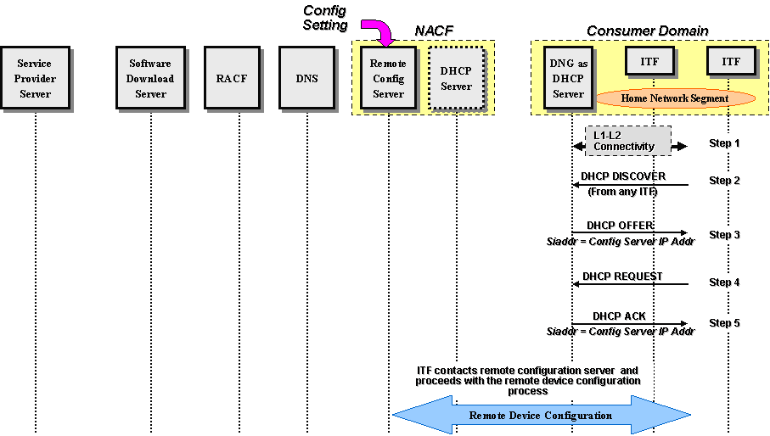
Figure 7-3: TD Network Attachment with a Local DHCP Server in the DNG

After acquiring the IP address of the remote configuration server, the TD interacts with the remote configuration server to acquire needed configuration parameters.
Remote DHCP Server across the network
In this case the DNG passes all DHCP messages transparently to the network. Figure 7-4 shows the sequence of events that take place when the TD is powered up or initialized.
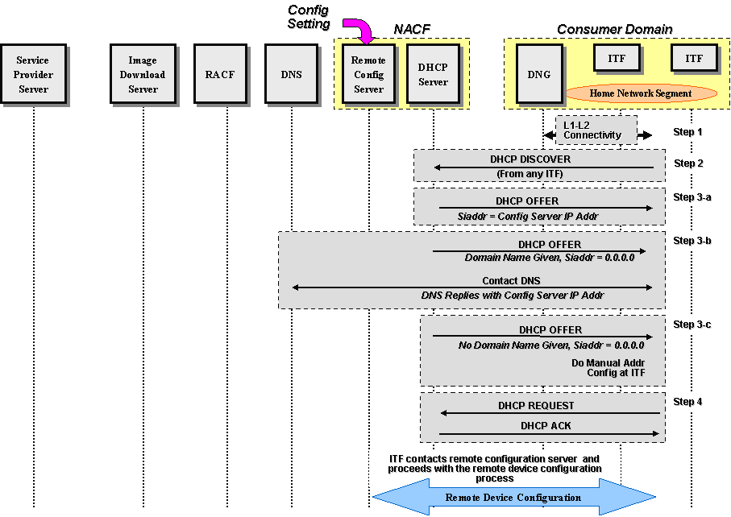
Figure 7-4: TD Network Attachment with a Remote DHCP Server

Specifically, the following takes place:
- The TD establishes L1 and L2 connectivity with the DNG across the home network, which could be a copper network, a coaxial network, fiber/plastic network, or wireless network (not shown in the figure above).
- The TD issues a DHCP DISCOVER message toward the DNG that must include all the mandatory DHCP options, per RFC 2131. The TD must also include option 60 to allow it to identify itself to the network. The DNG passes this DISCOVER message to the WAN network transparently.
- The network provider DHCP server replies to the TD with a DHCP OFFER message that must include all the DHCP mandatory options, per RFC 2131. The DHCP server must provide the following information to the TD:
    - TD IP address
    - TD network mask
    - DNS server IP address(es)
    - If available, the remote configuration server IP address
    - Default gateway IP address
The DNG must pass the DHCP OFFER message to the TD transparently.
There are three possibilities at this point reflected in the content of the DHCP OFFER message:
  - If the DHCP server is provisioned with the remote configuration server IP address, then it must include it in the siaddr field of the OFFER message. This is shown as step 3-a in the figure above.
  - If the DHCP server is provisioned with the remote configuration server domain name but not its IP address, then it must set siaddr = 0.0.0.0 and provide the remote configuration server domain name to the TD. The TD must interact with the DNS to resolve the remote configuration server IP address. This is shown as step 3-b in the figure above.
  - If the DHCP server is not provisioned with the remote configuration server addressing information (IP address or domain name) and therefore does not provide the remote configuration server IP address or its domain name, then there must be a mechanism in place to allow the end user to manually configure the TD or the TD device may obtain that information from its Service Provider. This is shown as step 3-c in the figure above.
- The DHCP protocol sequence completes with the standard DHCP REQUEST and DHCP ACK messages.
After acquiring the IP address of the remote configuration server, the TD interacts with the remote configuration server to acquire needed configuration parameters.

7.1.2.3 Service Provider Discovery
Service Provider discovery is the process by which an IPTV Terminal Device becomes aware of the available IPTV Service Providers, learns the location of their Service Discovery (SD) Servers and the means for attaching to each SD server. As a result, by contacting the discovered SD Server(s), a TD can perform the subsequent Services Discovery and Service Attachment procedures.
The Service Provider Discovery process is defined as a set of alternative procedures/cases defined below, which can be extended further.

Preconfigured or Manual
The TD may be preconfigured with the necessary information that allows its first contact with the Service Provider (SP), such as a list of SD Servers URLs or a well-known multicast stream address registered with IANA that conveys SD Servers hostname(s) associated with one or more SPs.

DHCP
In addition to acquiring its IP address from the DHCP server, in this scenario the TD can acquire its Service Provider(s) information through some DHCP option(s) as described in Appendix C.
7.1.2.4
A summary of the IPTV device Initialization and Attachment flow is represented in Figure 7-5 below.

Figure 7-5: IPTV Device Initialization and Attachment flow
Appendix A

DHCP Container Option
IPTV Service Provider(s) often needs to provide certain Service Provider (SP) domain-specific information, such as the entry point to SP Discovery process, to IPTV devices located in the consumer domain. Since the network attachment servers are homed in the Network Provider (NP) network, it is assumed that the SP(s) need to convey their associated discovery information to the NP. The NP DHCP server is configured with this information and provides it, upon request (using option 55), directly to the RG DHCP server by encapsulating it in a container, the contents of which the RG DHCP client does not process. The container option provides a mechanism through which the RG DHCP client can pass DHCP options to the RG DHCP server without explicit knowledge of the semantics of those options i.e. as an opaque container. The multiple DHCP options are sent opaquely from the SP DHCP server to the RG DHCP server (through the RG DHCP client) and then the RG DHCP server can explicitly process these options and pass them along to IPTV devices in the consumer network, upon request (using option 55). The details of the DHCP Container Option is defined in the following draft.

IETF draft, R. Droms, Container Option for Server Configuration, February 16, 2007, http://tools.ietf.org/id/draft-droms-dhc-container-opt-00.txt

More detailed flows illustrating the Container Option is included in the attached set of slides.

Since Container Option for Server Configuration mentioned above is still in draft form in IETF, it was decided not to include it in the body of this document until an official RFC number is assigned. At such time, it will be placed in the proper section in the document (DHCP-based SP Discovery).

_______________

see Appendix A for more details
see Appendix A for more details

