INTERNATIONAL TELECOMMUNICATION UNION |  |  |  | Focus Group On IPTV
TELECOMMUNICATION  STANDARDIZATION SECTOR  STUDY PERIOD 2005-2008 |  |  | FG IPTV-C-0774
 |  |  | English only
WG(s): 2 |  | 5th FG IPTV meeting:  Geneva, 23-31 July 2007
CONTRIBUTION
Source: | Digital Fountain
Title: | DVB Application Layer FEC Solution and ITU-T Y.1541 QoS Classes
ABSTRACT

This contribution discusses the use of Forward Error Correction to provide digital television services over networks compliant to the QoS requirements in ITU-T Recommendation Y.1541 (02/2006). We propose text to be added to the working document on application layer reliability solutions. In addition, the inclusion of an already agreed service requirement is proposed.

1 Introduction
ITU-T Recommendation Y.1541 (02/2006) describes a number of Quality of Service classes for IP networks. Appendix VIII of Y.1541 considers digital television transmission on IP networks and concludes that, through the use of Forward Error Correction, digital television quality requirements can be met using the new provisional QoS classes (classes 6 and 7) introduced in the 02/2006 version of the document.
This contribution presents results of simulations of the new Application Layer Forward Error Correction (AL-FEC) code standardised by the Digital Video Broadcasting project and proposed in FG IPTV-C-0586 to be adopted by ITU-T FG IPTV.
These simulations show that consumer digital television quality requirements can be met using the original “real-time” QoS classes in Y.1541 – Class 0 and Class 1 – with modest FEC overhead, not exceeding the FEC overhead as proposed in Table VIII.2/Y.1541 of Y.1541 for a different FEC code.
The living list on Application layer reliability solutions for IPTV provisionally endorses the DVB-IP AL-FEC solution. It also requests that the relation of the AL-FEC solution to the QoS classes in Y.1541 [ITU-Y.1541] shall be clarified, and especially recommended parameters settings for different QoS classes and different services is should be defined.

2 Applying AL-FEC to IPTV
The DVB AL-FEC code is a block erasure code, meaning that it applies erasure protection to blocks of packets of the original stream. The size of these blocks is one of the parameters of the code, usually expressed in terms of the “protection period” which is the interval of time taken to send the packets of a block.
For each block, the AL-FEC code provides a number of additional “repair” packets that can then be sent immediately after the original packets of the block (the “source” packets). The number of repair packets sent for each block is another parameter of the code, usually expressed as the “FEC overhead” – the ratio of repair packets to source packets.
The DVB-IP AL-FEC code used with suitable parameters has the property that if the total number of packets received for a block is one greater than the original number of source packets, then with high probability the block can be recovered. This remains true whatever mix of source and repair packets are received – i.e. whatever the pattern of loss.
There is a trade-off between these two parameters of the code, protection period and FEC overhead: in general if the protection period is increased then the FEC overhead required will decrease and vice versa, all other factors remaining equal.
The ‘other factors’ are the packet loss rate and pattern and the quality target. In order for the question of the ‘required FEC overhead’ to make sense, it is necessary to answer “required for what?” i.e. to define a quality target that the FEC must allow us to meet. Usually this is defined in terms of the mean time between visible artifacts (MTBA) in the video playout. Both DVB and the ATIS IIF have used a quality target of 4 hours MTBA for FEC discussions, roughly corresponding to the traditional DVB requirement of a maximum of one visible artifact per hour.

3 Additional latency due to FEC
The use of FEC adds latency to the data stream, because the receiver must wait until the end of each FEC block in order to perform decoding. Even if the first block does not require decoding, then it must still wait, otherwise there will not be time for decoding when it is needed for some later block. In the absence of other techniques, this latency therefore adds to the random access or channel change time.
Generally, a service provider will decide on an acceptable latency budget, and the largest FEC protection period that is consistent with this budget and supported by the FEC code will be chosen. It is therefore interesting to consider a wide range of protection periods, as this provides Service Providers with a wide choice of trade-off points. This feature was already recognized within ITU-T FG IPTV WG2 and an appropriate requirement was drafted. However, this requirement was not yet included into the IPTV Service Requirements document.
Another factor is that there are also many other things which contribute to channel change time, for example IGMP latency, the need to wait for an IDR frame, RTP buffering, video decoding buffer etc. These factors have already led to the development of a number of channel change acceleration techniques. A good survey is available in [isma-fcc] and some of the techniques described there are already deployed. These techniques can be used to mitigate the additional delay caused by the use of FEC, making it practical to consider relatively long protection periods without significantly impacting channel change time.

4 Packet loss models
Y.1541 QoS classes 0 and 1 specify an upper bound on the packet loss rate of 10⁻³, but do not specify packet loss patterns down to the granularity of relevance for an Forward Error Correction code. Forward Error Correction requirements may be affected by loss patterns at the granularity of a protection period, which might range from tens to hundreds of milliseconds. On the other hand, Y.1541 discusses measurement periods of 1 minute and reports the average loss across such a period, but does not detail the loss patterns within such a period. Thus, the Y.1541 measurement period can be considered too long in this context, consisting as it does of potentially hundreds of independent FEC protection periods, and modeling the average loss down to the granularity of an FEC protection period is needed to model the value of the FEC protection.
In order to present an idea of FEC performance with different loss patterns, we consider two packet loss models: an independent random loss model and a short burst loss model.
The independent random loss model assumes that each packet is lost with independent probability of 10⁻³. Although in practice IP packet losses are not independent, this channel provides some kind of baseline from which other cases can be assessed.
The short burst loss model considers burst outages of fixed duration, occurring at independent random intervals (Poisson distribution). This is intended to simulate a DSL access line subject to electrical impulse noise. In this case each impulse causes an outage equal in length to the DSL interleaving depth, which we take to be 8ms in this paper.
Y.1541 also specifies limits on the IP Packet Transfer Delay (IPTD) and the IP Packet Delay Variation (IPDV). For a streaming service such as IPTV the absolute IP Transfer delay is only important insofar as it affects channel change time and so need not be considered further here.
The IPDV may affect performance if it results in packets arriving too late to be rendered to the user. The use of FEC mitigates this problem, since as long as each packet arrives before the appointed time to decode its FEC block there will be no problem. Packets at the beginning of a block could arrive extremely late and still arrive in time. On the other hand if packets at the end of the block arrive too late then cannot be used, but these packets may be considered lost and recovered by the FEC.
Analysing the effective IPDV that can be tolerated for a given protection period is not straightforward, but for Classes 0 and 1 in Y.1541 the requirement of 50ms means that there would not be problems with the protection periods considered here.
It should be noted that with the addition of modest IPDV requirements, then Y.1541 Classes 2 and 3 would also be suitable for IPTV applications.

5 Simulation results
Results are presented in Figures 1 and 2 for Standard Definition (2.1Mbit/s) and Figures 3 and 4 for High Definition (9.4Mbit/s) video streams. The streams are assumed to be CBR MPEG-2 Transport Streams encapsulated within RTP packets with 7 MPEG-2 TS packets per RTP packet.
Each figure plots the required FEC overhead (y-axis) against the additional latency due to FEC (x-axis). The trade-off between FEC overhead and additional latency can easily be seen.
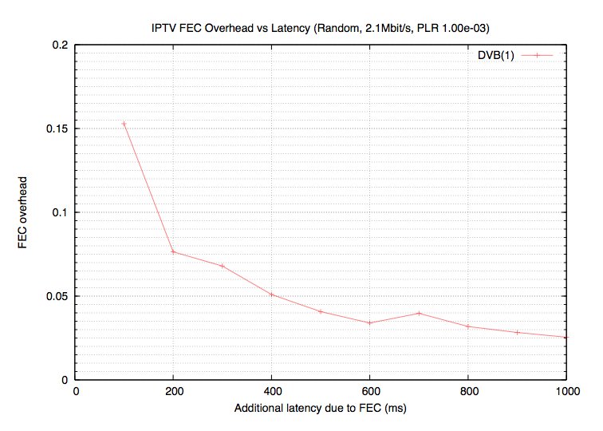
Figure 1: FEC overhead vs latency for Standard Definition stream with random packet loss
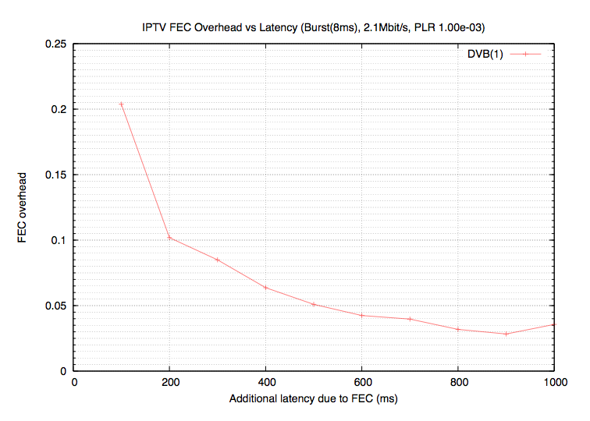
Figure 2: FEC overhead vs latency for Standard Definition stream with short burst packet loss
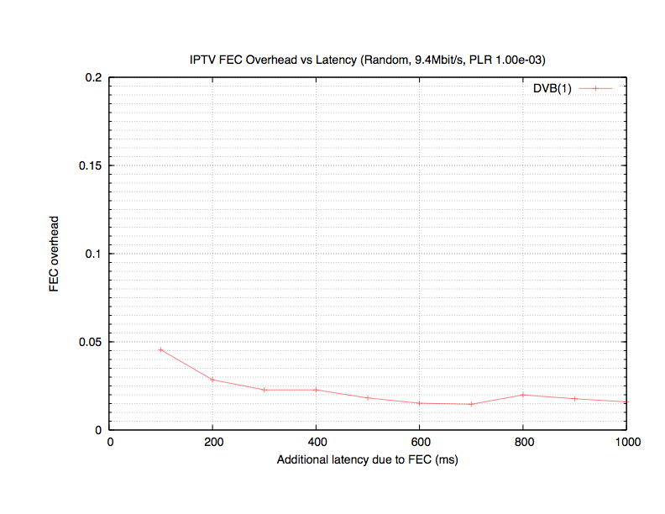
Figure 3: FEC overhead vs latency for High Definition stream with random packet loss
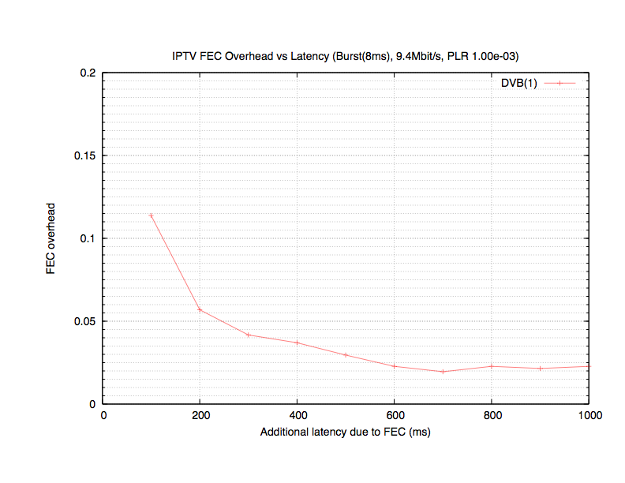
Figure 4: FEC overhead vs latency for High Definition stream with short burst packet loss

6 Conclusion
In this paper we considered the application of the DVB AL-FEC code for IPTV to video streams over networks conforming to Y.1541 QoS classes 0 and 1.
The results in Section 5 show that with modest additional delay and modest FEC overhead, a consumer television quality targets of a mean time between visible artifacts of 4 hours can be achieved using the standard Y.1541 QoS Classes 0 and 1. The availability of solutions, which allow trading channel switching times and efficiency, has also been shown. Therefore, what follows is text proposed to be added to ITU-T FG IPTV WDs.

7 Proposed Modifications to WD on Application Layer Reliability Solutions
It is proposed to add the following subsection to the working document on application layer reliability solutions.
<BEGIN ADDITION TO WD ON APPLICATION LAYER RELIABILITY>

9.3 Relation of solutions to the QoS classes in Y.1541

9.3.1 Overview
ITU-T Recommendation Y.1541 [ITU-T Y.1541] describes a number of QoS classes for IP networks. Specifically, Table 1/Y.1541 defines six IP network QoS classes and the respective network performance objectives. In addition, Table 3/Y.1541 proposes two additional provisional QoS classes mainly for the purpose to support sufficient QoS for digital television transmission. The difference to those in Table 1 is that these values need not to be met by networks until they are revised (up or down) based on operational experience.
Appendix VIII of Y.1541 considers digital television transmission on IP networks and concludes that, by the use of a specific application layer reliability solution digital television quality requirements can be met using the new provisional QoS classes (classes 6 and 7) introduced in the 02/2006 version of the document.
However, as stated in the document additional experience on application layer reliability solutions may allow revising the considerations on QoS classes 6 and 7. Application layer reliability solutions being considered in the ITU-T IPTV architecture are related to the QoS classes in Y.1541 and appropriate parameter settings should be applied.
For this relation, suitable performance metrics shall be applied. Table VIII.1/Y.1541 proposes some loss/error considerations. DVB and the ATIS IIF [ATIS-0800005] propose to measure the performance of solutions in terms of the mean time between visible artifacts (MTBA) in the video playout. Both have used a quality target of 4 hours MTBA, which also fits into the loss ratio recommendations of Table VIII.1/Y.1541.
Y.1541 QoS classes specify an upper bound on the packet loss ratio (Class 0-4: 10⁻³, provisional classes 6 and 7: 10⁻⁵), but do not specify packet loss patterns. However, suitable parameter settings to meet the requirements may be affected not only by the loss rate, but also by loss patterns. In order to present application layer reliability performance with different loss patterns, different packet loss models may be considered, e.g. independent random loss model or burst loss models.
Y.1541 also specifies limits on the IP Packet Transfer Delay (IPTD), IP Packet Delay Variation (IPDV), and IP Packet Error Rate (IPER). The effect of these parameters in relation to the application layer solution is also of interest.
The performance and parameter settings for a certain solution may also depend on the service bit rate. This effect should also be considered when relating solutions to QoS classes.

9.3.2 DVB-IPI AL-FEC solution

9.3.2.1 Parameters
The DVB AL-FEC code [ETSI TS102034, Annex E] is a block erasure code, meaning that it applies erasure protection to blocks of packets of the original stream. The code is basically fully determined by two parameters:
- The size of each of these blocks is usually expressed in terms of the protection period, which is the interval of time taken to send the packets of a block.
- For each block, the AL-FEC code provides a number of additional “repair” packets that can then be sent immediately after the original packets of the block (the “source” packets). The number of repair packets sent for each block is another parameter of the code, usually expressed as the FEC overhead – the ratio of repair packets to source packets.
There is a trade-off between these two parameters of the code, protection period and FEC overhead: in general if the protection period is increased then the FEC overhead required will decrease and vice versa, all other factors remaining equal. The ‘other factors’ are the packet loss rate and pattern and the quality target. This feature allows service operators to trade efficiency vs. channel switching times as recommended in requirement IPTV_QoS_0xx.
Note that the channel switching times correlate to the latency added by the AL-FEC. However, there are also many other things which contribute to channel change time, for example IGMP latency, the need to wait for an IDR frame, RTP buffering, video decoding buffer etc. These factors have already led to the development of a number of channel change acceleration techniques. A good survey is available in [isma-fcc] and some of the techniques described there are already deployed. These techniques can be used to mitigate the additional delay caused by the use of FEC, making it practical to consider relatively long protection periods without significantly impacting channel change time.

9.3.2.2 Relation to Network Performance Parameters
By some representative investigations, the AL-FEC solution is related to the different network parameters.
For the IPLR two models are considered:
- An independent random loss model assumes that each packet is lost with independent probability. Although in practice IP packet losses are not independent, this channel provides some kind of baseline from which other cases can be assessed.
- A short burst loss model considers burst outages of fixed duration, occurring at independent random intervals (Poisson distribution). This is intended to simulate a DSL access line subject to electrical impulse noise. In this case each impulse causes an outage equal in length to the DSL inter-leaving depth, which we take to be 8ms.
For a streaming service such as IPTV the absolute IPTD is only important insofar as it affects channel change time and so need not be considered further here for the simulations. The IPTD is additive to the latency introduced by the AL-FEC solution.
The IPDV may affect performance if it results in packets arriving too late to be rendered to the user. The use of FEC mitigates this problem, since as long as each packet arrives before the appointed time to decode its FEC block there will be no problem. Packets at the beginning of a block could arrive extremely late and still arrive in time. On the other hand if packets at the end of the block arrive too late then cannot be used, but these packets may be considered lost and recovered by the FEC.
In general, as long as the IPDV is in the range of the protection period, or the protection period is greater than the IPDV as defined in Y.1541, then for QoS classes 0-4 the IPDV does not have any influence on the performance. Therefore, for QoS classes 0 and 1 and protection periods of at least 50ms, the IPDV does not influence the performance. Furthermore, it should be noted that with the addition of modest IPDV requirements, then Y.1541 Classes 2-4 would also be suitable for IPTV applications, especially if the protection period is relaxed.
It is expected that erroneous packets are detected by the UDP checksum and therefore are converted to packet losses. As the IPER for QoS classes 0-4 is a magnitude less than the IPLR, this effect is negligible.

9.3.2.3 Recommended Parameter Settings
The recommended parameter settings for the DVB-AL-FEC solution for QoS classes 0-4 are provided in the following. The influence of IPTD, IPDV, and IPER has been discussed in clause 9.3.2.2. Therefore, the benchmarking and recommended parameter setting are provided for IPLR of 10⁻³ for two channel models, namely independent random packet losses (random) and the short burst model (burst) with 8ms independent burst losses.
Results are obtained for Standard Definition (2.1Mbit/s) and High Definition (9.4Mbit/s) video streams. The streams are assumed to be CBR MPEG-2 Transport Streams encapsulated within RTP packets with 7 MPEG-2 TS packets per RTP packet to achieve a MTBA of at least 4 hours. Table 1 shows the required overhead for different bit rates, different channel models at IPLR 10⁻³, and different protection periods.
Table 1 Required Overhead for DVB-IP AL-FEC for different bit rates, different channel models at IPLR 10e-3, and different protection periods.
Protection Period | Random,  2.1 MBit/s | Random,  9.4 MBit/s | Burst,  2.1 MBit/s | Burst,  9.4 MBit/s
100 ms | 16% | 5% | 20% | 12%
200 ms | 8% | 3.5% | 10% | 6%
400 ms | 5% | 3% | 7% | 4%
600 ms | 4% | 2% | 4% | 2.5%
800 ms | 3.5% | 2% | 4% | 2.5%
1000 ms | 3% | 2% | 4% | 2%
The results show that with modest additional delay and low to modest FEC overhead, a consumer television quality targets of a MTBA of 4 hours can be achieved using the standard Y.1541 QoS Classes 0 and 1. The provisional QoS classes 6 and 7 are not required by the use of the DVB-IP AL-FEC solution. Note that in all cases the enhanced decoder according to [DVB 086, Annex E] section E.5.1.2, was applied as the minimum decoder could not fulfil the service requirements.
In addition, note that if the FEC source block structure is chosen with proper alignment, for example with the random access points of the video stream, then the FEC latency can be absorbed into the video decoding buffer latency. This would mean that the protection period is in general not additive to the end-2-end latency, but generally lower. With encoding parameters and alignment strategies, even no difference in the latency may be observed when FEC is used and when it is not.

10 Conclusions
…
In the case that a network cannot fulfil the requested IPTV service requirements, e.g MTBA of at least 4 hours for IPTV LMB services, the use of the DVB-IPI AL-FEC solution [Annex E, DVB-086] is endorsed as the ITU-T AL-FEC solution.
- …
- The relation of the AL-FEC solution to the QoS classes in Y.1541 [ITU-Y.1541], especially recommended parameters settings for different QoS classes and different services is discussed in section 9.3.2, specifically in Table 1. Consumer television quality can be achieved using the standard Y.1541 QoS Classes 0 and 1 together with the DVB-IPI AL-FEC solution, low to modest overhead and the enhanced decoder according to [Annex E, DVB-086], section E.5.1.2.
<END ADDITION TO WD ON APPLICATION LAYER RELIABILITY>

8 Proposed New Service Requirement
It is proposed to add the WG2 agreed service requirement to the Working Document on IPTV Service Requirements:
<START ADDITION TO WD ON IPTV SERVICE REQUIREMENTS>
IPTV_QoS_0xx: The IPTV architecture is recommended to support reliability solutions which allow the service operator to trade efficiency vs. channel switching times and/or latency.
<END ADDITION TO WD IPTV SERVICE REQUIREMENTS>

References
[isma-fcc] “Fast channel changing in RTP” Internet Streaming Media Alliance http://www.isma.tv/technology/TD00096-fast-rtp.pdf

_______________

Note that in some cases the FEC overhead increases slightly with a slightly larger latency budget. This is due to the quantisation of the FEC overhead in units of one repair packet: the increase in overhead occurs at the block size at which the previous number, n, of repair packets per block is no longer sufficient and n+1 packets are required instead. In fact the MTBA with the larger overhead at the larger latency budget will be much higher than the previous, lower-overhead point, but this is not visible in these plots.

