INTERNATIONAL TELECOMMUNICATION UNION |  |  |  | Focus Group On IPTV
TELECOMMUNICATION  STANDARDIZATION SECTOR  STUDY PERIOD 2005-2008 |  |  | FG IPTV-C-0804
 |  |  | Original: English
WG(s): 2 |  | 5th FG IPTV meeting:  Geneva, 23-31 July 2007
CONTRIBUTION
Source: | Korea (Republic of)
Title: | Proposal on Section 6.3 Multicast in FG IPTV-DOC-0087
At the previous FG IPTV meetings, necessity of discussion for Multicast was raised. (Working Document of WG2, Traffic management for support of IPTV[3])
This document proposes the available multicast replication points to control the congestion of IPTV multicast traffic.

-------------------

1. Introduction
Multicast replication is one of the essential components to allow more efficient bandwidth utilization and efficient delivery of IPTV broadcast services. We can control congestion of IPTV multicast traffic through proper multicast replication depending on network environments.
Therefore, multicast congestion control through proper allocation of multicast replication points should be added in section 6.3 Multicast of FGIPTV-DOC-0087[3].

This contribution proposes the available multicast replication points to control congestion of IPTV multicast traffic.

2. Multicast in the working document, FGIPTV-DOC-0087(Traffic management for the support of IPTV services)

The current working document describes “multicast” as following.

“6.3 Multicast
IPTV network supports transportation of multicast traffic and multicast admission control policy for QoS of IPTV services. The multicast admission control system based on users’ admission control polity allocates, reserves resource and controls IPTV multicast transportation for subscribers. The multicast replication function forwards the IPTV multicast stream to subscribers according to their successful resources allocation in the network control system. So quality of service for IPTV multicast services will be able to be guaranteed by multicast admission.”
It requires additional description in detail on multicast replication function because this function is crucial for congestion control and QoS guarantee of multicasting traffic.

3. Multicast replication point
Multicast replication is one of the essential components to allow more efficient bandwidth utilization and efficient delivery of IPTV broadcast services. And the applicable multicast replication can control congestion of IPTV multicast traffic.
Though network elements may differ depending on the network topology and service subscription rates, etc., network elements including Broadband Access server, Access Router and L2 equipment can perform multicast replication as shown in Figure 1.

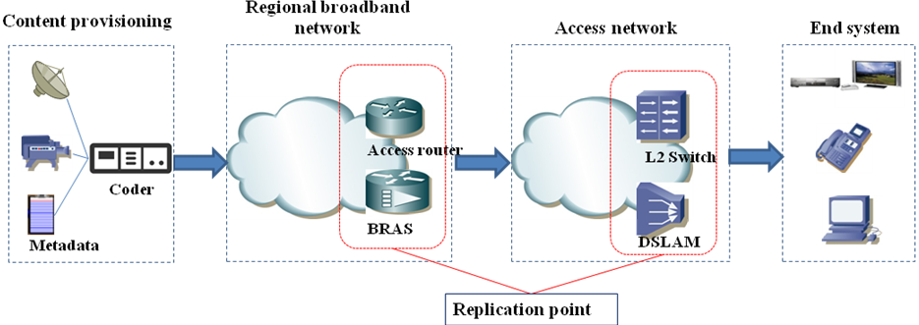
Figure1. Multicast replication points in the IPTV network.

The multicast replication point (RP) refers to the network node responsible for replicating video streams for users. It can be the Broadband Access Server (BAS)/Access Router (AR) or L2 equipment such as the Local Area Network (LAN) switch and Digital Subscriber Line Access Module (DSLAM). The network device serving as a RP replicates the multicast stream according to the request of Internet Group Management Protocol (IGMP). The equipment serving as the multicast RP is required to have good functionality and processing capability. The nearer the multicast replication points approach to users, the less bandwidth the network needs, while the management becomes more complex.
When selected as the multicast RP, the BAS/AR implements the user-oriented replication without requiring the access network to support multicast. This solution supports the simple in management. On the other hand, the BAS/AR poses higher bandwidth requirement for the access network. Moreover, the BAS/AR demands more on its port density and processing capability.
If L2 equipment nearest to the user (such as DSLAM or LAN switch) is selected as the multicast replication point, the bandwidth of the access network can be saved at the most. This solution supports distributed replication, so it has a relatively weak requirement for processing capability at the replication point. Hence, it is applicable for large-scale service deployment. However, the access network must support multicast, and the terminal equipment is required to support IGMP snooping. And also this solution had the complexity in management.
Therefore, when select the replication point, we should consider the condition of network environment and available subscribers to support IPTV services. Applicable replication points can support the efficient bandwidth utilization and efficient delivery of IPTV broadcast services. QoS for IPTV multicast services is able to be guaranteed by multicast congestion control through the proper selection of multicast replication point.

4. Proposal
We propose that section 3 in this contribution should be added to section 6.3 Multicast in the output document FGIPTV-DOC-0087[3].

Reference
[1] ITU-T FG IPTV Output Document FGIPTV-DOC-0092, IPTV Multicast Frameworks, May 2007
[2] DSL Forum, IPTV architecture overview, Sven Ooghe, April 2006
[3] ITU-T FG IPTV Output Document FGIPTV-DOC-0087, Traffic Management for support of IPTV services, May 2007
[4] DSL Forum Technical report TR-0592, Architecture requirements for the support of QoS Enabled IP services

____________

