This document proposes to attach QoE requirements for VoD trick mode in the working document No. 86, QoE Requirements for IPTV.
INTERNATIONAL TELECOMMUNICATION UNION |  |  |  | Focus Group On IPTV
TELECOMMUNICATION  STANDARDIZATION SECTOR  STUDY PERIOD 2005-2008 |  |  | FG IPTV-C-0809
 |  |  | Original: English
WG(s): 2 |  | 5th FG IPTV meeting:  Geneva, 23-31 July 2007
CONTRIBUTION
Source: | Korea (Republic of)
Title: | Consideration on QoE requirements for VoD trick mode in IPTV service

- Introduction
Video on Demand (VOD) is a service in which the subscriber can view a video content whenever desired. The operating assumption is that the content is stored in the provider’s VoD server. Subscriber accesses the movie from a library directory which may include a search engine that accesses movie description and rating. Subscribers typically have the ability to pause, play, rewind, fast forward the content, or even stop viewing it and return to it at a later time when using this service [1].
In this prospective, despite of a channel service in IPTV, VoD is still the primary service and the delivery method. At previous FG IPTV meetings, there were several comments on VoD trick features but most of all are not still reflected in the documents.
RTSP is broadly used for VoD trick mode. However, it’s not a sole enabler of VoD trick mode. There are other options like DSM-CC (Digital Storage Media - Command & Control) and SSP (Session Setup Protocol). Therefore, the necessity of preparation of the general VoD trick procedure which covers all these protocols arises.
In the working document, QoE Requirements for IPTV, section of “Requirements for VoD trick mode” remains empty. Accordingly, control functions, their latency and requirements are required to be described and are recommended to be filled by the following materials.

- QoE Requirements for VoD Trick Mode
Video on Demand (VOD) trick mode provides VCR-like features in VoD services. When a subscriber desires a video content through STB, the subscriber accesses the video content from the EPG which supports the contents-search engine to help access of content information. To guarantee VTR-like flexibility, this mode provides the trick ability to handle pause, play, rewind, fast forward, and stop entries for this control features.
  - Control Functions
VoD trick mode has VCR-like control functions. Therefore, to give VoD trick features, STB is required to support the following control functions:
- Video selection: Control function that selects the video contents. STB acquires contents information and identifies transport mechanisms.
- Play: Control function that plays selected entered contents.
- Stop: Control function that stops the indicated current video contents.
- Rewind: Control function that rewinds the indicated video contents.
- Pause: Control function that pauses the indicated video contents.
- FFW: Control function that fast-forwards the indicated video contents.

Figure 1 shows a general procedure for VoD trick features and the latency for each control function.
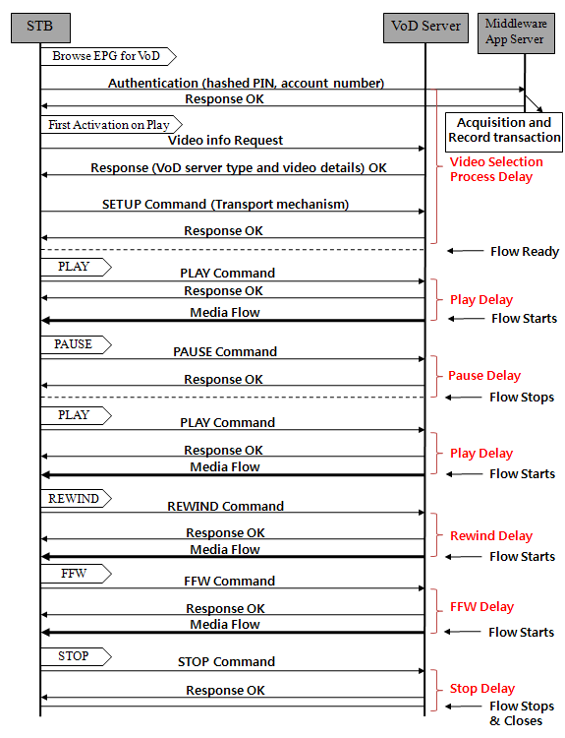
Figure 1 General Procedure for VoD Trick Features.
  - Trick Latency [1]
Correspondently, each control function (video selection, play, pause, rewind, FFW, stop) has its own delay. QoE metrics for VoD transaction quality are expressed by the following indicators:
- Video selection process delay: Timing period from the time when the subject is selected to the time when content is displayed.
- Play Delay: Timing period from the time when the Play entry was selected to the time the content is displayed.
- Stop Delay: Timing period from the time when the Stop play video entry was selected to the time the content is stopped playing as indicated by video content display.
- Rewind Delay: Timing period from the time when the Rewind video entry was selected to the time the rewind action is executed as indicated on display device.
- Pause Delay: Timing period from the time when the Pause video entry was selected to the time the pause action is executed as indicated on display device.
- FFW Delay: Timing period from the time when the Fast Forward video entry was selected to the time the FFW action is executed as indicated on display device.

  - Requirements for VoD Trick Features
In the QoE prospective, trick latency is one of the most important issues to guarantee satisfaction of subscribers. As each trick latency directly affects QoE, each latency is required to be minimized as possible to meet subscriber’s QoE for VoD trick features,

- Proposal
We propose to fill section 9.2, “Requirements for VoD trick mode” of the working document No 86. “QoE Requirements for IPTV” with following materials
  - QoE Requirements for VoD Trick Mode
Video on Demand (VOD) trick mode provides VCR-like features in VoD services. When a subscriber desires a video content through STB, the subscriber accesses the video content from the EPG which supports the contents-search engine to help access of content information. To guarantee VTR-like flexibility, this mode provides the trick ability to handle pause, play, rewind, fast forward, and stop entries for these control features.
    - Control Functions
To give VoD trick, STB/End user device should support the following control functions:
- Video selection: Control function that selects the video contents. STB acquires contents information and identifies transport mechanisms.
- Play: Control function that plays selected entered contents.
- Stop: Control function that stops the indicated current video contents.
- Rewind: Control function that rewinds the indicated video contents.
- Pause: Control function that pauses the indicated video contents.
- FFW: Control function that fast-forwards the indicated video contents.

Figure 1 shows a general procedure for VoD trick features and the latency for each control function.
Figure 1 General Procedure for VoD Trick Features.
    - Trick Latency [1]
Correspondently, each control function (video selection, play, pause, rewind, FFW, stop) has its own delay. QoE metrics for VoD transaction quality are expressed by the following indicators:
- Video selection process delay: Timing period from the time when the subject is selected to the time when content is displayed.
- Play Delay: Timing period from the time when the Play entry was selected to the time the content is displayed.
- Stop Delay: Timing period from the time when the Stop play video entry was selected to the time the content is stopped playing as indicated by video content display.
- Rewind Delay: Timing period from the time when the Rewind video entry was selected to the time the rewind action is executed as indicated on display device.
- Pause Delay: Timing period from the time when the Pause video entry was selected to the time the pause action is executed as indicated on display device.
- FFW Delay: Timing period from the time when the Fast Forward video entry was selected to the time the FFW action is executed as indicated on display device.

    - Requirements for VoD Trick Features
In the QoE prospective, trick latency is one of the most important issues to guarantee satisfaction of subscribers. As each trick latency directly affects QoE, each latency is required to be minimized as possible to meet subscriber’s QoE for VoD trick features,

* References
[1] A Framework for QoS Metrics and Measurements Supporting IPTV Services, ATIS-0800004, ATIS
[2] IPTV Services Architecture Requirements, ATIS-0800002, ATIS

___________________

