INTERNATIONAL TELECOMMUNICATION UNION |  |  |  | Focus Group On IPTV
TELECOMMUNICATION  STANDARDIZATION SECTOR  STUDY PERIOD 2005-2008 |  |  | FG IPTV-C-0823
 |  |  | English only
WG(s): 6 |  | 5th FG IPTV meeting:  Geneva, 23-31 July 2007
CONTRIBUTION
Source: | ETRI, Republic of Korea
Title: | Proposal for Retransmission of Digital Broadcasting Services over IPTV

- Introduction

This contribution introduces retransmission architecture of digital broadcasting services over IPTV, and proposes this architecture and relevant issues for consideration to be concerned by FG.
Digital broadcasting services (DBSs) means linear broadcasting services coming from terrestrial (or cable, satellite) or not prepared for IPTV services. It is sometimes necessary to retransmit DBSs over IPTV because of national regulations to play information role of the media for the public or as a business model to attract subscribers to IPTV. In addition, transparent retransmission of DBSs over IPTV is the plus side of one source multi-platform or multi-use.
DBSs can be considered as good content sources for IPTV because they provides high definition resolution video and high quality sound with rich and useful multimedia contents. However, these services are not compatible because they follow different standards such as MHP, ACAP, OCAP, and so on.
Therefore, we propose retransmission architecture and issues for consideration to provide interoperability and compatibility of DBSs over IPTV.

- Functional architecture

Figure 1 shows a functional architecture for retransmission of DBSs over IPTV. Content Provider offers a DBS as a kind of MPEG-2 transport stream packets with AV, metadata and applications. Service Provider delivers the DBS to Customer’s IPTV Client through retransmission process, and consists of 3 functional modules, namely Metadata Server, Application Server, and Video Server.

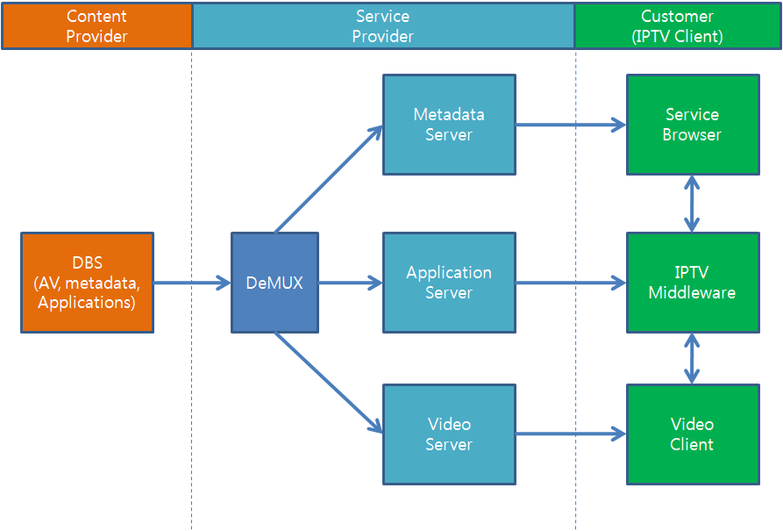
Figure 1. Functional architecture for retransmission of DBSs over IPTV

- Metadata Server:
- It should provide a mechanism to collect and manage metadata such as service information based on PSIP or DVB-SI, and application-related information from the DBS.
- It should add address information of Application Server and Video Server to metadata in order to enable Customer’s IPTV Client to download applications and video streams.
- It should provide a mechanism for transferring metadata for service discovery in IPTV Client.
- Application Server:
  - It should provide a mechanism to identify applications and extract and download them using DSM-CC object carousel.
  - It should provide an IP-based optimal protocol to deliver applications and application signaling information.
- Video Server:
  - It may function as a trans-coder that converts MPEG-2 into H.264 to save the network bandwidth.
  - It should provide an IP-based optimal streaming protocol to transfer AV streams with QoS/QoE mechanism.
Customer’s IPTV Client consists of Service Browser, IPTV Middleware, and Video Client.
- Service Browser:
  - It may function as a service navigation using metadata that enables users to find and select specific services.
  - It should obtain service information and application-related information about a selected service.
- IPTV Middleware:
  - It should be a general middleware to launch and manage the lifecycle of applications without dependency on a specific middleware.
- Video Client:
  - It should provide capability for downloading and displaying video streams.

- Retransmission issues

We summarize issues for consideration about retransmission as follows:
- Content Format
Common content format will be effective to make IPTV interoperable with broadcasting services, and is necessary for simultaneous retransmission of DBSs over IPTV. Moreover, a substantial number of service providers prepare their own services with a different format and standard. This cause incompatible service model and platform. Therefore, content format should be harmonized.
- Service Information
DBSs such as terrestrial, cable, or satellite provide service information as a kind of PSIP or DVB-SI. So it is cost-effective to re-use their information when retransmitting contents over IPTV. Therefore, it needs a standardized schema to ensure presentation and to deliver their information to IPTV terminal. In addition, monitoring mechanism to check the change of service information and to deliver updated service information should be included.
- Delivery Protocol
Traditionally, DBSs are delivered through MEPG-2 transport stream (TS), which is tightly coupled with audio, video, metadata, and applications. However, the MPEG-2 TS is not a good choice for IPTV because broadband IP networks provide bidirectional communication and a user can obtain metadata or applications from the application server or web site at any time. In addition, the DSM-CC object carousel is often used to deliver applications over MPEG-2 TS, but makes significant processing overhead of the complex tables. Therefore, it is necessary to define IP-based optimal delivery protocol to support DBSs over IPTV with some modification instead of bypassing MPEG-2 TS to IP network without modification.
- Application Model and Signalling
It is important to ensure identical presentation and interactivity for retransmitted broadcasting services over IPTV in accordance with intention of content authors including presentation timing control for the elements of the interactive applications. Application model and signalling is used to identify applications associated with a service and to manage the lifecycles of applications. Therefore, not only standardization of content format but also application model and signalling mechanism applicable to retransmission of DBSs should be considered in IPTV middleware.

- Proposal

In this contribution, we propose a functional architecture for retransmission of DBSs over IPTV. We hope that our retransmission architecture and its considerations would be concerned in chapter 11, “Retransmission and Legacy Related Issues” of WG6’s output document FG IPTV-DOC-0095.

- References

[1] FG IPTV-C-0398, “Requirements of IPTV Interactive Data Services for Retransmission of Terrestrial Data Broadcasting Service,” 3rd FG IPTV meeting, Jan. 2007.
[2] WP6M/179-E, “Consideration toward Liaison Reply to ITU-T FG-IPTV on Retransmission of Free-to-air Broadcasting Services over IPTV,” ITU-R, Apr. 2007.
[3] FG IPTV-C-0384, “Requirement for IPTV application signaling,” 3rd FG IPTV meeting, Jan. 2007.

