INTERNATIONAL TELECOMMUNICATION UNION |  |  |  | Focus Group On IPTV
TELECOMMUNICATION  STANDARDIZATION SECTOR  STUDY PERIOD 2005-2008 |  |  | FG IPTV-C-0874
 |  |  | English only
WG(s): 1 |  | 6th FG IPTV meeting:  Tokyo, Japan, 15-19 October 2007
CONTRIBUTION
Source: | Editor （ZTE Corporation）
Title: | FG IPTV-DOC-0116 Working Document: IPTV service scenarios
Abstract
(TBD)

IPTV Services, use cases, requirements and scenarios
Summary
The purpose of this working document is:
- to identify and define the IPTV services relevant for the IPTV FG activities
- to identify the different players and roles in the value chain
- to classify these IPTV services
- to specify use cases for these IPTV services
- to specify requirements for the different players involved in these IPTV services
- to specify scenarios identifying the flows between functions of players
Contributions are requested for the next meeting on:
- the identification of IPTV services, confirmation of relevance of proposed services
- the definition of these services
- The classification/grouping of all these services by criteria such as proximity, commonality, importance, relevance, priority, etc. Considering that work on use cases and scenarios will start with the most important/relevant services. We might identify a core set of services and additional services and reject some services depending on the received support.
- Use cases
- High level requirements for the different players
- Service scenarios
Keywords
TBD

Contents
1. Scope 4
2. References 4
3. Definitions 4
3.1. Terms defined elsewhere 4
3.2. Terms defined in this Document 4
4. Abbreviations and acronyms 5
5. Conventions 5
6. IPTV services description and use cases 5
6.1. Typical IPTV service 5
6.2. Broadcast services 6
6.2.1. Linear TV 6
6.2.2. Linear TV with trick mode 8
6.2.3. Pay per view 9
6.2.4. Electronic program guide (EPG) 9
6.2.5. Personal Broadcast Service 11
6.2.6. Hybrid: Online and Off-air TV Delivery 12
6.2.7. Linear TV with Multi-View service 12
6.3. On-demand service 12
6.3.1. Video on demand (VoD) 13
6.3.2. Music on demand (MoD) 13
6.3.3. Interactive games 13
6.3.4. On-demand with Multi-View service 14
6.3.5. 3rd party content delivery 14
6.4. Advertising service 15
6.4.1. Traditional advertising service 15
6.4.2. Targeted Advertising 16
6.4.3. On-demand Advertising 16
6.4.4. Interactive Advertising 17
6.4.5. Advertising message logging 17
6.5. Public interest service 17
6.5.1. Support for users with disabilities 17
6.5.2. Emergency communications 18
6.5.3. Community related information 18
6.6. Tele-services 22
6.6.1. Tele-learning 22
6.6.2. Tele-medicine 22
6.6.3. Monitoring services 22
6.7. Portal services 22
6.7.1. Data portal (walled garden, internet access, etc.) 22
6.7.2. Web-based IPTV Portal 22
6.7.3. Terrestrial portal (news, drama, sports, movies, etc.) 23
6.8. Hosting services 23
6.8.1. Business to business 23
6.8.2. User created content (UCC) hosting 24
6.8.3. CPU resource hosting 24
6.9. IPTV interactive service 24
6.9.1. Information (news, weather, transportation, local community etc.) 25
6.9.2. Commerce (banking, stock, shopping, ticketing, auction, product delivery, event, etc.) 26
6.9.3. Communication (e-mail, messenger, SMS, channel chatting, VoIP, web surfing, multiple video conference, video phone, etc.) 26
6.9.4. Entertainment (games, karaoke, photo album, lottery, blog, etc.) 27
6.9.5. Learning (infant, children, school student, languages, financial skill, etc.) 27
6.9.6. Government (notice, civil appeal, tax payment, poll, etc.) 27
6.10. Presence services 27
6.10.1. Basic Presence Service 29
6.10.2. Channel based Presence Service 29
6.10.3. Targeted Advertising based on Presence Service 29
6.11. Time-shifting service 29
6.12. Place-shifting service 30
6.13. Session mobility service 30
6.14. Supplementary content 30
6.14.1. Accessibility features 30
7. Commercial/business models of IPTV 31

IPTV Service scenarios

Scope
This working document identifies and defines IPTV services and scenarios. The IPTV services are classified and their requirements are defined. Use cases for IPTV services are also provided.

References
The following ITU-T Recommendations and other references contain provisions, which, through reference in this text, constitute provisions of this working document. At the time of publication, the editions indicated were valid. All Recommendations and other references are subject to revision; users of this working document are therefore encouraged to investigate the possibility of applying the most recent edition of the Recommendations and other references listed below. A list of the currently valid ITU-T Recommendations is regularly published.
The reference to a document within this working document does not give it, as a stand-alone document, the status of a Recommendation.
TBD

Definitions

Terms defined elsewhere
This Document uses the following terms defined elsewhere:
TBD

Terms defined in this Document
This Document defines the following terms:
3.2.1 Application provider: The application provider is the entity providing IPTV-related user interface applications.
3.2.3 Content aggregator: aggregate contents a la TV channel for example.
3.2.4 Content provider: The content provider is the entity owning contents or being licensed to sell content assets. Their role is contents production and delivery.
3.2.5 Network provider: The network provider is the entity connecting end-user and service providers with control and management for the secured delivery of contents in several layers such as core, distribution and access layer.
3.2.6 Service provider: The service provider is the entity providing a service to end-user through a procedure of receiving, manipulating, value-added processing and transmitting contents with security and management using an IPTV platform.
3.2.7 EPG: EPG is on-screen guiding to scheduled service program, scheduled interactive service program, contents and additional descriptive information based on preferring program and content information which user uses frequently. It allows a viewer to navigate, select and discover content by time, title, channel, genre, etc, by using of his remote control, a keyboard, a touchpad or even a phone keyboard.

Abbreviations and acronyms
This document uses the following abbreviations and acronyms
ECG Electronic Content Guide
EPG Electronic Program Guide
iTV Interactive TV
PPV Pay Per View
PVR Personal Video Recording
SMS Short message service
VoD Video on demand

Conventions
None

IPTV services description and use cases
[Editor’s notes: In order to have a better understanding of what is IPTV, this clause provides list of IPTV services to be considered in the activities of the ITU FG IPTV. This list is unordered. Contributions are expected on this list for clarification, support, relevance to the FG].

Typical IPTV service
This clause provides typical IPTV services to be considered in the activities of the ITU FG IPTV, which does not imply to be an exhaustive list.
[Editor’s note: Contributions are welcomed to reorganize this list to make its shape better.]
- NGN shall support diverse access transport function technologies.
[Editor’s note: It seems not be a service, contributions are welcomed to elaborate this depiction, or it will be removed next Tokyo meeting.]
- Linear TV (audio, video and data)
- Linear TV with Trick Modes
- Multi-View service
- Time-shift TV
- Pay Per View (PPV)
- Video/TV on Demand (VoD)
- Near VoD (Video on Demand) broadcasting
- Real VoD
- Download Based Video Content Distribution Services (Push VOD)
- Content download service
- PVR service (network or client-based)
- Interactive TV (iTV)
- End-user Originated content (Video, etc. and applications)
- End-user Originated broadcast TV (e.g. C2C hosting)
- Linear Broadcast Audio
- MoD (Music on Demand) including Audio book
- Pictures
[Editor’s note: Contributions are welcomed to elaborate this ‘Pictures’ service.]
- T-Learning (education for children, elementary, middle and high school student, languages and estate, etc.)
- Games
- Regulatory Information services
- T-information (news, weather, traffic and advertisement etc.)
- T-commerce (security, banking, stock, shopping, auction and ordered delivery, etc.)
- T-communication (e-mail, instant messaging, SMS, channel chatting, VoIP, Web, multiple video conference and video phone, etc.)
- T-entertainment (photo album, games, karaoke and blog, etc.)
[Editor’s note: Contributions are welcomed to make consistency of context, because T-xxx’s definition has not been gotten consensus.]
- Presence service
- Advertising
- Communications Messaging
- Service Information (EPG: Electronic Program Guide, ECG: Electronic Content Guide, etc.)
- Portal services
- Hybrid services
- 3rd party content services

Broadcast services
[Editor’s note: Contributions are welcomed to make some general depiction on Broadcast services.]

Linear TV
Editor's note: the following paragraph needs to be reworded for the sake of consistency and readability.
A key part of a typical IPTV Service is the delivery of Linear TV. This is received, from the existing broadcast transmission from a Content Provider, trans-coded and multicast by the Service Provider. The multicast streams are delivered by the Network Provider, via the Consumer’s Network to the End-user’s IPTV device.
Linear TV includes following approaches:
- Linear TV with audio and video: Linear TV with audio and video provides a picture quality similar to digital versatile disk (DVD) or higher quality display in many resolutions. Audio and video (audiovisual) signals are broadcasted and distributed to the downlink without uplink feedback in real time.
- Audio only: Audio only linear TV only delivers audio signals of sound, which has been processed like CD players from one point to another. Audio signals are broadcasted and distributed to the downlink without uplink feedback in real time.
- Linear TV with audio, video, and data: These services are A/V services which are combined with interactive data for the related or supplementary information of A/V program using bi-directional link. User can enjoy the downlink A/V stream and access more detailed or value-added information via uplink simultaneously.

Figure 6-1 shows an example of linear IPTV with PVR.
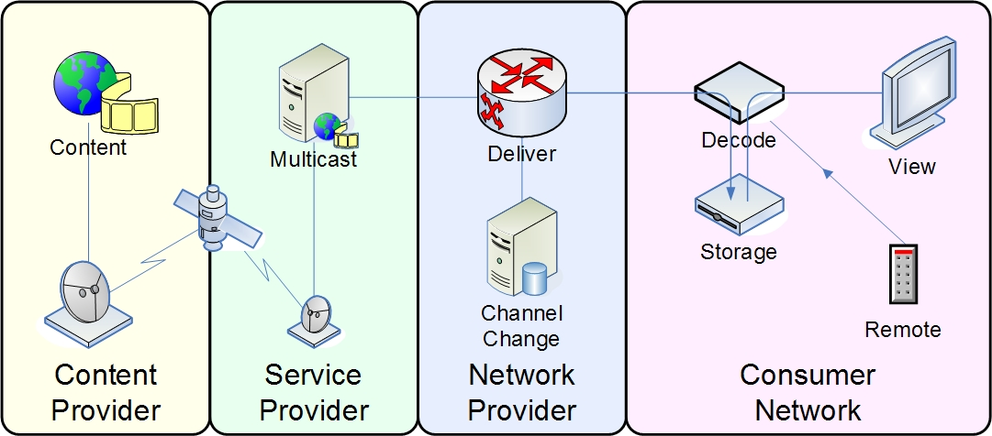
Figure 6-1: Linear IPTV with Local PVR
Editor's note: the above figure needs to be reworded and modified for the sake of consistency and readability.

Figure 6-2 shows a scenario for Channel-based service scenario for Linear TV
Editor's note: the above figure needs to be reworded and modified for the sake of consistency and readability.
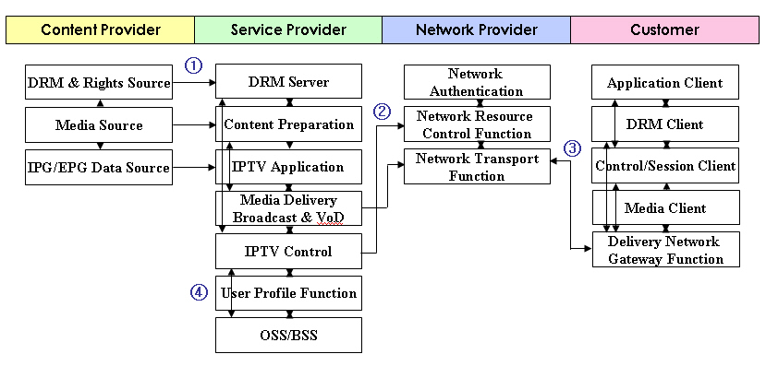
Figure 6-2: Channel-based IPTV Service Scenario for Linear TV

- Contents (video, audio, data, etc) with its IPG/EPG and DRM metadata that are produced and managed by Contents Provider are provided (delivered) to the Service Provider’s domain.
- Then Service Provider prepares for the contents to be broadcasted through IP and controls program schedule and its distribution. This procedure includes contents encoding, scrambling, muxing with security and service control (e.g., channel scheduling). After all these procedures, the scheduled channel information is provided to the IPTV end-users and the contents are ready for being broadcasted (or multicasted) through IP network.
- When a end-user triggers or selects the channel service following the channel information, the Delivery Network Gateway Function connects to the broadcast/multicast server through the IPTV Control/Session Client. This procedure may include multicast join or leave, service level negotiation for QoS. After the network and service authentication and authorization is succeeded, end-user’s Delivery Network Gateway Function receives the channel stream and then the stream is processed by Media Client and DRM Client for displays.
- All these procedures are monitored, supported, charged and analyzed by the Operational Support Systems, OSS, and Business Support Systems, BSS for successful operation and service management.

Linear TV with trick mode
- Linear TV with Trick Modes allows end-user to pause live TV, instant replay of interesting scenes, and skip advertising through PVR or DVR system.
- PVR service (network or client-based)
The Personal Video Recorder service is consumer based electronic device service that records live program to the hard drive digital storage in standalone set-top boxes or network. This can provide the “time shifting”, “trick modes”, and complementary convenience functions such as recording onto DVDs, commercial skip, sharing of recordings over the Internet, programming and remote control by PDA, networked PC, or web browser.
Additionally, based on the Linear TV service procedure, the service scenario for Linear TV with trick mode with or without storages on the end-user’s device (which is called as PVR, DVR, and Time-shifted) is as follows:.
Figure 6-3 shows a scenario for Channel-based IPTV Service Scenario for Linear TV with trick mode with or without storages:

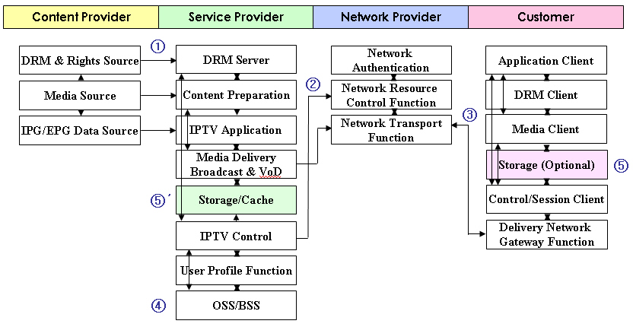
Figure 6-3: Channel-based IPTV Service Scenario for Linear TV with trick mode with or without storages

- ~ ④ The same as the Linear TV service procedure above.
- When the end-user’s IPTV terminal has its own storage and requests the trick mode service (PVR, DVR, Time-shifted), the terminal records the program contents in its storage with certain level of security. Then, the stored program contents are displayed. In this time, trick mode, forwarding, rewinding, pause, stop function are possible.
⑤' When the end-user requests the trick mode service (PVR, DVR, Time-shifted) without having their own storage in its IPTV terminal, the Service Provider records the programmed contents in the Storage/Cache. Then, the stored contents are displayed as end-user orders. In this time, trick mode, forwarding, rewinding, pause, stop function are possible.

Pay per view
Pay per view is a streaming service that end-users can purchase events or program to be seen on TV and pay for the choice of that events or program later. The user can buy the PPV service via on-screen guide, a telephone, or through a live end-user service representative and see the events or program at any time within the expiration date.
- OPPV (Order-ahead PPV): The ability to order PPV programming ahead of time.
- IPPV (Impulsive PPV): The ability to order PPV programming impulsively.

Electronic program guide (EPG)
[Editor’s note: contributions to elaborate the relationship between broadcast and EPG are welcomed, or this section will be moved out side of clause 6.2 in next Tokyo meeting. ]
Electronic program guide (EPG) is sometimes also known as an IMG (Internet Media Guide), IPG (Interactive Program Guide), or BCG (Broadband Contents Guide) in an equivalent meaning on-screen guide to scheduled service program, contents and additional descriptive information, allowing a viewer to navigate, select and discover content by time, title, channel, genre, etc, by using of his remote control, a keyboard, a touchpad or even a phone keypad. Generally, EPG can be displayed in several types such as Mosaic EPG, Box EPG, Text EPG, Mini EPG, Tree EPG and so forth in according to the service provider’s business model.
Figure 6-4 shows a scenario of EPG
Content Provider
Service Provider
Network Provider
User

IPTV Application
Application Client
2, 5
4, 8

1
7
9
Content Preparation
Content & Data Source
6
Application Profile Function
3
Service User Profile Function

IPTV Service Control Function or Core IMS

9
Control Client or Session Client

Figure 6-4: EPG service scenario

- Content provider provides the service provider with the contents.
- User turns on the user terminal.
- IPTV Application retrieves the available service list for the user from the service user profile
- IPTV Application delivers the usable service list to user terminal.
- User selects one of the available services like a broadcast service, an on-demand service, etc. Moreover, the user can search for the wanting programs and contents directly using the condition like genre, channel, etc. In case of the search service, 5, 7, 8 phases are repeated until the user finds the wanting programs and contents.
- IPTV Application must provide the user with the detailed information (EPG) for the selected service. In order to do it, first, IPTV Application retrieves the preferring program and content information (i.e., genre, channel, etc) through Application Profile Function. The preferring program and content information is the history of the program and content which the user uses frequently.
- IPTV Application retrieves the content metadata through the content preparation based on the preferring program and content information of the user or the search condition of the user.
- IPTV Application makes the EPG screen included the scheduled service program and content lists using the retrieved preferring program and content information or the search condition as well as the retrieved content metadata. And then it delivers the EPG screen to user terminal.
- User selects one of the scheduled service programs and contents on the EPG screen received from IPTV Application. After the user selects the scheduled service program and contents, the handling of the selected service program and contents is done by the IPTV Service Control Function or Core IMS through the request of the control client or the session control on the IPTV architecture.

Personal Broadcast Service
Personal IPTV broadcast service provides end-user with a way to advertise personal broadcast schedule and content description so that other end-users can find this information in the same way as other IPTV services. This service allows end-user to find and enjoy another end-user’s content, and makes IPTV end-user also be a content provider. Different from channel service, content is delivered from end-user to end-user. Service provider is just responsible for relaying session between broadcasting end-user and receiving end-users.

Figure 6-5: Use case of Personal Broadcast Service
- Metadata Registration: Content providing end-user prepares information about content they will broadcast and registers it to metadata distribution server. This can be done by, for example, making metadata file using some authoring tools. The metadata may contain source information like client ID, content ID, and any other content-relevant information for locating it
- Streaming & Session Info: Once content providing end-user registers metadata to server, service provider would find available network resource for streaming (e.g., bandwidth, multicast address), and then give this information to content providing end-user.
- Broadcast Content: Content providing end-user send an actual broadcasting stream with multicast or multiple unicasts
- Content Search: Receiving client make a search with keyword
- Search Result: Metadata server responds to search request and provide search result as reply
- Content Selection: Receiving client may be able to select a specific content with logical source information provided by content search result. In this process, service control functions may participate in session routing or charging information gathering
- Streaming & Session Info: This message contains actual content address and session information for receiving it
- Session Join: Receiving client request content delivery function to join the session with session info (including real location)
- Receive content: Receiving client receives the content from content delivery system

Hybrid: Online and Off-air TV Delivery
An alternative approach for the delivery of Liner TV is to enable the end-users IPTV device to directly receive the broadcast signal from the Content Provider. This will then be combined with On-Demand content delivered over the network from the Network Provider.
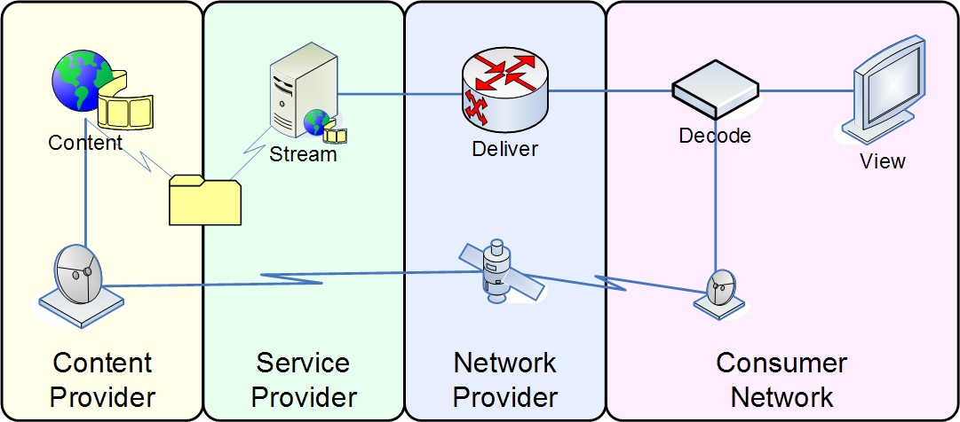
Figure 6-6: Hybrid: Online and Off-air TV Delivery
Editor's note: the above figure needs to be reworded and modified for the sake of consistency and readability.

Linear TV with Multi-View service
Linear broadcast TV with Multi-View is to provide more various different camera angles than the one station view in linear broadcast TV. The viewer can select angle which he likes to watch. For example, when the end-user watches the baseball game in linear broadcast TV, he can see the first base, third base, or backfield according to view’s wish not by the channel director’s attention.

On-demand service
The content is usually received from a content provider in the form of physical media, such as a digital video-tape. This will be stored and may be trans-coded by the service provider and made available as unicast streams. The unicast streams are delivered by the network provider, via the end-user’s network to the IPTV terminal device.

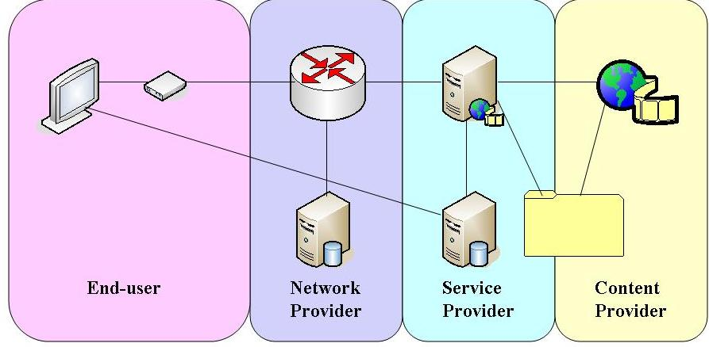

Figure 6-7: Content on Demand
[Editor’s note: Definition of Content on Demand is needed, contributions are welcomed on this point]

Video on demand (VoD)
VoD is a service where the end-user selects and watches the video content.. Depending of the transmission method, the VoD can be sub-categorized as below:
- Near VoD service is a consumer based video service which is broadcasted by multi-channel broadcasters using high-bandwidth distribution mechanisms. Multiple copies of a program are broadcast at short time intervals (typically 10–20 minutes) providing convenience for viewers, who can watch the program without needing to tune in at a scheduled point in time. The end-user has no control over the session except in choosing which program to watch.
- Real VoD service allows end-users to select and watch video content over a network as part of an interactive and enhanced selective service. Real VoD service is “stream” content service that is consumed while it is being delivered. The end-user has control over choosing which program or clips to watch.
- Push VoD (Which is a kind of download based video content distribution services) service is similar to the Real VoD in that end-users can select and watch video content over a network as part of an interactive and enhanced selective service. However, Push VoD is “download” content service that is brought in it entirely or partially to a set-top box or similar device before viewing starts.

Music on demand (MoD)
Music on demand (MoD) service allows the end-user to select music or audio contents such as music file, music video and audio book over an IP network as an interactive enhanced selective service like the Real VoD.

Interactive games
The service of interactive games allows user to select computer or video games over an IP network as an interactive enhanced selective service. Interactive games encompass interactive video games on television involving single and multiplayer competitions.

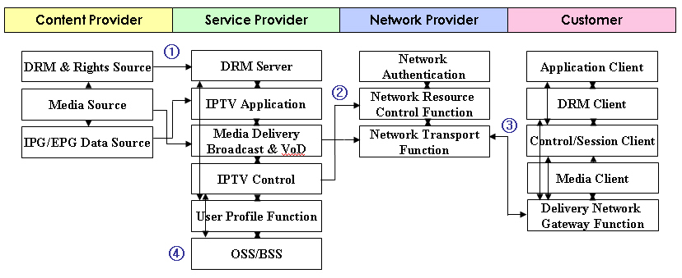
Figure 6-8: On demand-based IPTV service scenario
- Contents (video, audio, data, etc) with its metadata that are produced and managed by Contents Provider are provided (delivered) to the Service Provider’s domain. It can also include specific contents information (i.e., contents packaging, additional security information, etc).
- Then Service Provider transmits the received contents to the proper storage components through the Media Delivery interacting with the IPTV Control after additional processes such as service product managing, contents encryption, etc. Then, the contents list and relevant information are distributed to the network and end-users.
- When a end-user selects any on demand contents via its Application Client, the end-user’s IPTV terminal receives the content’s stream through proper authentication, SLA and access process. Then the received stream is displayed by the Media Client under the requested interaction with DRM Client. According to the service type, the procedure is divided as followings:
i) NVoD (Near VoD): The Delivery Network Gateway Function access contents through multicast join/leave and the connection is managed by the Control/Session Client.
ii) RVoD (Real VoD): The Delivery Network Gateway Function access contents through unicast request and the connection is managed by the Control/Session Client.
iii) Push VoD: STB or Mobile terminal receives the contents in each storage advance, then, when some degrees of content are received, contents are displayed.
- According to the end-user’s request, the OSS/BSS changes the status of end-user for CRM and charges the service price. OSS/BSS may also analyze the contents access frequency information with user profile for advanced service.

On-demand with Multi-View service
On-demand service with Multi-View is to provide more various different camera angles than the one station view in on-demand service such as video on demand (VoD), music on demand or push VoD. The viewer can select angle which he likes to watch. For example, when the end-user watches the baseball game in on-demand service, he can see the first base, third base, or backfield according to view’s wish not by the channel director’s attention.

3rd party content delivery
3rd Party Content Service is a consumer based wide selection service of contents. This 3rd party content service can provide interoperability of contents selection and supply between end-user and service provider. For this service, internetworking interface, interoperable middleware to support various selections of different contents source and contents protection scheme such as DRM (including CAS) are required to provide appropriate adaptation of 3rd party content service.

Advertising service
Figure 6-9: advertising service
[Editor’s note: Elaboration for this figure is needed, contributions are welcomed on this point]

Traditional advertising service
Traditional broadcast advertising is a commercial advertising or public promotion of goods, services, companies and ideas that are broadcast to the entire subscriber base in a region, usually inserted into between A/V programs. Each advertising service can be provided on a national basis or locally in a video clip or exclusive channel according to the service type and contract.
Advertisements can be inserted on a national basis or locally. Ad insertion is accomplished using an ad insertion system that populates ads in the video stream prior to being ingested by the IPTV acquisition system. This is typically applied to a Linear service.
Advertisement content is created by Contents provider and delivered to Service Provider. Advertisement is inserted in proper location of the video stream and delivered to user. User can see the advertisement during watching TV.
1 Contents Provider produces and manages contents for TV channel program with its metadata and provide (deliver) them to the Service Provider’s domain. And also advertiser produces advertising contents and provides it to Service Provider
2 Service Provider inserts advertisement contents in TV channel contents stream, and prepares for the contents with advertisement to be multicast through IP and controls program schedule and its distribution.
3 When a user triggers or selects the channel service following the channel information, the user IPTV device connects to the broadcast/multicast server through the IPTV Control/Session Client. This procedure may include multicast join or leave, service level negotiation for QoS.
4-a User device receives the channel stream and user can watch the TV channel program with advertisement.

Targeted Advertising
Targeted Advertising is a commercial advertising or public promotion of goods, services, companies and ideas, usually personalized for end-user’s desired profile characteristics in order to match the audience with the campaign objective requirements. Targeting of advertisements can, using the new description tools, take into account user preferences, usage history, personal characteristics (biographic and accessibility) and usage environments (terminals, networks and natural environmental characteristics).
An advertiser will want to ensure their commercials are only seen in areas where their products or services are available.
A consumer will want to set a preference to see a specific product or range of products depending on their purchasing needs or habits or interests (for instance they may be about to buy a car).
A consumer will want to set a preference to block specific products or range of products based on their purchasing needs, habits of lifestyles (for instance they could be strict vegetarians)
1 2 The same with traditional broadcast advertising
3 When a user triggers or selects the channel service following the channel information, Service Provider’s Service Control function checks the user profile and presence and control to sending different advertisement depend on user characteristics (on User profile and presence).
Other actions are the same with traditional broadcast advertising
4-b User’s device receives the channel stream and advertisement. User can watch the TV channel program with advertisement.

On-demand Advertising
On-demand Advertising is a commercial advertising or public promotion of goods, services, companies and ideas, after navigating and selection within the advertisement list which provided by service provider, user can watch the advertisement that she select.
Service provider delivers business advertising directory information for user to navigate and select. After navigating and selection within the advertisement list user can watch the advertisement that she select.
The IPTV service may also be used to deliver business advertising directory information (e.g., “Yellow Pages” information) regarding available business services. This information may include simple directory listings.
1 Advertiser produces advertising contents and provides it to Service Provider
2 Service Provider transmits the received advertisement contents to the proper storage components through the Media Delivery interacting with the IPTV Control. Then, the contents list and relevant information are distributed to the network and end-users.
3 A user navigates and selects any on-demand advertisement contents.
4-c User’s device receives the stream and user can watch the advertisement.

Interactive Advertising
Interactive Advertising is a commercial advertising or public promotion of goods, services, companies and ideas, which lets end-users send various types of requests and receive feedback with interactivity.
User clicks on an icon during advertising in order to connect web site to get the additional information on the product.
Click to call - Enables a consumer to press on a button (or click on an icon) in order to initiate a free call to discuss/purchase a certain product.
1 2 3 the same with one of above services.
4-c User’s device receives the stream and user can watch the advertisement. And click on an icon for connecting call (or connecting web server.).
5 User’s can connect free-call to discuss/purchase a certain product (or can get the more information on product and can buy it on line.)

Advertising message logging
[Editor’s note: Contributions are welcomed for elaboration in this clause]

Public interest service

Support for users with disabilities
Users with and without disabilities can benefit from supplementary content alongside and in synchronisation with the main content. The most familiar services are subtitling, which provides language translation of the dialogue, and captioning, which provides a transcript of sound effects as well as the dialogue to aid people who cannot hear the sound. The subtitling and captioning services can come in one of two forms: either as a text stream that must be rendered in the receiver with a local font or as a series of graphical bitmaps. There are advantages and disadvantages of each.
Another form of supplementary content is visual sign language translation for deaf people. A sign language interpreter appears in-vision, using hand gestures and mouth movements to convey the dialogue to viewers. Ideally, the position of the interpreter can be set by the user, as well as whether there is a solid or transparent background.
Audio description is a commentary explaining the significant visual aspects of the main content, primarily for the benefit of people who cannot see it, though it is also useful for people with learning difficulties. The commentary fits between the dialogue so as not to interfere with the main content, but to work in conjunction with it. Ideally the volume level and positioning of the audio description can be adjusted by the user.
Digital television equipment usually provides a user interface comprising a remote control and on-screen display. Some users need clearer, larger text or alternative colour combinations in order to read it. Others cannot see the screen at all and need alternative forms of information, such as spoken. The remote control also presents a challenge to those who cannot see or have dexterity limitations. Voice control or a much simpler form of button control can be provided.
[ITU-T Accessibility checklist]FSTP-TACL Telecommunications Accessibility Checklist
[ITU-T F.790] Telecommunications Accessibility Guidelines for the Elderly and People with Disablilities, should be consulted.

Emergency communications
People have different preferences, perhaps based on need, for delivery of notifications. As examples, output should be spoken, text, sign language, and output at different rates. The ITU-T Accessibility Checklist and ITU-T F.790 should be consulted.
Message content should include all pertinent details presented in a way that is easily and quickly understood by the population. This includes multiple languages in some cases, as well as the use of multimedia for illiterate or hearing/visually impaired individuals.
Spoken messages are particularly useful where the natural language text is not well supported by technology, and for reaching anyone who is unable to read at the moment.
The terminal notifies the user of an incoming Emergency Alert Notification (EAN) message both visually and audibly, or according to the user’s preferences and capabilities if they specify otherwise.

Community related information
These are services providing community related information, such as announcements, bus routes, weather and government services related information.

Emergency Communications Scenarios and Use Cases over IPTV Systems

Emergency Communications Generic Service Components
Under Emergency Communications circumstances, public authorities and citizen communities generally act as emergency message providers and consumers respectively. The public authority is in charge of emergency messages generation, audit and distribution. Figure 1 shows how the authority and community interact with each other and the messages in between them. While the Emergency Communications running over IPTV SYSTEMS and acting as complementary services, Emergency Communications would build more complete picture against its legacy uni-directional broadcasting, text or audio only mode. So in the IPTV systems point of view, bi-directional interactiveness emergency communications between the public authority and the citizen community would be focuses.
Figure 6-10 Emergency communications components and message interaction
We will present emergency messages and typical use cases across IPTV systems as four modes:
- Downwards with ECN usage scenario
- Upwards with ECR usage scenario
- Inter-group with ECI usage scenario
- Inter-authority with ECI usage scenario(irrelevant to IPTV systems, not involved in this document)

Downwards with ECN Usage Scenario
The public authority authenticated the emergency communication notification message from internal or external department. Then ECN would be distributed to specific community group or just broadcasting. Here Emergency Communications would be interleaved with normal multicast or VoD streaming. In this scenario, ECN could work in PUSH or PULL mode. In PUSH mode, the top priority event messages should be forced into IPTV broadcast systems whether the users subscribe event asynchronously or not. In PULL mode, users can synchronously request the specific interested ECN, such as traffic event in the specified districts or cities, weather warning from public departments.
IPTV system works as the distributor, and its broadcasting and multicasting would be networking enabler. Besides that, IPTV multicasting group management and programming or customised EPG would be service enhancement enabler.
Downwards usage scenario key points:
- ECN broadcasting in IPTV domain;
- ECN distribution toward specified communities upon their subscriptions;
- ECN distributed in PUSH or PULL mode;
- ECN media streaming overlapped normal streaming(text, audio and video);
- ECN media streaming interrupt normal streaming(text, audio and video);
- ECN distribution community groups correlate with IPTV subscribers and multicasting groups;

Upwards with ECR Usage Scenario
Emergency Communication report would be passed through IPTV systems into the public authority (such as fire station or medical centre, etc.), which is supplement to legacy emergency communications. Fire warning report, illegal house intrusion event report could be passed into the public authority. Monitor camera enabled STB would enhance this ECR usage, such as the stranger recognization warning, smoke sensor warning, etc.. Amount of personalized notices or warnings would be entering into IPTV systems, via which they are delivered to corresponding department. Types of personalized and customised emergency services would be implemented, such as personal medical services, home visual surveillance services, even global remote medical systems. By the means of IPTV video capabilities, ECR would be more diversified with video circumstantial evidence. In this scenario, IPTV systems would be flexibly integrated with other service systems, such as medical or fire centres, in which, open and standardized interfaces are necessary.
In ECR mode, IPTV systems work as emergency communication message sources with its interactive channels. These multi-media ECR would be passed into specified public authority, where ECR is authenticated and audited.
Upwards usage scenario key points:
- Multi-media ECR
- IPTV systems pass ECR into the specified public authority
- IPTV subscriber positioning and authenticating information should be delivered to public authority
- IPTV terminal capabilities, such as HD camera for legal evidence, event trigger, sensor, etc..
- IPTV service control part would be ECR awareness and route it to the correct EC responses

Inter-group with ECI Usage Scenario
ECI is part of UGC (user generation content) in IPTV systems. Apart from ECR, Emergency Communications reports going to the public authority, ECI from one user group could be delivered to another group for inter-group warning or notifications. In contrast to 4.3 ECR, IPTV systems are responsible for messages audit and authentication under the national regulations.

Emergency Communications Scenarios in IPTV Systems

Downwards with ECN Usage Scenario

Figure 6-11 Downwards with ECN Usage Scenario
- Normal broadcasting contents entering into IPTV SP domain from CP;
    - 1a. ECN coming into IPTV SP domain, and the media content into content preparation FE;
    - 1b. The public authority informs IPTV service control FE of ECN coming into IPTV domain;
- Upon ECN delivery mode, the content preparation FE interleave ECN with normal broadcasting content or interrupt normal broadcasting content, and compound media is ready for multicast streaming servers;
    - 2a. Compound media delivery into IPTV application server instead of multicast streaming services;
- IPTV service control checked ECN available, then request user or group and service information to instruct compound media where to go;
- User and service profile instructs IPTV application server to delivery the media(ECN receipt user group mapping to IPTV application user group);
- User and service profile informs IPTV service control of multicast streaming delivery(ECN receipt user group mapping to IPTV multicast group);
- Compound media is ready for multicast streaming server delivery with destination group information and service information;
- media goes to the final users and user groups, and it could be multicast streaming or any other application format, such as VoD, presence, VoIP or WEB servers.

Upwards with ECR Usage Scenario
TBD.

Inter-group with ECI Usage Scenario
TBD.

Tele-services

Tele-learning
[715]
Tele-learning is an instructional service for delivering education to students who are physically located in different geographic areas. Teachers and students can communicate in real time (i.e. both present at the same time) and/or non-real time (i.e. at time of their own choosing using a messaging capability) using video, audio, pictures and text etc.

Tele-medicine
[715]
Tele-medicine is a medical service which is provided to doctors and patients who are in different geographic areas from each other. Doctors can deal with patients by remote diagnosis, remote consultation, remote medical examination, medical education etc in real time (i.e. both present at the same time) and/or non-real time (i.e. at time of their own choosing using a messaging capability) using video, audio, pictures and text etc.

Monitoring services
Monitoring services are services which provide monitoring and surveillance capability. Examples of such services are heath monitoring, surveillance of places, etc.

Portal services
Portal service is a branded aggregation of products and services designed to satisfy a large majority of user’s needs, such as VoD, shopping, banking, communication, entertainment and other interactive services with portal menu. Portal service can target of end-users with broadcasting of commercials, advertisements and interactive response advertising.

Data portal (walled garden, internet access, etc.)
Data portal service is a branded aggregation of internet contents with wall garden access for information, shopping, banking, learning and other communication service with interactivity.
Also, it can support direct internet access for more specific information search.

Web-based IPTV Portal
Web-based IPTV Portal service: IPTV service incorporates with web portal services over IP network. The web portal is a platform that allows an organization to integrate its business information, applications, and services in web-based IPTV Portal service.

Figure 6-12: Web-based IPTV Portal service scenario
- Terrestrial/Cable/Satellite TV Broadcaster provide the contents to the service provider(Web-based IPTV Portal)
- Service provider encode the received audio/video source from Terrestrial/Cable/Satellite TV Broadcast receiver.
- Store the contents to the storage after additional process such as contents packaging, encryption, etc.
- End-user select the contents via EPG based on web which are provided by portal server.
- Portal server transmit the contents which are requested by end-user.
Ⓐ End-user request the web data services on Internet such as E-mail, FTP, messenger and Instant Messaging(IM).
Ⓑ Portal server provide the web data services.

Terrestrial portal (news, drama, sports, movies, etc.)
Terrestrial portal service is a branded aggregation of terrestrial contents such as news, drama, sports, movies, and talk show, etc. It provides basic terrestrial channel, VoD, PPV, contents connected interactive service, and multi-angle service with various terrestrial contents.

Hosting services
Hosting service is a type of IPTV platform & service hosting that provides organizations and individual users with on, off-line system and network for storing information, image, video, or any content accessible via the IPTV.

Business to business
The business to business hosting service is an IPTV hosting service for the special group or business unit subscriber. It connects the channel, VoD, and portal service made by end-user business unit to the IPTV platform to supply particular groups with real time broadcasting channels, value-added interactive services and T-community activity etc. Generally, it includes a regional community, religion unit, and small business company broadcasting and interactive data service.

User created content (UCC) hosting
User Created Contents (UCC) hosting service is an IPTV hosting service for individual end-user as a user generated Video, interactive content data. This service allows end-user to make their own channel like personal web TV by uploading A/V, application and other contents that they generate through IPTV hosting platform.

CPU resource hosting

IPTV interactive service
Interactive service lets end-users send various types of requests and receive feedback with interactivity.
The integrated internet service, in IPTV integrates current internet based on-line services and provides them within the IPTV service with following use cases.
Figure6-13: Use cases for the integrated internet services in IPTV
- The original contents and data sources are produced and delivered from the Content and Data Sources to the Content Preparation Function.
- Received and processed by the Content Preparation function, its metadata is delivered to the IPTV Application function and its contents are delivered to the Content Delivery & Storage Function under the control of the Content Delivery Control Function.
- When a client turns on, the updated IPTV service guide is transmitted based on their profile.
- When the client selects one of the integrated internet services, that information is transmitted from the Application Client to the IPTV Application.
- a. If the selection includes client-specific request, it is transmitted and processed by the Application Profile Function.
- b. If the selection requests more data or contents that are in the service provider’s storage, then the request is forwarded and dealt by the Content Delivery & Storage Function.
- c. If the selection includes more data or contents that are not in the service provider’s storage or includes requests that are out of the service provider’s coverage, then the request can be forwarded to the Content & Data Sources based on their policy.
- a. Proper response or reaction is taken by the IPTV Application.
- b. If necessary, the requested contents or data are transmitted by the Content Delivery & Storage Function under the control of the Content Delivery Control Function.

Information (news, weather, transportation, local community etc.)
IPTV Interactive Information is a television information service that supports a considerable amount of useful information such as news, weather, traffic situation and advertisements. Viewer can choose contents on the overlapped linked program screen or independent menu.
- Program survey services
- Games
- Targeted Advertising (personal, interactive, on demand related advertising, etc.)
Target Advertising is a commercial advertising or public promotion of goods, services, companies and ideas, usually personalized for end-user’s desired profile characteristics in order to match the audience with the campaign objective requirements. The advertising can be targeted according to a number of factors such as their programs of interest by utilizing niche programming, demographic classification (such as gender, age, language, education, income, race or ethnicity and geography), and the time of day, shopping habits and personal preferences. Target advertising can be more relevant in IPTV services than today’s TV advertising with personal, interactive, end-user related advertising characteristics.

Commerce (banking, stock, shopping, ticketing, auction, product delivery, event, etc.)
IPTV Interactive Commerce is a television commercial service that allows viewer to purchase goods and use financial services such as banking, stock, auction etc. For example, personal banking service can help user to view account balances, review past account activity, pay bills, and transfer money between accounts.

Communication (e-mail, messenger, SMS, channel chatting, VoIP, web surfing, multiple video conference, video phone, etc.)
IPTV Interactive Communication is a convergence service of telecommunication and broadcasting that compounds phone services (VoIP, video phone, multiple video conference, etc.) and internet-based communication services (Instant Messaging, Short-Messaging Service, Email, Web, etc.) with classical television services. It is usually provided by controlling multiple sessions for a phone service, an internet-based communication service and a television service. T-communication has a few combinations. Thus consumers can use the converged services that provide “a phone service and a TV service” or “a communication service and a television service” or “a phone service and a communication service and a television service” simultaneously.
IPTV Interactive Communication is a television communication service that enables end-user to exchange information such as voice, video, and data. Users can send (or receive) the mail and message while watching TV. In addition, viewers can simultaneously interact with other people via two-way video and audio transmissions using video conference. T-communication is a key convergence service of telecommunication and broadcasting in the IPTV.
- Video conferencing
A Total Conversation service is an audiovisual conversation service providing bidirectional symmetric real-time transfer of motion video, text and voice between users in two or more locations. This real time text differs from instant messaging systems because it is the transmission bi-directionally of one character at a time. This gives the user the feel of real-time communication, just like voice or video systems that transport streaming media over IP. The concept is aimed at providing for rich media real time conversation for all people and for varying situations. This includes but is not limited to people that are disabled in some way, e.g. the deaf or hard of hearing, blind etc, but also people who find themselves in a situation where the complementing media video, real-time text and voice together fulfils the conversation needs much better than only voice.
Total Conversation is an ITU service description in ITU-T Rec. F.703 and covers videophone with real time text. Ideally all videophones should offer "Total Conversation", but in many cases only video and audio are provided. F.703 is useful not only for the disabled but for anyone who can benefit from the textual back-up of for example technical data, language translations, verbal or signed conversations. It has uses for people who are not only deaf or disabled but people who can’t communicate in either of the two mediums or do not have the command of the spoken language used. Total Conversation’s use is useful to document factual information within videophone calls (e.g. phone numbers and addresses) without searching for pen and paper. An example would be to get a flight booking reference when making a travel arrangement.
- Messaging
An interactive service which offers user-to-user telecommunication between individual users. Messaging services may be immediate (e.g. instant messaging (IM)) or of a store-and-forward type (e.g. email and voice mail).
- TV-based conversational services

Entertainment (games, karaoke, photo album, lottery, blog, etc.)
IPTV Interactive Entertainment is a television entertainment service that contributes viewer’s amusement by providing exciting items such as games, karaoke, and photo album. Games can be sub-divided into single player and multi-player games according to the number of player. Moreover, it can be classified into a network linked game and a stand alone game according to the network interaction type. In the photo album, user can enjoy pictures which they upload or which are provided by provider and transfer it to other people’s TV, mobile phone or etc.

Learning (infant, children, school student, languages, financial skill, etc.)
IPTV Interactive Learning is a television learning service that educates viewers through lectures, tutorials, simulations, quiz, job aids, game, and more. Also, T-learning can be effectively provided by either combining distance learning with direct contact of human educational resources, or combining software driven resources with any other educational academy resources.

Government (notice, civil appeal, tax payment, poll, etc.)
IPTV Interactive Government is a television government service that treats civil appeal, tax payment, public poll, Government Issue notice and etc. T-government enhances the government productivity and transparency by unifying and opening administration service.

Presence services
[Editor’s note: Contributions are invited for polishing this subclause]
Presence Service is the capability to support management of presence information between watchers and presentities, in order to enable applications and services to make use of presence information.
Presence information is a set of attributes characterising current properties such as status(online, offline, meeting, on the phone, etc.), place(home, office, library, etc.), communication means(audio, video, text, etc), and so on.
Presentity is an entity that provides presence information.
Watcher is an entity that requests presence information about a presentity.
Presence Service provides access to presence information to be made available to other users or services including IPTV services.

Figure 6-14. Presence service scenario

- Content is acquired by the service provider from some sources such as a satellite downlink or a content library.
- The content is served to individual consumers.
- The presence information of users and information on users’ devices, services and service components is provided to the Presence Server. The information might be content information (Broadcast TV channel, VoD content, Commercial Advertising, etc.) currently accessed.
- The presence information can be distributed to other end-users.
Presence Service is the capability to support management of presence information between watchers and presentities, in order to enable applications and services to make use of presence information. The presence information is a set of attributes characterising current properties of presentities such as status, an optional communication address and other optional attributes, etc.
Presence Service is the capability to support management of presence information between watchers and presentities (RFC 2026, 2778), in order to enable applications and services to make use of presence information.
Presence Service results in presence information of a user and information on a user’s devices, services and service components being managed by the network.
Presence Service provides access to presence information to be made available to other users or services including IPTV services.
Example services might include:
- Electronic Program Guide(EPG) personalization based on presence on top of locally stored data
- Targeted advertising based especially when correlated with time of day
- Chatting with friends watching the same channel

Basic Presence Service
[Editor’s note: Contributions are invited for polishing this subclause]

User A is watching the TV.
User B logs in TV at home.
Now, user A knows that user B is at home and calls him.

Channel based Presence Service
[Editor’s note: Contributions are invited for polishing ‘Channel based’ in this subclause]

User A is watching the football match on the IPTV.
He would like to chat with friends who are watching the same channel.
He opens the IM client on the TV, and pushes the button marked as “Search for friends”.
On a mask on the screen he specifies the search criteria, that is “buddies watching the same channel now, and available for chatting”.
He gets a list and invites them all to a multi-point messaging session.

Targeted Advertising based on Presence Service

The presence server gathers the presence information of users and stores their log into a database with the approval of them. The presence information could be content information they watches, shopping habits, etc.
An advertiser requests the consumer log of users from the presence server and can make targeted advertisements.

Time-shifting service
An IPTV service in which subscribers can access (pause, rewind, fast forward, and etc) IPTV contents without time limitation. Therefore, this service is assuming that the IPTV contents are saved in a repository for later use.
In a traditional TV service the time shifting service has been provided by the recording functionality such as VCR (Video Cassette Recorder). Then, some products using hard drive instead of tape are starting to prevail while supporting some fancy services such as automatic recording with key words, the name of actor, and etc, which is called as DVR (Digital Video Recorder) or PVR (Personal Video Recorder).
Note that the content should be stored so that subscribers can retrieve it later. The PVR devices are storing the contents in local hard drive. We can call this approach as subscriber-based time-shifting service. However, if we consider some cases in which it is not appropriate to save the contents locally. For example, if the IPTV terminal is PDA, the size of hard drive is limited. The network-based time-shifting mechanism is needed for those kinds of cases, which is also called as NVR (Network Video Recorder). Examples of network-based time-shifting service include nCube's nPVR solution and Concurrent's Personal Video Channel (pVC) solution. In those solutions, hard drives are located at the network head-end as opposed to the subscriber's set-top box. In the network-based time-shifting service, the broadcasting traffic is transformed into on-demand traffic and service providers can leverage their existing VOD infrastructure already in place. Subscribers sign up for specific network-based time-shifting service and storage limits, and the service provider then gives them access to the IPTV content as it is delivered to their own terminals.
In summary, we can define two types of time-shifting service, subscriber-based and network-based time-shifting services in IPTV. In the following chapter, we are going to show the time-shifting service architecture according to the service types which is supported in the time-shifting service. Then, we are going to propose some requirements of the service.

Place-shifting service
An IPTV service in which subscribers can access (pause, rewind, fast forward, and etc) IPTV contents without place limitation. That is, this service makes subscriber see his or her subscribed IPTV contents anywhere. The place-shifting basically is to support users who move to the other place from the place where he or she originally subscribed for. This service is assuming that a user’s terminal can even be a mobile phone. However, since the mobile IPTV will be addressed in a separate category, we would not consider the case specifically.
Depending on who is taking care of redistributing the IPTV traffic, we can define two types of place shifting service, subscriber-based place-shifting and network-based place-shifting service. In subscriber-based place-shifting, a subscriber device redistributes traffic to the place where the user is currently located. In network-based place-shifting, service provider send the IPTV traffic to the moved place. The following sub-sections explain each type of the place-shifting service.

Session mobility service
An IPTV service in which an on-going multimedia session can be transferred seamlessly between different devices based on user preferences. That is, the service makes subscriber see his or her subscriber real time IPTV content seamlessly. It is different from Place-Shifting service for it is more suited for transferring on-going or real time sessions. The session mobility basically is to support capturing the session control context information from the originating terminal device and transferring them to the target terminal device by session transfer controller. And it also supports suspending and resuming session based on subscriber’s requirements. This service is allowed that a user’s terminal can even be a mobile device. However, since the mobile IPTV will be addressed in a separate category, we would not consider the case specially.

Supplementary content
This is defined as video, audio, textual, graphical or other forms of content that can be optionally accessed by the user and rendered by the terminal device. It has the following features:
- It only works in conjunction with the main content.
- It is synchronous with the main content.
Examples of use:

Accessibility features
- Subtitles and captions
These services can be provided by means of either textual or graphical supplementary content. Subtitles provide a real-time on-screen transcript of dialogue for the purpose of language translation. The subtitles and the dialogue are in different languages. Captions for the hard of hearing provide a real-time on-screen transcript of the dialogue as well as any sound effects. Different speakers are distinguished, usually by different colours. The captions and the dialogue are in the same language. The service is primarily to assist users having difficulty hearing the sound. Ideally, users may have some control over the position and size of the presentation.
- Audio description
Primarily intended to assist users who are unable to see the video content clearly, this service provides a commentary describing the visual events pertinent to the content. The narrative passages fit between the dialogue and other significant audio content so as not to interfere with it. Ideally the user can control the volume and spatial positioning of the audio or derive it from a separate output.
- Sign language interpretation
This service comes in the form of supplementary video content, usually smaller in image size to that the main video content. The video shows an interpreter who uses hand gestures and facial expression to convey the main audio content to sign language and lip readers. Ideally the user can control the position, size and background properties (solid or transparent and the colour, if solid). It is of sufficient temporal and spatial quality to enable sign reading and lip reading.
- Other services
Feature films on DVD frequently offer an alternative audio track that contains a commentary on the film by the director or actors. IPTV systems could provide the same service by means of supplementary audio content. It would also be possible to optionally show the commentators by means of supplementary video content.
News services often have 'tickers' in vision, of news headlines or financial information. However, different users have different preferences for these information mechanisms so they may best be provided in the form of selectable and customisable supplementary content. If this was provided in the form of supplementary textual content then terminal devices could render it in alternative formats such as speech or Braille.
Commentators for sports events could optionally be seen by means of supplementary video content. In fact, the main audio content could be just the 'natural sound' of the sport, with a choice of commentaries available as supplementary audio content.

Commercial/business models of IPTV
[editor’s note:] Contributions for elaboration are invited.
There are a number of well-known business models for service providers to support IPTV service and to make profitable revenue by composing various service products.
Generally, classified service products can be commercial model according to the service provider’s policy and marketing.
Here is a proposed list of business/commercial models but other models and combinations might be possible.
- Free
A viewer can watch IPTV service or use it without paying for it.
- Subscription
A viewer should pay an amount of money regularly in order to watch or use IPTV service.
- Pay per view (PPV) / Pay per use (PPU)
A viewer can purchase each service, content or application to be seen on TV at any time and pay for the only item he buys. E.g. each service or content can be purchased using an on-screen guide, an automated telephone system, or through a live end-user service representative.
- A La Carte
A viewer can buy whichever channels and contents he wants, and pay a price for each. In this time, the channel is composed not by the service provider but by the user.
- Cash-back Point
A cash-back point is prepaid e-money or ticket for IPTV service. With these cash-back points user can pay the service fee in IPTV service domain like real-money. User can acquire the cash-back points by buying it with real money or accumulating bonus cash-back point which accrues in a particular rate when they use the IPTV service. The cash-back point can be a unit of price of detailed service. (Similar to frequent flyers miles)
- Package
A viewer can select and use a set of products such as VOD (including channel) and T-entertainment (including game, karaoke and so forth) which are already organized by the service provider. Then, pay for the set of products which he or she chooses.

Annex A

[Editor’s note: Contributions are invited to make elaboration for this Annex ]
Personal IPTV broadcast service: service that enables user to broadcast their content which is already stored in or captured at real-time by terminal device.
France Telecom IPTV solution players
France Telecom started the deployment of TV services over ADSL access end of December 2003.
France Telecom has now more than 450 000 subscribers end of September 2006.
The new STB are now H.264 capable and HD-ready. The high-end STB features PVR functions.
To illustrate the relations between players in the operation of IPTV services, here are the different players in the France Telecom IPTV service.

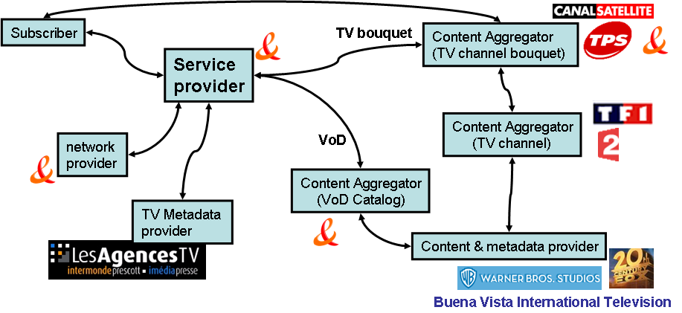
Figure A-1. Players in the France Telecom IPTV Service
Notes:
LesAgencesTV is a company providing metadata related to TV Channels
TPS and CanalSatellite are companies providing a bouquet of TV Channels. France Telecom provides its own bouquet
Buena Vista International Television, Warner Bros Studios and 20th Century Fox are companies providing movies (under contract with France Telecom) to be included in the France Telecom VoD Catalogue.

France Telecom plays different roles in the delivery of IPTV Services:
- Content aggregator
  - It creates its own TV Bouquet combining individual TV channels (TF1, 2, M6, etc.) and metadata coming from a TV channel metadata provider (Les Agences TV),
  - It creates its own VoD Catalog combining contents negotiated with content providers such as Warner Bros Studios, 20th Century Fox, etc.
- Service provider
  - It offers the subscription to its own TV bouquet and VoD Catalog.
  - It operates the IPTV architecture (TV Head-End, CDN, VoD servers, etc.) over its own network
Identification of metadata provider role
Content providers have of course metadata about their contents, so content providers are also metadata providers.
However, it exists also pure metadata providers (as illustrated in the France Telecom IPTV players) which provides metadata about contents but not the contents themselves.
Among the pure metadata providers we can find the EPG providers, newspapers, freelance journalists, individuals.
For example, they provide comments, opinions or critics about movies.
Model for relations between roles
The distribution of roles among the players in the France Telecom IPTV Service is not the only one possible.
So here is a proposal for a generic IPTV Service model.
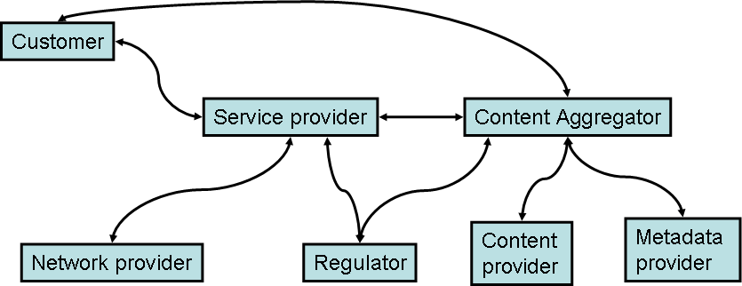
Figure A- 2. IPTV Service mode for relations between roles
A player may play different roles as shown in the France Telecom IPTV service (service provider, content aggregator, etc.) .
Identification of players/roles
- Content providers
- Application providers
- Content aggregators
- Service providers
- Network providers
- Consumers (subscriber, viewer, etc.)
- Regulators

Some companies may play several roles.
Definition of players/roles

____________________

