INTERNATIONAL TELECOMMUNICATION UNION |  |  |  | Focus Group On IPTV
TELECOMMUNICATION  STANDARDIZATION SECTOR  STUDY PERIOD 2005-2008 |  |  | FG IPTV-C-0928
 |  |  | English only
WG(s): 6 |  | 6th FG IPTV meeting:  Tokyo, Japan, 15-19 October 2007
CONTRIBUTION
Source: | ETRI
Title: | Proposal for modifications on section 12 of IPTV-DOC-0127
Abstract
This contribution clarifies retransmission and legacy related issues, which are currently described in section 12 of the “IPTV Middleware, Application and Content Platforms” document, and proposes that the following contents of this contribution be updated in section12 in order to enhance its accuracy and quality.

Proposal

This contribution proposes the enhancement of section 12 of IPTV-DOC-0127, “Working Document: IPTV Middleware, Application and Content Platforms”.

-------------------------------------------------

Retransmission and Legacy Related Issues

Introduction
IPTV service can be combined with other platform’s services such as terrestrial (cable, or satellite)digital broadcasting services. Sometimes it is necessary to re-transmit other platform’s services for the transparent service. The integrated IPTV service system may provide end-users with an easy interface to services on several platforms and allow service provider to make flexible, cost-effective, and efficient system by defining schema which is presented regardless of real time broadcasting and additional enhanced data service features.

Retransmission Approaches
Three approaches may be considered for describing functional architecture of retransmission that enables service providers to deliver digital broadcasting services over IP according to their purpose.

- Simple MPEG-2 TS based retransmission
The MPEG-2 TS is already widespread in the digital broadcasting services, and hence MPEG-2 TS based retransmission without any modification is a representative of simple retransmission model. It is intended to use existing broadcasting solutions in the retransmission of digital broadcasting services over IP networks.
- Modified MPEG-2 TS based retransmission
Besides simple retransmission, service providers sometimes want to reconfigure digital broadcasting services by adding their own metadata and applications with permission of content providers. They receive digital broadcasting services with an IRD (Integrated Receiver Decoder), multiplex them with their metadata and applications with MPEG-2 TS multiplexer, and deliver them over IP networks.
- Retransmission with direct transport over IP
Broadband IP networks provide bidirectional communication and the end-user can obtain AV, metadata, and applications from other IP sources not MPEG-2 TS. In addition, the DSM-CC object carousel is often used to deliver applications over MPEG-2 TS, but makes significant processing overhead of the complex tables in the end-user’s IPTV terminals. Therefore, retransmission of digital broadcasting services with direct transport over IP can be also considered.

Functional Architecture

The functional architecture is expected to provide functionality for all envisaged retransmission approaches. Figure 1 provides functional architecture for retransmission of digital broadcasting services over IPTV.

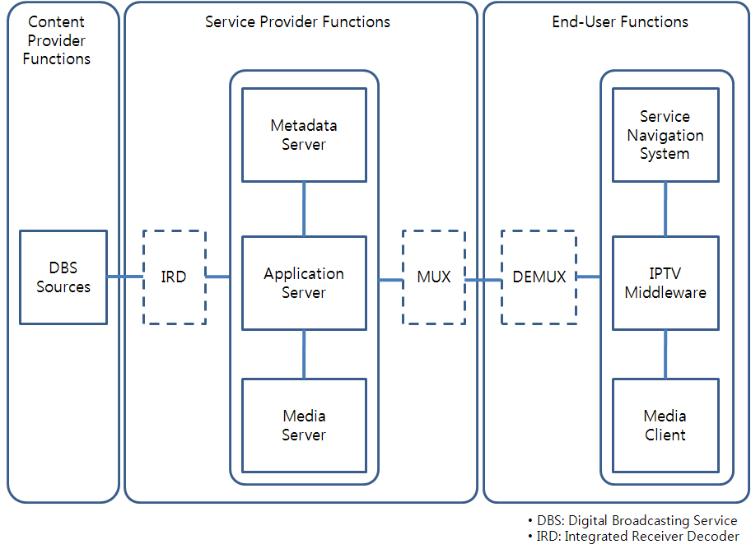
Figure 2. Functional Architecture for Retransmission

Functional Architecture Components

Content Provider Functions

The content provider functions are provided by the entity that owns or is licensed to sell content or content assets (i.e., owner of the content, metadata and usage rights), and provides the functions to deliver digital broadcasting services for retransmission over IPTV.

Service Provider Functions

The service provider functions provide the capabilities to facilitate interaction between the end-user functions in order to support actual retransmission of digital broadcasting services over IPTV.
- Metadata Server Functions
The metadata server functions provide the functions to collect and manage metadata such as service information (e.g. EPG), and to insert or modify metadata for retransmission over IPTV. Metadata server functions also provide the capability to transfer metadata for service discovery to the end-user’s service navigation system.
- Application Server Functions
The application server functions provide the functions to identify applications and deliver applications and application signalling information.
- Media Server Functions
The media server functions provide the functions to transfer AV streams with sufficient QoS/QoE.

End-User Functions

The end-user functions provide the capabilities to facilitate interaction between service provider functions in order to support the replay of retransmitted digital broadcasting services.
- Service Navigation System Functions
The service navigation system functions provide the functions for service discovery and selection of the available IPTV services using metadata.
- IPTV Middleware Functions
The IPTV middleware functions provide the functions to launch and manage the lifecycle of applications, and also provide application client functions to exchange information with the application server functions to support interactive applications.
- Media Client Functions

The media client functions provide the functions to receive and control the delivery of AV streams and also provide the capability for decoding of AV streams.

Legacy Related Issues

The legacy related issues shows several considerations to provide transparent retransmission of digital broadcasting services over IPTV.
- Content format issue
Legacy digital broadcasting services provide their own services with different content formats according to different standards such as ACAP, OCAP, MHP, and so on. Therefore, content formats of existing broadcasting services should be considered in the IPTV middleware to ensure identical representation of retransmitted digital broadcasting services over IPTV.
- Metadata issue
Legacy digital broadcasting services provide service information and it is cost-effective to re-use their information in the process of retransmission, and additional metadata and presentation schema should be considered to support retransmission over IPTV.
- Content delivery issue
Legacy digital broadcasting services use MEPG-2 TS for content delivery, which is tightly coupled with AV, metadata and applications, and so it is cost-effective to re-use MPEG-2 TS in the process of retransmission. While, the IP-based content delivery also should be considered to efficiently deliver contents in the process of retransmission through bi-directional communication.
- Application signalling issue
Application signalling is used to identify the application associated with a service and control the lifecycle of the application. Legacy digital broadcasting services uses MPEG-2 TS based encoding (e.g. AIT or XAIT) for application signalling. While, the application signalling (e.g. XML encoding of AIT) applicable for IPTV should be considered in the process of retransmission in addition to the already existing MPEG-2 TS based encoding.

References

[1] FG IPTV-DOC-0127, Working Document: IPTV Middleware, Application and Content Platforms
[2] FG IPTV-DOC-0115, Working Document: IPTV Architecture
[3] FG IPTV-C-0398, Requirements of IPTV Interactive Data Services for Retransmission of Terrestrial Data Broadcasting Service
[4] WP6M/179-E, Consideration toward Liaison Reply to ITU-T FG-IPTV on Retransmission of Free-to-air Broadcasting Services over IPTV
[5] FG IPTV-C-0384, Requirement for IPTV application signaling
[6] FG IPTV-DOC-0823, Proposal for Retransmission of Digital Broadcasting Services over IPTV

_______________

