INTERNATIONAL TELECOMMUNICATION UNION |  |  |  | Focus Group On IPTV
TELECOMMUNICATION  STANDARDIZATION SECTOR  STUDY PERIOD 2005-2008 |  |  | FG IPTV-C-0929
 |  |  | English only
WG(s): 4 |  | 6th FG IPTV meeting:  Tokyo, Japan, 15-19 October 2007
CONTRIBUTION
Source: | Alcatel Shanghai Bell Co., Ltd.
Title: | Proposal for IPTV Multicast Address/Domain Name Management Framework

Abstract
This contribution proposes a framework to manage multicast addresses and domain names of IPTV, in which network operators do not allocate multicast IP addresses to multicast channels of IPTV service providers directly, but register their domain names and assign multicast addresses to them dynamically. This framework brings many advantages to network operators, service providers, and end users.

Introduction
In current multicast IPTV services, service providers get a multicast IP address for every of their multicast IPTV channels from network operators and distribute IPTV contents to those addresses. In this mode, it is hard for network operators to manage their multicast resources (multicast addresses), since this management work (such as multicast address allocation, revocation, and rearrangement) will impact IPTV channels in services greatly. But as we know, multicast addresses are limited in number, especially in IPv4 environment. In order to make efficient use of this resource, it is very important for network operators to manage their multicast resources carefully and frequently. Our proposal provides such a framework for network operators to manage their multicast resource efficiently and easily, while brings little impact to IPTV channels in service. IPTV service providers and end users also benefit much from this framework. The following section defines the framework in detail.

Proposal

Framework
Figure 1 gives an overview of the multicast address / domain name management framework. It works as below:
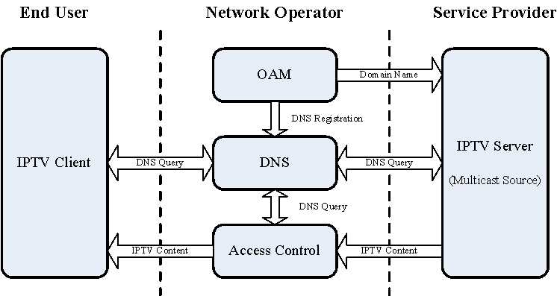
Figure 1: Framework of Multicast Address / Domain Name Management
1) Multicast resources (multicast IP addresses) are managed by network operators.
2) Network operators maintain DNS servers. Or network operators can register / deregister domain names of IPTV channels on DNS servers.
3) Network operators allocate necessary network resources to IPTV service providers. In this document, it means to allocate a multicast IP address to each of the multicast IPTV channels.
4) Network operators do not allocate multicast addresses to IPTV channels directly, but register them a domain name with a multicast address on the DNS server.
5) Network operators inform service providers about the domain names registered for their multicast IPTV channels.
6) When network operators need to do multicast address management work, they just modify domain name registration on DNS servers.
- Allocate a multicast address to an IPTV channel: register a domain name with a multicast address for the IPTV channel.
- Revoke a multicast address from an IPTV channel: deregister the domain name of the IPTV channel.
- Rearrange multicast addresses: modify domain name registration of IPTV channels.
7) Service providers get address information for their IPTV channels by DNS query, and send IPTV contents to those multicast addresses.
8) End users access the multicast IPTV channels by their domain names.
9) Network operators can make use of domain name information of IPTV channels to do IPTV service access control on both multicast sources (service providers) and multicast group members (end users).

Advantages
This framework brings many advantages to network operators, IPTV service providers, and end users, which are listed respectively as below:
1) Efficient and easy way to manage multicast resource
To network operators, it makes network resource management work more efficient and easier. Rearrangement of their multicast resource (multicast addresses) has little impact on content providers and end users. The only work the network operators should do is just change the domain name registration of multicast IPTV channels according to their new multicast address assignment plan.
2) Constant way to represent multicast IPTV channels
To IPTV service providers, they can represent their multicast IPTV channels with constant identifiers – domain names, instead of multicast addresses of those channels. They need not reinform their customers of addresses of their channels when multicast resources are rearranged by network operators.
3) Easy way to access multicast IPTV channels
To IPTV end users, it is much easier for them to remember domain names of IPTV channels rather than their IP addresses. They need not refresh the EPG every time they try to access IPTV channels, since URI of IPTV channels in the EPG downloaded before is almost constant, and can be reused again and again. This also makes it possible that end users access IPTV channels without downloading EPG first, but by inputting domain names of the IPTV channels manually.

______________

