Summary
INTERNATIONAL TELECOMMUNICATION UNION |  |  |  | Focus Group On IPTV
TELECOMMUNICATION  STANDARDIZATION SECTOR  STUDY PERIOD 2005-2008 |  |  | FG IPTV-C-0978
 |  |  | English only
WG(s): 1 |  | 6th FG IPTV meeting:  Tokyo, Japan, 15-19 October 2007
CONTRIBUTION
Source: | ETRI
Title: | Open IPTV Service Model and Scenario using NGN Open Service Environment
This contribution describes Open IPTV service model and related scenario incorporated with Open Service Environments in NGN.
Discussion
Currently ITU-T SG13 is developing a new standard for open service environment (OSE) in NGN which provides efficient and flexible capabilities based on the use of standard interfaces to NGN applications and user services thereby enabling applications to implement services that uses NGN network capabilities. The figure A shows the extended NGN architecture overlaying with open service environment capabilities [ITU-T Y.ngn-openenv].
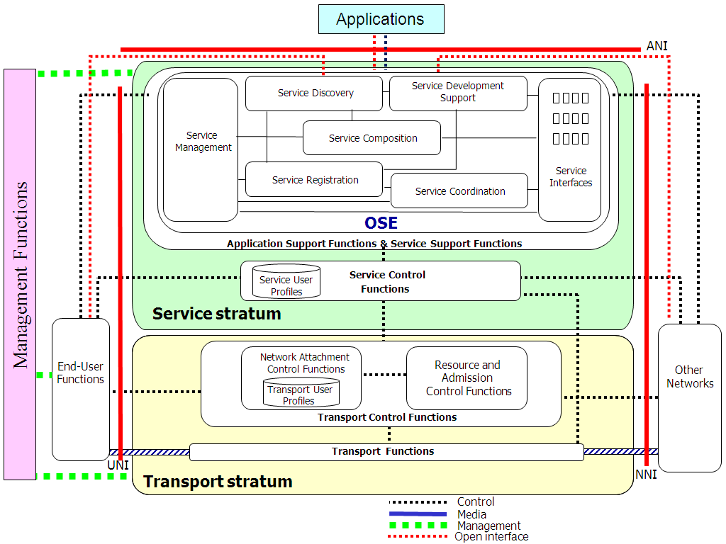
Figure A. Open Service Environment in NGN
Also, the IPTV functional architecture may be based on use of existing network components and technologies, as well as on NGN architectures. And the open interface is intended to stimulate the development of an innovative IPTV service by the 3rd party service provider who does not operate the network components required for IPTV functionality. The figure B shows NGN architecture for transport and service configuration [FG IPTV-DOC-115].

. 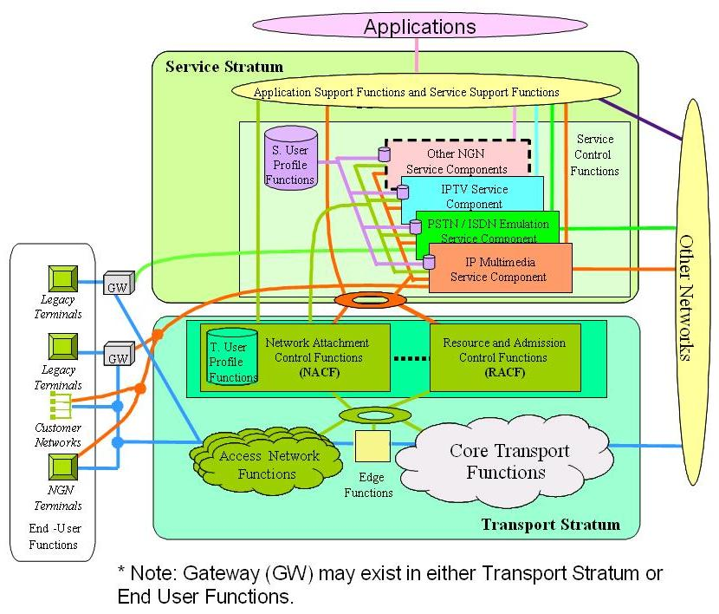
Figure B. NGN Architecture with transport and service configuration

From above assumptions, it is able to develop new kinds of IPTV services model and scenario in NGN through open and standard interfaces where IPTV applications in NGN could be implemented with unified interfaces and could also be utilized with various 3rd party applications. Especially, since IPTV service capabilities could be used from inside and outside of NGN openly manner, it facilitates cost effective development of IPTV service.
Hence, it would be useful to provide the NGN OSE-based Open IPTV service model and scenarios.
Proposed Scenario

- Open IPTV Service

  - Open IPTV Service over NGN Open Service Environment
Open IPTV service is an extended and advanced IPTV service which is implemented by open and standard interfaces for IPTV service. It allows service provider include 3rd party service provider who does not operate the network components required for IPTV functionalities to use the IPTV service functions as well as other NGN capabilities.
NGN open service environment (OSE) capabilities can be used to support open interface for IPTV. With this, it is possible to make open interface for various IPTV related function in NGN. NGN OSE has much capability to support various service operations such as service development support, service coordination, service discovery, service management, service composition, service registration and interworking between service creation environments [ITU-T Y.ngn-openenv].
Open IPTV service can be implemented by NGN OSE which will provide efficient and flexible capabilities based on the use of standard interfaces to IPTV applications as well as NGN application and user services, thereby enabling IPTV applications to implement services that use NGN capabilities.
With unified open and standard IPTV interfaces over NGN OSE, Open IPTV service also allows application developer to implement the IPTV applications with interoperability, reusability and portability.

  - Open IPTV Service Model
Open IPTV service model is based on the NGN architecture basically. Figure 1 shows the reference NGN architecture for Open IPTV service.
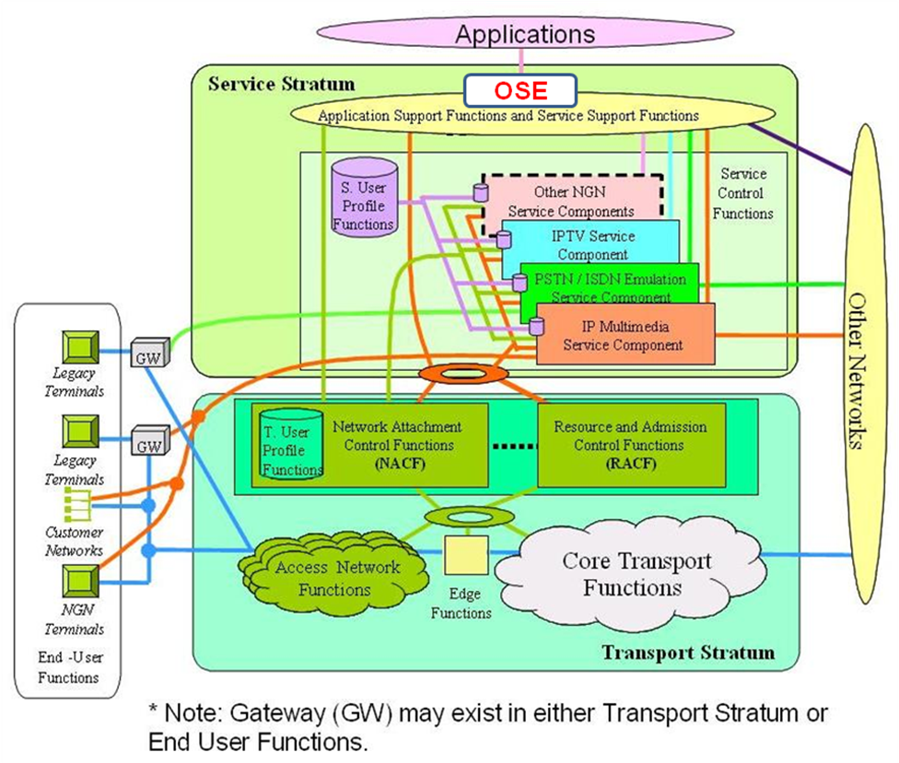
Figure 1: Reference NGN architecture for Open IPTV service

With OSE capabilities, Open IPTV Service has benefits as followings:
- Benefits of Open IPTV Service
  - It enables service provider to use IPTV service components as well as NGN capabilities with open and standard interfaces.
  - It enables service provider to implement the IPTV service very easily and quickly so that the IPTV service can be delivered with cost effective & on-the-fly manner.
  - It enables service provider to deliver the IPTV service without IPTV core service component in NGN.
  - It enables IPTV terminal to access IPTV application with unified interfaces so that IPTV service has a user terminal independent capabilities.
  - It enables application developer to implement the IPTV service with interoperability, reusability and portability.
  - It enables IPTV service to support the interoperability among various IPTV services in NGN.
  - It enables IPTV service to implement an innovative IPTV service by the 3rd party service provider.

From the IPTV service architecture [FG IPTV-DOC-115], NGN OSE-based Open IPTV service model can be derived by OSE capabilities as shown in figure 2. All the interactions with service support functions, service support functions, content delivery functions and IPTV terminal function as well as content provider function and management functions could be exposed with unified and openly manner. Therefore, in OSE-based Open IPTV service model, it can support both IPTV application and 3rd party IPTV application without any other gateway or proxy function in application functions.
Figure 2: NGN OSE-based Open IPTV service model
  - Open IPTV Service Scenario
(TBD)
[Notes:] High-level service scenario will be described here based on the Open IPTV service model. Related contributions are welcomed to make more relevant scenarios.

Proposal
We suggest that the proposed Open IPTV service and model is included as a new type of service scenario to WG1 Working Document: IPTV service scenario (FG IPTV-DOC-0116).

References
[ITU-T Y.2201] ITU-T Recommendation Y.2201 (2006), NGN release 1 requirements
[ITU-T Y.ngn-openenv] Open service environment capabilities for NGN applications and user services
[FG IPTV-DOC-115] FG IPTV WG1 Working Document: IPTV Architecture (5th FG IPTV meeting)
[FG IPTV-DOC-116] FG IPTV WG1 Working Document: IPTV Service Scenarios (5th FG IPTV meeting)
_______________

