INTERNATIONAL TELECOMMUNICATION UNION |  |  |  | Focus Group On IPTV
TELECOMMUNICATION  STANDARDIZATION SECTOR  STUDY PERIOD 2005-2008 |  |  | FG IPTV-C-0979
 |  |  | English only
WG(s):4 |  | 6th FG IPTV meeting:  Tokyo, Japan, 15-19 October 2007
CONTRIBUTION
Source: | ETRI
Title: | Editorial Revision of Section 11 (11. Overlay multicast networking) of Working Document (FG IPTV-DOC-0124)
The contribution proposes the editorial revision for Section 11 (11. Overlay multicast networking) of Working Document (FG IPTV-DOC-0124).

Overlay multicast networking

Control framework for IPTV service level multicast
Service Level Multicast constructs and manages logical multicast path to to support internet group application services over the unicast/multicast network. After exchange of control messages for service level multicast, a multicast data delivery path is constructed over physical transport network, and a logical multicast control path will be created by using multiple end hosts. Along the logical delivery path for real-time or reliable data transport, service level multicast function is performed with cooperation among upstream and downstream IMAs at service level. Only after the physical data delivery path is established via service level multicast control, IPTV applications can work as if they were in a native IPTV multicast network.
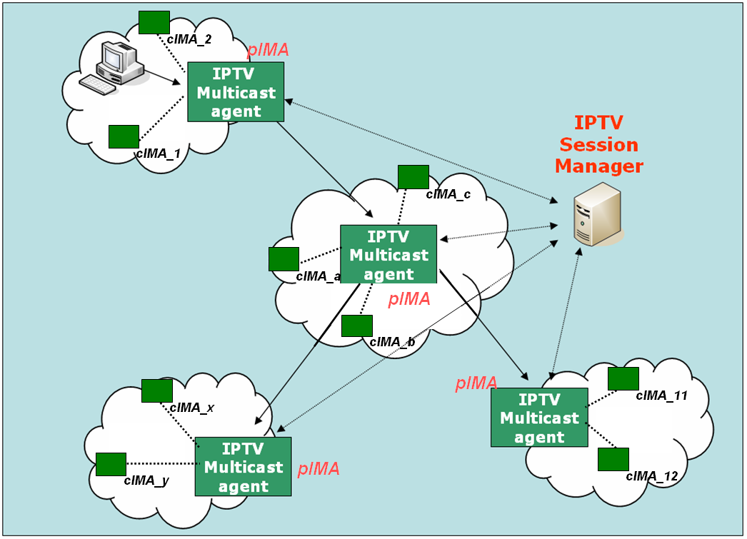
Figure 1 - Functional Architecture for Service Level Multicast Capabilities for IPTV

IPTV Session Manager (ISM)
ISM is involved in session configuration and maintenance for IPTV service flows. A single ISM can handle one or multiple sessions simultaneously, and it can provide the following functionalities:
- Session initialization: ISM allocates ISID (IPTV Session ID) for new session.
- Session release: Session can be released as needed.
- Session membership management
- Session status monitoring: this function enables reporting of the status of data channel, monitoring of data throughput, gathering multicast protocol topology information

IPTV Multicast Agent ( IMA )
IMA constructs overlay multicast delivery path over physical transport path, and forwards data along the constructed physical transport path. An IMA consists of two functional modules, multicast control module and multicast session control module. The main function of former is to establish multicast delivery path and that of latter to setup multicast session along the paths constructed by multicast session control module. IMA performs the control functions to exchange control messages with other entities. Its major functions are as follows.
- Session join: each IMA contacts with Session Manager.
- Session leave: when an IMA wants leave the session, it gives notice to pIMAs and cIMAs
- Session maintenance: relay request and its response will be exchanged between the two IMAs periodically.
- Loop detection & avoidance
- Partitioning detection & recovering
- Parent switching
- IPTV Session status reporting
In order to perform service level multicast of IPTV streaming applications, the functional blocks for IPTV service control are shown as Figure 2.
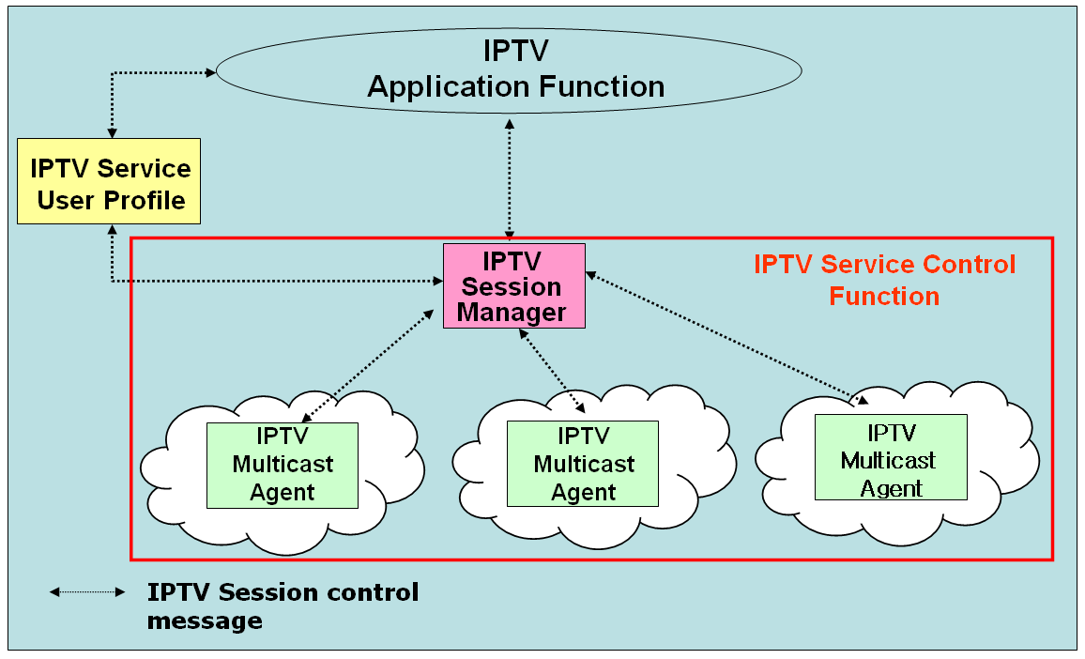

Figure 2 - Functional blocks of IPTV session control for IPTV application services

Media signalling proxy
Media signalling proxy is a function to get media status in overlay multicast network by transfer media connection signalling between end hosts and obtain media session status of end hosts.
In order to get media status of overlay multicast network, media signalling proxy is recommeded to be supported by IPTV overlay multicast system. Figure 3 shows how media signalling proxy operates.
Figure 3 - Media Signalling proxy

Overlay IPTV multicast control
Although IP multicast has not deployed globally, a lot of local networks have already been equipped with IP multicast transport. Ethernet-based LANs and private networks such as corporate and campus networks substantially provide the multicast transport capability within their local subnet or administrative domains. Recognizing these observations, there is a crucial need to use an alternative multicast delivery scheme for IPTV service. IPTV overlay networking for multicast will be an alternative solution to provide actually clinging to replicate unicast/multicast method on servers. It makes good use of existing unicast, multicast and/or multicast tunnelling schemes for diverse IPTV services (e.g., various types of group applications).
The overlay multicast control function for IPTV supports overlay session control function over physical transport network. To support the scalable session control function for overlay multicast, a hierarchical overlay multicast control will be introduced as shown in Figure 20..
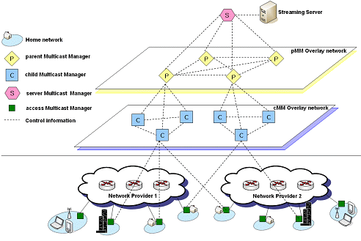

Figure 4 – Hierarchical structure of overlay IPTV multicast control

Control Function for IPTV overlay multicast
The control mechanism for IPTV overlay multicast creates/changes multicast session topology according to service requirements, network provider’s requirement, service provider’s requirement, user’s requirement and others. The IPTV overlay multicast requires control functions to support optimization of overlay routing, resource control and QoS support. Addition/deletion/changeof multicast session for additional IPTV service users can be controlled by modification of logical delivery path in IPTV overlay network.

Group membership management
The group membership for IPTV overlay multicast considers group size, number of group member and rate of group membership change.
- Group Membership Control: It is a function that provides mechanisms to join and leave group for IPTV overlay multicast. It may also provide the function to create or maintain the multicast groups.
- Group Partitioning: It is necessary to optimize the multicast efficiency by sub-grouping to underlying physical transport networks. Two optimization approaches to realize the group partitioning in IPTV overlay multicast will be introduced to support the following functions.
- Global group partitioning: The global group partitioning optimizes the resource usage of local network. If a multicast group in the physical transport network is experiencing serious traffic explosion temporarily, the control function of IPTV overlay multicast will be able to make a global group into multiple sub-groups to avoid the problems.
- Server group partitioning: In order to avoid performance degradation of IPTV servers, the server group partitioning will be introduced to optimize the resource usage of server network. The partitioning is performed by IPTV overlay multicast control function.

Admission control for QoS in IPTV overlay multicast network
In order to support QoS for IPTV services in overlay multicast network, resource control function for IPTV overlay network will perform resource management and admission control function in IPTV overlay multicast network.

Security for IPTV overlay multicast
IPTV overlay multicast uses shared network resource and multiple distributed overlay resources to transport data. When a user requests IPTV service, security process needs for IPTV overlay multicast function.
Overlay multicast confronts with various vulnerabilities and risks that impede from being widely deployed in mission critical business systems and applications. There are three important security challenges for the overlay network service model: Confidentiality and Integrity, Authenticity, and Availability. These three important security challenges can be classified with some properties for architectures and algorithms for building secure and scaleable information dissemination services on wide area overlay networks.

Node functions for IPTV overlay routing
An overlay multicast node function will be designated to perform overlay routing, contents location control and distribution control function for IPTV services. The designated node has full knowledge of other multicast node in the session, information on contents server and distribution control information.. In order to keep the updated information on multicast nodes, state updates occur periodically via broadcasting among all multicast nodes.

An overlay multicast node will provide few information to provide the requirements for overlay multicast resource control.
- Logical ID Assignment for overlay nodes: The overlay nodes will perform an identification function with session ID according to region or overlay IPTV service etc.
- Logical ID Assignment for contents server
- IPTV overlay multicast management function: The overlay node will collect and stores information on overlay networking management, and selects neighbour overlay nodes to exchange the information.

QoS control at overlay multicast network for IPTV services

Functional position of resource control
If the information on IPTV transport networks is directly collected and managed by IPTV overlay nodes to establish overlay transport route and configuration session topology, it will be serious burden to handle overheads in IPTV overlay networks. It is assumed that resource control functions for IPTV overlay network is located between IPTV overlay network and physical transport network, and it performs collection of information about network resource and provides QoS control to transport network.
As shown in Figure 5, it is necessary that resource control function is introduced to provide interface function for IPTV overlay multicast QoS control between physical transport and IPTV overlay network. This function performs collection and management of transport network resource (e.g., DiffServ) via specified interface (e.g. SNMP). And overlay network nodes create tree topology and optimized route to support QoS requirements of IPTV users through information collected by Resource Control function. And RCF can have the interfaces such as COPS, Diameter and H.248 to install/uninstall the policy decision for transport network The interface between overlay network and RCF will be further study. The interface may be proprietary of IPTV service providers.

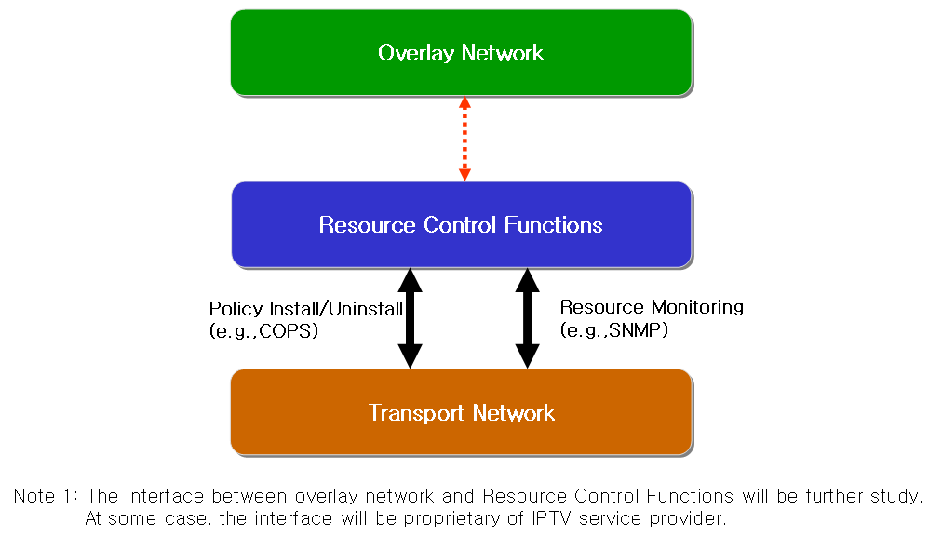

Figure 5 - Resource control architecture in IPTV overlay network

Resource control function
The requirements for resource control are as follows
- The Resource Control Function will collect information for resource control from transport network with periodic or aperiodic. According to initiation of overlay network nodes, Resource Control function collects data for resource and QoS control.
- Resource control should be able to communicate with Resource Control Function in heterogeneous or other network.
- The following information collected is transferred to overlay network, and then overlay network creates route and optimized tree to support QoS for IPTV overlay network.
- Link State Information: it includes available bandwidth information, delay, packet loss and jitter of link.
- Routing Information: it includes routing algorithm that is used to transport network equipments and routing information of them (e.g. neighbour routing information, routing table .etc)
- Multicast Traffic Information: it includes multicast traffic parameters (e.g. channel information, type of service, user profile, source content information) per channel or session of IPTV multicast.

Resource control function for IPTV overlay multicast QoS in wired/wireless/mobile networks.
The Session Manager configures routes among IPTV overlay network nodes and optimizes tree topology for multicast sessions according to information of Resource Control Function. RCF has resource information from transport network such as link state information, routing information, multicast traffic information and so on. Session manager requests the resource information in transport network to RCF. RCF verifies the resource status based on gathered information, and makes the policy decision for the request. Session manager confirms the received message from RCF, and compares with service information. Then session manager sends the policy installing request message to RCF. After receiving the policy request message, RCF sends the policy installing request message to transport network through the configured path for overlay network. Figure 6 shows the application of Resource Control Function in wired/wireless/mobile networks for IPTV overlay multicast QoS control.

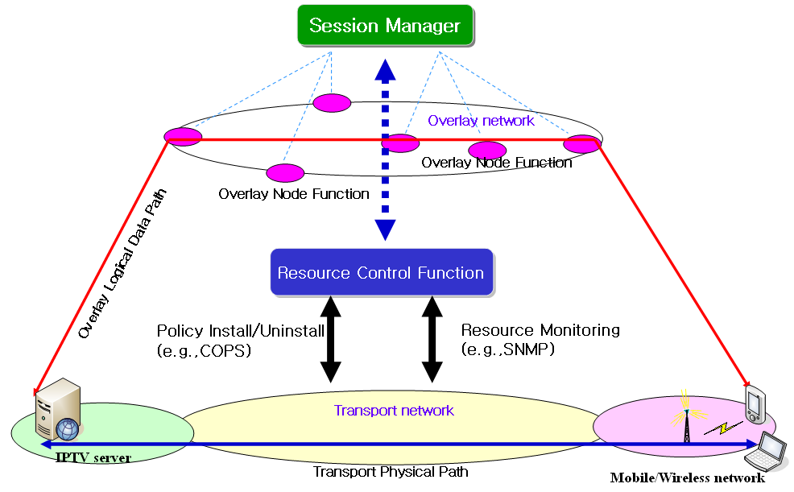

Figure 6 Application of resource control function in wired/wireless/mobile networks for IPTV overlay multicast QoS control

Network measurement function
In order to ensure high end-to-end service quality of the IPTV services, IPTV overlay multicast measurement system needs to be deployed to measure the IP network performance, e.g. bandwidth, packet loss between overlay nodes such that the appropriate overlay path is selected.
As part of resource control, network measurement includes receiving interface, measurement interface and forwarding interface. Receiving interface receives measurement requests from session manager and forwards them to measurement interface. Measurement interface measures the network performance between network nodes and forwards the results to forwarding interface. Forwarding interface sends the results to overlay network or other network measurement to share information.

