Abstract
INTERNATIONAL TELECOMMUNICATION UNION |  |  |  | Focus Group On IPTV
TELECOMMUNICATION  STANDARDIZATION SECTOR  STUDY PERIOD 2005-2008 |  |  | FG IPTV-C-1101
 |  |  | English only
WG(s): 1, 4, 6 |  | 7th FG IPTV meeting:  Qawra, St. Paul’s Bay, Malta, 11-18 December 2007
CONTRIBUTION
Source: | France Telecom (France)
Title: | Comments on WG6 DOC-0161: IPTV Middleware, Applications and Content Platforms and WG4 DOC-0156: IPTV Network Control Aspects on Service Discovery
This contribution aims at improving the section on "Service discovery".

Proposal
DOC-0161 addresses in Section 13 the Service Discovery issue. However more specification is needed.
There are several steps in the Service Discovery:
- step 1: discovery of IPTV Service Provider Description entry points
- step 2: acquisition of IPTV Service Provider Description and IPTV Service Provider selection
- step 3: acquisition of IPTV Service Description and IPTV Service Selection
- step 4: service selection and acquisition
Step 1 should be dealt with in WG1 or WG4 (IPTV network control aspects)
Step 2 and 3 should be dealt with in WG6.
Step 4 is not addressed here but is the logical step after step 3, when available services discovered in step 3 are made visible for the end-user selection.

Step 1. Discovery of IPTV Service Provider Description entry points.
When the Terminal Device get attached to the network, it has to know from where to get the description of the IPTV Service Providers available to it. This is what is called an entry point.
An IPTV Service Provider Description entry point can be a multicast or a unicast address.

There are different ways for the Terminal Device to get IPTV Service Provider Description entry points:
- A well known multicast address registered with IANA,
- Starting with an entry point address provisioned in the Terminal Device Configuration Data
- Starting with a domain name in the Terminal Device Configuration Data and using DNS to acquire entry point addresses
- At network connection, with DHCP, the Terminal Device might be provided with domain names to be used to acquire entry point addresses via DNS

2. Acquisition of IPTV Service Provider Description
Depending on the entry point type, the Terminal Device will issue an HTTP, S-HTTP or IGMP request as follows to get information about IPTV Service providers:
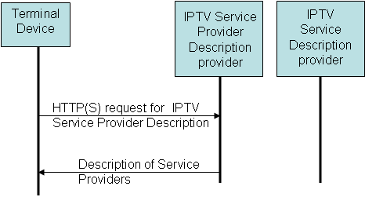
Figure 1. Http(s) request for IPTV Service Provider Description
In this case the Service Provider Description Provider may answer with a set of metadata containing the description of the available Service Providers.

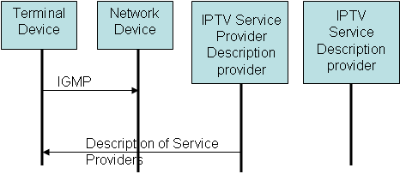
Figure 2. IGMP request to receive IPTV Service Provider Description
In this case the Service Provider Description Provider sends periodically the set of metadata containing the description of the available Service Providers.
The information about IPTV Service Providers may contain for each service provider:
- Unique Service Provider Identifier (e.g. a domain name)
- Service Provider Name in different languages
- Service Provider Description in different languages
- Entry point to get Service Description
This is a limited information which does not include description of the Services provided by these Service Providers.

2. Acquisition of IPTV Service Description
Recognizing the Service Provider you are subscribed to or after user selection, then the Terminal Device will send an HTTP, S-HTTP or IGMP request as follows to get information about the IPTV Services available from the selected Service Provider.
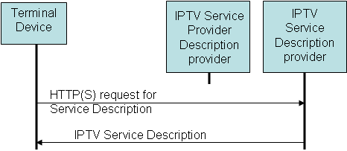
Figure 3. Http(s) request for IPTV Service Description
The IPTV Service Provider Description Provider and the Service Description Provider can be merged in some configurations.
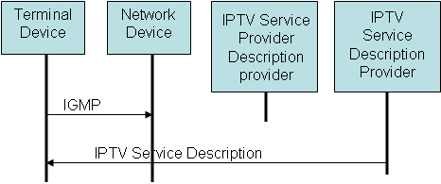
Figure 4. IGMP request to receive IPTV Service Description

3. Gap analysis
3.1. Standards for Entry Point Discovery
- ETSI TS 102034: Digital Video Broadcasting (DVB); Transport of MPEG-2 Based DVB Services over IP Based Networks.
  - In this specification several ways to discover entry point addresses for non-IMS Terminal Device are described.

3.2. Standards for Service Provider Description
- ETSI TS 102034: Digital Video Broadcasting (DVB); Transport of MPEG-2 Based DVB Services over IP Based Networks.
  - In this specification the "Service Provider Description" is encoded in the "Service provider Discovery Record"

3.3. Standards for Service Description
- ETSI TS 102034: Digital Video Broadcasting (DVB); Transport of MPEG-2 Based DVB Services over IP Based Networks.
  - In this specification the "Service Description" is encoded in the "Broadcast Discovery Record" and in the "Content on Demand Discovery Record"

3.4. Standards for the delivery of Service Provider Description and Service Description
- ETSI TS 102034: Digital Video Broadcasting (DVB); Transport of MPEG-2 Based DVB Services over IP Based Networks. This specification includes:
  - Protocol for Multicast Delivery of SD&S (Service Discovery & Selection)
  - Protocol for Unicast Delivery of SD&S Information

___________________

