INTERNATIONAL TELECOMMUNICATION UNION |  |  |  | Focus Group On IPTV
TELECOMMUNICATION  STANDARDIZATION SECTOR  STUDY PERIOD 2005-2008 |  |  | FG IPTV-C-1115
 |  |  | English only
WG(s): 4 |  | 7th FG IPTV meeting:  Qawra, St Paul’s Bay, Malta, 11-18 December 2007
CONTRIBUTION
Source: | ETRI
Title: | Revision of Appendix II for “IPTV Multicast Frameworks” Document ( FG IPTV-DOC-0157)
The revised Appendix II for the document “IPTV Multicast Frameworks (FG IPTV-DOC-0157)” is proposed as follows.

------------------------------------------
APPENDIX II
Procedure to provide QoS and Resource Control Functions for IPTV Overlay Multicast

II.1 Resource Control Functional
If the information on IPTV transport networks is directly collected and managed by IPTV overlay nodes to establish overlay transport route and configuration session topology, it will be serious burden to handle overheads in IPTV overlay networks. It is assumed that resource control functions for IPTV overlay network is located between IPTV overlay network and physical transport network, and it performs collection of information about network resource and provides QoS control to transport network.
As shown in figure II-1 it is necessary that resource control function is introduced to provide interface function for IPTV overlay multicast QoS control between physical transport and IPTV overlay network. This function performs collection and management of transport network resource (e.g., DiffServ) via specified interface (e.g. SNMP). And overlay network nodes create tree topology and optimized route to support QoS requirements of IPTV users through information collected by Resource Control function. And RCF can have the interfaces such as COPS, Diameter and H.248 to install/uninstall the policy decision for transport network. The interface between overlay network and RCF will be further study, and its interface may be proprietary of IPTV service providers.

The requirements for resource control are as follows
- The Resource Control Function will collect information for resource control from transport network with periodic or a periodic. According to initiation of overlay network nodes, Resource Control function collects data for resource and QoS control.
- Resource control should be able to communicate with Resource Control Function in heterogeneous or other network.
- The following information collected is transferred to overlay network, and then overlay network creates route and optimized tree to support QoS for IPTV overlay network.
- Link State Information: it includes available bandwidth information, delay, packet loss and jitter of link.
- Routing Information: it includes routing algorithm that is used to transport network equipments and routing information of them (e.g. neighbour routing information, routing table .etc)
- Multicast Traffic Information: it includes multicast traffic parameters (e.g. channel information, type of service, user profile, source content information) per channel or session of IPTV multicast.

II.2 Resource control function for IPTV overlay multicast QoS in wired/wireless/mobile networks.
The Session Manager configures routes among IPTV overlay network nodes and optimizes tree topology for multicast sessions according to information of Resource Control Function. RCF has resource information from transport network such as link state information, routing information, multicast traffic information and so on. Session manager requests the resource information in transport network to RCF. RCF verifies the resource status based on gathered information, and makes the policy decision for the request. Session manager confirms the received message from RCF, and compares with service information. Then session manager sends the policy installing request message to RCF. After receiving the policy request message, RCF sends the policy installing request message to transport network through the configured path for overlay network. Figure II-1 shows the application of Resource Control Function in wired/wireless/mobile networks for IPTV overlay multicast QoS control.

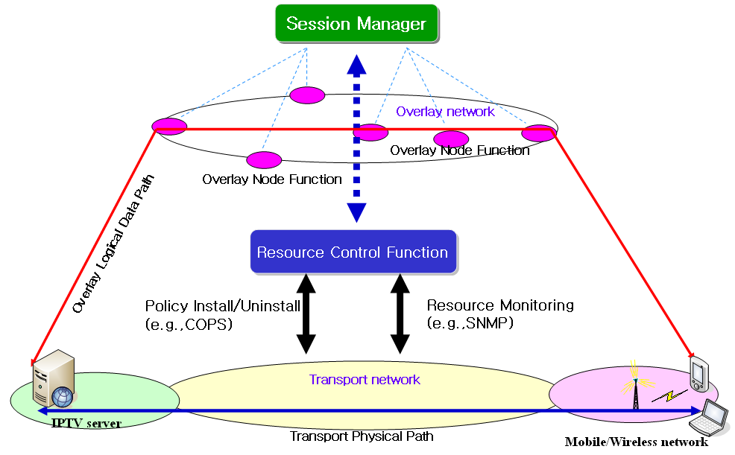

Figure II-1 Application of resource control function in wired/wireless/mobile networks for IPTV overlay multicast QoS control

II.3 Procedure to provide QoS and Resource Control Functions for IPTV Overlay Multicast
When Session Manger requests information on overlay networking paths to Resource Control Function, and Resource Control Function collects the transport network information using SNMP. Resource Control provides the QoS and resource information of transport networks to Session Manager. In order to compromise the requested requirements on QoS and resource availability of IPTV overlay multicast paths, Session Manager may re-negotiate with Resource Control Function. If the provisioning of Resource Control Function is not satisfied by Session Manager, it is ignored and discarded. Figure II.12shows procedure to create IPTV overlay multicast service to be with QoS requirements of IPTV overlay multicast paths in IPTV overlay network.

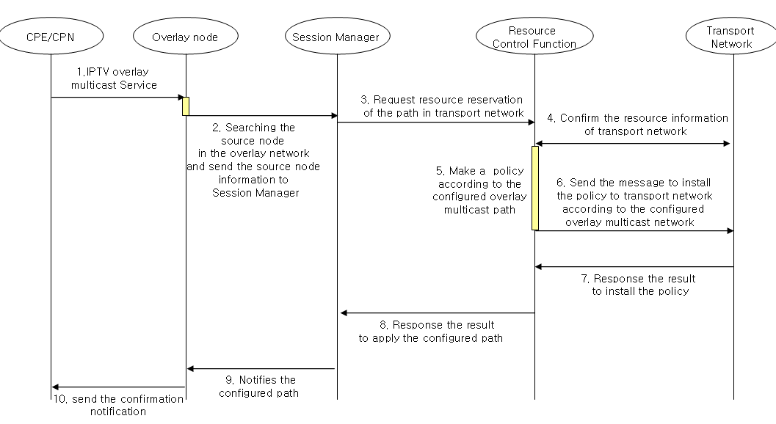
Figure II.2 - Procedure to create overlay multicast paths with Resource Reservation and Control in IPTV Overlay Network
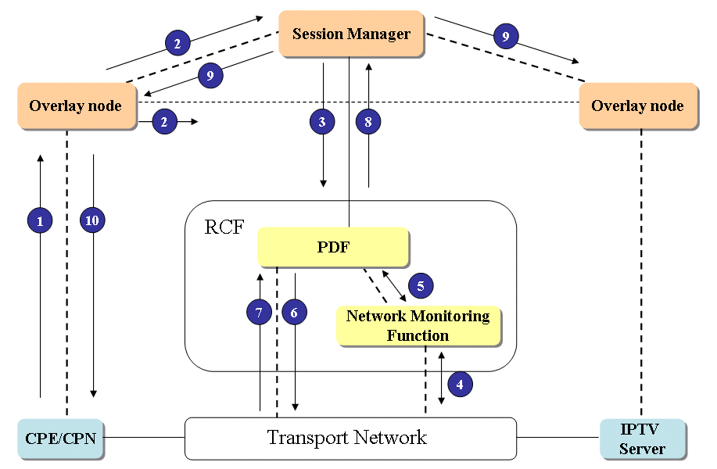
Figure II.3 – Procedure to exchange control information for provision of QoS and resource management in IPTV Overlay Network.
Figure II.3 shows an example of procedure to exchange control information for provision of QoS and resource management in IPTV Overlay Network (the same procedure of Figure II.2 is likely to Figure II.2). The RCF in IPTV Overlay Network will have similar function with Policy Decision Function. PDF performs control function based on the policies from network provider, service provider or service control function to provide QoS and resource control function to IPTV information delivery path.
The request for resource reservation and QoS control function on physical transport paths, which are mapped with logical paths in IPTV overlay network, is initiated by Session Manager, and delivered to PDF in RCF. PDF installs the policies on physical transport network, and it performs resource control function on the physical paths. The procedures in Figure II.1 and Figure II.2 are as follow.
- When IPTV overlay multicast is requested from CPE/CPN, overlay node search the originating node of contents, and forwards the information of the originating node to Session Manager. (①~②)
- Session Manager requests the Resource Control Function for the paths in accordance with IPTV session and service requirements. (③)
- If the requested requirements are met with the physical transport network, Resource Control Function confirms the resource reservation of the transport network, and applies a policy in accordance with the requests of Session Manager. (④~⑤)
- Resource Control Function sends the message to install the policy to transport network according to configured overlay multicast paths. (⑥~⑦)
- Session Manager notifies the configured path to overlay node and confirmation notification will be sent to the CPE/CPN. (⑨~⑩)

_______

