INTERNATIONAL TELECOMMUNICATION UNION |  |  |  | Focus Group On IPTV
TELECOMMUNICATION  STANDARDIZATION SECTOR  STUDY PERIOD 2005-2008 |  |  | FG IPTV-C-1118
 |  |  | English only
WG(s): 2, 4 |  | 7th FG IPTV meeting:  Qawra, St Paul’s Bay, Malta, 11-18 December 2007
CONTRIBUTION
Source: | Digital Fountain
Title: | IPTV-related Protocols for Application Layer Error Recovery Mechanisms
ABSTRACT
This document proposes to update the document on IPTV-related Protocols with the protocols in the working document on “Application Layer Error Recovery Mechanisms.”

1 Introduction
The WG2 of the IPTV FG on IPTV has drafted a Working Document on “Application Layer Error Recovery Mechanisms.” The document includes different mechanisms for the recovery of lost packets, especially if the IPTV network functions cannot provide sufficient QoS. Application Layer Error Recovery Mechanisms are included in IPTV-related protocol. This document proposes to update the IPTV-related Protocols related working document with the relevant protocols. As the IPTV-related protocol document is not yet progressed significantly, Digital Fountain as the editor of this document offers to work on the integration of the relevant protocol during the Malta meeting.

2 Background
To provide some background information, Figure 1 provides an overview on Application Layer Forward Error Correction (AL-FEC) integrated in IPTV-related protocols. Prominently the IETF has defined components and protocols, which allow delivering files or streaming content to single or multiple/many users in parallel over IP transport bearers. However, also other bodies have combined and extended IETF tools with other tools to provide successful service delivery.
In most deployed IPTV LMB services, audio/video (A/V) streams are multiplexed into an MPEG-2 Transport Stream. The resulting MPEG-2 packets are encapsulated either directly in UDP or in RTP/UDP. The use of Real-Time Transport Control Protocol (RTCP) allows sending information to receivers about transmission statistics, and IGMP provides means to join and leave multicast streams. Especially Mobile IPTV services rely commonly on direct encapsulation of A/V streams into media specific RTP payload formats. The Real-Time Streaming Protocol (RTSP) may be used for control of the delivery of broadcast TV and audio programs as well as for on-demand and download delivery.
For non-real time services, the A/V streams are multiplexed and encapsulated in a file format (FF), which after being downloaded, permits for local playback. For the transport of such multimedia files in download delivery services TCP/IP may be used. For the case of file distribution over IP multicast the IETF has specified a File Delivery over Unidirectional Transport (FLUTE) protocol for unidirectional file delivery. FLUTE provides mechanisms to signal and map the properties of a file to the Layered Control Transport (LCT) and the Asynchronous Layered Coding (ALC) protocol such that receivers can extract all relevant file parameters from the received files.
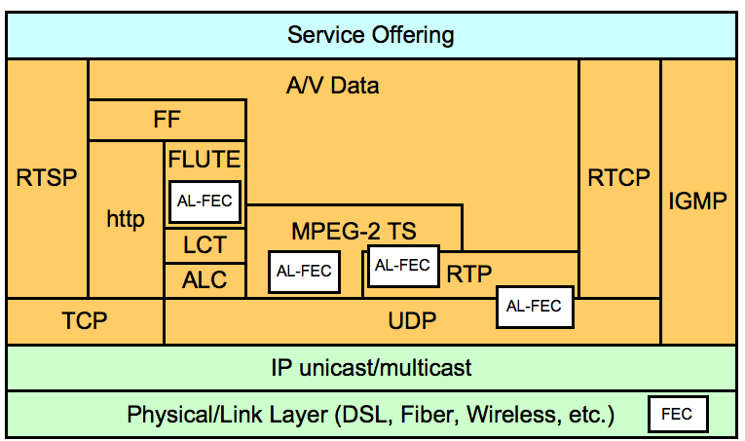
Figure 1 Application Layer FEC in IPTV-related Protocols

3 Proposal
It is proposed to add the Application Layer Error Recovery Protocols relevant for IPTV in an appropriate form to the Working Document on “IPTV-related protocols”. Digital Fountain as the editor of the application layer reliability document offers to work on the integration of the relevant protocols during the Malta meeting. For easier processing the WD on “Application Layer Error Recovery Mechanism” is embedded.
In addition, it is proposed to integrate the AL-FEC relevant configuration information into the relevant IPTV-related protocol document. The configuration information currently in the living list for application layer error recovery mechanisms, see document T05-FG.IPTV-DOC-0153. The relevant item is provided below:

Item 9 (added 6th Meeting of ITU-T FG IPTV, Tokyo): Signalling and Control Information for DVB-IP AL-FEC mechanism
Source: FG IPTV-C-1000, Digital Fountain, “Signalling and Control Information for DVB-IP AL-FEC mechanism”
The ITU-T FG IPTV does not yet define a full set of content delivery protocols, i.e. the control and transport protocols are still under review. However, it quite likely that the media will be transported either through MPEG-2 TS over RTP/UDP or by generic audio/video streams. Therefore, DVB AL-FEC solution likely covers the expected transport protocols.
With respect to control protocols, the details to support the AL-FEC mechanism need to be specified at this point, but it is essential to understand what control information needs to be transported for the AL-FEC, once the content delivery protocol more clearly defined.
For the control protocols, it is proposed to use the same semantics for the ITU-T FG IPTV AL-FEC as for the DVB-IP AL-FEC solution as specified in section E.6. The details on the syntax still need to be defined.
The following information may be necessary to be conveyed for the AL-FEC (see also [ETSI TS 102 034]):

FEC Base Address
In the multicast case, this option may be included in messages from server to client. It indicates the IP Multicast address on which the base AL-FEC layer may be found. If not included then the base AL-FEC layer is sent on the same multicast address as the source data.

FEC Base Port
This option may be included in messages from server to client and from client to server. It indicates the UDP destination port for the base AL-FEC layer. When included in a message from client to server, it indicates that AL-FEC is supported by the client and specifies the destination UDP port that should be used for the AL-FEC base layer. When included in a message from server to client, it indicates the UDP destination port that the server will use for the AL-FEC base layer. In the multicast case, if this option is specified but the FEC Base Address is not, then the AL-FEC layer is assumed to be available on the same multicast address as the main stream. If this header is not specified then AL-FEC is not provided and the FEC Base Address shall not be present. This header shall be present if the FEC Enhance Port header is present.

FEC Enhance Address
In the multicast case, this option may be included in messages from server to client. It indicates the IP Multicast address on which an enhancement AL-FEC layer may be found. This option may be repeated to specify multiple enhancement layers.

FEC Enhance Port
This option may be included in messages from server to client and from client to server. It indicates the UDP destination port for the enhancement AL-FEC layer. When included in a message from client to server, it indicates that the AL-FEC enhancement layer is supported by the client and specifies the destination UDP port that should be used for the AL-FEC enhancement layer. When included in a message from server to client, it indicates the UDP destination port that the server will use for the AL-FEC enhancement layer. In the multicast case, if this option is specified but the FEC Enhance Address is not, then the AL-FEC enhancement layer is assumed to be available on the same multicast address as the main stream. If this header is not specified then AL-FEC enhancement is not provided and the FEC Enhance Address shall not be present. This header shall only be present if the FEC Base Port Layer header is present.

FEC MaxBlockSize
This indicates the maximum number of stream source packets that will occur between the first packet of a source block (which is included) and the last packet for that source block (source or repair).

FEC MaxBlockTime
This indicates the maximum sending duration of any AL-FEC block in milliseconds.

FEC OTI
This indicates the FEC Object Transmission Information for the Raptor AL-FEC layer(s).

A specific syntax for transporting this information can be found in [ETSI TS 102 034]
______________

