INTERNATIONAL TELECOMMUNICATION UNION |  |  |  | Focus Group On IPTV
TELECOMMUNICATION  STANDARDIZATION SECTOR  STUDY PERIOD 2005-2008 |  |  | FG IPTV-DOC-0066
 |  |  | English only
WG(s): 2 |  | 3rd FG IPTV meeting:  Mountain View, 22–26 January 2007
OUTPUT DOCUMENT
Source: | Editor
Title: | Working document - Performance monitoring for IPTV
Performance monitoring for IPTV
Summary
TBD
Keywords
TBD
Introduction
TBD
Contents
1. Scope 3
2. References 3
3. Definitions 3
4. Abbreviations 4
5. Conventions 4
6. Monitor Points 4
6.1. Point 1 – PT1 5
6.2. Point 2 – PT2 5
6.3. Point 3 – PT3 6
6.4. Point 4 – PT4 6
6.5. Point 5 – PT5 6
7. Monitoring Parameters 6
7.1. Service Parameters 6
7.2. Channel Parameters 7
7.3. Network Parameters 7
8. Monitoring methods 8
8.1. Generalized Monitoring Method for multi-media data based on transmission packet loss 8
8.2. Bearer Network Monitoring 10
8.3. Network Performance Monitoring 10
8.4. IPTV Service Attribute Monitoring 10
8.5. Video Quality Monitoring 10
8.6. Audio Quality Monitoring 14
8.7. Ancillary Attribute Monitoring 14

Scope
This working document defines performance monitoring for IPTV. Monitoring parameters, monitoring points and monitoring methods are defined that allow the service provider/network operator to monitor the performance of the service delivery to the end user.
What does “performance monitoring for IPTV” mean, anyway? [ed. Subject for future contributions]
QoS is an important consideration for the network operator and QoE is more important to the end user.

References
The following ITU-T Recommendations and other references contain provisions, which, through reference in this text, constitute provisions of this working document. At the time of publication, the editions indicated were valid. All Recommendations and other references are subject to revision; users of this working document are therefore encouraged to investigate the possibility of applying the most recent edition of the Recommendations and other references listed below. A list of the currently valid ITU-T Recommendations is regularly published.
The reference to a document within this working document does not give it, as a stand-alone document, the status of a Recommendation

[editor comment: The reference numbers need to be fixed still]
[Y.1540] ITU-T Recommendation Y.1540 (yyyy), Internet protocol data communication service – IP packet transfer and availability performance parameters
[BT.500] ITU-R Recommendation ITU-R BT.500-11(yyyy), Methodology for the subjective assessment of the quality of television pictures
[D.97] ITU-T COM12 D.97 Packet Loss Distributions and Packet Loss Models
[E.800] ITU-T Recommendation E.800 (1994), Terms and Definitions Related to Quality of Service and Network Performance Including Dependability
[RFC2550] IETF RFC 2550 (1998), RTP Payload Format for MPEG 1 and MPEG 2 Video
[RFC3357] IETF RFC 3357 (August 2002). R. Koodli and R. Ravikanth, “One-way Loss Pattern Sample Metrics”.
[RFC3393] IETF RFC 3393 (2002), IP Packet Delay Variation Metric for IP Performance Metrics (IPPM)
[RFC3611] IETF RFC3611 RTCP Extended Reports (VoIP Metrics block)
[RFC3984] IETF RFC 3984 (2005), RTP Payload Format for H.264 Video
[TR126] DSL Forum draft specification TR-126 (yyyy), Triple Play Services Quality of Experience Requirements, V 1.0
[Y.1541] ITU-T Recommendation Y.1541 (2006), Network Performance Objectives for IP-based Services

Definitions
This working document uses or defines the following terms:
TBD

Abbreviations
This working document uses the following abbreviations.
BE Best Effort
FR Full Reference
I Interactive
IPDV IP Packet Delay Variation
IPER IP Error Rate
IPLR IP Packet Loss Rate
IPRR IP Reordering Ratio
IPTD IP Packet Transfer Delay
LL Low Loss
NR No Reference
RR Reduced Reference
RTI Real-Time Interactive
RTMU Real-Time Multicast & Unicast
U Unspecified
VoIP Voice over IP
VTC Video Teleconference

Conventions
TBD

Monitor Points
The entire content delivery chain can be divided into multiple domains. Operators at domain borders have the option to perform monitoring which, when taken together, form an end-to-end monitoring topology.
This domain approach is independent of any specific monitoring method (eg. RR).
Monitored performance characteristics, across a single domain or multiple domains, can be integrated with existing or new OSS and/or NMS systems.
The exact topology and domains will vary from one operator to another, however, monitoring can be applied at each domain boundary. An example topology with domain boundaries is shown in Figure 1. Different aspects can be monitored at each domain boundary as outlined below.

Editors note: Modification of the figure and following text is needed based on WG1 domain definitions
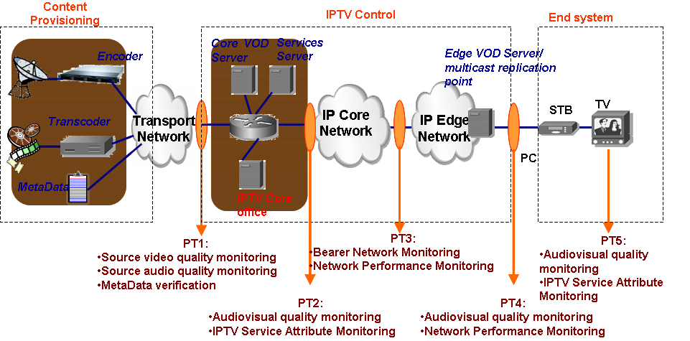Figure 1: Monitoring Points

Point 1 – PT1
This point demarcates the domain border between content provision and IPTV control. It should aim for source video quality monitoring, source audio quality monitoring, and metadata verification.

Point 2 – PT2
This point demarcates original streaming quality monitoring, such as Audiovisual quality monitoring, IPTV Service Attribute Monitoring, and metadata verification.

Point 3 – PT3
This point demarcates the IP Core and IP Edge networks where monitoring of IP-related performance parameters, such as Bearer Network Monitoring, Network Performance Monitoring are important.

Point 4 – PT4
This point is closest to the user where monitoring the quality of streaming, audiovisual quality, and IPTV Service Attribute Monitoring are important.

Point 5 – PT5
This point is at the final end point and directly relates to end user QoE. Monitoring audiovisual quality and IPTV Service Attribute Monitoring are important.

Monitoring Parameters

Service Parameters
Quality Television Service

Video
Audio
Meta Data

Parental control
EPG
Subtitles

Figure 2: Television Service Quality

Channel Line Up

Service Meta-Data (eg. EPG, Subtitles, Parental Control, etc.)

Channel Zap Time

Content on Demand (VOD/KOD) Request Performance

Channel Parameters

Channel Attributes

Perceptual Video Quality

Perceptual Audio Quality

Ancillary Channel Associated Attributes

Subtitles

Closed Captions

Descriptive Audio

Conditional Access/Scrambling Considerations

Network Parameters
[editor: The following might be optional however, they do form a collection of monitoring parameters. It still must be defined which are optional and mandatory]
Y.1540 defines parameters for network performance and RFC 3357 defines loss distance, loss period, loss noticeable rate, loss period length, and inter loss period length.
In addition to parameters above, the following parameters are also required for monitoring IPTV performance.

Link IP Layer Used Bandwidth.
Is defined as the sum of the IP layer bandwidth for all IP packet flows within in a link.

Link IP Layer Available Bandwidth.
Is defined as the maximum IP layer bandwidth which the link can provide without influencing other existing flows (background flows) in the link.
NOTE 1 – For a given link, the "Link IP Layer Available Bandwidth" plus the "Link IP Layer Used Bandwidth" is equal to the "Link IP Layer Bandwidth".
NOTE 2 – With the knowledge of the values of the above two parameters the network providers can determine the bandwidth utilization ratio of a link.

End-to-End IP Layer Bandwidth.
Is defined as the maximum IP layer bandwidth an end-to-end path can provide given no background flows exist along that end-to-end path. It can be also understood as equal to the lowest Link IP Layer Bandwidth along that end-to-end path, and hence the bottleneck along that path.

End-to-End IP Layer Available Bandwidth.
Is defined as the maximum IP layer bandwidth which an end-to-end path can provide without influencing other existing flows (background flows) along that path.

Loss run length distribution
Let $l_{i}$, i = 1, 2, … , n-1 denote the number of loss bursts of length i, where n-1 is the longest loss burst. L denotes the number of total lost packets (L > 0). The loss run length distribution can be calculated as $l_{i}$/L, i = 1, 2, … , n-1. [RFC3357]

Error-free interval distribution
Let $f_{i}$, i = 1, 2, … , n-1 denote the number of error-free intervals having length i, where n-1 is the longest error-free interval. F denotes the number of total received packets (F > 0). The error-free interval distribution can be calculated as $f_{i}$/F, i = 1, 2, … , n-1.

Packet Loss Metrics & Models
- Sparse bursts
Sparse bursts ([D.97] and [RFC3611]) are periods of high packet loss, analogous to severely errored seconds. These may be modelled using multistate Markov Models or Gilbert-Elliott models. A sparse burst is a period that begins and ends with a lost (or discarded) packet during which some constraint is satisfied. In [RFC3611] the defined constraint is that within a burst there must be less than Gmin consecutively received packets. Gmin is selected such that the minimum effective loss rate within a burst corresponds to the lowest packet loss rate at which some noticeable distortion occurs within the decoded media stream. Sparse burst are often due to network congestion, RED and related effects.
- Continuous bursts
Continuous bursts are periods during which every packet is lost. Contiguous losses may occur due to packetization (i.e. packing several transport packets within an IP packet), to link failures within an IP network or other phenomena.
- Isolated losses
Isolated lost packets typically occur due to bit errors in transmission or excessive collisions on local area networks.

Monitoring methods

Generalized Monitoring Method for multi-media data based on transmission packet loss
In this method, monitoring points are composed of some sampling points and a reference point. At the reference point, the whole copies of data sent by the sender must be obtained, and the sampling points can be located wherever service monitoring is requested. A bidirectional channel between the reference point and the sampling points is essential, see Figure 3.

Figure 3: Performance monitoring point deployment

After the reference point get the whole copies of sender’s data, the relations between transmission packet number and the characteristics are established and saved. For example, we want to monitor video performance, so video parameters are saved, such as video frame number, macro-block number and location, etc. One example of establishing the index is shown in Figure 4.

Figure 4: Example Index
At the sampling point, received packets are sorted according to packet numbers. We can find out which packets are lost by checking the integrity of packets then feed back to the reference point.
At the reference point, according to loss packet numbers from the sampling points, we can retrieve loss characteristics according to the stored relationship between the transmitted packet number and their characteristics. Consequently we can judge which grade current service belongs to. The graded means and details are not discussed in this proposal.

Bearer Network Monitoring

Network Performance Monitoring

IPTV Service Attribute Monitoring

Channel Line Up Validation

Service Meta-Data Validation

Channel Zap time

Video Quality Monitoring
Perceptual objective video quality measurements can be divided largely into three categories: full-reference (FR), reduced-reference (RR), and no-reference (NR). In the full-reference method, quality measurements are made assuming that both the source and the processed video sequences are available (Figure 5). In the reduced-reference method, features are extracted from the source video sequence and the processed video sequence (Figure 6). From these features, perceptual objective measurements of video quality are computed. In the no-reference method, perceptual video quality evaluation is made based solely on the processed video sequence (PVS) without using the source video sequence (SRC).

Figure 5: A full-reference model (SRC: source video sequence, PVS: processed video sequence).

Figure 6: A reduced-reference model (SRC: source video sequence, PVS: processed video sequence).

In the current VQEG multimedia test plan, the goal is to develop all the three methods (FR, RR, NR) for three video formats (QCIF, CIF, VGA). Table 1 summarizes the objective models considered in the VQEG multimedia test plan.

QCIF | FR, RR (1kbit/s, 10kbit/s), NR
CIF | FR, RR (10kbit/s, 64kbit/s), NR
VGA | FR, RR (10kbit/s, 64kbit/s, 128kbit/s), NR
Table 1: Objective models considered in the VQEG multimedia test plan
On the other hand, the reduced-reference and no-reference methods can be employed to monitor the perceptual video quality at the receiver.

Back channel requirements
IPTV terminals may have video quality evaluation function and reporting function of the video quality scores to IPTV servers (or service managing servers) in order to gather video quality reports from all or some of IPTV terminals.
When this approach is employed, an appropriate transmission protocol to send video quality scores and other information related with end-user quality is required. Furthermore, an appropriate transmission protocol to send feature information is required, when a reduced reference method is employed for video quality evaluation.
This approach is shown in Figure 7.

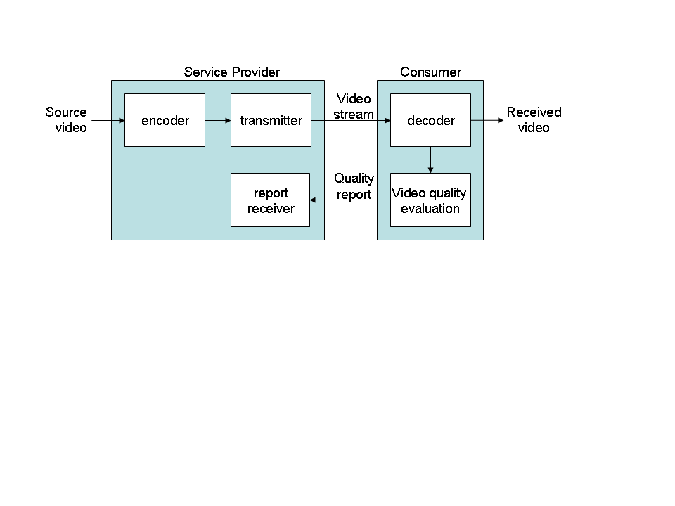
Figure 7: Back Channel for Quality Reporting

Full-Reference Models
Since a full-reference model requires that source video sequences at the receiver or that processed video sequences should be available at the transmitter, it is not easy to employ a full-reference method in IP-TV applications.

Reduced-Reference Models
A reduced-reference method can be employed to monitor the perceptual video quality at the receiver. If a reduced-reference method is used at the receiver, the transmitter needs to transmit feature data in addition to video data (Figure 3). When a reduced-reference is to be employed in IP-TV applications, a transmission protocol to send the feature data should be specified. It is desirable that the feature data should be available at the receiver in a timely manner. It is preferred that the feature data is sent with a time advance. Furthermore, some error handling mechanisms should be employed for sending the feature data.

Figure 8: A block diagram of video quality monitoring using an RR model

No-Reference Models
When a no-reference method is used, there may be no special requirements for the system.
Although the performance of no-reference methods is inferior to that of full-reference and reduced-reference methods, it can be improved by developing NR methods which also use video stream data.

Reconstructing the received video using transmission error information
In digital communications, transmission errors include packet loss and packet delay and their effects can be exactly identified when video data is transmitted using packets. Furthermore, if there is no transmission error, the video quality at the receiver will be identical to the video quality of the video sent by the transmitter. Therefore, if the receiver sends transmission error information which includes information on packet loss and delay in packetized video transmission, the service provider can exactly reconstruct the received video seen at the receiver (Fig. 6). Finally, the service provide may use a FR or RR method to evaluate the video quality of the received video seen at the receiver. Table 2 describe messages for sending transmission error information to the service provider.
Figure 9: A method for a transmitter to monitor video quality at a receiver using transmission

Table 2: Message Descriptions

Type of transmission errors | Message descriptions
Information on the receiver | A model identification message
Source Identifier | A source identification message
Information on a lost packet | A lost packet index
Information on lost packets | A starting packet index and an ending packet index of the lost packets
Information on a delayed frame | A delayed frame index and the amount of delayed time
Information on a skipped frame | A skipped frame index
Information on skipped frames | A starting frame index and an ending frame index of the skipped frames

Audio Quality Monitoring

Ancillary Attribute Monitoring

Subtitles

Closed Captions

Descriptive Audio

___________

