Performance Monitoring for IPTV
INTERNATIONAL TELECOMMUNICATION UNION |  |  |  | Focus Group On IPTV
TELECOMMUNICATION  STANDARDIZATION SECTOR  STUDY PERIOD 2005-2008 |  |  | FG IPTV-DOC-0121
 |  |  | English only
WG(s): 2 |  | 5th FG IPTV meeting:  Geneva, 23 – 31 July 2007
OUTPUT DOCUMENT
Source: | Editor
Title: | Working document: Performance monitoring for IPTV
(July 2007)

Summary
TBD
Keywords
TBD
Introduction
TBD
Contents
1 Scope 2
2 References 2
3 Definitions 2
4 Abbreviations and acronyms 2
5 Conventions 2
6 Monitor points 2
6.1 Monitoring Point Definitions 2
7 Monitoring parameters 2
7.1 Physical Layer Parameters 2
7.2 IP Layer/Network Parameters 2
7.3 Transport Stream parameters 2
7.4 Service Line-Up parameters 2
7.5 Channel Attribute parameters 2
7.6 VOD Parameters 2
7.7 Other Parameters 2
8 Monitoring methods 2
8.1 Generalized monitoring method for multi-media data based on transmission packet loss 2
8.2 Bearer network monitoring 2
8.3 Network performance monitoring 2
8.4 IPTV service attribute monitoring 2
8.5 Video quality monitoring 2
8.6 Audio quality monitoring 2
8.7 Ancillary attribute monitoring 2
Annex A 2
Considerations for Network Performance Monitoring when using Overlay Networks 2
1 Overlay Measurement 2
2 Measurement Unit 2

List of Figures
Figure 1 - Monitoring Points 2
Figure 2 - Television Service Hierarchy 2
Figure 3 - Television Service Quality 2
Figure 4 - Performance Monitoring Point Deployment 2
Figure 5 - Typical Index Structure 2
Figure 6 - A Full-Reference Model 2
Figure 7 - A Reduced-Reference Model 2
Figure 8 - Back Channel for Quality Reporting 2
Figure 9 - A streaming server which optimizes codec parameters based on the perceptual quality 2
Figure 10 - A network provider which uses perceptual quality information 2
Figure 11 - A block diagram of video quality monitoring using an RR model 2
Figure 12 - A method for a transmitter to monitor video quality at a receiver using transmission 2
Figure 13 - Relationship between packet-layer model and bit stream layer model 2
Figure 14 - Input requirements for FR hybrid perceptual/bit-stream models 2
Figure 15 - Input requirements for RR hybrid perceptual/bit-stream models 2
Figure 16 - Input requirements for NR hybrid perceptual/bit-stream models 2
Figure 17 - Generating and transmitting video quality scores of compressed data 2
Figure 18 - Input requirements for a FR hybrid perceptual/bit-stream model which uses the video quality scores of transmitted compressed video data 2
Figure 19 - Input requirements for a RR hybrid perceptual/bit-stream model which uses the video quality scores of transmitted compressed video data 2
Figure 20 - Input requirements for a NR hybrid perceptual/bit-stream model which uses the video quality scores of transmitted compressed video data 2

List of Tables
Table 1 - Monitoring points and parameters
Table 2 - Transport Stream Monitoring Parameters
Table 3 - Video Quality Measurements in Various Domains 2
Table 4 - Objective Models Considered in the VQEG Multimedia Test Plan
Table 5 - Message Descriptions

Performance Monitoring for IPTV
(July 2007)

Scope
This document defines performance monitoring for IPTV. Monitoring parameters, monitoring points and monitoring methods are defined that allow the service provider/network operator to monitor the performance of the service delivery to the end user.
What does “performance monitoring for IPTV” mean, anyway? [ed. Subject for future contributions]
QoS is an important consideration for the network operator and QoE is more important to the end user.

References
The following ITU-T Recommendations and other references contain provisions, which, through reference in this text, constitute provisions of this working document. At the time of publication, the editions indicated were valid. All Recommendations and other references are subject to revision; users of this working document are therefore encouraged to investigate the possibility of applying the most recent edition of the Recommendations and other references listed below. A list of the currently valid ITU-T Recommendations is regularly published.
The reference to a document within this working document does not give it, as a stand-alone document, the status of a Recommendation.

[ITU-T Y.1540] ITU-T Recommendation Y.1540 (2002), Internet protocol data communication service – IP packet transfer and availability performance parameters
[ITU-R BT.500] ITU-R Recommendation ITU-R BT.500-11(2002), Methodology for the subjective assessment of the quality of television pictures
[ITU-T D.97] ITU-T COM12 D.97 Packet Loss Distributions and Packet Loss Models
[ITU-T E.800] ITU-T Recommendation E.800 (1994), Terms and Definitions Related to Quality of Service and Network Performance Including Dependability
[ITU-T Y.1541] ITU-T Recommendation Y.1541 (2006), Network Performance Objectives for IP-based Services
[ETSI TR 101-290] ETSI Technical Report 101-290 (2000), Digital Video Broadcasting (DVB); Measurement guidelines for DVB systems
[IETF RFC2550] IETF RFC 2550 (1998), RTP Payload Format for MPEG 1 and MPEG 2 Video
[IETF RFC3357] IETF RFC 3357 (August 2002). R. Koodli and R. Ravikanth, “One-way Loss Pattern Sample Metrics”.
[IETF RFC3393] IETF RFC 3393 (2002), IP Packet Delay Variation Metric for IP Performance Metrics (IPPM)
[IETF RFC3611] IETF RFC3611 RTCP Extended Reports (VoIP Metrics block)
[IETF RFC3984] IETF RFC 3984 (2005), RTP Payload Format for H.264 Video
[DSL TR-126] DSL Forum draft specification TR-126 (2006), Triple Play Services Quality of Experience Requirements, V 1.0

Definitions
This working document uses or defines the following terms:
TBDError: Reference source not found

Abbreviations and acronyms
This working document uses the following abbreviations and acronyms:
AAA Authentication, Authorization, and Accounting
CAT Conditional Access Table
DSCS Double Stimulus Comparison Scale
DSCQS Double Stimulus Continuous Quality Evaluation
EPG Electronic Program Guide
FR Full Reference
HTTP Hyper Text Transfer Protocol
IGMP Internet Group Management Protocol
IPDV IP Packet Delay Variation
IPER IP Error Rate
IPLR IP Packet Loss Rate
IPRR IP Reordering Ratio
IPTD IP Packet Transfer Delay
KOD Karaoke On Demand
MAE mean absolute error
MPTS Multi-Program Transport Stream
MSE Mean Square Error
NMS Network Management System
MOS Mean Opinion Score
NR No Reference
OSS Operations Support System
PID Program Identifier
PSNR Peak Signal to Noise Ratio
PVS Processed Video Sequence
QoE Quality of Experience
RF Radio Frequency
RR Reduced Reference
SI System Information
SPTS Single Program Transport Stream
SRC Source Video Sequence
SSCQE Single Stimulus Continuous Quality Evaluation
STB Set Top Box
TS Transport Stream
VoIP Voice over IP
XML Extensible Markup Language

Conventions
TBD

Monitor points
The entire content delivery chain can be divided into multiple domains. Operators at domain borders have the option to perform monitoring which, when taken together, forms an end-to-end monitoring topology.
This domain approach is independent of any specific monitoring method (e.g. RR).
Monitored performance characteristics, across a single domain or multiple domains, can be integrated with existing or new OSS and/or NMS systems.
The exact topology and domains will vary from one operator to another; however, monitoring can be applied at each domain boundary. An example topology with domain boundaries is shown in Figure 1. Different aspects can be monitored at each domain boundary as outlined below.

[Editors note: Modification of the figure and following text is needed based on WG1 domain definitions]
Error: Reference source not found
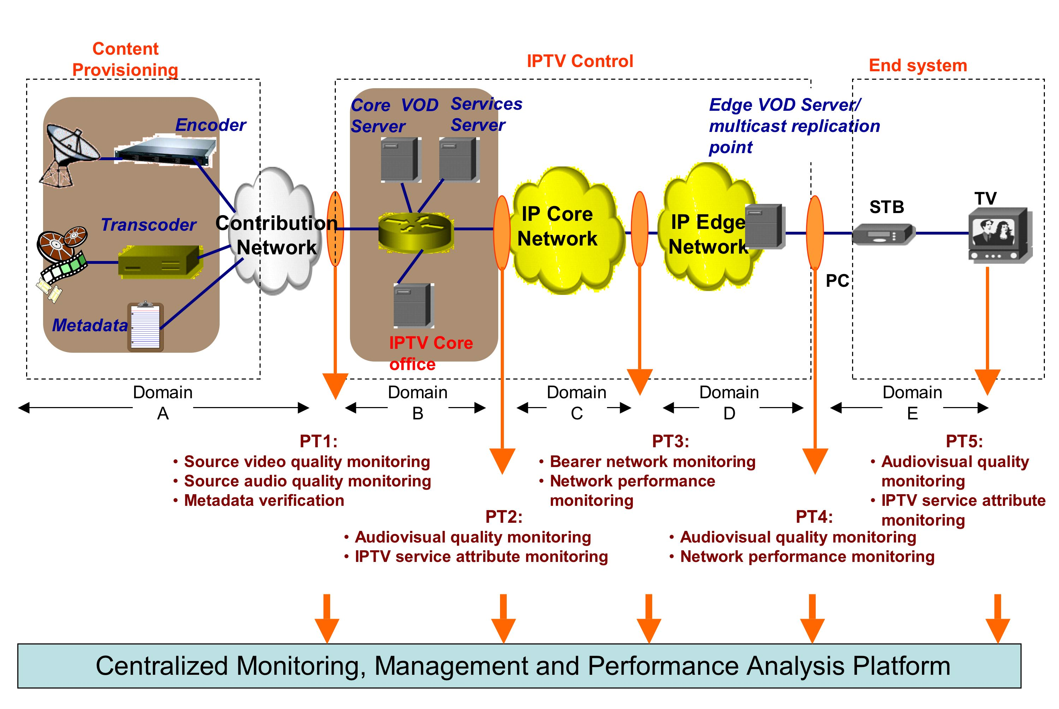
Figure 1 - Monitoring Points
A whole performance monitoring system is recommended to include a performance monitoring management platform.
The management platform entity manages monitoring tasks for all points and collects parameters from all points, performs performance analysis, and generates reports. The range of the management platform covers all five domains as shown in Figure 1.

Monitoring Point Definitions

Point 1 – PT1
This point demarcates the domain border between content provision and IPTV control. It should aim for source video quality monitoring, source audio quality monitoring, and metadata verification.

Point 2 – PT2
This point demarcates original streaming quality monitoring, such as audio-visual quality monitoring, IPTV Service Attribute Monitoring, and metadata verification.

Point 3 – PT3
This point demarcates the IP Core and IP Edge networks where monitoring of IP-related performance parameters, such as Bearer Network Monitoring, Network Performance Monitoring are important.

Point 4 – PT4
This point is closest to the user where monitoring the quality of streaming, audio-visual quality, and IPTV service attribute monitoring are important.

Point 5 – PT5
This point is at the final end point and directly relates to end user QoE. Monitoring audiovisual quality and IPTV service attribute monitoring are important.

Monitoring parameters
This section describes the parameters which need to be monitored at different stages of an end-to-end IPTV delivery chain. With reference to Figure 1 which identifies monitoring points and domains, specific parameters are applicable to only few domains, but all parameters listed are equally significant for monitoring the true performance of IPTV delivery.
There is a hierarchical relationship within an IP television service, where a physical interface (e.g. Ethernet) can carry one or many IP flows, those IP flows in turn carry single or multiple program transport streams, each channel/program within, having multiple attributes defining the content.
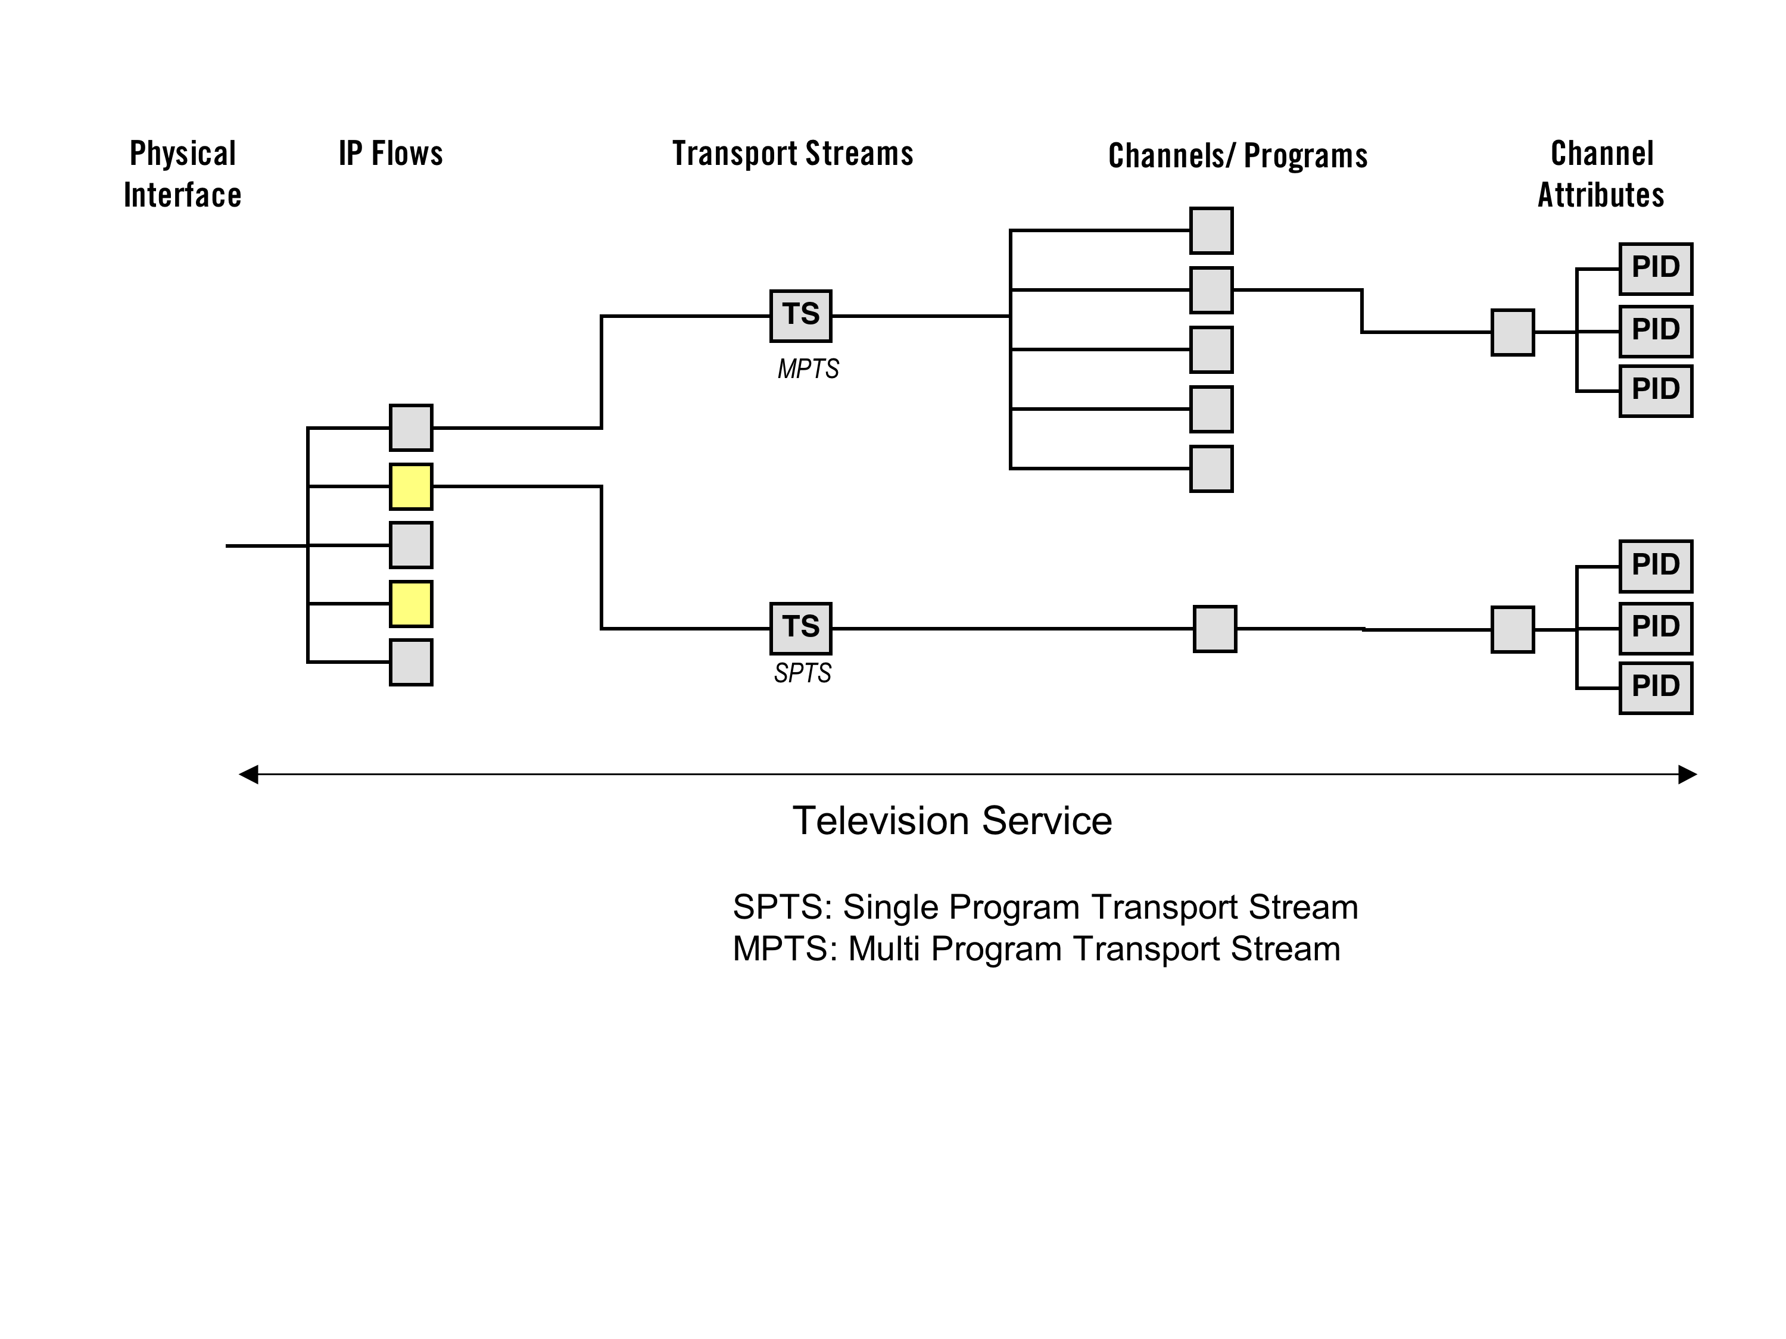
Figure 2 - Television Service Hierarchy
With reference to the monitoring points identified in Figure 1, the applicable parameters across different domains are marked as “Yes” in, Error: Reference source not found, below. The parameters themselves are defined in Section 7.

Table 1 - Monitoring points and parameters
Monitoring Parameters | Domain A | Domain B  (PT1- PT2) | Domain C  (PT2- PT3) | Domain D  (PT3- PT4) | Domain E  (PT4- PT5)
Physical Layer Parameters
RF Integrity | Yes
Available Bandwidth | Yes | Yes | Yes | Yes | Yes
IP Layer Parameters
Packet Loss Metrics | Yes (Only for content over IP contribution) |  | Yes | Yes | Yes
Jitter | Yes (Only for content over IP contribution) |  | Yes | Yes | Yes
IGMP join/ leave time |  |  |  | Yes | Yes
IP Flow List | Yes | Yes | Yes | Yes | Yes
Transport Layer Parameters
Packet Loss Metrics | Yes |  | Yes | Yes | Yes
Jitter | Yes |  | Yes | Yes | Yes
TR 101 290 | Yes  Priority 1, 2 & 3 | Yes  Priority 1 and 2 | Yes  Priority 1 | Yes  Priority 1 | Yes  Priority 1
Service Line-up Parameters
Meta Data Verification (parental control/ EPG/ Subtitles) | Yes | Yes |  |  | Yes
Metadata Validity | Yes | Yes |  |  | Yes
Metadata Integrity | Yes | Yes |  |  | Yes
Channel Zap time |  |  |  |  | Yes
Channel Line Up Verification |  | Yes |  |  | Yes
Buffering Delay |  |  |  |  | Yes
Decoding Delay |  |  |  |  | Yes
Channel Attribute Parameters
Video/Audio Bandwidth | Yes | Yes | Yes | Yes | Yes
Video Quality | Yes | Yes |  |  | Yes
Audio Quality | Yes | Yes |  |  | Yes
Blackout Detection | Yes | Yes |  |  | Yes
Freeze Frame Detection | Yes | Yes |  |  | Yes
Audio Loss/ Presence | Yes | Yes |  |  | Yes
VOD Parameters
VOD Request Performance |  |  |  |  | Yes
VOD Request Accuracy (Correctness Rate) |  |  |  |  | Yes
Buffering Delay |  |  |  |  | Yes
Decoding Delay |  |  |  |  | Yes
Connection Success Rate |  | Yes | No | Yes
Connection Time |  | Yes | No | Yes | Yes
Other Parameters
AAA Success Rate |  | Yes |  |  | Yes

Physical Layer Parameters

RF Integrity

Available Bandwidth

IP Layer/Network Parameters
[editor: The following might be optional however, they do form a collection of monitoring parameters. It still must be defined which are optional and mandatory]
Y.1540 defines parameters for network performance and RFC 3357 defines loss distance, loss period, loss noticeable rate, loss period length, and inter loss period length.
In addition to parameters above, the following parameters are also required for monitoring IPTV performance.

Link IP Layer Used Bandwidth.
Is defined as the sum of the IP layer bandwidth for all IP packet flows within in a link.

Link IP Layer Available Bandwidth.
Is defined as the maximum IP layer bandwidth which the link can provide without influencing other existing flows (background flows) in the link.
NOTE 1 – For a given link, the "Link IP Layer Available Bandwidth" plus the "Link IP Layer Used Bandwidth" is equal to the "Link IP Layer Bandwidth".
NOTE 2 – With the knowledge of the values of the above two parameters the network providers can determine the bandwidth utilization ratio of a link.

End-to-End IP Layer Bandwidth.
Is defined as the maximum IP layer bandwidth an end-to-end path can provide given no background flows exist along that end-to-end path. It can be also understood as equal to the lowest Link IP Layer Bandwidth along that end-to-end path, and hence the bottleneck along that path.

End-to-End IP Layer Available Bandwidth.
Is defined as the maximum IP layer bandwidth which an end-to-end path can provide without influencing other existing flows (background flows) along that path.

Loss run length distribution
Let $l_{i}$, i = 1, 2, … , n-1 denote the number of loss bursts of length i, where n-1 is the longest loss burst. L denotes the number of total lost packets (L > 0). The loss run length distribution can be calculated as $l_{i}$/L, i = 1, 2, … , n-1. [IETF RFC3357]

Error-free interval distribution
Let $f_{i}$, i = 1, 2, … , n-1 denote the number of error-free intervals having length i, where n-1 is the longest error-free interval. F denotes the number of total received packets (F > 0). The error-free interval distribution can be calculated as $f_{i}$/F, i = 1, 2, … , n-1.

Packet Loss Metrics & Models
- Sparse bursts
Sparse bursts ([ITU-T D.97] and [IETF RFC3611]) are periods of high packet loss, analogous to severely errored seconds. These may be modelled using multi-state Markov Models or Gilbert-Elliott models. A sparse burst is a period that begins and ends with a lost (or discarded) packet during which some constraint is satisfied. In RFC3611 the defined constraint is that within a burst there must be less than Gmin consecutively received packets. Gmin is selected such that the minimum effective loss rate within a burst corresponds to the lowest packet loss rate at which some noticeable distortion occurs within the decoded media stream. Sparse burst are often due to network congestion, RED and related effects.
- Continuous bursts
Continuous bursts are periods during which every packet is lost. Contiguous losses may occur due to packetization (i.e. packing several transport packets within an IP packet), to link failures within an IP network or other phenomena.
- Isolated losses
Isolated lost packets typically occur due to bit errors in transmission or excessive collisions on local area networks.

Streaming Jitter (SJ)
The SJ represents the maximum and minimal bit rate of the streaming server output streaming. The SJ is a from network’s viewpoint and it is a vital metric when monitoring the performance.

Transport Stream parameters
The MPEG-2 Transport Stream protocol facilitates the exchange of audio/video services with associated System Information tables between compatible equipment. This mechanism is commonly used in broadcast environments.
IPTV operators might plan to deploy networks that do not use the Transport Stream protocol. This approach compromises the interoperability between networks and equipment. Such deployments have to rely on proprietary equipment. This also ties the operator with a particular equipment vendor or product family.
The following paragraphs assume that the Transport Stream packet headers are not encrypted. Some encryption schemes might involve the scrambling of all data after the IP header. In such cases, no monitoring of Transport Stream parameters is possible. Only IP related statistics would be relevant.
ETSI TR 101 290 [ETSI TR 101-290] defines the essential TS parameters to be monitored. These are categorized according to severity and are listed as Priorities 1, 2 and 3.
- Priority 1 is defined as those “necessary for de-codability (basic monitoring)”,
- Priority 2 is “recommended for continuous or periodic monitoring”, and
- Priority 3 is defined as “application dependant monitoring”
Scenario 1: DVB Compliant MPEG-2 Transport streams delivery of IPTV
Monitoring all the parameters listed in Priority 1,2 and 3 of the [ETSI TR 101 290] specification are ESSENTIAL in this scenario.
Scenario 2: IPTV MPEG-2 Transport Streams without DVB System Information Tables
Operators adopt multiple approaches to deliver IPTV. The use of DVB System Information (SI) tables is optional, as operators might utilize other mechanisms to describe events and associated data. In the absence of DVB SI, certain Transport Stream tests described in the TR 101 290 specification are still applicable.
All the tests in Priority 1 are relevant. These tests relate to basic MPEG-2 Transport Stream parameters, regardless of whether DVB SI is used.
Monitoring the Conditional Access Table (CAT) in Priority 2 is not required. The encryption algorithms used in IPTV systems might not conform to conditional access signalling protocol. All other Priority 2 parameters should be monitored.
Tests in Priority 3 are specific to DVB SI and are thus not required. IPTV operators typically utilize proprietary means to specify EPG and other data services.
Transport stream parameters– End to End IPTV monitoring
With reference to the monitoring points identified in Figure 1, the applicable transport stream parameters across different domains are marked as “Yes” in Table 2, below.

Table 2 - Transport Stream Monitoring Parameters

TR 101 290 | Domain A | Domain B  (PT1 to PT2) | Domain C  (PT2 to PT3) | Domain D  (PT3-PT4) | Domain E  (PT4- PT5)
Priority 1 | Yes | Yes | Yes | Yes | Yes
Priority 2 | Yes (excluding CAT_error test) | Yes (excluding CAT_error test)
Priority 3 | Yes

Service Line-Up parameters
Quality Television Service

Video
Audio
Meta Data

Parental control
EPG
Subtitles

Figure 3 - Television Service Quality

Channel line up
It is essential to monitor the parameters applicable to the entire channels/programs offering of the IPTV Service. Monitoring these parameters is essential as it details the presence and correctness of channels intended to be delivered over the service.
Some of the parameters that need to be monitored are:
- Number of channels on the service
- Channel Identity (ID) Number
- The names of the services
- Source of content for the services (content provider/ aggregator)
- Number of interactive channels
- Number of free to air/ pay channels
- Genre of channel content and number in each genre

Service meta-data (eg. EPG, subtitles, parental control, etc.)
- Parental or age rating
- Source provider of meta-data
- Language sets correctness
- EPG correlation to actual content
- Correctness of subtitling
- Size of meta-data
- Availability of meta-data
Metadata Validity (MV)
Metadata Validity is for checking whether the metadata files from content provision meet or comply with the language used, syntax and semantics which has been specified in advance. For example, the IPTV control domain should check if the file used XML as the description language if XML is the normative description language for IPTV metadata file.
Metadata Integrity (MI)
Metadata Integrity is for checking whether the metadata files from content provision has contain all the necessary information and comply with the metadata specification. For example, the IPTV control domain should check all the attributes such as information about director, actor and so on when it received a metadata file of a movie for VOD purpose.

Channel zap time
The measure of channel zap time is the time it takes for the channel to change from the moment the subscriber presses the button on the remote till the video leaves the display.
Channel zap time is typically measured in milliseconds (ms).

IGMP internal processing delay

Buffering delay
Buffering delay represents the amount of elapsed time between the first media packet arriving at STB and the time the receiving buffer is filled.

Decoding delay
Decoding delay represents the elapsed time from first packet leaving the buffer until the first frame of decoded video leaves the decoder.

Correctness Rate (CR)
The correctness rate is the number of times the “correct” content expected by the user is played as a percentage of total number of requests attempted by users in a pre-defined time interval. The CR can be treated as an important parameter to measure the overall users’ experience of the IPTV service.

Connection Success Rate (CSR)
The Connection Success Rate is the number of connections which were successfully established with the streaming server as a percentage of total attempted connections in a unit time. The CSR is a good viewpoint from users’ experience when using IPTV service.

Connection Time (CT)
Connect time measures the amount of time elapsed between the initial request by the media player or STB and the start of buffering. This time may include Domain Name System (DNS) lookup and resolution, metafile actions, RTSP handshakes and the transport of the first byte of data to the player. The CT is also a good viewpoint from IPTV users’ experience.

Channel Attribute parameters
As described in Figure , each channel has specific attributes attached to it. They are embedded as part of the transport stream carrying the channels. The PID (program ID) defines the identity of the program being carried by the transport stream (TS).

Channel attributes
Multiple attributes of each channel have to be monitored to ensure the performance of the service.

PID (Program ID)

Type: Audio/ Video/ Data

Aspect Ratio
- Conditional Access Enabled/ Disabled
- Age rating

Encoding Format of the channel

Bit-rate of the channel

Bit-rate of each component of the channel in case it carries more than one type of information (eg. Audio and Video)

Video quality
Video quality assessment represents the video quality grade by assessing according to the quality assessment parameter sets, subjective assessment, or objective assessment.
The user perception of video quality can only be approximated by using objective estimation models and represented as an MOS (Mean Opinion Score).

Audio quality
Audio quality assessment represents the audio quality grade by assessing according to the quality assessment parameter sets, subjective assessment, or objective assessment.
The user perception of audio quality can only be approximated by using objective estimation model and represented as an MOS (Mean Opinion Score).

Ancillary channel associated attributes

Subtitles

Closed captions

Descriptive audio

Conditional access/scrambling considerations

VOD Parameters

Content on Demand (VOD/KOD) request performance
Similar to channel zap time the “true” performance of VOD/KOD request performance cannot be measured by ignoring human elements (the requesting client) of the whole IPTV system. It can only be measured as the time it takes for the video to leave the screen from the time the user pressed the button on the remote requesting for the content.
RTSP latency is not the sole indicator of request performance for VOD/KOD.

Other Parameters

AAA Success Rate (AAASR)
The success rate about service related request from end users should reflect the users’ experience. So authentication, authorization, and accounting success rate should be monitored.

Monitoring methods

Generalized monitoring method for multi-media data based on transmission packet loss
In this method, monitoring points are composed of some sampling points and a reference point. At the reference point, the whole copies of data sent by the sender must be obtained, and the sampling points can be located wherever service monitoring is requested. A bidirectional channel between the reference point and the sampling points is essential, see Figure .

Figure 4 - Performance Monitoring Point Deployment
There are three steps required to execute this method:
Step 1. After the reference point get the whole copies of sender’s data, the relations between transmission packet number and the characteristics are established and saved.
One typical index structure is shown in Figure .

Figure 5 - Typical Index Structure
A typical index structure includes three parts: Packet No., Packet Type, and Index Data. Packet No.: specifies the received multi-media packet number, which is used to retrieve the multi-media data.
Packet Type: specifies the type of current multi-media packet, which can be video type or audio type.
Index Data: specifies the multi-media characteristics corresponding to the packet number.
For video type, the index data should include Video Parameters, video frame number, Macro-block Information and Residual Information, where Macro-block Information and Residual Information are optional multi-media characteristics for index construction.
Video Parameters: specifies the parameters of video sequences, such as image width, image height, video frame rate, video format, etc.
Video Frame number: specifies the video frame index corresponding to the multi-media video packet.
Macro-block Information: specifies the feature data that is used to reconstruct damaged video frames, including block type, block address, motion vector, reference picture index, etc.
Residual Information: specifies the difference between a prediction of a sample and its decoded value for each pixel.
For audio type, the index data should include Audio Parameters, Audio Frame No.
Audio Parameters: specifies the parameters of audio.
Audio Frame No.: specifies the video frame index corresponding to the multi-media audio packet.
Step 2. At the sampling point, received packets are sorted according to packet numbers. We can find out which packets are lost by checking the integrity of packets then feed back to the reference point.
Step 3. At the reference point, according to loss packet numbers from the sampling points, we can retrieve loss characteristics according to the stored relationship between the transmitted packet number and their characteristics. Consequently we can judge which grade current service belongs to. The graded means and details are not discussed in this proposal.

Bearer network monitoring

Network performance monitoring
A network element device or dedicated measurement device can perform network performance monitoring. Methods of network performance monitoring are divided largely into two categories: active monitoring and passive monitoring.
In the active monitoring, a measurement device injects test packets into the network, and the same device or a separate device at other points within the network measures test packets. This method makes the network suffers extra traffic during active monitoring time. On the other hand, it provides control of traffic generation based on variant scenario.
In the passive monitoring, a measurement device just observes characteristics of packets on a network link. The observed characteristics can be used for flow analysis. This method does not generate any extra traffic, so it can measure real network status. However, there are limitations in observing characteristics of all packets and in estimating trouble scenarios.

Monitoring Procedure

IPTV service attribute monitoring

Channel line up validation
All the channels in the service should be tested. This has to take into account the various service plans and also region specific channels.
8.4.1.1 Channel Line Up Validation for Domain B
Channel line up validation at Domain B involves checking the various unicast and multicast IP flows prior to delivery from the headend. All the outgoing IP flows should be checked. Their unicast and multicast addresses should be correlated with the channel line up. This will ensure that the IP flows’ addresses are configured correctly.
8.4.1.2 Channel Line Up Validation for Domain E
Channel line up validation at Domain E involves examining the IP traffic entering the STB as well as the audio/video output of the STB.
Examining the STB’s incoming IP traffic requires checking the unicast or multicast address. Each channel is typically assigned a multicast address. A remote control should be used to invoke channel change on the STB. A correlation should be made between the remote control’s channel change parameter and the multicast address of the IP traffic. This channel – multicast address correspondence is specific to an operator’s service. This test also ascertains whether an STB has received the correct channel – multicast address mapping information.
The presence and status of the audio/video output of the STB should be checked whenever a new channel change command is issued by the remote control. Presence indicates whether any audio/video content is produced. Status indicates whether the video is frozen or is in the blackout condition. For the case of audio, silence and tone should be checked. This test is applicable to all the available audio/video outputs of the STB.

Service meta-data validation
Meta-Data is typically delivered via tables in the Transport Stream, or by other means, which might comprise of XML tables, HTTP traffic, encrypted data and out-of-band channel delivery. The method in which meta-data is represented and delivered is usually operator and STB specific. This implies a potentially proprietary approach to decoding and examining the meta-data.
8.4.2.1 Service Meta-Data Validation at Domains A and B
Meta-data that are generated and subsequently embedded in the IP flows or delivered by other means should be decoded and validated against the operator’s service offering. Multiple meta-data sets can be checked simultaneously.
8.4.2.2 Service Meta-Data Validation at Domain E
Meta-data is usually presented to the user in the form of an Electronic Program Guide. The STB’s incoming IP traffic should be decoded appropriately at monitoring point 4, according to the method of delivering the meta-data. This meta-data should be checked against the operator’s service offering. Only one meta-data set can be checked at any one time.

Channel zap time
Channel zap time can be measured by taking the time difference between the channel change commands from the remote control and the time the new channel’s video and audio are presented on the display. This measurement method takes into account the STB’s internal data buffering and also the audio/video decoding time.
A device can be used to detect the presence of the new channel’s video and audio content. This entails connecting the audio/video outputs of the STB to a display device. An appropriate method must be employed to determine whether audio/video content relating to the new channel is actually received.

Video quality monitoring
Video quality assessment can be carried out in two ways:
- Subjective assessment
- Objective assessment
Objective assessment can be further subdivided into the following:
- Methods based on perceptual models of the Human Visual System, and
- Methods based on parametric models

Subjective quality monitoring
There are a number of subjective video quality measurement methods suggested in ITU-R BT. 500 [ITU-R BT.500] . Depending on the impairment being evaluated, the selection of a method requires careful considerations of sequence duration, transmission condition, ecological environment and other factors. The output of the subjective tests is often an average of the quality ratings called Mean Opinion Score (MOS).
ITU-R BT.500-7 recommends a five-grade impairment scale:
5 – imperceptible
4 – perceptible, but not annoying
3 – slightly annoying
2 – annoying
1 – very annoying
The grading of video quality can also be expressed as a percent from 0 to 100, with 0 indicating no distortion. The higher the value is, the greater the distortion occurs.
ITU-R BT.500-11 includes specifications on how to perform different types of subjective test. The double stimulus continuous quality scale (DSCQS) and double stimulus comparison scale (DSCS) are both double stimulus where viewers rate the quality or change in quality of two video streams (reference and impaired). The single stimulus continuous quality evaluation (SSCQE) assesses only one impaired video stream. The DSCQS is claimed to be less sensitive to the context, while SSCQE is claimed to produce more representative estimates for quality monitoring.

Objective quality monitoring
Many advances have been made in objective video quality monitoring techniques. Although not as accurate as subjective quality measurement, objective assessment can provide quick support to fine-tuning network variables. Due to the complexity and time consuming of subjective video monitoring, there has been significant development of perceptual video quality measurement (PVQM) algorithms in recent years in an attempt to replicate the scores given by subjects in an objective tool. Objective quality monitoring can be classified into following categories:
- Techniques based on models of human video perception
- Techniques based on video signal parameters
Human video perception models attempt to emulate the characteristics of the human vision system to obtain video quality scores. A good model should yield high correlation to the ratings the actual viewers would provide. Three popular approaches can be used:
- Full reference (FR) – both the original transmitted and received video are available to determine the video quality (Figure ).
- Reduced reference (RF) – partial information about transmitted video and full information about received video are available to determine the video quality (Figure ).
- No reference (NF) – only the received video is available to determine the video quality.
By comparison between the transmitted and received video, various parameters can be obtained which are valuable in quality monitoring. Mean square error (MSE) and mean absolute error (MAE) calculate the frame difference between corresponding streams. The difference can also be assessed by the peak signal to noise ratio (PSNR) which is the log of the ratio of the peak signal squared to the MSE in a similar fashion to analogue system.

Figure 6 - A Full-Reference Model

Figure 7 - A Reduced-Reference Model
The three objective models of measuring video quality can be applied to different parts of the IPTV delivery chain. Table 3shows the relevance of the three models in the five domains.
Table 3 - Video Quality Measurements in Various Domains

 | Domain A | Domain B | Domain C | Domain D | Domain E
Full Reference | Yes | Yes
Reduced Reference | Yes | Yes |  |  | Yes
No Reference | Yes | Yes |  |  | Yes

Back channel requirements
IPTV terminals may have video quality evaluation function and reporting function of the video quality scores to IPTV servers (or service managing servers) in order to gather video quality reports from all or some of IPTV terminals.
When this approach is employed, an appropriate transmission protocol to send video quality scores and other information related with end-user quality is required. Furthermore, an appropriate transmission protocol to send feature information is required, when a reduced reference method is employed for video quality evaluation.
This approach is shown in Figure .

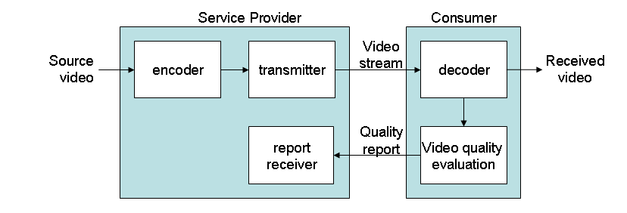
Figure 8 - Back Channel for Quality Reporting

Quality measurements can be made at various measuring points including a number of reference points and terminals and can be used for various purposes. For example, they can be used for quality-based billing. Quality monitoring can be also used to optimize codec parameters at streaming servers. Furthermore, it can be used for network management. Therefore, depending on applications, the unit in which quality measurements are performed should send the quality scores to the corresponding destination. If the quality scores are used for quality-based billing, the measuring unit should send the information to the service provider (Figure 7). When quality scores are used to optimize the codec parameters, the measuring unit needs to send the information to a streaming server (Figure 10). If they are to be used for network management, the measurement results need to be sent to the network provider (Figure 10).
Figure 9 - A streaming server which optimizes codec parameters based on the perceptual quality

Figure 10 - A network provider which uses perceptual quality information

Full-Reference Models
A full-reference model requires that both source video sequences and processed video sequences should be available at the measurement point.
[Editor: specific details on Full Reference measurement methods must still be defined]

Reduced-Reference Models
A reduced-reference method can be employed to monitor the perceptual video quality ata measurement point. If a reduced-reference method is used at the receiver, the transmitter needs to transmit feature data in addition to video data (Figure 11). When a reduced-reference is to be employed in IPTV applications, a transmission protocol to send the feature data should be specified. It is desirable that the feature data should be available at the receiver in a timely manner. It is preferred that the feature data is sent with a time advance. Furthermore, some error handling mechanisms should be employed for sending the feature data.

Figure 11 - A block diagram of video quality monitoring using an RR model

No-Reference Models
When a no-reference method is used, there may be no special requirements for the system.
Although the performance of no-reference methods is inferior to that of full-reference and reduced-reference methods, it can be improved by developing NR methods which also use video stream data.

Reconstructing the received video using transmission error information
In digital communications, transmission errors include packet loss and packet delay and their effects can be exactly identified when video data is transmitted using packets. Furthermore, if there is no transmission error, the video quality at the receiver will be identical to the video quality of the video sent by the transmitter. Therefore, if the receiver sends transmission error information which includes information on packet loss and delay in packetized video transmission, the service provider can exactly reconstruct the received video seen at the receiver (Figure ). Finally, the service provide may use a FR or RR method to evaluate the video quality of the received video seen at the receiver. Error: Reference source not found describe messages for sending transmission error information to the service provider.
Figure 12 - A method for a transmitter to monitor video quality at a receiver using transmission

Table 2 - Message Descriptions
Type of transmission errors | Message descriptions
Information on the receiver | A model identification message
Source Identifier | A source identification message
Information on a lost packet | A lost packet index
Information on lost packets | A starting packet index and an ending packet index of the lost packets
Information on a delayed frame | A delayed frame index and the amount of delayed time
Information on a skipped frame | A skipped frame index
Information on skipped frames | A starting frame index and an ending frame index of the skipped frames

Packet-layer model
The packet-layer model can estimate video quality using IP information that excludes video-related payload information, as shown in Figure 12. This model cannot take into account the effects of video content on the subjective quality. Its computational load is very light because it does not use video-related payload information.

Bit stream layer model
It is possible that an objective model may have access to bit stream data from which the model can obtain additional information on transmission errors (e.g., delay, packet loss), codec parameters (e.g., type, bit-rates, frame rates, codec parameters), etc. This kind of information is easily available from bit-stream data at the receiver. It is expected that such models may provide improved performance in terms of accuracy and speed compared to objective video quality models which use only processed video sequences.
The bit stream layer model can estimate the quality of each video sequence using IP information that includes video-related payload information, as shown in Figure . That is, it can take into account the effects of video contents.

Figure 13 - Relationship between packet-layer model and bit stream layer model Hybrid perceptual/bit-stream models
If an IPTV terminal or monitoring equipment is to use such a hybrid perceptual/bit-stream model for quality monitoring, it should provide bit-stream data to the model. The input requirements for hybrid perceptual/bit-stream models are shown in Figure 12, Figure 13, and Figure 14.

Figure 14 - Input requirements for FR hybrid perceptual/bit-stream models

Figure 15 - Input requirements for RR hybrid perceptual/bit-stream models

Figure 16 - Input requirements for NR hybrid perceptual/bit-stream models
In order to improve the accuracy of objective models, it is also possible to transmit video quality scores of the compressed video data which are transmitted (Figure ). It has been known that if video quality measurements are made every half second, they will provide sufficient information on the video quality of the processed video sequence. If there are no transmission errors, the video quality at the receiver would be the same as that of the transmitted video sequence. If transmission errors occur, the received video sequence suffers from both compression impairments and transmission error impairments. With video quality scores available, an objective model which measures the video quality of the received video sequence may be improved, particularly for NR models. The video quality scores can be transmitted as meta-data. Alternatively, they can be transmitted using watermark techniques.

Figure 17 - Generating and transmitting video quality scores of compressed data

If an IPTV terminal or monitoring equipment are to use these objective models for quality monitoring, the input requirements are shown in Figure through Figure 17.

Figure 18 - Input requirements for a FR hybrid perceptual/bit-stream model which uses the video quality scores of transmitted compressed video data

Figure19 - Input requirements for a RR hybrid perceptual/bit-stream model which uses the video quality scores of transmitted compressed video data

Figure 20 - Input requirements for a NR hybrid perceptual/bit-stream model which uses the video quality scores of transmitted compressed video data

Audio quality monitoring

Ancillary attribute monitoring

Subtitles

Closed captions

Descriptive audio
Annex A
Considerations for Network Performance Monitoring when using Overlay Networks
(This annex forms an integral part of this document)
- Overlay Measurement
In applications such as IPTV overlay multicast, the overlay path is constructed between overlay nodes in the application layer to perform overlay functions. In order to ensure high performance of the overlay network, overlay measurement needs to be carried out to measure the IP network performance, e.g. bandwidth, packet loss between overlay nodes such that the appropriate overlay path is selected.
On the other hand, overlay measurement can also be used by the service providers to monitor the IP network performance of the delivered applications to help ensure QoS to the end users. For example, if the IP network performance of an overlay path is poor, another overlay path may be constructed to guarantee good service quality to the end users.

Measurement Unit
A network measurement unit for overlay measurement is recommended to be deployed in the IP network layer. The reason is that the network measurement unit could reside on, or correspond with one or more existing network monitoring points (defined in Section 6 – “Monitor Points” in WD – “Performance Monitoring for IPTV”) to utilize the capability of performance monitoring of these monitoring points.
overlay network
IP network
commands receiving

measurement
monitoring points
results forwarding

Figure A.1 - Network Measurement Unit
Hence, a network measurement unit could include a receiving function, measurement function and forwarding function, as shown in Figure A.1. The receiving function receives overlay measurement commands from the overlay network and forwards the commands to the measurement function. The measurement function calls the network monitoring points to measure the performance between network devices and forwards the results to the forwarding function. The forwarding function sends the network measurement results to the overlay network.
___________

