INTERNATIONAL TELECOMMUNICATION UNION |  | Focus Group On IPTV
TELECOMMUNICATION  STANDARDIZATION SECTOR  STUDY PERIOD 2005-2008 |  | FG IPTV-DOC-0149
 |  | English only
WG(s): 1 |  | 6th FG IPTV meeting:  Tokyo, Japan, 15-19 October 2007
OUTPUT DOCUMENT
Source: | Editor
Title: | Working Document: IPTV service scenarios

Abstract
(TBD)

IPTV Services, use cases, requirements and scenarios
Summary
The purpose of this working document is:
- to identify and define the IPTV services relevant for the IPTV FG activities
- to identify the different players and roles in the value chain
- to classify these IPTV services
- to specify use cases for these IPTV services
- to specify requirements for the different players involved in these IPTV services
- to specify scenarios identifying the flows between functions of players
Contributions are requested for the next meeting on:
- the identification of IPTV services, confirmation of relevance of proposed services
- the definition of these services
- The classification/grouping of all these services by criteria such as proximity, commonality, importance, relevance, priority, etc. Considering that work on use cases and scenarios will start with the most important/relevant services. We might identify a core set of services and additional services and reject some services depending on the received support.
- Use cases
- High level requirements for the different players
- Service scenarios
Keywords
TBD

Contents
1. Scope 4
2. References 4
3. Definitions 4
3.1. Terms defined elsewhere 4
3.2. Terms defined in this Document 5
4. Abbreviations and acronyms 5
5. Conventions 6
6. IPTV services description and use cases 6
6.1. Typical IPTV service 6
6.2. Broadcast services 8
6.2.1. Linear TV 8
6.2.2. Linear TV with trick mode 9
6.2.3. Pay per view 10
6.2.4. Electronic program guide (EPG) 10
6.2.5. Personal Broadcast Service 12
6.2.6. Hybrid: Online and Off-air TV Delivery 14
6.2.7. Linear TV with Multi-View service 14
6.3. On-demand service 14
6.3.1. Video on demand (VoD) 15
6.3.2. On-demand with Multi-View service 17
6.3.3. Music on demand (MoD) 17
6.4. Advertising service 18
6.4.1. Traditional advertising service 18
6.4.2. Targeted Advertising 19
6.4.3. On-demand Advertising 19
6.4.4. Interactive Advertising 20
6.4.5. Advertising message logging 20
6.5. Public interest service 20
6.5.1. Support for users with disabilities 20
6.5.2. Emergency communications 21
6.5.3. Community related information 21
6.6. Tele-services 25
6.6.1. Tele-learning 25
6.6.2. Tele-medicine 25
6.6.3. Monitoring services 25
6.7. Portal services 25
6.7.1. Data portal (walled garden, internet access, etc.) 25
6.7.2. Web-based IPTV Portal 25
6.7.3. Terrestrial portal (news, drama, sports, movies, etc.) 26
6.8. Hosting services 27
6.8.1. Business to business 27
6.8.2. User created content (UCC) hosting 27
6.8.3. CPU resource hosting 27
6.9. IPTV interactive service 27
6.9.1. Information (news, weather, transportation, local community etc.) 28
6.9.2. Commerce (banking, stock, shopping, ticketing, auction, product delivery, event, etc.) 28
6.9.3. Communication (e-mail, messenger, SMS, channel chatting, VoIP, web surfing, multiple video conference, video phone, etc.) 28
6.9.4. Entertainment (games, karaoke, photo album, lottery, blog, etc.) 29
6.10. Presence services 29
6.10.1. Basic Presence Service 30
6.10.2. Channel based Presence Service 31
6.10.3. Targeted Advertising based on Presence Service 31
6.11. Time-shifting and Place-shifting service 31
6.12. Session mobility service 32
6.13. Supplementary content 32
6.14. 3rd party content delivery 33
7. Commercial/business models of IPTV 33

IPTV Service scenarios

Scope
This document identifies and defines a list of IPTV services and scenarios to be considered in the activities of FG-IPTV. The IPTV services are classified and use cases are provided.

References
The following ITU-T Recommendations and other references contain provisions, which, through reference in this text, constitute provisions of this working document. At the time of publication, the editions indicated were valid. All Recommendations and other references are subject to revision; users of this working document are therefore encouraged to investigate the possibility of applying the most recent edition of the Recommendations and other references listed below. A list of the currently valid ITU-T Recommendations is regularly published.
The reference to a document within this working document does not give it, as a stand-alone document, the status of a Recommendation.

[IPTV.ARCH] ITU-T FG IPTV working document (FG IPTV-DOC-0115), IPTV architecture
[ITU-T F.703] ITU-T Recommendation F.703 (2000), Multimedia Conversation Service Description
[ITU-T F.790] ITU-T Recommendation F.790 (2007), Telecommunications accessibility guidelines for older persons and persons with disabilities
[ITU-T M.1400] ITU-T Recommendation M.1400 (2006), Designations for interconnections among operators' networks
[ITU-T Q.1290] ITU-T Recommendation Q.1290 (1998), Glossary of terms used in the definition of intelligent networks
[ITU-T Accessibility checklist] ITU-T FSTP-TACL (2006), Telecommunications Accessibility Checklist
[IETF RFC2778] IETF RFC 2778 (2000), A Model for Presence and Instant Messaging
[3GPP TS 22.141] 3GPP Technical Report 22.141 v7.0.0, Presence Service: Stage1 (Release 7)

Definitions

Terms defined elsewhere
This Document uses the following terms defined elsewhere:
3.1.1 Network provider [ITU-T Q.1290]: The organization that maintains and operates the network components required for IPTV functionality. A network provider can optionally also act as service provider.
3.1.2 Service provider [ITU-T M.1400]: A general reference to an operator that provides telecommunication services to customers and other users either on a tariff or contract basis. A service provider may or may not operate a network. A service provider can optionally be a customer of another service provider

Terms defined in this Document
This Document defines the following terms:
3.2.1 Application provider: The application provider is the entity providing IPTV-related user applications.
3.2.2 Content aggregator: aggregate contents a la TV channel for example.
[Editor’s Note: Elaboration on the Content aggregator is required.]
3.2.3 Content provider: The content provider is the entity owning contents or being licensed to sell content assets. Their role is contents delivery.
3.2.4 Electronic program guide (EPG): A structured set of data, intended to provide information on available content that may be accessed by end-users.

Abbreviations and acronyms
This document uses the following abbreviations and acronyms
A/V Audio / Video
ADSL Asymmetric Digital Subscriber Line
BSS Business Support Systems
C2C Customer-to-Customer
CAS Conditional Access System
CD Compact Disc
CRM Customer Relationship Management
DRM Digital Rights Magnagement
DVD Digital Versatile Disk
DVR Digital Video Recorder
EAN Emergency Alert Notification
ECG Electronic Content Guide
ECI Emergency Communications Information
ECN Emergency Communications Notifications
ECR Emergency Communication Report
EPG Electronic Program Guide
FTP File Transfer Protocol
HD High Defintion
IM Instant Messaging
IPG Interactive Program Guide
IPPV Impulsive PPV
IPTV IP-based TV
iTV Interactive TV
MoD Music on Demand
NVoD Near VoD
OPPV Order-ahead PPV
OSS Operational Support Systems
PC Personal Computer
PDA Personal Digital Asissant
PPU Pay Per Use
PPV Pay Per View
PVR Personal Video Recording
RVoD Real VoD
QoS Quality of Service
SMS Short message service
STB Set Top Box
TV Television
UCC User Created Content
UGC User Generated Content
VCR Video Cassette Recorder
VoD Video on demand
VoIP Voice over IP

Conventions
None

IPTV services description and use cases
[Editor’s note: Contributions to make more detailed description about combination of services, such as communication services are required.]

Typical IPTV service
[Editor’s note: Contributions are welcomed to elaborate on the “typical.”]
This clause provides a list of IPTV services to be considered in the activities of the ITU FG IPTV, which does not imply to be an exhaustive list. It is categorized by their service characteristics from end-user’s perspective.
- Content services
- Linear TV (audio, video and data)
- Linear Broadcast Audio
- Linear TV with Trick Modes
- Multi-View service
- Pay Per View (PPV)
- Personal Broadcast Service
- PVR service (network or client-based)
- Time-shift TV
- Video on Demand (VoD)
  - Near VoD (Video on Demand) broadcasting
  - Real VoD
- Download Based Video Content Distribution Services (Push VoD)
- Music on Demand (MoD) including Audio book
- Content download service
- Service Information (EPG: Electronic Program Guide, ECG: Electronic Content Guide, etc.)
- 3rd party content services
- End-user Originated content (Video, etc. and applications)
- Regulatory Information services
- Advertising
- Hybrid services
- Interactive services
- Interactive TV (iTV)
- Learning services (education for children, elementary, middle and high school student, languages and estate, etc.)
- Information services (news, weather, traffic, etc.)
- Entertainment services (photo album, games, karaoke and blog, etc.)
- Portal services
- Commerce services (security, banking, stock, shopping, auction and ordered delivery, etc.)
- Interactive Advertising
- Communication services
- Communication service (e-mail, instant messaging, SMS, channel chatting, VoIP, Web, multiple video conference and video phone, etc.)
- Communications Messaging
- Presence service

Broadcast services
[Editor’s note: Contributions are welcomed to make some general depiction on Broadcast services.]
Broadcast services are services which comprise a one-way transmission of content from one point (the source) to two or more points (the receivers).

Linear TV
Editor's note: the following paragraph needs to be reworded for the sake of consistency and readability.
A key part of a typical IPTV Service is the delivery of Linear TV. This is received, from the existing broadcast transmission from a Content Provider, trans-coded and multicast by the Service Provider. The multicast streams are delivered by the Network Provider, via the Consumer’s Network to the End-user’s IPTV device.
Linear TV includes following approaches:
- Linear TV with audio and video: Audio and video (audiovisual) signals are broadcasted and distributed to the downlink without control of the broadcast. The quality is comparable or better than the today’s TV experience.
- Audio only: Audio signals are broadcasted and distributed to the downlink without control of the broadcast. The quality is comparable or better than the today’s Audio-CD.
- Linear TV with audio, video, and data: These services are A/V services which are combined with interactive data for the related or supplementary information of A/V program using bi-directional link. User can watch the downlink A/V stream and can access more detailed or value-added information via uplink simultaneously.

Figure 6-1 shows an example of linear TV with PVR.
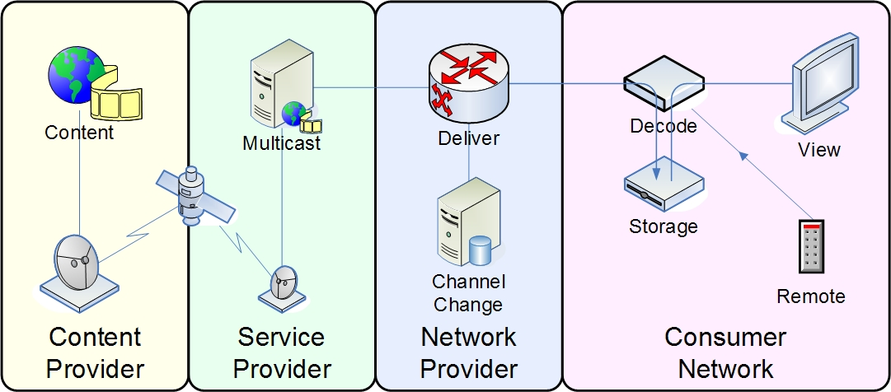
Figure 6-1: Linear TV with Local PVR
[Editor's note: the above figure needs to be reworded and modified for the sake of consistency and readability.]
[Editor’s Note: Contributions are required to exchange the term “Customer” into “End user” and rewording of “Storage” as “Local PVR”]
[Editor’s Note: Waiting for the feedback from the WG5 to elaborate on the storage for local PVR.]

Figure 6-2 shows a scenario for Channel-based service scenario for Linear TV
Figure 6-2: Channel-based IPTV Service Scenario for Linear TV

- Contents (video, audio, data, etc) with its metadata and DRM sources that are produced and managed by Contents Provider are delivered to the Service Provider.
- Then Service Provider prepares for the contents to be broadcasted through IP and controls program schedule and its distribution. After all these procedures, the scheduled channel information is provided to the End Users and the contents are ready for being broadcasted (or multicasted) through IP-based network.
- When an End User triggers the channel service or selects a channel, the request is sent to the Service Provider. This procedure may include service negotiation (i.g., QoS, price, etc.) and service availability confirmation procedures.
- If the request is allowed to the End User, then the Service Provider interacts with the Network Provider for transmission. This procedure may include the network resource reservation to guarantee the contracted service level.
- After that, the Service Provider responses channel access information (i.e., address info.) and then the End User can watch the channel using the information. This procedure may include multicast join or leave.

Linear TV with trick mode
- Linear TV with Trick Modes allows the end-user to pause live TV, instant replay of interesting scenes, and skip content through time-shifted PVR or DVR operations.
- PVR service (network or client-based)
The Personal Video Recorder service is an end user controlled electronic device service that records live program to a digital storage in either standalone set-top boxes or network. This can provide the “time shifting”, “trick modes”, and complementary convenience functions such as recording onto DVDs, commercial skip, sharing of recordings over the Internet, programming and remote control by PDA, networked PC, or web browser.
Figure 6-3 shows a scenario for Channel-based IPTV Service Scenario for Linear TV with trick mode:
Figure 6-3: Channel-based IPTV Service Scenario for Linear TV with trick mode

1 ~ 5. The same as the linear TV service procedure in Figure 6-2.
6a. When the End User’s IPTV terminal has its own storage and the user requests any trick mode function, the programmed content is recorded by its Storage Function with certain level of security and is displayed later by the End User’s selection.
6b. If the End User requests the trick mode service without having their own storage in their IPTV terminal, then the programmed content is recorded in the storage or cache within the Service Provider’s Contents Delivery Storage Function and is displayed later by the End User’s selection.

Pay per view
Pay per view is a streaming service where end-users can purchase events or program to be seen on TV. The user can buy the PPV service e.g. via an on-screen guide, a telephone, or through the Internet and see the events or program at any time within the expiration date.
- Order-ahead PPV (OPPV): The ability to order PPV programming ahead of time.
- Impulsive PPV (IPPV): The ability to order PPV programming impulsively.

Electronic program guide (EPG)
Electronic program guide (EPG) is an on-screen guide to scheduled programs, contents with additional descriptive information, allowing a viewer to navigate, select and discover content by time, title, channel, genre, etc, by using of his remote control, a keyboard, a touchpad or even a phone keypad. Generally, EPG can be displayed in several types such as Mosaic EPG, Box EPG, Text EPG, Mini EPG, Tree EPG and so forth in according to the service provider’s business model.
Traditionally, in Broadcast Services, Electronic Programming Guide services have been provided to allow end-users to easily browse television or live video content listings in an effort to easily find and select television content to view and/or record. According to the typical use of the EPG service, an EPG is an on-screen guide used to display scheduled broadcast television programs, allowing a viewer to navigate, select, and discover content by time, title, channel, genre, etc. In other service offerings detailed in the Service Scenarios document, EPG is not relevant. On-Demand Services may utilize some form of content catalog to allow easy browsing and selecting of content, but this is not live content and certainly an EPG would not be used in this “catalog” type scenario. Also, EPG may be an end-user Interactive Service but it is not a bi-directional Interactive Service for end-user interaction with a server or head-end.
Figure 6-4 shows a scenario of EPG
Content Provider
Service Provider
Network Provider
End User

IPTV Application
Application Client
2, 5
4, 8

1
7
9
Content Preparation
Content & Data Source
6
Application Profile Function
3
Service User Profile Function

IPTV Service Control Function

9
Control Client or Session Client

Figure 6-4: EPG service scenario
[Editor’s note: Figures are required to be aligned with the order of “Figure 5-1: IPTV Functional Domains” in the IPTV Architectures’ working document.]

- The Content provider delivers the contents to the service provider.
- The User turns on the user terminal.
- The Service Provider’s IPTV Application retrieves the available service list for the user according to the service user profile
- The IPTV Application delivers the service list to user terminal.
- The User selects one of the available services like a broadcast service, an on-demand service, etc. Moreover, the user can search for certain programs and contents using the condition like genre, channel number, etc. In case of the search service, 5, 7, 8 phases are repeated until the user finds the desired programs and contents.
- The IPTV Application must provide the user with the detailed information (EPG) for the selected service. For this, the IPTV Application first retrieves the preferring program and content information (i.e., genre, channel, etc) through the Application Profile Function. The user’s preferences can be derived from the history of the program and content which the user frequently chooses.
- The IPTV Application retrieves the content metadata through the content preparation function based on the program and content information preferred by the user or the search conditions of the user.
- The IPTV Application generates the EPG screen including the scheduled service program and content lists using the preferred program and content information or the search condition as well as the retrieved content metadata. Finally, it delivers the EPG screen to user’s terminal.
- The User selects one of the scheduled programs and contents from the EPG screen which is received from the IPTV Application. After the user’s selection of program and contents, the further handling of the selected program and contents is performed by the IPTV Service Control Function or the Core IMS through the request of the control client or the session control in the IPTV architecture.

Personal Broadcast Service
The personal IPTV broadcast service provides the end-user with a way to advertise personal broadcast schedule and content description so that other end-users can find this information in the same way as other IPTV services. This service allows end-user to find and enjoy another end-user’s content, and makes the IPTV end-user also be a content provider. Different from channel service, the content is delivered from end-user to end-user. The service provider is just responsible for relaying session information between the broadcasting end-user and the receiving end-users.

Figure 6-5: Use case of Personal Broadcast Service
[Editor’s note: Figures are required to be aligned with the order of “Figure 5-1: IPTV Functional Domains” in the IPTV Architectures’ working document.]

- Metadata Registration: The content providing end-user prepares information about the content. He will broadcast and registers it in the metadata distribution server. This can be done by, for example, uploading a metadata file (generated e.g. by the use of some authoring tools). The metadata may contain source information like client ID, content ID, and any other content-relevant information for locating it.
- Streaming & Session Info: Once the content providing end-user registers the metadata with the server, the service provider would find available network resource for the streaming (e.g., bandwidth, multicast address), and then give this information back to the content providing end-user.
- Broadcast Content: The content providing end-user is sending an actual broadcasting stream with multicast or multiple unicasts
- Content Search: The receiving client makes a search (e.g. with keyword).
- Search Result: The metadata server responds to this search request and provides a result as reply.
- Content Selection: The receiving client may be able to select a specific content with logical source information provided by content search result. In this process, service control functions may participate in the session routing or gathering of charging information.
- Streaming & Session Info: This message contains the actual content address and session information for receiving it.
- Session Join: The receiving client request from the content delivery function to join the session with session info (including real location).
- Receive content: The receiving client receives the content from the content delivery system

Hybrid: Online and Off-air TV Delivery
An alternative approach for the delivery of Liner TV is to enable the end-users IPTV device to directly receive the broadcast signal from the Content Provider e.g. via traditional distribution techniques like digital satellite TV, terrestrial digital TV. This will then be combined with On-Demand content delivered over the network from the Network Provider.
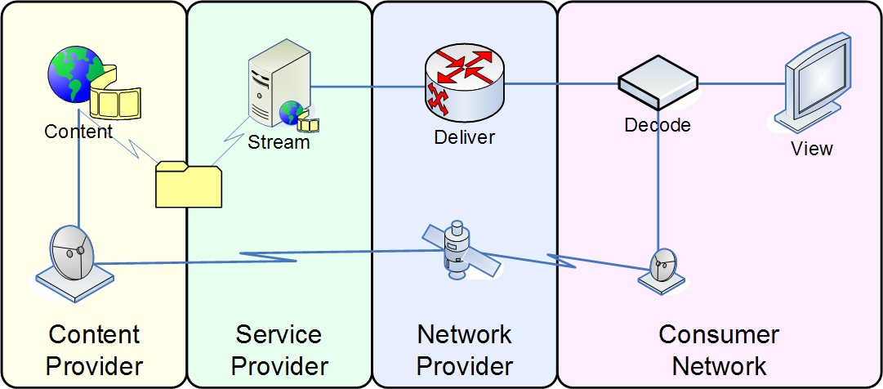
Figure 6-6: Hybrid: Online and Off-air TV Delivery
Editor's note: the above figure needs to be reworded and modified for the sake of consistency and readability.

Linear TV with Multi-View service
Linear broadcast TV with Multi-View is a way to provide one scene with different camera angles. The user can select this angle which he likes to watch. For example, when the end-user watches the baseball game in linear broadcast TV, he can see the first base, third base, or backfield according to his wishes, not the angle the channel director prefers.

On-demand service
Content prepared and delivered by the content provider for retrieval is received and stored by the service provider. If necessary a trans-coding to satisfy the storage media conditions is performed. The user can then select and retrieve such contents from this storage at any time. The content is then provided via a unicast or multicast stream to the user.

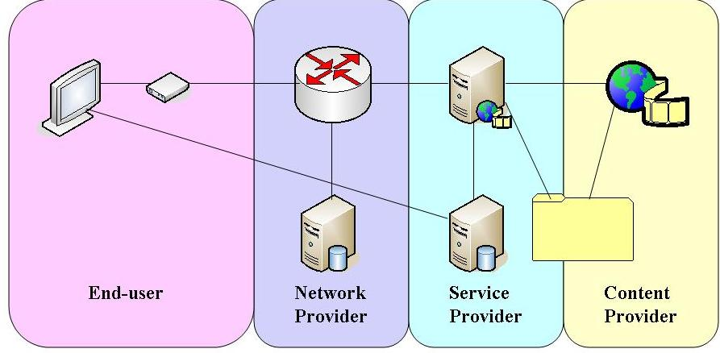
Figure 6-7: Content on Demand
[Editor’s note: Definition of Content on Demand is needed, contributions are welcomed on this point]

Video on demand (VoD)
VoD is a service where the end-user selects and watches video content which is stored by the service provider. Different sub-categories of VoD can be distinguished as following sub-chapters.

Near VoD (NVoD)
- Near VoD is a video service where multiple copies of a program are broadcast at short time intervals (typically 10–20 minutes) providing convenience for viewers. The user can watch the program without the need to tune in at a scheduled point in time, instead, he was to wait in maximum the interval time to get the start of the program. The end-user has no control over the session except in choosing which program to watch. A service scenario for Near VoD is shown in Figure 6-8.
Figure 6-8: Service Scenario for Near VoD

- Video contents with its metadata and DRM sources that are produced and managed by Contents Provider are delivered to the Service Provider.
- With the contents, Service Provider prepares for the Near VoD service by their policy. This procedure may include EPG update, contents management with security, and the contents distribution. After all these procedures, the list of VoD contents and relevant information is provided to the End Users.
- When an End User selects a Near VoD content, the request(s) is sent to the Service Provider. This procedure may include service negotiation (i.g., QoS, price, packaging option, etc.) and service availability confirmation procedures.
- If the request is allowed to the End User, then the Service Provider interacts with the Network Provider for transmission. This procedure may include the network resource reservation to guarantee the contracted service level.
- After that, the Service Provider responses the content access information (i.e., location info. or address info.) and then the End User can start to watch the video using the information. In this procedure, the content can be delivered by both unicast and multicast.

Real VoD
- Real VoD is a video service which allows the end-users to select and watch video content at any point of time. The end-user has full control over choosing which program or clips to watch and when starting to watch. A service scenario for Real VoD is shown in Figure 6-9.
Figure 6-9: Service Scenario for Real VoD

- Video contents with its metadata and DRM sources that are produced and managed by Contents Provider are delivered to the Service Provider.
- With the contents, Service Provider prepares for the Real VoD service by their policy. This procedure may include EPG update, contents management with security, and the contents distribution. After all these procedures, the list of VoD contents and relevant information is provided to the End Users.
- When an End User selects a Real VoD content, the request(s) is sent to the Service Provider. This procedure may include service negotiation (i.g., QoS, price, packaging option, etc.) and service availability confirmation procedures.
- If the request is allowed to the End User, then the Service Provider interacts with the Network Provider for transmission. This procedure may include the network resource reservation to guarantee the contracted service level.
- After that, the Service Provider responses the content access information (i.e., location info.) and then the End User can start to watch the video using the information. In this procedure, the content can be delivered by unicast.

Push VoD
- Push VoD is a video service similar to the Real VoD in that end-users can select and watch video content over a network as part of an interactive and enhanced selective service. However, Push VoD is a “download” of content (entirely or partially) to a set-top box or similar device before the viewing starts.

On-demand with Multi-View service
On-demand service with Multi-View is to provide more various different camera angles than the one station view in Video on-demand. The viewer can select the angle which he likes to watch. For example, when the end-user watches the baseball game in on-demand service, he can see the first base, third base, or backfield according to his wishes, not those predefined by a channel.

Music on demand (MoD)
Music on demand (MoD) is an audio service which allows the end-user to select music or audio contents as an interactive enhanced service like the Real VoD.

Advertising service
Figure 6-10: advertising service
[Editor’s note: Elaboration for this figure is needed, contributions are welcomed on this point]
[Editor’s note: Figures are required to be aligned with the order of “Figure 5-1: IPTV Functional Domains” in the IPTV Architectures’ working document.]

Traditional advertising service
Traditional advertising is the broadcast of commercial advertising or public promotion of goods, services, companies and ideas. Every user in a certain region will receive this advertisement, which are usually inserted into or between A/V programs. Each advertising service can be provided on a national basis or regionally/locally, either in the form of a video clip or within an exclusive channel according to the service type and contract.
Ad insertion is accomplished using an ad insertion system that populates advertisements in the video stream prior to being ingested by the IPTV acquisition system. This is typically applied to a Linear service.
[Editor’s Note: Refine wording is encourage to elaborate on the expressions like “populate”, “generate”, “produce”, “bundle different advertisements”, “IPTV Acquisition System”.]
Advertisement content is created by Contents providers and delivered to the Service Provider. An advertisement is inserted in a proper location of the video stream and delivered to user. The user can see the advertisement while watching the TV program.
1 The Content Provider produces and manages contents for TV channel program with its metadata and provides (delivers) them to the Service Provider’s domain. The advertiser produces advertising contents and provides it also to the Service Provider.
2 The Service Provider inserts the advertisement contents in the proper TV channel contents stream. The contents (with the advertisement included) will then be delivered to the user by a multicast stream.
3 When a user triggers or selects the channel service following the channel information, the user IPTV device connects to the broadcast/multicast server through the IPTV Control/Session Client. This procedure may include multicast join or leave, service level negotiation for QoS.
4-a User device receives the channel stream and user can watch the TV channel program with advertisement.

Targeted Advertising
Targeted Advertising is a commercial advertising or public promotion of goods, services, companies and ideas, usually personalized for end-user’s desire according to his profile characteristics in order to match the audience with the campaign objective requirements. Targeting of advertisements can, using the new description tools, take into account user preferences, usage history, personal characteristics (biographic and accessibility) and usage environments (terminals, networks and natural environmental characteristics).
[Editor’s Note: Encouraging further description on the “new description tools.”]
Advertisers want to ensure their commercials are only seen in areas where their products or services are available.
Consumers want to set a preference to see only specific products or ranges of products depending on their purchasing needs or habits or interests (for instance they may be about to buy a car).
Consumers want to set a preference to block specific products or range of products based on their purchasing needs, habits of lifestyles (for instance they could be strict vegetarians)
1 2 The same with traditional broadcast advertising
3 When a user triggers or selects the channel service following the channel information, Service Provider’s Service Control function checks the user profile and presence and control to sending different advertisement depend on user characteristics (on User profile and presence).
Other actions are the same with traditional broadcast advertising
4-b The user’s device receives the channel stream with advertisements included. User can watch the TV channel program with advertisement.

On-demand Advertising
On-demand Advertising is a commercial advertising or public promotion of goods, services, companies and ideas, where the service provider delivers business advertising directory information for user to navigate and select. After navigating and selecting within the advertisement list, user can watch the advertisement that he selected.
The IPTV service may also be used to deliver business advertising directory information (e.g., “Yellow Pages” information) regarding available business services. This information may include simple directory listings.
1 The advertiser produces advertising contents and provides it to the Service Provider
2 The Service Provider transmits the received advertisement contents to the proper storage components through the Media Delivery interacting with the IPTV Control. Then, the contents list and relevant information are distributed via the network to the end-users.
3 A user navigates and selects any on-demand advertisement contents.
4-c The user receives the stream and can watch the advertisement.

Interactive Advertising
Interactive Advertising is a commercial advertising or public promotion of goods, services, companies and ideas, which lets end-users send various types of requests and receive feedback with interactivity.
The user clicks on an icon during advertising in order to connect to a web site to get additional information on the product.
After pressing a “click-to-call” button (or click on an icon) the user initiates a free call to discuss/purchase a certain product.
1 2 3 the same with one of above services.
4-c The user receives the stream and user can watch the advertisement. And click on an icon for connecting to a web server.
5 The user can initiate a free-call to discuss/purchase a certain product (or can get the more information on product and can buy it on line.)

Advertising message logging
Advertising message logging is a tool used to record information about advertising message, such as message text and click-times, etc. If necessary, advertising message can be captured into a log file. The naming of the log file is recommended to use an absolute pathname. This is necessary, as the log file is opened at each point that a message needs to be written to it. For the sake of convenience and easiness, the advertising message log window can be designed. It displays the information of the advertising message logging in the form of menu. Options on the Message Log window include:
- View message log information
- Operating record
- Copy a message
- Clearing the Message Log
Message log information includes advertising message text, time, channel. Some ads are interactivity advertising， when audience watch them ,they can make online purchases by click operating, the action can be recorded in logging file. Context in logging file can be copied or cleared up by selecting Copy a message or Clearing the Message Log.

Public interest service

Support for users with disabilities
Users with and without disabilities can benefit from supplementary content alongside and in synchronisation with the main content. The most familiar services are subtitling, which provides language translation of the dialogue, and captioning, which provides a transcript of sound effects as well as the dialogue to aid people who cannot hear the sound. The subtitling and captioning services can come in one of two forms: either as a text stream that must be rendered in the receiver with a local font or as a series of graphical bitmaps. There are advantages and disadvantages of each.
Another form of supplementary content is visual sign language translation for deaf people. A sign language interpreter appears in-vision, using hand gestures and mouth movements to convey the dialogue to viewers. Ideally, the position of the interpreter can be set by the user, as well as whether there is a solid or transparent background.
Audio description is a commentary explaining the significant visual aspects of the main content, primarily for the benefit of people who cannot see it, though it is also useful for people with learning difficulties. The commentary fits between the dialogue so as not to interfere with the main content, but to work in conjunction with it. Ideally the volume level and positioning of the audio description can be adjusted by the user.
Digital television equipment usually provides a user interface comprising a remote control and on-screen display. Some users need clearer, larger text or alternative colour combinations in order to read it. Others cannot see the screen at all and need alternative forms of information, such as spoken. The remote control also presents a challenge to those who cannot see or have dexterity limitations. Voice control or a much simpler form of button control can be provided.

Emergency communications
People have different preferences, perhaps based on need, for delivery of notifications. As examples, output should be spoken, text, sign language, and output at different rates. The ITU-T Accessibility Checklist and ITU-T F.790 should be consulted.
Message content should include all pertinent details presented in a way that is easily and quickly understood by the population. This includes multiple languages in some cases, as well as the use of multimedia for illiterate or hearing/visually impaired individuals.
Spoken messages are particularly useful where the natural language text is not well supported by technology, and for reaching anyone who is unable to read at the moment.
The terminal notifies the user of an incoming Emergency Alert Notification (EAN) message both visually and audibly, or according to the user’s preferences and capabilities if they specify otherwise.

Community related information
These are services providing community related information, such as announcements, bus routes, weather and government services related information.
One of the example services is the government service treats civil appeal, tax payment, public poll, Government Issue notice and etc. It could enhance the government productivity and transparency by unifying and opening administration service.

Emergency Communications Scenarios and Use Cases over IPTV Systems

Emergency Communications Generic Service Components
Under Emergency Communications circumstances, public authorities and citizen communities generally act as emergency message providers and consumers respectively. The public authority is in charge of emergency messages generation, audit and distribution. Figure 6-10 shows how the authority and community interact with each other and the messages in between them. While the Emergency Communications running over IPTV architectures and acting as complementary services, Emergency Communications would build more complete picture against its legacy uni-directional broadcasting, text or audio only mode. So in the IPTV systems point of view, bi-directional interactiveness emergency communications between the public authority and the citizen community would be focuses.
Figure 6-11 Emergency communications components and message interaction
Present emergency messages and typical use cases across IPTV systems can be divided as four modes:
- Downwards with ECN usage scenario
- Upwards with ECR usage scenario
- Inter-group with ECI usage scenario
- Inter-authority with ECI usage scenario(irrelevant to IPTV systems, not involved in this document)

Downwards with ECN Usage Scenario
The public authority authenticated the emergency communication notification message from internal or external department. Then ECN would be distributed to a specific community group or just broadcasting. Here Emergency Communications would be interleaved with normal multicast or VoD streaming. In this scenario, ECN could work in PUSH or PULL mode. In PUSH mode, the top priority event messages should be forced into IPTV broadcast systems, regardless whether the users subscribe to such asynchronous events or not. In PULL mode, users can synchronously request the specific interested ECN, such as traffic event in the specified districts or cities, or weather warning from public departments.
The IPTV system works as the distributor, and its broadcasting and multicasting capabilities are the networking enabler. Besides that, IPTV multicasting group management and programming or customised EPG are the service enhancement enabler.
The key points of the Downwards usage scenario are:
- ECN broadcasting in IPTV domain;
- ECN distribution toward specified communities upon their subscriptions;
- ECN distributed in PUSH or PULL mode;
- ECN media streaming overlapped normal streaming(text, audio and video);
- ECN media streaming interrupt normal streaming(text, audio and video);
- ECN distribution community groups correlate with IPTV subscribers and multicasting groups;

Upwards with ECR Usage Scenario
The Emergency Communication report (ECR) would be passed through IPTV systems into the public authority (such as fire station or medical centre, etc.), which is supplement to legacy emergency communications. Fire warning report, illegal house intrusion event report could be passed into the public authority. Monitor camera enabled STB would enhance this ECR usage, such as the stranger recognizing warning, smoke sensor warning, etc.. Amount of personalized notices or warnings would be entering into IPTV systems, via which they are delivered to corresponding department. Types of personalized and customised emergency services would be implemented, such as personal medical services, home visual surveillance services, even global remote medical systems. By the means of IPTV video capabilities, ECR would be more diversified with video circumstantial evidence. In this scenario, IPTV systems would be flexibly integrated with other service systems, such as medical or fire centres, in which, open and standardized interfaces are necessary.
In ECR mode, IPTV systems work as emergency communication message sources with its interactive channels. These multi-media ECR would be passed into specified public authority, where ECR is authenticated and audited.
Upwards usage scenario key points:
- Multi-media ECR
- IPTV systems pass ECR into the specified public authority
- IPTV subscriber positioning and authenticating information should be delivered to public authority
- IPTV terminal capabilities, such as HD camera for legal evidence, event trigger, sensor, etc..
- IPTV service control part would be ECR awareness and route it to the correct EC responses

Inter-group with ECI Usage Scenario
ECI is part of user generated content (UGC) in IPTV systems. Apart from ECR, Emergency Communications reports going to the public authority, ECI from one user group could be delivered to another group for inter-group warning or notifications. In contrast to 4.3 ECR, IPTV systems are responsible for messages audit and authentication under the national regulations.

Emergency Communications Scenarios in IPTV Systems

Downwards with ECN Usage Scenario

Figure 6-12 Downwards with ECN Usage Scenario
[Editor’s note: Figures are required to be aligned with the order of “Figure 5-1: IPTV Functional Domains” in the IPTV Architectures’ working document.]

- Normal broadcasting contents entering into the IPTV Service Provider domain from the Content Provider;
    - 1a. ECN coming into the IPTV Service Provider domain, and the media content into content preparation function;
    - 1b. The public authority informs the IPTV service control function of ECN coming into the IPTV system;
- Upon ECN delivery mode, the content preparation function interleaves the ECN with normal broadcasting content or interrupts the normal broadcasting content, and compound media is ready for delivery by the multicast streaming servers;
    - 2a. Compound media is delivery to the IPTV application server instead of the multicast streaming servers;
- The IPTV service control checks ECNs available, then checks user or group profile and service information to instruct the compound media where to be sent;
- The User and service profile instructs the IPTV application server to deliver the media(ECN receipt user group mapping to IPTV application user group);
- The User and service profile informs the IPTV service control of multicast streaming delivery(ECN receipt user group mapping to IPTV multicast group);
- The compound media is ready for delivery by the multicast streaming server with destination group information and service information;
- The media goes to the final users and user groups. It could be multicast streaming or any other application format, such as VoD, presence, VoIP or WEB servers.

Upwards with ECR Usage Scenario
TBD.

Inter-group with ECI Usage Scenario
TBD.

Tele-services

Tele-learning
Tele-learning is an instructional service for delivering educational contents e.g. infant, children, school student, languages, financial skill, etc to students who are physically located in different geographic areas. Teachers and students can communicate in real time (i.e. both present at the same time) and/or non-real time (i.e. at time of their own decision using a messaging capability) using video, audio, pictures and text etc.

Tele-medicine
Tele-medicine is a medical service which is provided to doctors and patients who are in different geographic areas from each other. Doctors can deal with patients by remote diagnosis, remote consultation, remote medical examination, medical education etc in real time (i.e. both present at the same time) and/or non-real time (i.e. at time of their own decision using a messaging capability) using video, audio, pictures and text etc.

Monitoring services
Monitoring services are services which provide monitoring and surveillance capability. Examples of such services are heath monitoring, surveillance of places, etc.

Portal services
Portal service is a branded aggregation of products and services designed to satisfy a large majority of user’s needs, such as VoD, shopping, banking, communication, entertainment and other interactive services with portal menu. Portal service can target of end-users with broadcasting of commercials, advertisements and interactive response advertising.
[Editor’s note: Contributions are welcomed to elaborate on the definition of the “Portal service”]

Data portal (walled garden, internet access, etc.)
Data portal service is a branded aggregation of internet contents with wall garden access for information, shopping, banking, learning and other communication service with interactivity.
Also, it can support direct internet access for more specific information search.

Web-based IPTV Portal
The web portal is a platform that allows an organization to integrate its business information, applications, and services in a web-based IPTV Portal for easy navigation and access.

Figure 6-13: Web-based IPTV Portal service scenario
[Editor’s note: Figures are required to be aligned with the order of “Figure 5-1: IPTV Functional Domains” in the IPTV Architectures’ working document.]

- Terrestrial/Cable/Satellite TV Broadcaster provide the contents to the service provider(Web-based IPTV Portal)
- Service provider encodes the received audio/video source from Terrestrial/Cable/Satellite TV Broadcast receiver.
- Store the contents to the storage after additional process such as contents packaging, encryption, etc.
- End-user selects the contents via EPG based on web which are provided by portal server.
- Portal server transmits the contents which are requested by end-user.
Ⓐ End-user request the web data services on Internet such as E-mail, FTP, messenger and Instant Messaging(IM).
Ⓑ Portal server provide the web data services.

Terrestrial portal (news, drama, sports, movies, etc.)
Terrestrial portal service is a branded aggregation of terrestrial contents such as news, drama, sports, movies, and talk show, etc. It provides basic terrestrial channel, VoD, PPV, contents connected interactive service, and multi-angle service with various terrestrial contents.
[Editor’s note: Contributions are required to elaborate on the “terrestrial portal”, “terrestrial contents”, and “terrestrial channel.”]

Hosting services
Hosting service is a type of IPTV platform & service hosting that provides organizations and individual users with on, off-line system and network for storing information, image, video, or any content accessible via the IPTV.

Business to business
The business to business hosting service is an IPTV hosting service for the special group or business unit subscriber. It connects the channel, VoD, and portal service made by end-user business unit to the IPTV platform to supply particular groups with real time broadcasting channels, value-added interactive services and T-community activity etc. Generally, it includes a regional community, religion unit, and small business company broadcasting and interactive data service.

User created content (UCC) hosting
User Created Contents (UCC) hosting service is an IPTV hosting service for individual end-user as a user generated Video, interactive content data. This service allows end-user to make their own channel like personal web TV by uploading A/V, application and other contents that they generate through IPTV hosting platform.

CPU resource hosting
[Editor’s note: Contributions on descriptions and scenarios on CPU resource hosting is requested.]

IPTV interactive service
Interactive services let end-users send various types of requests and receive feedback with interactivity.
The integrated internet service, in IPTV integrates current internet based on-line services and provides them within the IPTV service with following use cases.
Figure 6-14: Use cases for the integrated internet services in IPTV
[Editor’s note: Figures are required to be aligned with the order of “Figure 5-1: IPTV Functional Domains” in the IPTV Architectures’ working document.]

- The original contents and data sources are produced and delivered from the Content and Data Sources to the Content Preparation Function.
- Received and processed by the Content Preparation function, its metadata is delivered to the IPTV Application function and its contents are delivered to the Content Delivery & Storage Function under the control of the Content Delivery Control Function.
- When a client turns on, the updated IPTV service guide is transmitted based on their profile.
- When the client selects one of the integrated internet services, that information is transmitted from the Application Client to the IPTV Application.
- a. If the selection includes client-specific requests, it is transmitted and processed by the Application Profile Function.
- b. If the selection requests more data or contents that are in the service provider’s storage, then the request is forwarded and dealt with by the Content Delivery & Storage Function.
- c. If the selection includes more data or contents that are not in the service provider’s storage or includes requests that are out of the service provider’s coverage, then the request can be forwarded to the Content & Data Sources based on their policy.
- a. Proper response or reaction is taken by the IPTV Application.
- b. If necessary, the requested contents or data are transmitted by the Content Delivery & Storage Function under the control of the Content Delivery Control Function.

Information (news, weather, transportation, local community etc.)
IPTV Interactive Information is an information service that supports a considerable amount of useful information such as news, weather, traffic situation and advertisements. Viewer can choose contents on the overlapped linked program screen or independent menu. An example of the information service is a program survey service.

Commerce (banking, stock, shopping, ticketing, auction, product delivery, event, etc.)
IPTV Interactive Commerce is a commercial service that allows viewer to purchase goods and use financial services such as banking, stock, auction etc. For example, personal banking service can help user to view account balances, review past account activity, pay bills, and transfer money between accounts on their IPTV terminal.

Communication (e-mail, messenger, SMS, channel chatting, VoIP, web surfing, multiple video conference, video phone, etc.)
IPTV Interactive Communication is a converged service of telecommunication and broadcasting that compounds phone services (VoIP, video phone, multiple video conference, etc.) and internet-based communication services (Instant Messaging, Short-Messaging Service, Email, Web, etc.) with classical television services. It is usually provided by controlling multiple sessions for a phone service, an internet-based communication service and a television service. IPTV Interactive Communication services have a few combinations. Thus consumers can use the converged services that provide “a phone service and a TV service” or “a communication service and a television service” or “a phone service and a communication service and a television service” simultaneously.
IPTV Interactive Communication is a communication service that enables end-user to exchange information such as voice, video, and data. Users can send (or receive) the mail and message while watching TV. In addition, viewers can simultaneously interact with other people via two-way video and audio transmissions using video conference.
- Video conferencing
A Total Conversation service is an audiovisual conversation service providing bidirectional symmetric real-time transfer of motion video, text and voice between users in two or more locations. This real time text differs from instant messaging systems because it is the transmission bi-directionally of one character at a time. This gives the user the feel of real-time communication, just like voice or video systems that transport streaming media over IP. The concept is aimed at providing for rich media real time conversation for all people and for varying situations. This includes but is not limited to people that are disabled in some way, e.g. the deaf or hard of hearing, blind etc, but also people who find themselves in a situation where the complementing media video, real-time text and voice together fulfils the conversation needs much better than only voice.
Total Conversation is an ITU service description in ITU-T Rec. F.703 and covers videophone with real time text. Ideally all videophones should offer "Total Conversation", but in many cases only video and audio are provided. F.703 is useful not only for the disabled but for anyone who can benefit from the textual back-up of for example technical data, language translations, verbal or signed conversations. It has uses for people who are not only deaf or disabled but people who can’t communicate in either of the two mediums or do not have the command of the spoken language used. Total Conversation’s use is useful to document factual information within videophone calls (e.g. phone numbers and addresses) without searching for pen and paper. An example would be to get a flight booking reference when making a travel arrangement.
- Messaging
An interactive service which offers user-to-user telecommunication between individual users. Messaging services may be immediate (e.g. instant messaging (IM)) or of a store-and-forward type (e.g. email and voice mail).
- TV-based conversational services

Entertainment (games, karaoke, photo album, lottery, blog, etc.)
IPTV Interactive Entertainment is a television entertainment service that contributes viewer’s amusement by providing exciting items such as games, karaoke, and photo album. Games can be sub-divided into single player and multi-player games according to the number of player. Moreover, it can be classified into a network linked game and a stand alone game according to the network interaction type. In the photo album, user can enjoy pictures which they upload or which are provided by provider and transfer it to other people’s TV, mobile phone or etc.
[Editor’s note: Contributions are welcomed to elaborate on the “stand alone game.”]

Interactive games
Interactive Games is a kind of service which allows the user to interactively play games over a network. Interactive games may involving single and multiplayer competitions.

Presence services
[Editor’s note: Contributions are invited for polishing this subclause]
Presence Service is the capability to support management of presence information between watchers and presentities, in order to enable applications and services to make use of presence information.
Presence information is a set of attributes characterising current properties such as status(online, offline, meeting, on the phone, etc.), place(home, office, library, etc.), communication means(audio, video, text, etc), and so on. [3GPP TS 22.141]
Presentity is an entity that provides presence information.
Watcher is an entity that requests presence information about a presentity. [IETF RFC2778]
Presence Service provides access to presence information to be made available to other users or services including IPTV services.
Example services might include:
- Electronic Program Guide(EPG) personalization based on presence on top of locally stored data
- Targeted advertising based especially when correlated with time of day
- Chatting with friends watching the same channel

Figure 6-15. Presence service scenario

- Content is acquired by the service provider from some sources such as a satellite downlink or a content library.
- The content is served to individual consumers.
- The presence information of users and information on users’ devices, services and service components is provided to the Presence Server. The information might be content information (Broadcast TV channel, VoD content, Commercial Advertising, etc.) currently accessed.
- The presence information can be distributed to other end-users.

Basic Presence Service
[Editor’s note: Contributions are invited for polishing this subclause]
User A is watching the TV.
User B logs in TV at home.
Now, user A knows that user B is at home and calls him.

Channel based Presence Service
[Editor’s note: Contributions are invited for polishing ‘Channel based’ in this subclause]
User A is watching the football match on the IPTV.
He would like to chat with friends who are watching the same channel.
He opens the IM client on the TV, and pushes the button marked as “Search for friends”.
On a mask on the screen he specifies the search criteria, that is “buddies watching the same channel now, and available for chatting”.
He gets a list and invites them all to a multi-point messaging session.

Targeted Advertising based on Presence Service
The presence server gathers the presence information of users and stores their log into a database with the approval of them. The presence information could be content information they watches, shopping habits, etc.
An advertiser requests the consumer log of users from the presence server and can make targeted advertisements.

Time-shifting and Place-shifting service
- Time-shifting service
An IPTV service in which subscribers can access and control (pause, rewind, fast forward, etc.) IPTV contents without time limitation. Therefore, this service is assuming that the IPTV contents are saved in a repository for later use.
In a traditional TV service the time shifting service has been provided by the recording functionality such as VCR (Video Cassette Recorder). Then, some products using hard drive instead of tape are starting to prevail while supporting some fancy services such as automatic recording with key words, the name of actor, and etc, which is called as DVR (Digital Video Recorder) or PVR (Personal Video Recorder).
Note that the content should be stored so that subscribers can retrieve it later. The PVR devices are storing the contents in local hard drive. We can call this approach as subscriber-based time-shifting service. However, we can consider some cases in which it is not appropriate to save the contents locally. For example, if the IPTV terminal is PDA, the size of hard drive is limited. The network-based time-shifting mechanism is needed for those kinds of cases, which is also called as NVR (Network Video Recorder). In those solutions, hard drives are located in the service provider’s domain as opposed to the subscriber's set-top box. In the network-based time-shifting service, the broadcasting traffic is transformed into on-demand traffic and service providers can leverage their existing VOD infrastructure already in place. Subscribers sign up for specific network-based time-shifting service and storage limits, and the service provider then gives them access to the IPTV content as it is delivered to their own terminals.
In summary, we can define two types of time-shifting service, subscriber-based and network-based time-shifting services in IPTV.
- Place-shifting service
An IPTV service in which subscribers can access (pause, rewind, fast forward, and etc) IPTV contents without place limitation. That is, this service makes subscriber see his or her subscribed IPTV contents anywhere. The place-shifting basically is to support users who move to the other place from the place where he or she originally subscribed for. This service is assuming that a user’s terminal can even be a mobile phone. However, since the mobile IPTV will be addressed in a separate category, we would not consider the case specifically.
Depending on who is taking care of redistributing the IPTV traffic, we can define two types of place shifting service, subscriber-based place-shifting and network-based place-shifting service. In subscriber-based place-shifting, a subscriber device redistributes traffic to the place where the user is currently located. In network-based place-shifting, service provider send the IPTV traffic to the moved place.

Session mobility service
An IPTV service in which an on-going multimedia session can be transferred seamlessly between different devices based on user preferences. That is, the service makes subscriber see his or her subscribed real time IPTV content seamlessly. It is different from Place-Shifting service for it is more suited for transferring on-going or real time sessions. The session mobility basically is to support capturing the session control context information from the originating terminal device and transferring them to the target terminal device by session transfer controller. And it also supports suspending and resuming the session based on the subscriber’s requirements. This service is allowing that a user’s terminal can even be a mobile device. However, since the mobile IPTV will be addressed in a separate category, we would not consider the case specially.

Supplementary content
This is defined as video, audio, textual, graphical or other forms of content that can be optionally accessed by the user and rendered by the terminal device. It has the following features:
- It only works in conjunction with the main content.
- It is synchronous with the main content.
Examples of use are:
- Subtitles and captions
These services can be provided by means of either textual or graphical supplementary content. Subtitles provide a real-time on-screen transcript of dialogue for the purpose of language translation. The subtitles and the dialogue are in different languages. Captions for the hard of hearing provide a real-time on-screen transcript of the dialogue as well as any sound effects. Different speakers are distinguished, usually by different colours. The captions and the dialogue are in the same language. The service is primarily to assist users having difficulty hearing the sound. Ideally, users may have some control over the position and size of the presentation.
- Audio description
Primarily intended to assist users who are unable to see the video content clearly, this service provides a commentary describing the visual events pertinent to the content. The narrative passages fit between the dialogue and other significant audio content so as not to interfere with it. Ideally the user can control the volume and spatial positioning of the audio or derive it from a separate output.
- Sign language interpretation
This service comes in the form of supplementary video content, usually smaller in image size to that the main video content. The video shows an interpreter who uses hand gestures and facial expression to convey the main audio content to sign language and lip readers. Ideally the user can control the position, size and background properties (solid or transparent and the colour, if solid). It is of sufficient temporal and spatial quality to enable sign reading and lip reading.
- Other services
Feature films on DVD frequently offer an alternative audio track that contains a commentary on the film by the director or actors. IPTV systems could provide the same service by means of supplementary audio content. It would also be possible to optionally show the commentators by means of supplementary video content.
News services often have 'tickers' in vision, of news headlines or financial information. However, different users have different preferences for these information mechanisms so they may best be provided in the form of selectable and customisable supplementary content. If this was provided in the form of supplementary textual content then terminal devices could render it in alternative formats such as speech or Braille.
Commentators for sports events could optionally be seen by means of supplementary video content. In fact, the main audio content could be just the 'natural sound' of the sport, with a choice of commentaries available as supplementary audio content.

3rd party content delivery
[Editor’s Note: Contributions to elaborate on the 3rd Party Content Service is required.]
3rd Party Content Service is a consumer based wide selection service of contents. This 3rd party content service can provide interoperability of content selection and supply between end-user and service provider. For this service, internetworking interface, interoperable middleware to support various selections of different contents source and contents protection scheme such as DRM (including CAS) are required to provide appropriate adaptation of 3rd party content service.

Commercial/business models of IPTV
[editor’s note:] Contributions for elaboration are invited.
[Editor’s note: Contributions to clarify or show some examples of the business use cases in case of multiple provider environments are required.]
There are a number of well-known business models for service providers to support IPTV service and to make profitable revenue by composing various service products.
Generally, classified service products can be commercial model according to the service provider’s policy and marketing.
Here is a proposed list of business/commercial models but other models and combinations might be possible.
- Free
A viewer can watch IPTV service or use it without paying for it.
- Subscription
A viewer should pay an amount of money regularly in order to watch or use IPTV service.
- Pay per view (PPV) / Pay per use (PPU)
A viewer can purchase each service, content or application to be seen on TV at any time and pay for the only item he buys. E.g. each service or content can be purchased using an on-screen guide, an automated telephone system, or through a live end-user service representative.
- A La Carte
A viewer can buy whichever channels and contents he wants, and pay a price for each. In this time, the channel is composed not by the service provider but by the user.
- Cash-back Point
A cash-back point is prepaid e-money or ticket for IPTV service. With these cash-back points user can pay the service fee in IPTV service domain like real-money. User can acquire the cash-back points by buying it with real money or accumulating bonus cash-back point which accrues in a particular rate when they use the IPTV service. The cash-back point can be a unit of price of detailed service. (Similar to frequent flyers miles)
- Package
A viewer can select and use a set of products such as VOD (including channel) and T-entertainment (including game, karaoke and so forth) which are already organized by the service provider. Then, pay for the set of products which he or she chooses.

Annex A

[Editor’s note: Contributions are invited to make elaboration for this Annex ]
An IPTV solution players with multiple roles
The following figure depicts the relations between players in the operation of IPTV services.

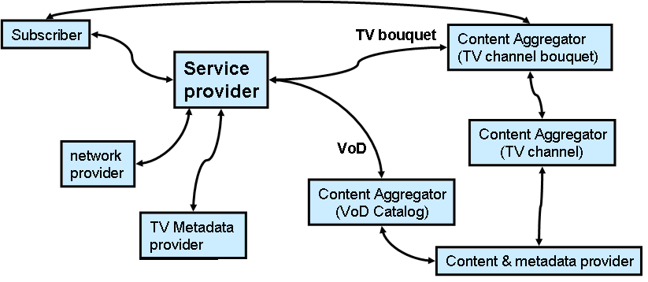
Figure A-1. Players in operating IPTV Services

A company can play different roles in the delivery of IPTV Services:
- Content aggregator
  - It creates its own TV Bouquet combining individual TV channels and metadata coming from a TV channel metadata provider,
  - It creates its own VoD Catalog combining contents negotiated with content providers.
- Service provider
  - It offers the subscription to its own TV bouquet and VoD Catalog.
  - It operates the IPTV architecture (TV Head-End, CDN, VoD servers, etc.) over its own network
Identification of metadata provider role
Content providers have of course metadata about their contents, so content providers are also metadata providers.
However, there are true metadata providers who provide metadata about contents but not the contents themselves.
Among the pure metadata providers we can find the EPG providers, newspapers, freelance journalists, individuals.
For example, they provide comments, opinions or critics about movies.
Model for relations between roles
The distribution of roles among players can be manifold.
So here is a proposal for a generic IPTV Service model.
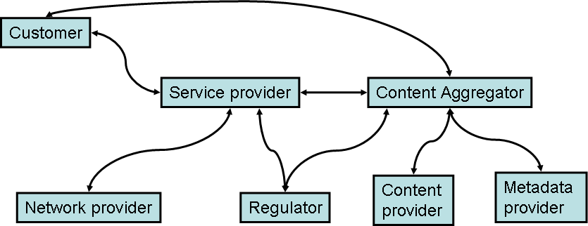
Figure A- 2. IPTV Service mode for relations between roles
A player may play different roles e.g. service provider, content aggregator, etc.

Identification of players/roles
- Content providers
- Application providers
- Content aggregators
- Service providers
- Network providers
- Consumers (subscriber, viewer, etc.)
- Regulators

____________________

