INTERNATIONAL TELECOMMUNICATION UNION |  |  |  | Focus Group On IPTV
TELECOMMUNICATION  STANDARDIZATION SECTOR  STUDY PERIOD 2005-2008 |  |  | FG IPTV-DOC-0175
 |  |  | English only
WG(s): 3 |  | 6th FG IPTV meeting:  Tokyo, Japan, 15-19 October 2007
OUTPUT DOCUMENT
Source: | Editor
Title: | Living List: IPTV Security Aspects

Summary
TBD

Keywords
TBD

Introduction
TBD
Content
1 Scope 4
2 References 4
3 Definitions and Terms 4
4 Abbreviations and acronyms 4
5 Security Threats 4
5.1 Content Security Threat 4
5.2 Service Security Threat 4
5.3 Network Security Threat 4
5.4 Terminal Device Security Threat 4
5.5 Subscriber Security Threat 4
6 Security Requirements 5
6.1 Content Security Requirement 5
6.2 Service Security Requirement 5
6.3 Network Security Requirement 5
6.4 Terminal Device Security Requirement 5
6.5 Subscriber Security Requirement 5
7 Security Architecture 5
7.1 Security Trust Model 5
7.2 Security General Framework 5
7.2.1 Content Protection Architecture 6
7.3 Security Function Modules 6
7.4 Security Interfaces 10
8 Security Mechanisms 10
8.1 Content Security Mechanisms 10
8.1.1 Content Protection 12
8.1.2 Conditional Access 12
8.1.3 Digital Rights Management 13
8.2 Service Security Mechanisms 16
8.2.1 Service Authentication 16
8.2.2 Service Authorization 17
8.3 Network Security Mechanisms 17
8.4 Terminal Device Security Mechanisms 17
8.4.1 Terminal Device Authentication 17
8.4.2 Terminal Device Authorization 18
8.4.3 Terminal protection 18
8.5 Subscriber Security Mechanisms 18
8.5.1 Subscriber Authentication 18
8.5.2 Subscriber Authorization 19
8.5.3 Subscriber information Protection 19

[Editor Note: No new materials are added in the living list during Tokyo meeting And the review of this LL in order to extract some useful materials into WG3 Working Document for next meeting (Malta, December 11-18, 2007) was solicited for WG3 experts.]
Editors Note: The following identifier BEGIN and END is an internal label that designates materials boundary in this document. This label is expected to be used for internal tracking purposes.
- Scope
- References
- Definitions and Terms
This Document defines the following terms:
TBD.
- Abbreviations and acronyms
This Document uses the following abbreviations.
TBD.
- Security Threats

Content Security Threat

Service Security Threat

Network Security Threat

Terminal Device Security Threat

Subscriber Security Threat

- Security Requirements

Content Security Requirement

Editors Note: already be merged in service requirement section of OD.

Service Security Requirement
************************from contribution Mountain View meeting*********************
------------BEGIN
Editors Note: already be merged into service security requirement section in OD.
Editors Note: already be merged into service security requirement section in OD.
Editors Note: Already be merged in service security requirement section in OD.

Network Security Requirement
************************from contribution Mountain View meeting*********************
------------BEGIN
Editors Note: already be merged into service security requirement section in OD.
**************************From the contributions Busan meeting*********************
----------------------BEGIN
Editors Note: already be merged into service security requirement section in OD.

Terminal Device Security Requirement

**************************From the contributions Busan meeting*********************
----------------------BEGIN
Editors Note: already be merged into service security requirement section in OD.
Editors Note: already be merged into service security requirement section in OD.

Subscriber Security Requirement
- Security Architecture

Security Trust Model
TBD.

Security General Framework

    - Content Protection Architecture

************************from old living list*************************************
------------BEGIN

NEED TO BE DISCUSSED AND ADD THE DELINEATION OF THIS FIGURE.
SEC_ARCH_0005:

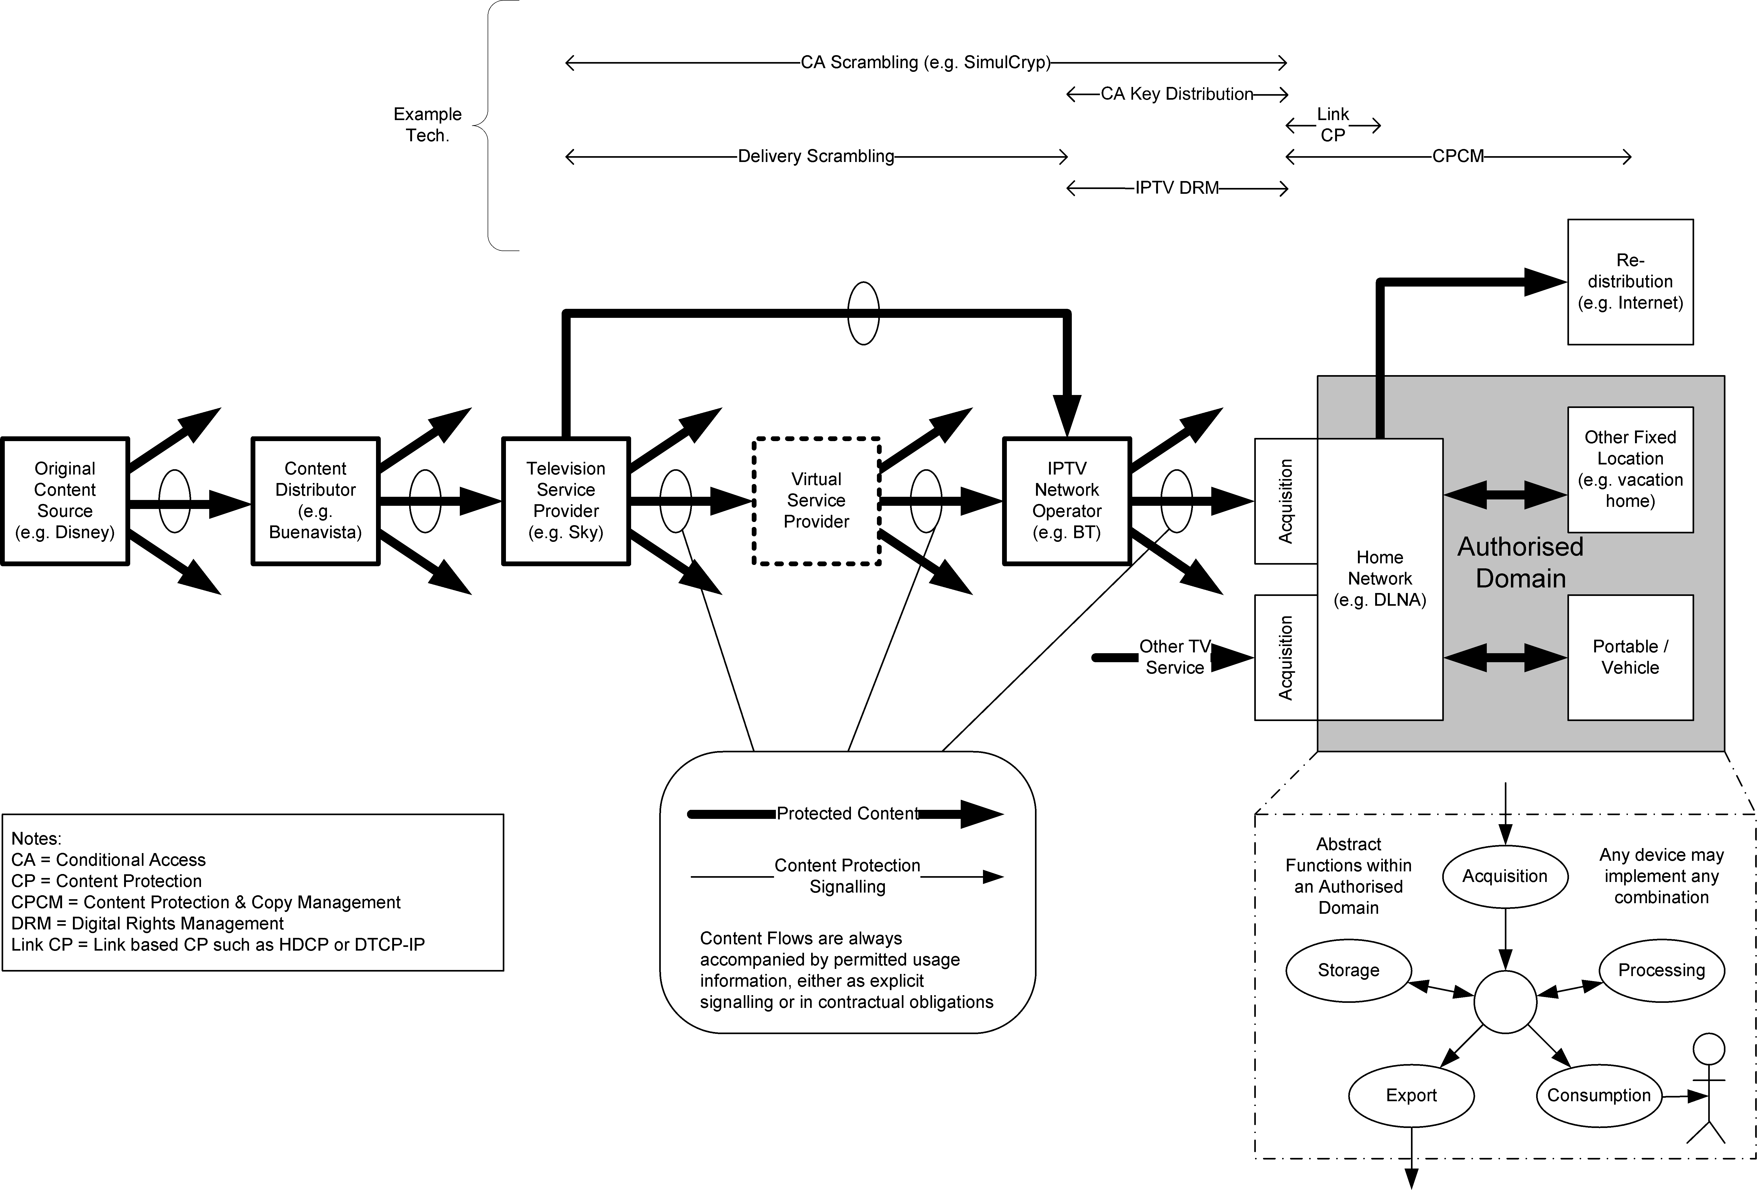
Figure 4

Security Function Modules

************************from old living list*************************************
------------BEGIN
Editors Note: consider the following under the security architecture section in OD.
SEC_ARCH_0008:

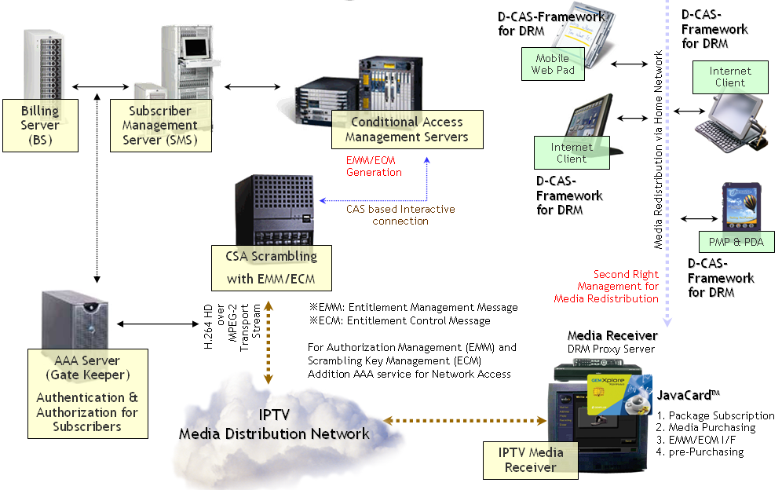
Figure 7
There are 2 categories to make this contents protection system within IPTV mechanism. First protection the network access via AAA service. Second, the media itself protection via CA or DRM method.
All access from the subscribers are connected to the SMS (Subscriber Management System) and BS (Billing Server) to request the access bill to the each subscriber of IPTV.
After receiving the media, storing and re-distribution, converting to other CODEC, transfer to the other display devices should be controlled by DRM. But for DRM control, it is needed to proxy service for faster service. So, the main receiver (we guess it might be STB with HDD) should do the role of DRM proxy server within the home.

Editors Note: to be discussed.
SEC_ARCH_0009:

The specifications of a CAS/DRM system that implements all these security functions are shown below.
Figure 8

- CAS/Digital Rights management
The conditions below are not necessarily exclusive requirements; they can be realized through different means.

- IP channel services
If a content scrambler key is used as a method of delivery, it is desirable to use ECM (in band), which is compatible with the current streamings of the particular country question.
In the case of free channels where content protection needs to be considered, it is desirable that content is viewable only by means of multicast data transmission—a method that allows content be viewed without a subscriber contract.
- EMM/PKI (out of band)
As a delivery method of subscriber contract renewal information, utilizing the two-way nature of communication, it is desirable to deliver content by a method such as PKI—which provides a secure channel for data equivalent to EMM, an extension of current broadcasts.
- Various VOD and download services: control by license issue
While there are many conceivable types of VOD services, it is desirable in all cases to utilize a payment method for viewer conditions and licenses.

  - Content protection
- Content encryption method
In IP channel services, it is generally expected that content is viewable immediately after selecting a channel. For this reason, it is desirable to use a time-limited licensing that is compatible with broadcast methods. In the case of VOD streaming and download services, since content is delivered by unicast in response to the demand of the viewer, it is desirable to have a license key for each item of content, for encrypting the content in advance.
- Encryption algorithms
It is desirable to use encryption methods that are standardized, and widely respected. Based on links IPTV service to the broadcasting of each country, it is not essential to narrow down to one algorithm. However, when selecting new encryption algorithms, it is desirable that encryption be at least 128 bit.
  - Security
Smartcard-based “CAS” for Broadcasting are now widespread, so it is desirable to utilize smartcards. However, since technology built in to CPEs is now highly advanced, if the following conditions can be met, it is acceptable to use Download-CAS or a DRM-like implementation of CAS/DRM built in to the CPE—without the need for smartcards. Given the falling costs of building complex functionality into hardware, it is expected that in the coming years CAS/DRM systems will be increasingly implemented by way of software.
- There is compatibility between the responsibility dividing line of the service provider and the responsibility dividing line of transmission systems and CPE functions include CAS/DRM modules
- Due consideration is given software anti-tampering measures
- IPTV service is not completely interrupted, even to exchange a CAS/DRM module due to the occurrence piracy has occurred

  - Authentication/Authorization

1) PKI base
When multiple IPTV service operators share a single CPE, it is most effective if the CAS/DRM is also shared. If this is done, then in view of the frequent M&As that occur between IPTV service providers, it is preferable to use PKI (Public Key Infrastructure), whereby sharing is not necessary, instead of a common key system in which all viewers share a private key.
2) Attacks on the systems of IPTV service providers and protection of personal data
From the perspective of attacks on the systems of IPTV service providers and protection of personal data, it is preferable that the service provider implements, as far as possible, two-way authentication based on PKI.
3) Validity period and renewal of public key certificate and CRL operation
Normally, in order to limit the security risk, a validity period is set for public key certificates used for PKI. It is necessary to take care in setting validity periods, because, unlike in the case of PCs and other devices, it is not always easy to update the certificates CPEs..
Normally, CRL operation is necessary for public key certificates. For anti-piracy measures reason, it is necessary to take care in implementing CRL processing of CPEs and CAS/DRM modules.
--------------END

Security Interfaces
TBD.

- Security Mechanisms

Content Security Mechanisms

************************from contribution Mountain View meeting*********************
------------BEGIN
Editors Note:Had been included and merged into architecture in fifth Geneva meeting..

************************from contribution first IPTV meeting*********************
------------BEGIN

Editors Note: consider the following under the content security mechanism section in OD from the contributions in the first IPTV meeting
SEC_MECH_0001:

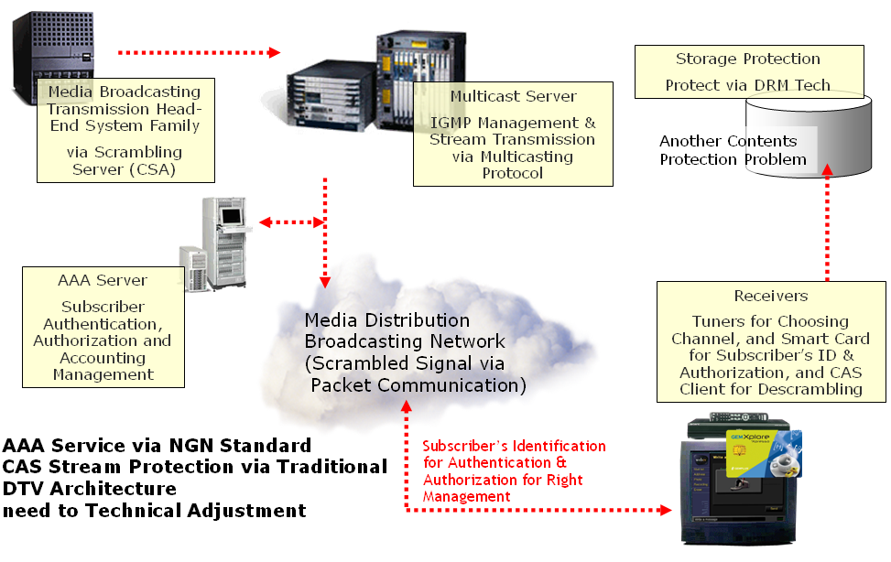
Figure 9

IPTV is based on communication technology, and always the subscriber can interchange any message with the server which would be logically located in broadcasting center. So, there are two kinds of contents protection mechanism should be considered.
First, access the IPTV broadcasting network. In many case, there is already standard mechanism for subscriber authentication, authorization and accounting, called AAA. That can do the role of toll-gate to prohibit the entrance illegal users into the IPTV network.
Second, scrambling media stream like similar mechanism of traditional can be considered. However, it is different from traditional broadcasting, because IPTV can confirm and acknowledge for each packet through open but secured protocol, like SSL. In addition, the new IPTV CA system can send to subscriber not only 2 the keywords (EMM, ECM), but also its encryption mechanism (the encryption mechanism) for each media. If it is realized we can get 3 merits.
- Each medium ((multiple) audio, video, (multiple) interactive software with data, any other information like SI) can use different encryption method according to the business model. So, the broadcaster can sell each medium through subscriber’s request.
- The encryption method can be vary according to the time goes. The encryption method can be vary even during the broadcasting is on-air. All encryption method always downloaded to the each subscriber with the keywords.
- The responsibility of contents protection should be to the contents provider, because all contents method should be transferred to the broadcasters with their A/V stream. However, if the broadcaster wants the broadcaster can install their own contents protection system like traditional broadcasting system.
Therefore, it is suggested the 2 mechanisms are all needed to IPTV for dual protection.
--------------END

**************************From the contributions Busan meeting*********************
----------------------BEGIN
Editors Note: Had been included in OD as security threats before fifth Geneva meeting

    - Content Protection
TBD.
    - Conditional Access
TBD.
************************from old living list*************************************
------------BEGIN
Editors Note: to be discussed.
SEC_MECH_0003:

Conditional Access (CA) provides the restriction of content viewing to authorized users through scrambling or encryption of media. CA has a long history in television broadcast via cable and satellite television through both proprietary (e.g. DigiCypher and Nagravision) and standard means (e.g. DVB-CA, ATSC-CA).
Common terms in CA for the control of authorization for content rights are Entitlement Control Message (ECM) which defines a protected resource and Entitlement Management Message (EMM) which grants rights to a given subscriber or their agent to view a set of content described by ECMs. Both ECMs and EMMs may be transmitted with the controlled content or through a separate channel, depending on implementation. EMMs can be delivered either through a digital communication channel or on a smart card delivered to the subscriber. The former is more relevant to the DRM discussion.

CPE
Encryptor
encrypted stream

[w/ embedded ECMs]
CA Server
keys
EMMs w/ keys
decrypted stream
Display Device
Keys for an asset are shared across all users within the CA server domain
unencrypted stream
Authentication
[ECMs]

Figure 10 - Conditional Access Logical View

--------------END

    - Digital Rights Management

************************from old living list*************************************
------------BEGIN
Editors Note: to be discussed .
SEC_MECH_0004:

Digital Rights Management (DRM) is sometimes thought of as the “digital management of rights” or as the “management of digital rights”. In fact, DRM provides the “digital management of rights to digital assets”. DRM combines Conditional Access and Copy Protection, this combination allows the addition of richness to the policies that can be expressed and enforced on protected assets. DRM allows assets to be protected and then a variety of policies specified by the asset owner on how the asset may be used. A DRM scheme must support the following critical attributes of rights which may be granted:
- who has access
  - a subscriber, a user, or any group or combination of these
- on which devices
  - a device or a group of devices
- to which agents
  - a DRM client implementation (“DRM agent”) or group of agents
- when do they have access
  - for what time period, how many times may access be granted
- to which features
  - e.g. a set of software features, video on demand trick modes, etc.
- with what output
  - what output formats (analogue and digital) are supported for this content, with what restriction (e.g. is 1080i digital video display allowed without HDMI/HDCP support in the display device)
  - what export formats are supported (e.g. analog output must support Macrovision, digital storage must support DVB-CPCM or digital output must support DTCP)
It must be possible to combine these attributes, such as granting the right: a particular High Definition movie may be viewed by users with a certain subscription ID, on any trusted DRM agent, for 1 week, as many times as they like, on TVs at 1080i, through digital output supporting DTCP, or through analogue output supporting CGMS-A.
It is critical that a DRM solution provides protection for both the asset owner and the asset licensee, allowing free and unencumbered use of asset within the rights of the subscriber. It is also beneficial if a DRM system can support the distribution and control of assets by “users” as well as traditional service providers – this provides for a much richer content and service exchange and engenders innovation and business.
In order to facilitate DRM, two key network services are required:
- Trust establishment and verification between the DRM rights issuer and the DRM agent
- A secure time source to facilitate time based rights expression
Additionally, the ability to facilitate forensic analysis and prosecution of breaches of key information are critical to the long term success of any content licensing model, implying the integration of Digital Watermarking technologies into DRM systems.
DRM Agent 1
Rights Issuer
unprotected
content
“unprotected”
content
Display Device
Keys for an asset are specific to a subscription
Asset Owner
Asset Provider
rights
definition
keys
(either direction)
request or distribute license
AAA /
Payment
rights request or delivery
purchase
DRM Agent 1
protected
content
request or distribute license
User
Display Device
“unprotected”
content
Figure 11 – Digital Rights Management Logical View; Rights Issuer, Asset Provider, Asset Owner, and AAA/Payment may be a single or any multiple legal or business entities

Editors Note: Had been merged into OD in Fifth Geneva meeting..
- Authorized Output
While not a DRM mode per se, DRM systems may nonetheless need to deal with authorized output. This is content sent to a display device for direct consumer viewing or listening. Some examples of authorized output interfaces are DTCP, HDCP, CPRM, etc.

Editors Note: consider the following under the content or service security mechanism section in OD.
SEC_MECH_0006:

Stepwise Approach:
We need discuss on the stepwise approach for this mechanism. First step, we should make the standard only for IPTV distribution media protection.
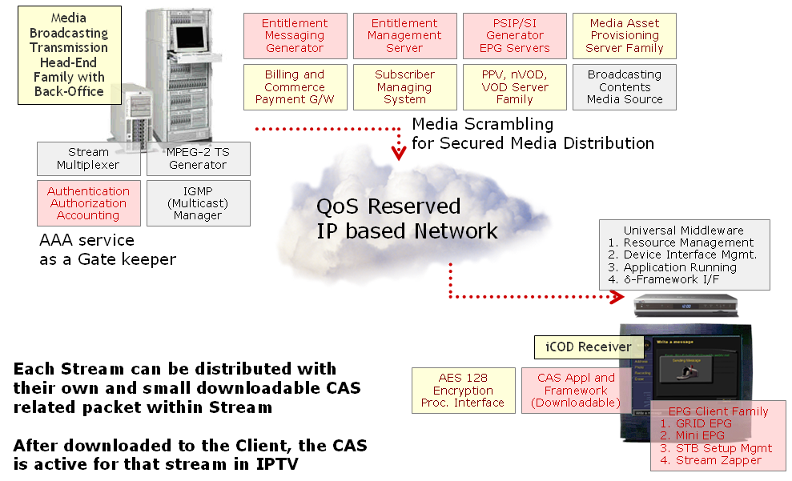
Figure 12

In this phase, we should define all downloadable mechanism for the CA system, from encryption and distribution of keywords, then decryption. However, it is more important to define all running framework on downloaded CA packets in client, because all secured keyword can be with its encryption mechanism. The following is an example of the client CA software architecture.
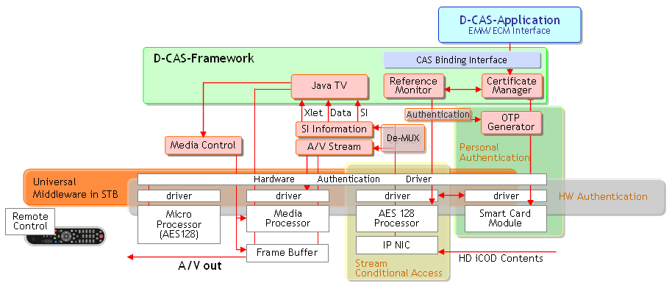
Figure 13

In second step, we should define on DRM and media life cycle management mechanism, we will call this mechanism as DRM.
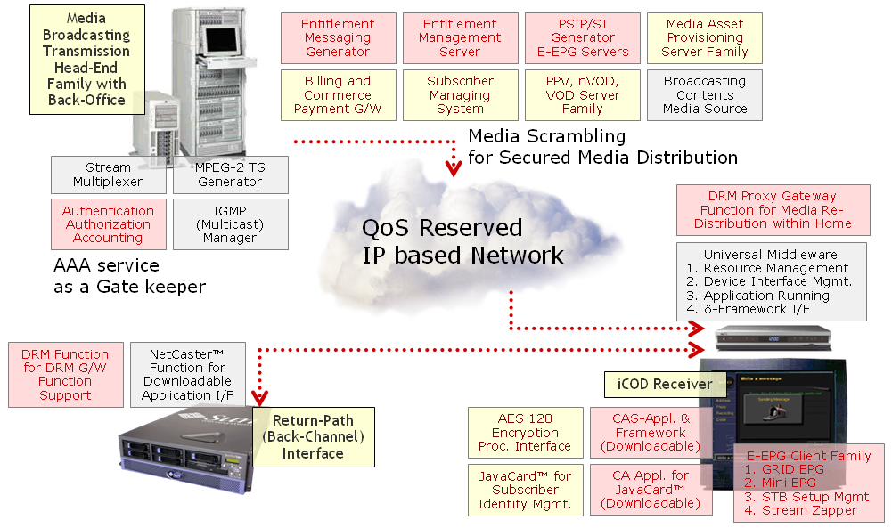
Figure 14

--------------END

Service Security Mechanisms
    - Service Authentication

    - Service Authorization
TBD.

Network Security Mechanisms
**************************From the contributions Busan meeting*********************
----------------------BEGIN
Editors Note: Had been included in OD as security threats before fifth Geneva meeting.

Terminal Device Security Mechanisms
TBD.
    - Terminal Device Authentication
TBD.
**************************From the contributions Busan meeting*********************
----------------------BEGIN
Editors Note: to be discussed .
SEC_MECH_0010:
There are two phases of terminal device authentication. In the initial device installation phase, a PKI based challenge response model could be used to establish permanent key. The second phase would be subsequent power-on device authentication by using the already established permanent key after installation.
The permanent key should be generated during terminal installation. Once it is generated, it should be scrambled and stored in a permanent storage inside the terminal device with basic secured access control. The permanent key should not be changed until a new installation process is performed. Several security measures shall be considered when establishing permanent key.
- It is preferred to use PKI mechanism to secure the channel of generating the permanent key.
- Basic challenge and response method should be adopted in the process of generating permanent key.
- It is highly recommended to have certain hardware component such as secure processor and/or secured micro co-processor to facilitate the permanent key generation process, message encryption and key storage.
Instead of using permanent key to secure the service channels between the terminal devices and authentication server, a terminal device should use the permanent key to generate the session key and use it to encrypt the communication channels with authentication servers.
- And session key could be changed in operator specified interval. This will enhance the overall security of subscriber authentication system.
- A re-authentication process at a certain interval is recommended to exchange new session key.
-----------------------END

    - Terminal Device Authorization
TBD.
    - Terminal protection
TBD.
**************************From the contributions Busan meeting*********************
----------------------BEGIN
Editors Note:Had been included in OD as security threats before fifth Geneva meeting .

Subscriber Security Mechanisms
TBD.
    - Subscriber Authentication
TBD.
**************************From the contributions Busan meeting*********************
----------------------BEGIN
Editors Note: to be discussed.
SEC_MECH_0012:

The following diagram depicts a general model of the STB and subscriber authentication based the standard Kerberos token mechanism.

- STB and Authentication Server

STB communicates with the authentication server for initial terminal and subscriber device installation and authentication, as well as for subsequent power on authentications. All the service access tokens are generated by authentication server.

- STB and application servers and other resources
The communications between STB and application servers in the IPTV system are secured by access tokens that STB acquired in its authentication process with the authentication server.
STB
Service API’s
Authentication Client
Authentication Server
VoD
EPG
VAS
DRM
Billing
.
1. Installation and Authentication
2. Token Generation

Token based service verification
.

Figure 15

-----------------------END

    - Subscriber Authorization
TBD.

    - Subscriber information Protection
**************************From the contributions Busan meeting*********************
----------------------BEGIN
Editors Note: Had been included in OD as security threats before fifth Geneva meeting.

_________________

