 | INTERNATIONAL TELECOMMUNICATION UNION |  |  |  | Focus Group On IPTV
 | TELECOMMUNICATION  STANDARDIZATION SECTOR  STUDY PERIOD 2005-2008 |  |  | FG IPTV-IL-0109
 |  |  |  | English only
WG(s): 6 |  |  | 6th FG IPTV meeting:  Tokyo, Japan, 15-19 October 2007
INCOMING LIAISON STATEMENT

Source: |  | Rapporteur Q23/16
Title: |  | Reply LS on speech and audio codecs (FG-IPTV-OL-0068)

 | INTERNATIONAL TELECOMMUNICATION UNION |  |  |  |  | COM 16 – LS 247 – E
TELECOMMUNICATION
STANDARDIZATION SECTOR
STUDY PERIOD 2005-2008
English only
Original: English
Question(s): |  | 23/16 | Geneva, 12 October 2007
LIAISON STATEMENT
Source: |  | Rapporteur Q23/16
Title: |  | Reply LS on speech and audio codecs (FG-IPTV-OL-0068)
LIAISON STATEMENT
To: |  | ITU-T FG-IPTV WG 6
Approval: |  | ITU-T Q23/16 Rapporteur meeting (Geneva, 12 October 2007)
For: |  | Action
Deadline: |  | 26 January 2008
Contact: |  | Hervé Taddei  Nokia Siemens Networks  Germany |  | Tel: +49 89 636 48747  Fax: +49 89 636 49802  Email: herve.taddei@nsn.com
Contact: |  | Yushi Naito  Mitsubishi Electric Corporation  Japan |  | Tel: +81 46 741 2449  Fax: +81 467 41 2019  Email: Naito.Yushi@dr.MitsubishiElectric.co.jp
Q23/16 would like to thank the IPTV FG for their LS on speech and audio codecs (our TD 405/Gen, yours FG IPTV-OL-0068).
We would like to inform you with the requested information (see next pages of this LS) on the already standardized audio and speech conversational codecs that could be relevant for the IPTV content coding tool box (i.e. G.722, G.722.1 and G.722.1 Annex C, G.722.2 and G.729.1).
Please note that these codecs will be particularly suited for usage where delay reduction and compression efficiency for voice or mixed voice and audio signals is required
The next Q23/16 Rapporteur meeting is scheduled 28 Jan – 1 Feb 2008.

ITU-T G.722.1 and G.722.1 Annex C

Contact: Minjie Xie, Polycom, Inc., USA
Tel.: +1 781 270 0159 Email: Minjie.Xie@polycom.com

The main body of ITU-T Recommendation G.722.1 [1] describes a wideband coding algorithm that provides an audio bandwidth of 50 Hz to 7 kHz, operating at a bit rate of 24 kbit/s or 32 kbit/s. ITU-T Recommendation G.722.1 Annex C (“G.722.1C”) [1] is a doubled form of the G.722.1 main body to permit 14 kHz audio bandwidth using a 32 kHz audio sample rate, at 24, 32, and 48 kbit/s. Both G.722.1 and G.722.1 Annex C codecs feature very high audio quality, extremely low computational complexity, and low algorithmic delay compared to other state-of-the-art audio coding algorithms.
The G.722.1 algorithm is based on transform coding, using a Modulated Lapped Transform (MLT) and operates on frames of 20 ms corresponding to 320 samples at a 16 kHz sampling rate. Because the transform window length is 640 samples and a 50 per cent overlap is used between frames, the effective look-ahead buffer size is 320 samples. Hence the total algorithmic delay of the coder is 40 ms. Figure 1 shows a block diagram of the encoder.

Figure 1 - Block diagram of the G.722.1 encoder
The MLT performs a frequency spectrum analysis on audio samples and converts the samples from the time domain into a frequency domain representation. Every 20 ms the most recent 640 audio samples are fed to the MLT and transformed into a frame of 320 transform coefficients centered at 25 Hz intervals. In each frame the MLT transform coefficients are divided into 16 regions, each having 20 transform coefficients and representing a bandwidth of 500 Hz. As the bandwidth is 7 kHz, only the 14 lowest regions are used. For each region the region power or the root-mean-square (rms) value of the MLT transform coefficients in the region is computed and scalar quantized with a logarithmic quantizer. The obtained quantization indices are differentially coded and then Huffman coded with a variable number of bits. Using the quantized region power indices and the number of bits remaining in the frame, the categorization procedure generates 16 possible categorizations to determine the parameters used to quantize and code the MLT transform coefficients. Then, the MLT transform coefficients are normalized, scalar quantized, combined into vectors, and Huffman coded. The bit stream is transmitted on the channel in 3 parts: region power code bits, 4 categorization control bits, and then code bits for MLT transform coefficients.
G.722.1C has the same algorithmic steps as the G.722.1 main body, except that the algorithm is doubled to accommodate the 14 kHz audio bandwidth. G.722.1C still operates on frames of 20 ms and has an algorithmic delay of 40ms, but due to the higher sampling frequency the frame length is doubled to 640 samples from 320 samples and the transform window size increases to 1280 samples from 640 samples. Compared to the G.722.1 main body, the specific differences in the G.722.1C encoder are as follows:
- Double the MLT transform length from 320 to 640 samples
- Double the number of frequency regions from 14 to 28
- Double the sizes of Huffman coding tables for encoding quantized region power indices
- Double the threshold for adjusting the number of available bits from 320 to 640

Figure 2 – Block diagram of the G.722.1 decoder
Figure 2 shows a block diagram of the decoder. In each frame the region power code bits are first extracted from the received data and then decoded to obtain the quantization indices for the region powers. Using the same categorization procedure as the encoder, the set of 16 possible categorizations computed by the encoder are recovered and the categorization used to encode MLT transform coefficients is found with the received 4 categorization control bits. For each region the variable bit-length codes for MLT transform coefficients are decoded with the appropriate category and the MLT transform coefficients are reconstructed. The reconstructed MLT transform coefficients are converted into time domain audio samples by an Inverse MLT (IMLT). Each IMLT operation takes in 320 MLT transform coefficients to produce 320 audio samples.
Following are the main changes in the G.722.1C decoder when compared to G.722.1.
- Double the number of frequency regions from 14 to 28
- Double the threshold for adjusting the number of available bits from 320 to 640
- Extend the centroid table used for reconstruction of MLT transform coefficients
- Double the IMLT transform length from 320 to 640 samples

Low complexity is a major technical advantage of G.722.1 and G.722.1C compared to other codecs with similar performance in this bit-rate range. Table 1 and Table 2 present the computational complexity in units of Weighted Million Operations Per Second (WMOPS) [2] and memory requirements in bytes of G.722.1 and G.722.1C, respectively.
Table 1 – Computational complexity in WMOPS
Codec | Bit rate  (kbit/s) | Encoder  (WMOPS) | Decoder  (WMOPS) | Encoder+Decoder  (WMOPS)
G.722.1 | 24 | 2.3 | 2.7 | 5.0
G.722.1 | 32 | 2.4 | 2.9 | 5.3
G.722.1C | 24 | 4.5 | 5.3 | 9.7
G.722.1C | 32 | 4.8 | 5.5 | 10.3
G.722.1C | 48 | 5.1 | 5.9 | 10.9

Table 2 – Memory requirements in Bytes
Codec | RAM | Data-ROM
G.722.1 | 11 K | 20 K
G.722.1C | 18 K | 30 K

In March 2005, as a part of the G.722.1 Annex C development process in ITU-T, subjective characterization tests were performed on G.722.1C by an independent listening lab according to a test plan [3] designed by the ITU-T Q7/SG12 Speech Quality Experts Group (SQEG). More details about test design and data analysis can be found in [3][4][5][6]. A well-known MPEG audio codec was used as the reference codec in the tests [3]. Statistical analysis of the test results showed that G.722.1C met all performance requirements. For speech signal, G.722.1C was better than the reference codec at 24 and 32 kbit/s and G.722.1C at 48 kbit/s was not worse than the reference codec operating at either 48 or 64 kbit/s [5]. For music and mixed content such as film trailers, news, jingles and advertisement, G.722.1C was better than the reference codec at all bit rates and G.722.1C at 48 kbit/s was also better than the reference codec operating at 64 kbit/s [6].
The RTP payload for G.722.1 and G.722.1C is specified in ITU-T Recommendation G.722.1 Annex A [1], and also specified in IETF RFC 3047 [7] and draft-ietf-avt-rfc3047-bis-04 [8] which updates RFC 3047 adding support for G.722.1C.
REFERENCES
- ITU-T Rec. G.722.1, "Coding at 24 and 32 kbit/s for hands-free operation in systems with low frame loss", May 2005.
- ITU-T Rec. G.191, "Software tools for speech and audio coding standardization", September 2005.
- ITU-T WP3/SG16 AC-05-17, "Characterization Listening Test Plan of the 14kHz Low-Complexity Audio Coding Algorithm at 24, 32 and 48 kbps Extension to ITU-T G.722.1", April 2005.
- ITU-T WP3/SG16 AC-05-16, "Processing Test Plan of the 14kHz Low-Complexity Audio Coding Algorithm at 24, 32 and 48 kbps Extension to ITU-T G.722.1", April 2005.
- ITU-T WP3/SG16 AC-05-29, "Characterization test results of the 14 kHz low-complexity audio coding algorithm at 24, 32, and 48 kbit/s extension to ITU-T G.722.1: phase 1", April 2005.
- ITU-T WP3/SG16 AC-05-30, "Characterization test results of the 14 kHz low-complexity audio coding algorithm at 24, 32, and 48 kbit/s extension to ITU-T G.722.1: phase 2", April 2005.
- IETF RFC 3047: "RTP Payload Format for ITU-T Recommendation G.722.1".
- IETF Document draft-ietf-avt-rfc3047-bis-04: "RTP Payload Format for ITU-T Recommendation G.722.1".

ITU-T G.729.1 - An 8-32 kbit/s scalable wideband coder bitstream interoperable with G.729
Contact: Mi Suk Lee, ETRI, Korea
Tel.: +82 (0) 42 860 6148 Email: lms@etri.re.kr
The G.729.1 coder is an 8-32 kbit/s scalable wideband extension of G.729 [1]. The output of G.729.1 has a bandwidth of 50-4000 Hz at 8 and 12 kbit/s and 50-7000 Hz from 14 to 32 kbit/s. At 8 kbit/s, G.729.1 is fully interoperable with G.729, G.729 Annex A, and G.729 Annex B.
G.729.1 is recommended as optional codec for NG-DECT to provide high wideband voice quality in current "32 kbit/s" DECT channel. The main specific features are the interoperability with widely deployed G.729 based VoIP systems and the specific design for usage over packetized networks (high robustness to packet losses). Scalability can be also identified as a specific feature to easily and efficiently quality/bandwidth usage tradeoff.
The encoder produces an embedded bitstream structured in 12 layers corresponding to 12 available bit rates from 8 to 32 kbit/s. The bitstream can be truncated at the decoder side or by any component of the communication systems to adjust "on the fly" the bit rate to the desired value with no need for outband signalling. Figure 1 shows the G.729.1 bitstream format.

Figure 1: G.729.1 bitstream format (compliant with G.192)
The underlying algorithm of the G.729.1 coder is based on a three-stage coding structure: embedded Code-Excited Linear Predictive (CELP) coding of the lower band (50-4000 Hz), parametric coding of the higher band (4000-7000 Hz) by Time Domain Bandwidth Extension (TDBWE), and enhancement of the full band (50-7000Hz) by a predictive transform coding technique referred to as Time-Domain Aliasing Cancellation (TDAC).

Overview of Encoder
The G.729.1 encoder structure is shown in Figure 2. The coder operates on 20 ms frame and the default sampling rate is 16000 Hz. However, the 8000 Hz sampling frequency is also supported.
The input signal is first split into two subbands using a QMF filterbank and then decimated. The high-pass filtered lower band signal is coded by the 8-12 kbit/s narrowband embedded CELP encoder. The difference between the input and local synthesis signal of the CELP encoder at 12 kbit/s is processed by the perceptual weighting filter. The weighted difference signal is then transformed into frequency domain by MDCT.
The spectral folded higher band signal is pre-processed by a low-pass filter with 3000 Hz cutoff frequency. The resulting signal is coded by the TDBWE encoder and the signal is also transformed into frequency domain by MDCT. The MDCT coefficients of lower band and higher band signal are finally coded by the TDAC encoder.
In addition, some parameters are transmitted by the frame erasure concealment (FEC) encoder in order to introduce parameter-level redundancy in the bitstream. This redundancy allows improving quality in the presence of erased frames.
Figure 2: High-level block diagram of the encoder

Overview of Decoder
A functional diagram of the decoder is presented in Figure 3. The decoding depends on the actual number of received layers or equivalently on the received bit rate.
If the received bit rate is:
- 8 kbit/s (Layer 1): The layer 1 is decoded by the embedded CELP decoder. Then the decoded signal is post-filtered and post-processed by a high-pass filter. The QMF synthesis filterbank generates the output with a high-frequency synthesis set to zero.
- 12 kbit/s (Layers 1 and 2): The layer 1 and 2 are decoded by the embedded CELP decoder and the synthesized signal is then post-filtered and high-pass filtered. The QMF synthesis filterbank generates the output with a high-frequency synthesis set to zero.
- 14 kbit/s (Layers 1 to 3): In addition to the narrowband CELP decoding and lower band adaptive post-filtering, the TDBWE decoder produces a high-frequency synthesis which is then transformed into frequency domain by MDCT so as to zero the frequency band above 3000 Hz in the higher band spectrum. The resulting spectrum is transformed in time domain by inverse MDCT and overlap-add before spectral folding. In the QMF synthesis filterbank the reconstructed higher band signal is combined with the respective lower band signal reconstructed at 12 kbit/s without high-pass filtering.
- Above 14 kbit/s (Layers 1 to 4+): In addition to the narrowband CELP and TDBWE decoding, the TDAC decoder reconstructs MDCT coefficients, which correspond to the reconstructed weighted difference in lower band and the reconstructed signal in higher band. In the higher band, the non-received subbands and the subbands with zero bit allocation in TDAC decoding are replaced by the level-adjusted subbands of MDCT coefficients which are produced by TDBWE. The lower band and higher band MDCT coefficients are transformed into time domain by inverse MDCT and overlap-add. The lower band signal is then processed by the inverse perceptual weighting filter. To attenuate transform coding artefacts pre/post-echoes are detected and reduced in both the lower and higher band signals. The lower band synthesis is post-filtered, while the higher band synthesis is spectrally folded. The lower band and higher band signal are then combined and up-sampled in the QMF synthesis filterbank.
Figure 3: High-level block diagram of the decoder
RTP payload
To transmit the G.729.1 bitstream over RTP, the RTP payload format specified in RFC 4749 [2] is used. The payload consists of one byte header and zero or more consecutive audio frames at the same bit rate. The payload header consists of two fields: 4 bit MBS and 4 bit FT.
MBS (Maximum Bit rate Supported) indicates a maximum bit rate to the encoder at the receiver site. Because of the embedded property of the G.729.1 coder, the encoder can send frames at the MBS rate or any lower rate. Also, as long as it does not exceed the MBS, the encoder can change its bit rate at any time without previous notice. The MBS values from 0 to 11 represent the bit rate from 8 to 32 kbit/s, respectively. And the MBS value 15 assigned to a multicast group application.
FT (Frame Type) indicates the encoding rate of the frames in the packet. The FT values from 0 to 11, like a MBS, indicate the bit rate from 8 to 32 kbit/s. The FT value 15 indicates that there is no audio data in the payload.
Audio data of a payload contains one or more consecutive audio frames at the same bit rate. The audio frames are packed in order of time, that is, oldest first.
Reference
[1] ITU-T Rec. G.729.1: “G.729 based Embedded Variable bit-rate coder: An 8-32 kbit/s scalable wideband coder bitstream interoperable with G.729”, 2006.
[2] IETF RFC 4749: “RTP payload format for G.729.1 Audio codec”, 2006
ITU-T G.722
Contact: Stéphane Proust, France Telecom, France
Tel.: +33 (0) 2 96 05 17 42 Email: stephane.proust@orange-ftgroup.com

The ITU-T G.722 is an audio coding system which may be used for a variety of higher quality wideband (50 to 7000 Hz) speech applications. It has been standardized in 1988 to enhance the audio quality of applications like video and audio conferencing over ISDN networks and has been used for some specific radio broadcast usage as well. G.722 usage has recently strongly increased for VoIP: it has been selected as mandatory codecs for New Generation wideband DECT terminals and is gaining momentum for enhanced wideband voice services over IP networks thanks to some attractive features like low delay, low complexity and license free status.

Overview of main functional features
G.722 has three modes of operation corresponding to the bit rates of 64, 56 and 48 kbit/s. The G.722 encoder produces an embedded 64 kbit/s bitstream structured in 3 layers corresponding to these 3 operating modes. The bits corresponding to the last 2 layers can be skipped by the decoder or any other component of the communication systems to dynamically reduce the bit rate to 56 kbit/s or 48 kbit/s which corresponds to 1 or 2 bits "stolen" from the low band.
Encoding/decoding operations are performed on a sample per sample basis which limits the algorithmic delay to 1,625ms.
Complexity is limited and can be estimated to around 10 MIPS.
Appendix III and IV of ITU-T G.722 Recommendation propose two possible standardized packet loss mechanisms to strongly increase G.722 audio quality for usage over IP networks subject to packet losses.
For usage of G.722 over IP networks, format of RTP payload is specified in RFC 3551.

Overview of G.722 SB-ADPCM encoder
The coding system uses sub-band adaptive differential pulse code modulation (SB-ADPCM). The frequency band of the input signal (sampled at 16 kHz) is split into two sub-bands by two linear-phase non-recursive digital QMF filters (Quadrature Mirror Filtors): [0, 4 kHz] for the lower band and [4, 8 kHz] for the higher band. The signals in each sub-band (now sampled at 8 Khz) are encoded using ADPCM with 6 bits per sample for the lower band and 2 bits for the higher band. The number of bits allocated to the lower band are reduced to 5 bits and 4 bits for the 56 kbit/s and 48 kbit/s modes respectively.

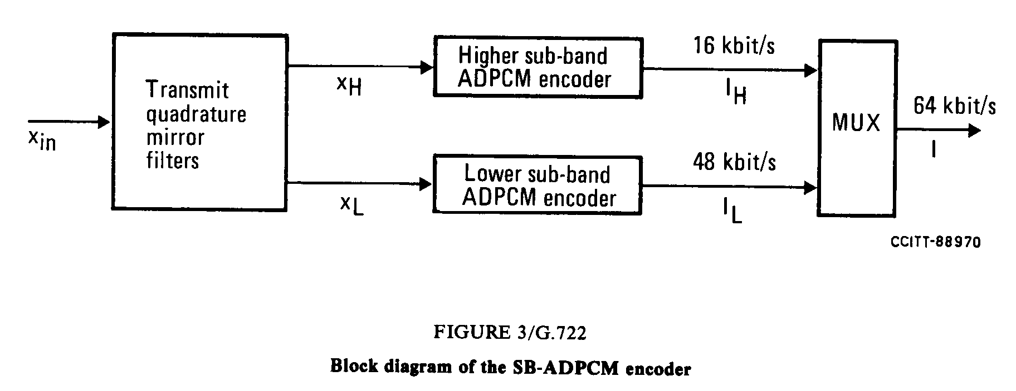
Lower sub-band ADPCM encoder
The lower sub-band input signal, x_{L} after subtraction of an estimate, s_{L} , of the input signal produces the difference signal, e_{L}. An adaptive 60-level non linear quantizer is used to assign six binary digits to the value of the difference signal to produce a 48 kbit/s signal, I_{L}. In the feedback loop, the two least significant bits of I_{L} are deleted to produce a 4-bit signal I_{Lt}, which is used for the quantizer adaptation and applied to a 15-level inverse adaptive quantizer to produce a quantized difference signal, d_{Lt}. The signal estimate, s_{L} is added to this quantized difference signal to produce a reconstructed version, r_{Lt}, of the lower sub-band input signal. Both the reconstructed signal and the quantized difference signal are operated upon by an adaptive predictor which produce the estimate, s_{L}, of the input signal, thereby completing the feedback loop.
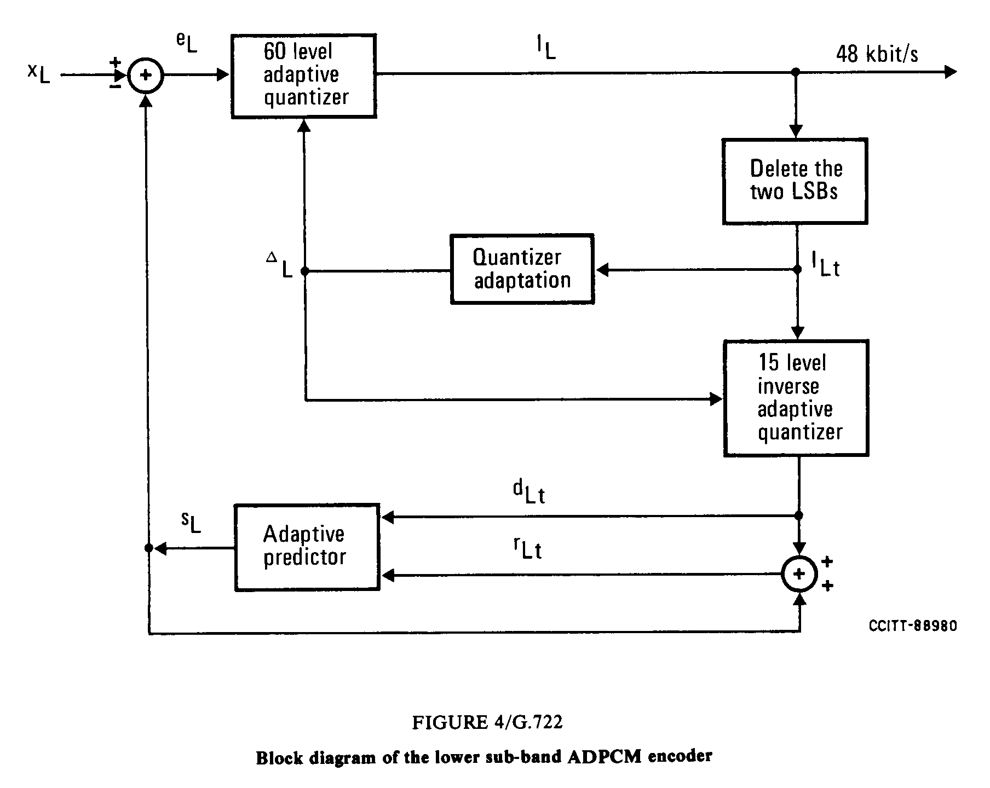
Higher sub-band ADPCM encoder
Same encoding scheme is used for higher sub-band with 4 level non linear quantizer, 4 level inverse adaptive quantizer and no deleted bits.

Overview of G.722 SB-ADPCM decoder
G722 decoder can operate in any of three possible variants depending on the received indication of the mode of operation as shown in following block diagram:
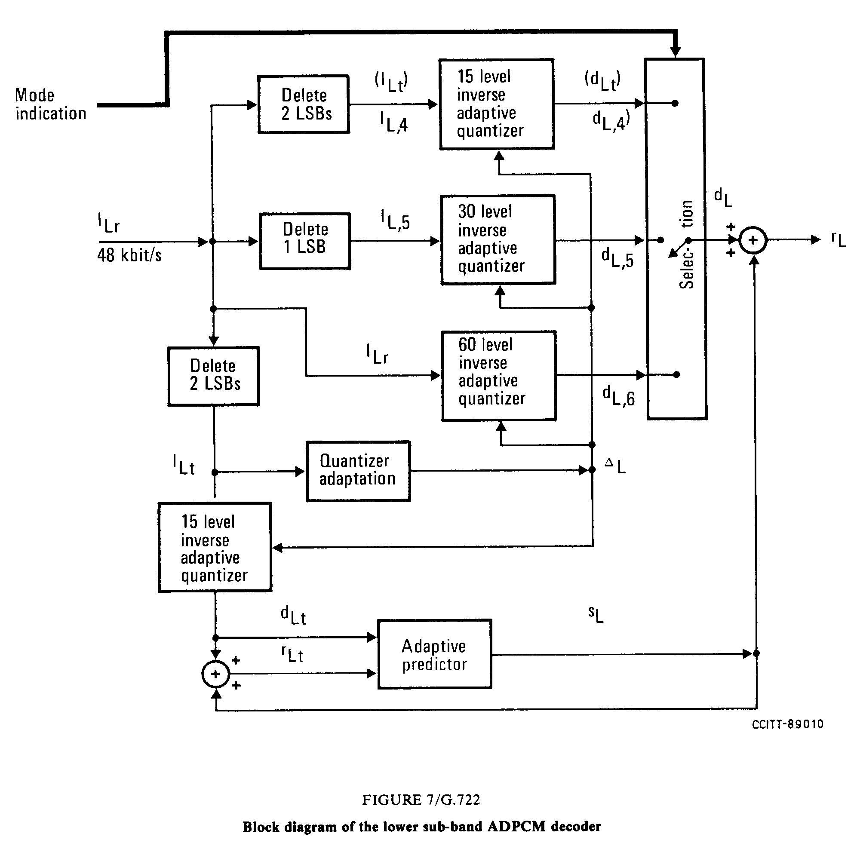
The path which produces the estimate, s_{L}, of the input signal including the quantizer adaptation, is identical to the feedback portion of the lower sub-band ADPCM encoder. The reconstructed signal, r_{L}, is produced by adding to the signal estimate one of three possible quantized difference signals, d_{L,6}, d_{L,5} or d_{L,4} (= d_{Lt}), selected according to the received indication of the mode of operation.
Upper band decoder has the same structure with a single 4 level inverse adaptive quantizer

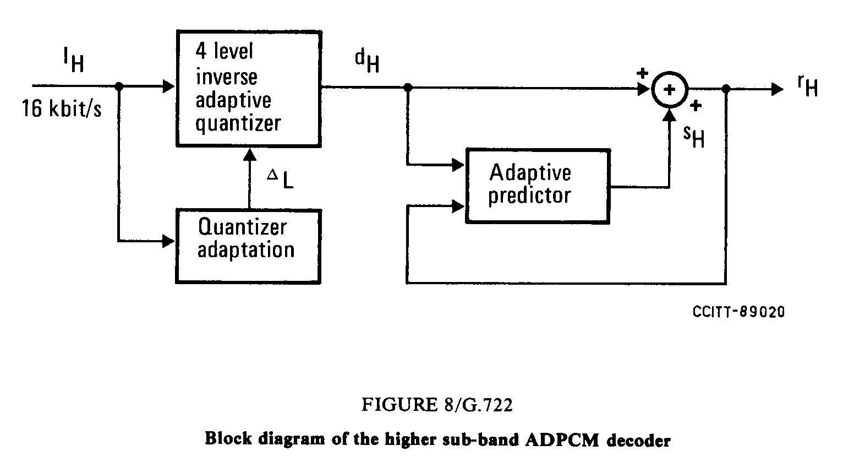
The output decoded signal is then reconstructed by interpolation of the decoded lower band and higher band from 8 kHz to 16 kHz. The combination of the transmit and the receive QMF filters.
ITU-T G.722.2 (3GPP AMR-WB)
Contact: Jari Haqvist, Nokia, Finland
Tel.: +358 (50) 4835459 Email: jari.hagqvist@nokia.com

The AMR-WB codec has been standardized by both the ITU-T (as Recommendation G.722.2) and 3GPP. It is a multi-rate codec that encodes wideband audio signals sampled at 16 kHz (with a signal bandwidth of 50-7000 Hz). The AMR-WB codec consists of nine modes with bit rates of 23.85, 23.05, 19.85, 18.25, 15.85, 14.25, 12.65, 8.85 and 6.6 kbps. AMR-WB also includes a 1.75 kbps background noise mode that is designed for the Discontinuous Transmission (DTX) operation in GSM and can be used as a low bit rate source-dependent back ground noise mode in other systems.
In 3GPP, the AMR-WB codec has been specified in several specifications. TS 26.171 [1] gives a general overview of the AMR-WB standards. The algorithmic detailed description is given in TS 26.190 [2], and the fixed point and floating point source code are given in TS 26.173 [3] and TS 26.204 [4], respectively. Voice Activity detection is given in TS 26.194 [5] and comfort noise aspects are detailed in TS 26.192 [6]. Frame erasure concealment is specified in TS 26.191 [7].
In ITU-T the same specifications are reproduced in Recommendation G.722.2 and its annexes [8].
In 3GPP, AMR-WB is the mandatory codec for several services when wideband speech sampled at 16 kHz is used. These services include circuit switched and packet-switched telephony, 3G-324H multimedia telephony, Multimedia Messaging Service (MMS), Packet-switched Streaming Service (PSS), Multimedia Broadcast/Multicast Service (MBMS), IP multimedia Subsystem (IMS) Messaging and Presence, and Push-to-talk over Cellular (PoC).

Overview of AMR-WB codec
The codec is based on the code-excited linear predictive (CELP) coding model. The codec operates at an internal sampling frequency of 12.8 kHz. The input signal is processed in 20 ms frames (256 samples).
The signal flow at the encoder is shown in Figure 1. After decimation, high-pass and pre-emphasis filtering is performed. LP analysis is performed once per frame. The set of LP parameters is converted to immittance spectrum pairs (ISP) and vector quantized using split-multistage vector quantization (S-MSVQ). The speech frame is divided into 4 subframes of 5 ms each (64 samples). The adaptive and fixed codebook parameters are transmitted every subframe. The quantized and unquantized LP parameters or their interpolated versions are used depending on the subframe. An open-loop pitch lag is estimated in every other subframe or once per frame based on the perceptually weighted speech signal.
Then the following operations are repeated for each subframe:
- The target signal x(n) is computed by filtering the LP residual through the weighted synthesis filter with the initial states of the filters having been updated by filtering the error between LP residual and.
- The impulse response, h(n) of the weighted synthesis filter is computed.
- Closed-loop pitch analysis is then performed (to find the pitch lag and gain), using the target x(n) and impulse response h(n), by searching around the open-loop pitch lag. Fractional pitch with 1/4th or 1/2nd of a sample resolution (depending on the mode and the pitch lag value) is used. The interpolating filter in fractional pitch search has low pass frequency response. Further, there are two potential low-pass characteristics in the adaptive codebook and this information is encoded with 1 bit.
- The target signal x(n) is updated by removing the adaptive codebook contribution (filtered adaptive codevector), and this new target, x₂(n), is used in the fixed algebraic codebook search (to find the optimum innovation).
- The gains of the adaptive and fixed codebook are vector quantified with 6or 7 bits (with moving average (MA) prediction applied to the fixed codebook gain).
- Finally, the filter memories are updated (using the determined excitation signal) for finding the target signal in the next subframe.
The signal flow at the decoder is shown in Figure 2. At the decoder, the transmitted indices are extracted from the received bitstream. The indices are decoded to obtain the coder parameters at each transmission frame. These parameters are the ISP vector, the 4 fractional pitch lags, the 4 LTP filtering parameters, the 4 innovative codevectors, and the 4 sets of vector quantized pitch and innovative gains. In the 23.85 kbit/s mode, also the high-band gain index is decoded. The ISP vector is converted to LP filter coefficients and interpolated to obtain LP filters at each subframe. Then, at each 64-sample subframe:
- The excitation is constructed by adding the adaptive and innovative codevectors scaled by their respective gains.
- The 12.8 kHz speech is reconstructed by filtering the excitation through the LP synthesis filter.
- The reconstructed speech is de-emphasized.
Finally, the reconstructed speech is upsampled to 16 kHz and high-band speech signal is added to the frequency band from 6 kHz to 7 kHz.

Figure 1 – Detailed block diagram of the ACELP encoder
Figure 2 - Detailed block diagram of the ACELP decoder

Performance of AMR-WB
The AMR-WB codec has been extensively tested by 3GPP and ITU-T to assess its subjective performance in various application scenarios.
3GPP Technical Report TR 26.976 [9] provides information of the AMR-WB Characterisation, Verification and Selection Phases. Experimental test results from the speech quality related testing are reported to illustrate the behaviour of the AMR-WB codec. Additional information is provided, e.g., on implementation complexity of the AMR-WB codec. TR 26.935 [10] provides information on the performances of default speech codecs in packet switched conversational multimedia applications. The codecs under test included AMR-WB.

Transport and storage of AMR-WB
The RTP payload for AMR-WB is specified in RFC 3267 [11]. It supports encapsulation of one or multiple AMR-WB transport frames per packet, and provides means for redundancy transmission and frame interleaving to improve robustness against possible packet loss. The payload supports two formats, bandwidth-efficient and octet-aligned. The minimum payload overhead is 9 bits per RTP-packet in bandwidth-efficient mode and 2 bytes per RTP-packet in octet aligned mode. The use of interleaving increases the overhead per packet slightly. The payload also supports CRC and includes parameters required for session setup. 3GPP TS 126 234 (PSS) [12] and TS 126 346 (MBMS) [13] use this payload.
The AMR-WB ISO-based 3GP file format is defined in 3GPP TS 26.244 [14], with the media type “audio/3GPP”. Note that the 3GP structure also supports the storage of other multimedia formats, thereby allowing synchronized playback. In addition, an additional file format is specified in RFC 3267 for transport of AMR-WB speech data in storage mode applications such as email. The AMR-WB MIME type registration specifies the use of both the RTP payload and storage formats.

References:
[1] 3GPP TS 26.171: “AMR Wideband Speech Codec; General Description".
[2] 3GPP TS 26.190: “AMR Wideband Speech Codec; Transcoding functions".
[3] 3GPP TS 26.173: “AMR Wideband Speech Codec; ANSI-C code".
[4] 3GPP TS 26.204: “ANSI-C code for the Floating-point Adaptive Multi-Rate Wideband (AMR-WB) speech codec”
[5] 3GPP TS 26.194: “AMR Wideband Speech Codec; Voice Activity Detection (VAD)".
[6] 3GPP TS 26.192: “AMR Wideband Speech Codec; Comfort Noise Aspects".
[7] 3GPP TS 26.191: “AMR Wideband Speech Codec; Error Concealment of Lost Frames.
[8] ITU-T Recommendation G.722.2: “Wideband coding of speech at around 16 kbit/s using Adaptive Multi-rate Wideband (AMR-WB)”
[9] 3GPP TS 26.976: “Performance characterization of the Adaptive Multi-Rate Wideband (AMR-WB) speech codec”.
[10] 3GPP TS 26.935: “Packet Switched (PS) conversational multimedia applications; Performance characterization of default codecs”.
[11] IETF RFC 3267, “Real-Time Transport Protocol (RTP) Payload Format and File Storage Format for the Adaptive Multi-Rate (AMR) and Adaptive Multi-Rate Wideband (AMR-WB) Audio Codec,”
[12] 3GPP TS 26.234: “Transparent end-to-end Packet-switched Streaming Service (PSS); Protocols and codecs”.
[13] 3GPP TS 26.346: “Transparent end-to-end Packet-switched Streaming Service (PSS); 3GPP SMIL language profile”.
[14] 3GPP TS 26.244: “Transparent end-to-end packet switched streaming service (PSS); 3GPP file format (3GP)”.
_____________________

