Geneva, 9 May 2007
INTERNATIONAL TELECOMMUNICATION UNION
Telecommunication
Standardization Bureau

Ref: | TSB Collective letter 9/TAS
Tel:  Fax:  E-mail: | +41 22 730 5989  +41 22 730 5853  tsbsg3@itu.int | - To the members of the Tariff Group for Asia and Oceania (TAS Group)

Subject: | Meeting of the Regional Tariff Group for Asia and Oceania (TAS Group) and Seminar on tariff issues  Seoul, Korea, 3 – 6 July 2007

Dear Sir/Madam,
1 During the last meeting of the TAS Group held in Tokyo in May 2006, the TAS Group agreed that its next meeting should be scheduled for spring/summer 2007, and Study Group 3 had endorsed this proposal at its meeting in March 2007. I am now pleased to inform you that the TAS Group is to meet from 3 to 6 July 2007 inclusive at the kind invitation of the Ministry of Information and Communication (MIC) of the Republic of Korea. The meeting will take place in the headquarters of the Telecommunications Technology Association (TTA) in Seongnam City, south part of Seoul, and will be preceded by a seminar of three sessions (from 3 to 4 July - morning inclusive) focusing on tariff issues and country case studies.
2 The seminar, organized with the cooperation of the Telecommunication Development Bureau (BDT), will start at 09:30 hours on 3 July 2007. The meeting of the TAS Group will start at 14:00 hours on the following day and will be restricted to delegates and representatives of administrations and recognized operating agencies of the region, in conformity with § 2.3.2 of Section 2 of Resolution 1 of the World Telecommunication Standardization Assembly (Florianópolis, 2004). The registration of delegates will take place in the morning of 3 July at the meeting venue as from 08:30 hours.
3 In agreement with the Chairman of the TAS Group, the seminar and the meeting will be conducted in English without interpretation.
4 The draft agenda of the TAS Group meeting, as prepared by the Chairman of the TAS Group, may be found in Annex 1 hereto.
5 As it will be seen from the agenda, the purpose of the meeting will be to analyze the results of the cost study realized in the TAS region and to study how this cost study can be reflected in the accounting rates negotiation. The TAS Group should also give consideration to the new study items identified during the last TAS meeting. In preparation for the meeting hereby convened, reference should be made to Report TAS-R 2 (September, 2006). Administrations and recognized operating agencies are invited to submit contributions and also to respond to TSB Collective letters 7/TAS and 8/TAS of 1 December 2006 concerning the inquiry on the results of the cost study for inward IDD services in direct and transit relations, and the Questionnaire on the movement of accounting rates (both questionnaires are available online at http://www.itu.int/ITU-T/othergroups/tas/tas-eform1.html ).
6 You will shortly be receiving a letter of invitation from BDT for the Regional Seminar to be held just before the TAS meeting.
7 Would you please read carefully Annex 2 to this collective letter which contains practical information kindly provided by the host organization.
In particular, I would point out that you should announce your participation using the Attachments 1 (with a copy to the Telecommunication Standardization Bureau) and 2 directly to the host organization by not later than 11 June 2007.
For those who need a Visa, the Attachment 3 should be sent to the host organization by not later than 1 June 2007.
8 Pursuant to the provisions of Recommendation A.1 of the WTSA (Florianópolis, 2004) contributions to the work of the TAS Group shall be submitted to the Director of the Telecommunication Standardization Bureau (TSB).
Contributions which cannot reach TSB by 24 June 2007 must be sent directly to the host organization at the address given hereunder, with a copy to TSB.
With a view to settling any questions which might arise concerning contributions, the name, the fax and telephone numbers and the e-mail address of the person to be contacted should be indicated on contributions. Accordingly, please give those details on the cover page of all documents.
Address for sending contributions after 22 June 2007:
Dr Byoung Nam Lee
Vice-Chairman of the TAS Group
Senior Researcher
Protocol Engineering Center
ETRI
161 Gajeong-Dong, Yusong-gu
DAEJEON, 305-700
Republic of Korea
Tel: +82 42 860.6636
Fax: +82 42 861.5404
Email: b.n.lee@etri.re.kr
It is important to note that participants should enquire in advance whether they need a visa for Seoul and apply to the Consulate or Embassy of Korea in their respective country.
Yours faithfully,
Malcolm Johnson
Director of the Telecommunication
Standardization Bureau
Annexes: 3
ANNEX 1
(to TSB Collective letter 9/TAS)

Draft Agenda

- Opening of the meeting
- Approval of the agenda
- Available documents
- Review of TAS and ITU activities
- Results of the TAS questionnaires
- TAS cost model enhancements (LRIC)
- Traffic declarations and settlement procedures
- Accounting rates issues:
  - Mobile termination charge
  - Shortening of the settlement period and establishment of a dispute resolution procedure
  - Discussion on network externalities
  - Settlement of mobile data communication including SMS, MMS, Video/Music
  - Fraud and risk management
- IP Telephony
- IP traffic recording
- International Internet Connectivity
- Effect of migration of traditional traffic to the hubbing
- Review of International Telecommunication Regulations
- Preparation of WTSA-08, revision of Resolutions
- Future work programme
- Other business
- Next meeting
annex 2
(to TSB Collective letter 9/TAS)

GENERAL INFORMATION
ITU-T TAS Meeting
(3 – 6 July, 2007, Seoul, Korea)

Venue Information
Venue: TTA (Telecommunications Technology Association)

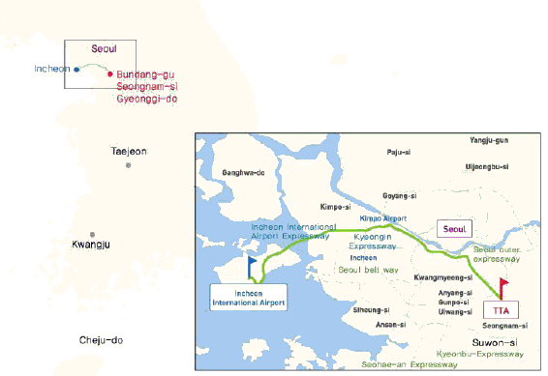
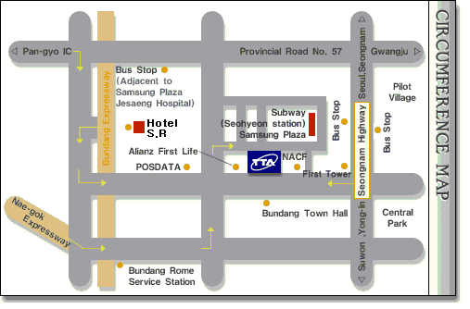
Address: 267-2 Seohyeon-dong, Bundang-gu, Seongnam-city, Gyonggi-do, Korea
Phone: +82 31 724 0085
E-mail: ssoh@tta.or.kr
Home page: http://www.tta.or.kr/English/

Floor Information
9th Floor of TTA
9-A
9-B
9-C
Drafting group’s
Room
Main Meeting Room
Secretariat Room
Chairman’s
Room
Man’s
toilet
Woman’s
toilet
Elevator
Elevator
Stair
Stair
Coffee
Lounge
Registration
Internet
Cafe

Transfers from Airport
TTA is located in the downtown area and the center of Seongnam-City, approximately one hour from Airport.

Please refer following websites for airport transportation information.
- Incheon Airport: http://www.airport.or.kr/Eng/transportation/bus.jsp

In order to ensure smooth access from Incheon International Airport to TTA, we are please to provide some practical information.

- Arrival at Incheon International Airport  When you’re arrived at the airport, please pick up some useful information, e. g., City Maps, Tourist Information booklet at Information Center located inside of the airport building, please see the right picture. | 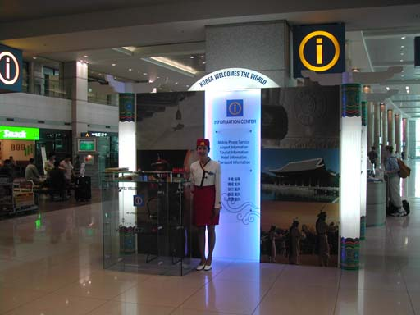
- At near to Exit Number #5, you can buy the Ticket for Airport Limousine Bus from the Airport to Bundang (or Seohyoen Station), the fare is 12,000Won. Please also see the right picture.  ※ Please Note; Using the TAXI from the Airport to TTA or to Downtown is not recommended due to high cost. (50,000Won/85,000Won for Delux Taxi) | 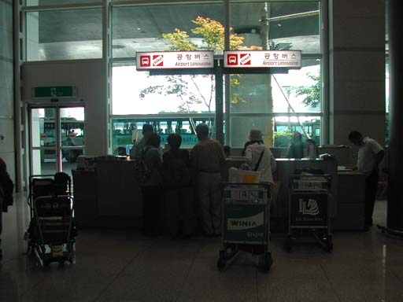
- If you are sure to get the Ticket, then you can move to Airport Limousine BUS STOP #7B with getting out the Airport building through the Exit Number #7. | 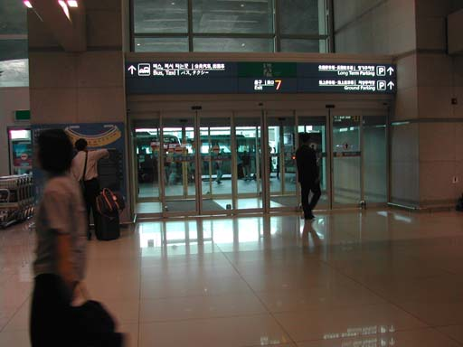
- As soon as you’re getting out from the Airport Building, you can find the Bus Stop #7B. The Interval of the Bus operation is about 20 minutes. Please wait there for moments when you’re middle of the Interval. | 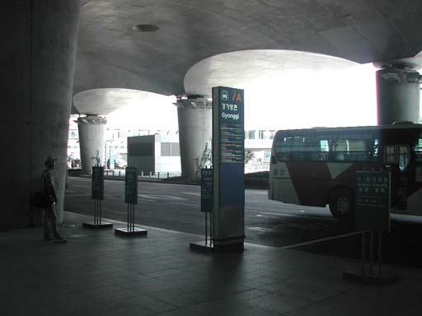
- When you’re in time, you’ll get right Airport Limousine Bus to Bundang (or Seohyoen Station). Please check the picture on your right. | 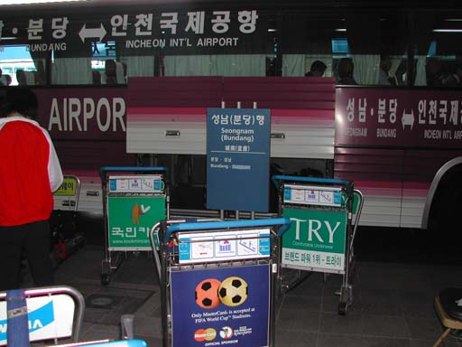
- Another picture of Airport Limousine Bus to Bundang (or Seohyoen Station). From the Airport to Bundang will takes about an hour. Please remember the name of Bus Stop, Seohyoen-Station, first stop after departure from the Airport. | 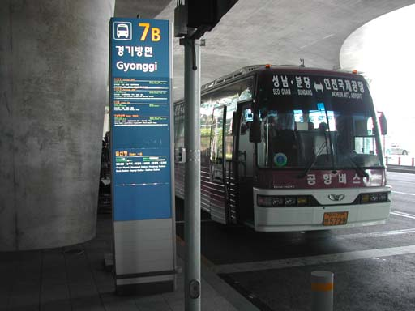

* If you are come to Gimpo airport, you also can take Airport Bus from Gimpo airport to Seongnam (Bundang), the fare is 6,000Won. Please remember the name of Bus Stop, Seohyoen-Station, first stop after departure from the Airport.

Hotels
Two hotels are recommended by the host organization, i.e. the Hotel S.R and GALLERY Hotel.
(See registration form in Annex x)
- Hotel rooms will be assigned on a first-come-first-serve basis, thus early reservation is recommended.
- In order to guarantee your reservation, your credit card information is necessary for a deposit
equivalent to one night. Total amount of the hotel fee will be charged directly by the hotel when checking out.
- Any changes or cancellations regarding room reservation should be informed by e-mail or faxed to the hotel.

Travel Information

Visa
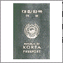
Any foreign visitors wishing to enter Korea must have a valid passport. Tourists may visit Korea for 15 days without a visa, but proof of confirmed round air reservation is required. However, some countries require visas to enter the Republic of Korea. For more information, please visit the Ministry of Foreign Affairs and Trade at www.mofat.go.kr. If you need invitation letter for VISA, to make smooth preparation of this meeting, please make sure the deadline( ) requesting invitation letter for VISA.

Currency & Exchange

The Korean currency unit is the WON (indicated ￦). Bank notes are ￦10,000, ￦5,000, ￦1,000 bills and coin denominations are ￦500, ￦100, ￦50, ￦10. One US dollar is about ￦940 as of April, 2007. Money can be exchanged at Incheon International Airport, banks, and hotels. http://www.keb.co.kr/IBS/english/fx/rate/average/index.jsp


Weather
The Weather in June is usually hot. The average temperature is 16~29°C (60.8~84.2°F). For more detailed climate information, please contact the Korea Meteorological Administration:
http://www.kma.go.kr

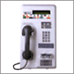
Telephone Calls
A local calls cost ￦70 for three minutes. To make an international call, first dial the international dialling code (001, 002 or 008), then the country code, area code, and the local telephone number. You may also rent a cellular phone at the Incheon International Airport.

Electricity
The standard supply is 220 volts with AC/60 cycles. Outlets for 220 volts are available at the hotels.

The two following outlets are compatible with those available in Korea.

a) It is popularly known as the europlug which is described in CEE 7/16
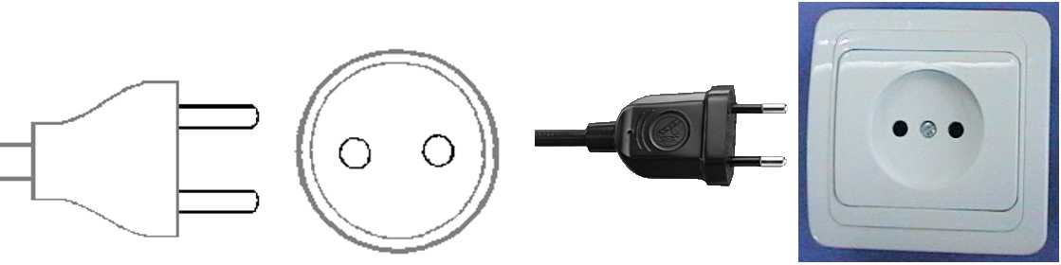
b) This plug is similar to the above except that it is round and has the addition of two grounding clips on the side of the plug
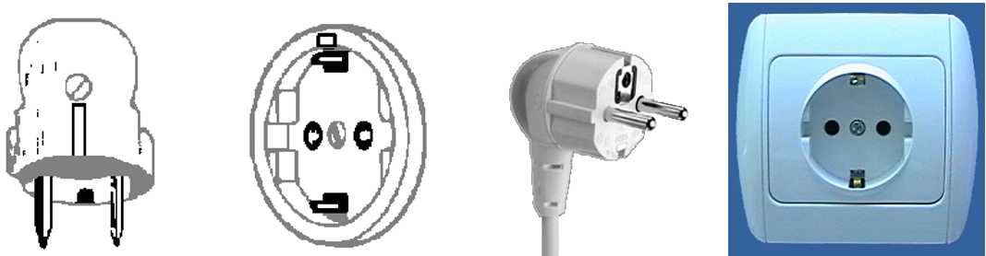

Emergencies
Police 112
Fire Department 119
Medical Emergencies 1339

Business Hours
Government offices are open from Monday to Friday between the hours of 09:00 and 18:00.
Most private businesses open at anywhere from 08:30 to 10:00 and close in the evening. Banks are a major exception. Their business hours are from 09:30 to 16:30 on weekdays. They are closed Saturdays and Sundays.
Foreign diplomatic missions in Seoul generally maintain strict business hours including lunch. They are usually open from 09:00 to 17:00 on weekdays and are closed on Saturdays and Sundays.
Major departments stores are usually open from 10:30 to 20:00, including Sundays, but smaller shops tend to be open earlier and close later every day of the week

Automated Teller Machines (ATM) for Foreign Travelers
Travelers who carry internationally recognized credit cards can get a cash advance in Korean won at Automated Teller Machines (ATMs) installed at airports, major hotels, department stores, subway stations and tourist attractions.

Tipping
Tipping is not a traditional Korea custom. A 10% service charge is added to your bill at all tourist hotels and 3-10% at some big restaurants.

Tax
Value-added tax (VAT) is levied on most goods and services at a standard rate of 10% and is included in the retail price. In tourist hotels, this 10% tax applies to meals and other services and is added into the bill.

Mail
Domestic postal rates are ￦190 for a letter of up to 25g, ￦1,490 for registered letter of no more than 25g, and ￦1,500 or ￦2,000 for a package of up to 2kg. A postcard costs ￦160.
■ Korea post: www.koreapost.go.kr

Newspaper, TV and Radio
There are three English-language dailies, the Korea Times and the Korea Herald, and the International Herald Tribune Joongang Daily. They are available at most news stands and in most hotel gift shops.
Korea has fine TV networks, all broadcasting in Korean (KBS1, KBS2, MBC, SBS, and EBS). Along with the national broadcasting networks, there are also many cable TV channels specializing in a wide field of programming including news, movies, entertainment, sports, etc. Of note is Arirang TV, a special English channel produced in Korea (cable channel #50). The channel features programming in politics, the economy, community, and culture, providing insight and understanding about things Korean through popular TV serial dramas with English subtitles. Some 90 hotels in Korea offer Arirang TV on cable or satellite.

Korea & Korean Tourism
Please visit the following Websites for more information on Korea and possible tours:
http://www.kois.go.kr
http://www.tour2korea.com

Local time
GMT + 9 hours. (same as Tokyo time)

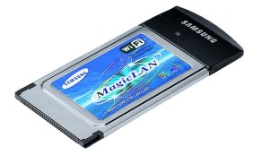
Computer Networking
Each meeting room will be equipped with wireless access (Wireless LAN, supporting IEEE802.11b, 2.4GHz band) to the Internet. Those who wish to use the wireless access must be equipped with the necessary hardware and correctly configured PC.

Attachment 1
(to Annex 2 to TSB Collective letter 9/TAS)

REGISTRATION FORM
TAS Group Meeting and Seminar
Seoul, Korea, 3-6 July 2007
Please complete a separate form for each delegate and return by 11 June 2007 to:

Ms. Sesoon Oh  Telecommunications Technology Association (TTA) | Tel: +82 31 724.0085  Fax: +82 31 724.0119  Email: ssoh@tta.or.kr

With a copy to TSB - Fax: +41 22 730 5853

I participate in the following: | Seminar | TAS Group meeting

 | Mr |  | Mrs |  | Miss

_________________________________________________ |  |  |  | _________________________________________________
Family Name |  |  |  | Country
_________________________________________________ |  |  |  | _________________________________________________
First Name |  |  |  | Name of Administration of Member State *
_________________________________________________ |  |  |  | _________________________________________________
Accompanied by – please specify name |  |  |  | Name of Sector Member / Associate / Other
Complete address of Administration or Organization:
_________________________________________________ |  |  | Tel:____________________________________________________
_________________________________________________ |  |  | Fax:____________________________________________________
_________________________________________________ |  |  | E-mail:_________________________________________________
Private address during the meeting:
_________________________________________________ |  |  | Tel:____________________________________________________
_________________________________________________ |  |  | Fax:____________________________________________________
_________________________________________________ |  |  | E-mail:_________________________________________________
Date: _________________________ | Signature: _______________________________________________________

- Blank page -
Attachment 2
(to Annex 2 to TSB Collective letter 9/TAS)

TAS Group Meeting and Seminar
Seoul, Korea, 3-6 July 2007

HOTEL RESERVATION FORM
Phone: +82 31 702-6565 (Please quote group name 'ITU-T')
Fax: +82 31 705-7891 (Please quote group name 'ITU-T')
E-mail: kyttop76@naver.com (Please quote group name ‘ITU-T’)
Sales Executive: Yong-Tae, KIM (Mr.)
This form should be completed and returned not later than 11 June 2007
- I do not need hotel reservation – will make own arrangement.
Family Name: …………………………..……… First Name: ………………………………………
Organization: ……………………………..…… Country: ………………………………………….
Telephone: ………………………………...…… Fax: ………………………………………………
E-mail: …………………………………….……
Check in date: ………………………………… Check out date: …………………………………
Room Nights: ………… Days Number of people: ………… Person

Hotel | Room |  | Fare
SR Hotel | With breakfast  (for 1 or 2 person) | Standard Double bed ( ) | ( ) KRW 99,000
SR Hotel | With breakfast  (for 1 person) | Deluxe Double bed ( ) | ( ) KRW 132,000
Gallery Hotel | Without breakfast  (for 1 or 2 person) | Standard Room ( )  Deluxe Room ( ) | ( ) KRW 132,000  ( ) KRW 143,000
Gallery Hotel | With breakfast  (for 1 or 2 person) | Standard Room ( )  Deluxe Room ( ) | ( ) KRW 143,000 (1 person)  ( ) KRW 154,000 (1 person)
* All rates are quoted in KRW (Korean Won). US$ 1 is KRW 930.90 as of April 2007.
The exchange rate for US Dollar is subject to change.
* This room fare is specially discounted for the ITU-T TAS.
* Service Charge and VAT are included in the above room fare.
* Hotel rooms must be guaranteed against a credit card and the reservation must be cancelled 3 days
prior to arrival day to avoid a “no-show” charge.
Please circle one credit card from the following:
VISA, MASTER CARD, AMERICAN EXPRESS, DINERS CLUB etc.
Credit Card No: ………………………………..…… Expire date: …………………………………
Name of the card holder: ………………………………………………………………………………
Signature: …………………………………………………………………………………
- Blank page -
Attachment 3
(to Annex 2 to TSB Collective letter 9/TAS)

TAS Group Meeting and Seminar
Seoul, Korea, 3-6 July 2007

Request for Letter of Invitation for VISA issue to participate in ITU-T TAS Meeting

If needed, please return this form to Ms. Sesoon Oh, no later than 1 June 2007 for the processing of formal invitation letter.
(E-mail: ssoh@tta.or.kr, Tel: Tel : +82 31 724 0085, Fax: +82 31 724 0119)

Family Name
Given Name
Date of Birth(yyyy/mm/dd)
Gender
Company(Individual Member)
Nationality
Passport Number
Mailing Address
(With postal code)
Expected entry date
Expected departure date
Tel.
Fax.
E-mail

