Ginebra, 7 de febrero de 2008
UNIÓN INTERNACIONAL DE TELECOMUNICACIONES
Oficina de Normalización
de las Telecomunicaciones

Ref.: | Carta colectiva TSB 6/6
Tel.: | +41 22 730 5515
Fax:  Correo-e: | +41 22 730 5853  tsbsg6@itu.int | A las Administraciones de los Estados Miembros de la Unión, a los Miembros del Sector UIT-T y a los Asociados del UIT-T  que participan en los trabajos de la  Comisión de Estudio 6

Asunto: | Reunión de la Comisión de Estudio 6  Wuhan, China, 14-18 de abril de 2008

Muy señora mía/Muy señor mío:
1 De conformidad con el programa de reuniones del Sector de Normalización de las Telecomunicaciones de la UIT para 2008 (véase http://itu.int/events/upcomingevents.asp?sector=ITU-T), me complace informarle de que la Comisión de Estudio 6 (Planta exterior e instalaciones interiores conexas) se reunirá en Wuhan, China, del 14 al 18 de abril de 2008 ambos inclusive, gracias a la amable invitación del Ministerio de Industria de la Información de ese país.
La reunión se celebrará en el Hotel East Lake (Donghu) de Wuhan, China.
La reunión comenzará a las 09.00 horas del primer día. La inscripción de los participantes comenzará a las 08.00 horas. En la entrada del hotel se dará información detallada sobre las salas de reunión.
2 Los debates se celebrarán conforme a las decisiones tomadas con respecto a las disposiciones vigentes.
3 En el anexo 1 adjunto figura el proyecto de orden del día preparado por el Presidente de la Comisión de Estudio 6.
4 En el anexo 2 adjunto figura el proyecto de programa de trabajo preparado por el Equipo de Dirección de la Comisión de Estudio 6.
5 El anexo 3 contiene información de carácter práctico facilitada por la organización anfitriona.
6 Para facilitar sus trámites, se adjunta como anexo 4 un formulario de confirmación de reservas de hotel.
7 Se informa a los participantes que en esta reunión se trabajará sin documentos impresos. En cada sala de reunión se instalará una línea de acceso inalámbrica (LAN inalámbrica con IEEE802.11b, banda de 2,4 GHz) a Internet. Los delegados que deseen utilizarla deben disponer de un PC correctamente configurado y de los componentes físicos necesarios. Los delegados que deseen copias impresas podrán imprimirlas en la zona a ellos destinada o traerlas consigo. No se distribuirán documentos impresos. Las contribuciones podrán descargarse directamente de la página web del UIT-T (http://www.itu.int/md/T05-SG06-080414/sum/en).
8 De conformidad con lo dispuesto en la Recomendación A.1 (2006), las Contribuciones a los trabajos de la Comisión de Estudio se transmitirán a la Oficina de Normalización de las Telecomunicaciones (TSB). Las Contribuciones recibidas por la TSB por lo menos diez días naturales antes de la fecha fijada para el comienzo de la reunión se publicarán en la dirección web de la Comisión de Estudio 6. Por tanto estas Contribuciones deberán obrar en poder de la TSB a más tardar el 3 de abril de 2008. Las Contribuciones recibidas por lo menos dos meses antes del comienzo de la reunión podrán traducirse, llegado el caso, con arreglo a las disposiciones en vigor.
Se alienta a los participantes a presentar contribuciones mediante el correspondiente formulario disponible en la página web inicial de la Comisión de Estudio 6, o por correo electrónico enviado a la siguiente dirección: tsbsg6@itu.int. En la dirección web del UIT-T figuran instrucciones detalladas.
Le recomendamos encarecidamente que utilice el juego de plantillas a fin de armonizar la presentación de los documentos del UIT-T y, al mismo tiempo, facilitar y hacer más eficaz su producción. Se pueden telecargar desde la página web de cada Comisión de Estudio del UIT-T en "Guides, Tools and Templates" (http://www.itu.int/ITU-T/studygroups/templates/index.html).
Para resolver todas las posibles cuestiones que se planteen en relación con las contribuciones, en adelante se indicará en las mismas el apellido de la persona encargada, sus números de telefax y de teléfono, así como su dirección de correo electrónico (e-mail). Para ello, le ruego indique esta información en la portada de todos los documentos.
9 Para que la TSB pueda tomar las disposiciones necesarias sobre la documentación y organización de la reunión, le ruego me comunique cuanto antes, por carta, por fax (+41 22 730 5853) o por correo electrónico (tsbreg@itu.int) y a más tardar el 14 de marzo de 2008, una lista de las personas que representarán a su Administración, Miembro del Sector, Asociado, organización regional y/o internacional u otra entidad. Se ruega también a las Administraciones que indiquen el nombre de su jefe de delegación (y jefe adjunto, si procede). Deberá adjuntarse a dicha lista el formulario de inscripción debidamente rellenado (un ejemplar por participante) que figura en el anexo 5 a la presente.
10 Le recordamos que los ciudadanos procedentes de ciertos países deben solicitar un visado para ingresar en China. Pueden presentar la solicitud para obtenerlo en la oficina de representación de China en su país (embajada o consulado) o, en su defecto, en la más próxima a su punto de partida (véase el apartado 5 del Anexo 3). Se invita a los participantes que necesiten una carta de presentación y/o una carta que justifique la solicitud del visado para ingresar en la República Popular de China a que se dirijan a la persona de contacto en ese país, Sra. Nancy Li, y envíen la correspondiente copia a la Sra. Jing Li. En el apartado 3 del Anexo 3 puede hallarse información detallada al respecto.
Tenga por favor en cuenta que los trámites para la obtención de un visado pueden llevar tiempo, por lo que le rogamos solicitar una carta de invitación cuanto antes.
11 La organización anfitriona organizará una visita a la Represa de las Tres Gargantas (Three Gorges Dam) el sábado 19 de abril de 2008. En el Anexo 4 figura el formulario de inscripción.
Atentamente,
Malcolm Johnson
Director de la Oficina de Normalización
de las Telecomunicaciones

Anexos: 5
ANNEX 1
(to TSB Collective letter 6/6)
Draft agenda for the meeting of Study Group 6
(Wuhan, 14-18 April 2008)
Opening of meeting
Approval of agenda
Feedback and status reports on interim activities (since November 2007)
SG chairmen’s meetings (matters of interest to SG 6)
TSAG meetings (matters of interest to SG 6)
Status on EDH facilities
Questionnaires issued
Objectives for this meeting
Work Plan for this meeting
Conduct of and facilities available for the meeting
Documents and their allocation
Guidelines for the meeting of Working Parties
Intellectual Property Rights Inquiry (Plenary)
Reports of Working Parties
Approval of any draft Recommendations referred back to SG during AAP
Consent of any draft Recommendations for AAP
Agreement on other texts
Liaison and interaction with other groups
Review of work programme
Other matters for resolution at Study Group level
Future activities
Miscellaneous
Closing

ANNEX 2
(to TSB Collective letter 6/6)
Draft timetable for the meeting of Study Group 6
(Wuhan, 14-18 April 2008)

1Q 09:30 - 10:45  2Q 11:15 - 12:30  3Q 14:30 - 15:45  IV 4Q 16:15 - 17:30 | Monday  14  April |  |  |  | Tuesday  15  April |  |  |  | Wednesday16  April |  |  |  | Thursday  17  April |  |  |  | Friday  18  April
 | 1Q | 2Q | 3Q | 4Q | 1Q | 2Q | 3Q | 4Q | 1Q | 2Q | 3Q | 4Q | 1Q | 2Q | 3Q | 4Q | 1Q | 2Q | 3Q | 4Q
SG 6 Plenary
Working Party Plenaries
Working Parties
Workshop ^{(Note)}

Note: Tentative workshop structure
Subject: Fibre and cable infrastructure technologies for NGN and FTTH deployment
– Session 1: Planning and Design of the Access network
– Session 2: Standardization of new fibres/cables and PON network measurements and maintenance
– Session 3: Improved installation techniques
– Session 4: Round table
– YOFC company visit

ANNEX 3
(to TSB Collective letter 6/6)

Additional information on the meeting of Study Group 6
(Wuhan, China, 14-18 April 2008)

1 Venue of the meeting
Beijing
Wuhan
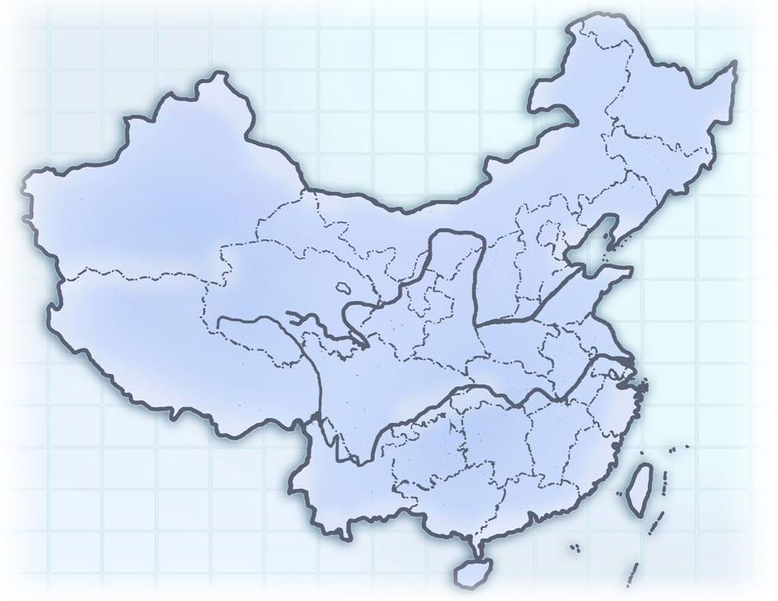
The meeting will be held in
East Lake (Donghu) Hotel, Wuhan.
Hotel Address: 142 East Lake Road, Wuchang District, Wuhan, China
Tel: + 86-27-68881888
Fax: + 86-27-68881659
You can get more information of the hotel from the website: http://www.el-h.com
It will take about one hour from Wuhan Tianhe Airport to the hotel by taxi.

2 Accommodation
The meeting will be held in East Lake (Donghu) Hotel. So we suggest you to stay in the same hotel.
General information of the hotel:
Wuhan East Lake Hotel is a garden-style hotel with an area of 0.83 km². It’s located by the side of scenic East Lake, bordering the East Lake Park in the east and facing Luojia Hill and Mo Hill across the lake in the west. East Lake Hotel presents the most pleasurable views with tall trees and beautiful flowers everywhere in the courtyard, which is now known as Hubei State Hotel for its beautiful natural environment and impressive history. It has received Chinese government leaders such as Mao Zedong, Zhou Enlai, Deng Xiaoping, Hu Jintao, etc.

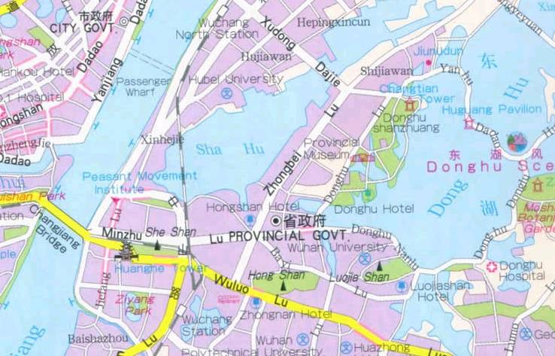
East Lake (Donghu) Hotel

The sketch map of East Lake Hotel is shown below.
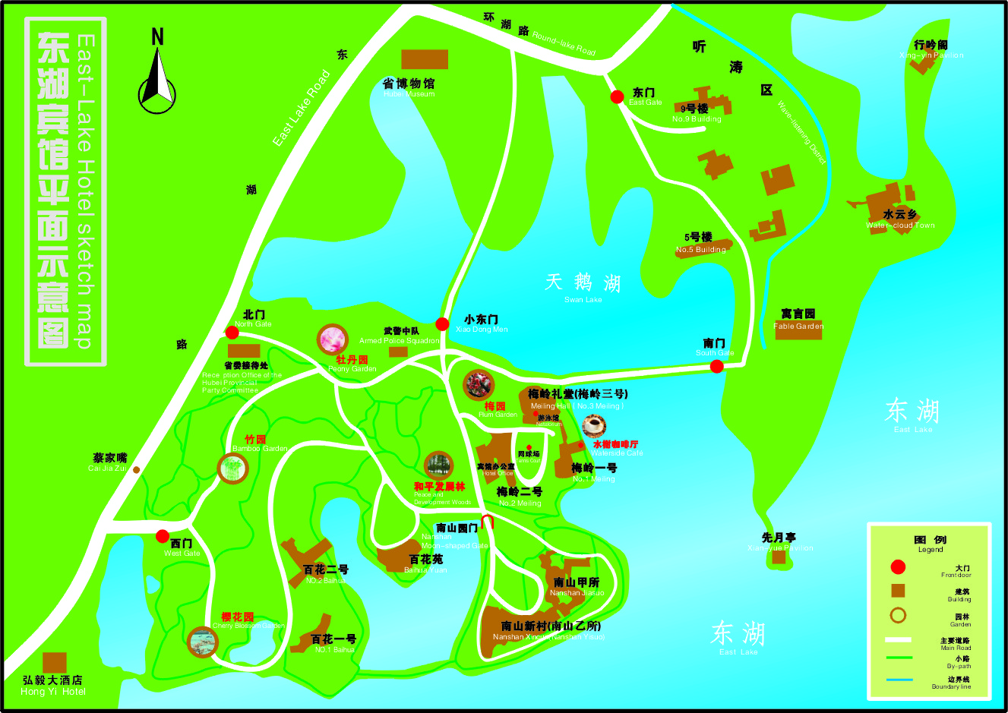

The rooms in Nanshan Yisuo are reserved for the meeting, and you can check in just on the first floor of Nanshan Yisuo.
The meeting will be held in Honghu Hall on the second floor of the same building.

Nanshan Yisuo
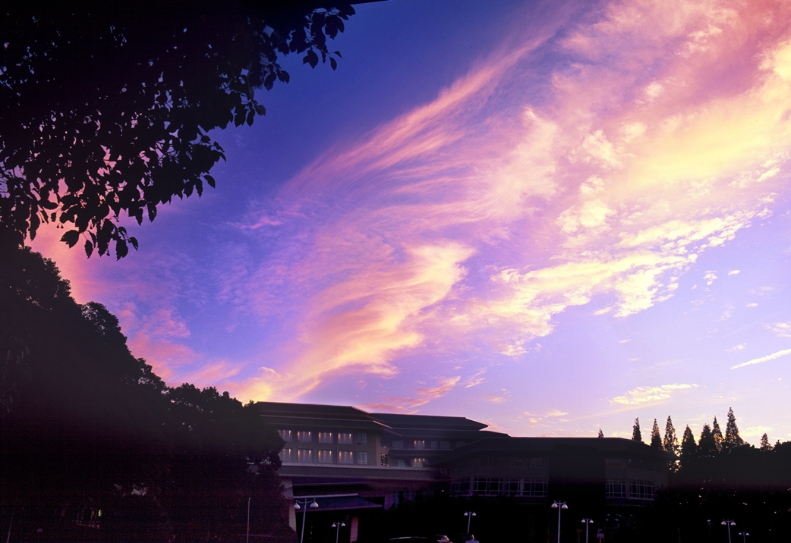

3 Hotel booking
For East Lake Hotel booking, please fill in the attached "Hotel booking form (Annex 4)" and send it to the contact persons before 30 March 2008 (Beijing time):

Ms. Nancy Li | Ms. Jing Li
Yangtze Optical Fibre and Cable Company Ltd. | Yangtze Optical Fibre and Cable Company Ltd.
4# Guanshan Er Road | 4# Guanshan Er Road
Wuhan, China | Wuhan, China
Tel: +86-27-67887324 | Tel: +86-27-67887636
Fax: +86-27-87801760 | Fax: +86-27-87412477
E-mail: lijun_mkt@yofc.com | E-mail: lijing@yofc.com

Room rates:
888 RMB per night for single room, 988 RMB per night for deluxe standard room and 100 RMB per night for extra bed.
No charge for children under 12 years old when sharing the same room with their parents. All major credit cards are accepted.

Transportation
Pick-up service will be arranged at Wuhan Tianhe Airport. Please inform the contact persons in China of your arrival date and flight number by email before March 30, 2008.

If you don’t need pick-up, you can take a taxi to get to the hotel from the airport:
• The hotel is 42 kilometres from Wuhan Tianhe Airport;
• It takes you about 1 hour by taxi to get to the hotel from the airport;
• The taxi fee is about 110 RMB, which is about 15 USD. (You can change your money at the airport.)
• There is a region outside the arrival hall specially for taking the taxi.

5 Visa requirements
All foreigners intend to enter into or exit from the Chinese territory should apply to the Chinese visa authorities for a Chinese visa before entry.
Where to apply for Chinese visa?
The overseas Chinese visa authorities are Chinese embassies, consulates, visa offices, and other agencies abroad authorized by the Ministry of Foreign Affairs of China. Applicant should apply to the nearest Chinese visa authorities.
When to apply for the visa?
The best time to apply for your visa is one month before your departure. The visa is normally good for entry within 90 days of issuance. Single-entry visa is usually valid for a 30-day visit, which means the visa is only good for 30 days after your entry date.
What to submit?
To apply for a Chinese visa you should prepare:
- Your passport should have a full blank visa page, and the period of validity should be more than 6 months from the date you submit your materials;
- Filling out the “VISA APPLICATION FORM OF THE PEOPLE’S REPUBLIC OF CHINA” ;
- A recent 2-inch, bareheaded and full-faced passport photo;
- And some other applying materials;
For further information, please consult the nearest Chinese visa authorities.
Validity of visa: normally speaking, a visa is valid for 3 months from the date of issuance and on any day within this period, the visa holder may enter China.
Duration of stay specified in the visa: normally speaking, a visa holder may stay in China for 1 month which counts from the date of his/her entrance into China. To stay longer, you need to specify your request in your application form and it will be subject to the permission of the consul in charge.
For further information, please consult the nearest Chinese visa authorities.
There is a brief introduction to Chinese visa and the procedure for visa application at the website of Chinese government: http://english.gov.cn/2005-08/27/content_26714.htm

Participants who need an invitation letter and/or a visa supporting letter for entering China, please fill in the form below, and send it to the contact persons in China (see section 3 above).
In consideration of the time for applying for a Chinese visa, please send the information for invitation before 29 February, 2008. After the contact persons get the information, they will fax you the VISA APPLICATION FORM with the seal of the Foreign Affairs Division of the Ministry of Information Industry of China. The original VISA APPLICATION FORM is only provided upon request.

Name
Gender
Nationality
Passport No.
Title
Date of birth
Fax No.
If you need more help, please do not hesitate to get in touch with the contact persons in China.

6 General information of China

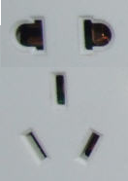
6.1 Electrical appliances
The standard AC power supply in China is 220V, 50 Hz. The typical power outlet/connector used in China is shown in the picture on the right. The normal 3-pin US power input or 2-pin European power input doesn't fit to them well. If your appliances operate on a different voltage, please take your transformers along with you.

6.2 Currency, credit cards and traveller cheques
The currency in China is RMB; most places don’t accept other kind of currency. However, most hotels and banks in China can change foreign currency for RMB. Credit cards can be used in hotels, restaurants and shopping malls. Traveller cheque is not very convenient to use in China. The table below lists the approximate exchange rate for RMB：

1 USD | 7.245 RMB
1 EUR | 10.545 RMB

6.3 Climate in Wuhan
Wuhan has a sub-tropical wet monsoon climate with four distinct seasons. The city enjoys abundant rainfall, with an average annual rainfall of about 1,200 millimetres (47 inches). The sunshine is sufficient, accounting for 1,810-2,100 hours a year. The average yearly temperature is 15.8-17.5 ℃ (60.4-63.5 ℉). As one of the three 'Furnace Cities' in China, it has an unbearably sultry and hot summer. Every summer, days with a temperature reaching over 40 ℃ (104 ℉) number around a dozen. In winter, coldness penetrates every corner of the city. It is quite pleasant in spring and autumn, and the best time to visit Wuhan is March, April, September and October.
In April, the average high temperature is 20-22℃(68-72℉) and the average low is 11-13℃ (52-56 ℉).

6.4 Time difference
Wuhan is in the GMT+8 time zone.
ANNEX 4
(to TSB Collective letter 6/6)

Meeting of Study Group 6
(Wuhan, China, 14-18 April 2008)
HOTEL AND TOUR RESERVATION FORM
Reservation:
Name of the hotel: |  | East Lake (Donghu)Hotel
Room Type |  | Single Room 888RMB  Deluxe Standard Room 988 RMB
Bed Number
Number of Breakfast
Smoking or non-smoking
Check-in date: |  |  | Check-out date:
Personal information:
Your name and first name:
Name of your Company:
Address of your Company:
Tel: |  |  |  | Fax:
E-mail address:
Optional tour:
Optional tour to the Three Gorges Dam will be arranged on April 19, 2008. Do you wish to take the tour?
Yes No

Note: Please send this form by 30 March directly to the contact persons in China:
Ms. Nancy Li  Yangtze Optical Fibre and Cable Company Ltd.  4# Guanshan Er Road  Wuhan, China  Tel: +86-27-67887324  Fax: +86-27-87801760  E-mail: lijun_mkt@yofc.com | Ms. Jing Li  Yangtze Optical Fibre and Cable Company Ltd.  4# Guanshan Er Road  Wuhan, China  Tel: +86-27-67887636  Fax: +86-27-87412477  E-mail: lijing@yofc.com

ANNEX 5
(to TSB Collective letter 6/6)

ITU-TSB | Study Group 6 meeting  Wuhan, China, 14-18 April 2008
REGISTRATION FORM
To be returned to TSB by fax (+41 22 730 5853) or e-mail (tsbreg@itu.int) by 14 March 2008

Mr Mrs Ms Miss |  |  |  |  | _______________________________________________  Country
____________________________________________  Family name |  |  |  |  | ______________________________________________  Name of Administration of Member State*
____________________________________________  First name |  |  |  |  | ______________________________________________  Name of Sector Member / Associate / other
Full address of administration or organization:
______________________________________________ |  |  |  | Tel: _____________________________________________
______________________________________________ |  |  |  | Fax: _____________________________________________
______________________________________________ |  |  |  | E-mail: __________________________________________
*For delegates of Member States: Function at the meeting |  |  |  |  | Hotel or other address in Wuhan
 |  |  |  |  | Hotel: __________________________________________
(C) Head of delegation |  |  |  |  | Address: ________________________________________
(CA) Deputy head of delegation |  |  |  |  | ___________________________________________
(D) Delegate |  |  |  |  | Tel: ____________________________________________
Important Note:

This meeting will be paperless
Date: ___________________________ | Signature: ______________________________________

________________

