الاتحــاد الــدولي للاتصــالات
مكتب تقييس الاتصالات
 |  | جنيف، 28 نوفمبر 2007
المرجع: | المراجعة 1 لـ  TSB Collective letter 9/11
هاتف:  فاكس:  البريد الإلكتروني: | +41 22 730 5866  +41 22 730 5853  tsbsg11@itu.int | إلى إدارات الدول الأعضاء في الاتحاد، وأعضاء قطاع تقييس الاتصالات في الاتحاد، والمنتسبين إلى قطاع تقييس الاتصالات في الاتحاد، المشاركين في أعمال لجنة الدراسات 11

الموضوع: اجتماع لجنة الدراسات 11
سيول، جمهورية كوريا
23-16 يناير 2008

حضرات السادة والسيدات،
تحية طيبة وبعد ...
1 بناءً على طلب رئيس لجنة الدراسات 11 وعلى تأييد اجتماع هذه اللجنة (جنيف، 27-23 أبريل 2007) أود أن أحيطكم علماً بأن لجنة الدراسات 11 (متطلبات وبروتوكولات التشوير) ستجتمع في سيول، جمهورية كوريا، في الفترة من 16 إلى 23 يناير 2008، بناءً على دعوة كريمة من وزارة المعلومات والاتصالات في جمهورية كوريا.
وسيفتتح الاجتماع في الساعة 0930 من اليوم الأول. وسيبدأ تسجيل المشاركين في الساعة 0830. وبإمكان المشاركين أن يتسجلوا أيضاً اعتباراً من يوم الأحد 13 يناير 2008 (من الساعة 1600 حتى الساعة 1800). ستعرض التفاصيل المتعلقة بالقاعات في مكان الاجتماع.
2 ستجري المناقشات طبقاً للقرارات المتخذة استناداً إلى الأحكام السارية.
3 ويرد في الملحق 1 لهذه الرسالة مشروع جدول الأعمال، الذي أعد بالاتفاق مع رئيس لجنة الدراسات 11 السيد يوكيو هيراماتسو، اليابان.
1.4 ويرد في الملحق 2 لهذه الرسالة مشروع الجدول الزمني، الذي أعد بالاتفاق مع رئيس لجنة الدراسات 11.
2.4 ويسترعي اهتمامكم إلى الأعمال المنسقة المخطط لها تحت لواء شبكات الجيل التالي - مبادرة المعايير العالمية (NGN-GSI) (25-14 يناير 2008). يرجى الملاحظة أن أنشطة قطاع التقييس الأخرى سوف تجري في هذه الفترة. ولسوف تحتوي الرسالة المعممة TSB 174 موجز الأنشطة التي ستجري أثناء هذه الفترة.
5 وترد معلومات إضافية عن الاجتماع في الملحق 3
6 وطبقاً لأحكام التوصية A.1 (2006)، تقدم المساهمات في أعمال لجنة الدراسات إلى مكتب تقييس الاتصالات (TSB). وتنشر المساهمات التي يستلمها المكتب في موعد أقصاه 6 يناير 2008 في موقع لجنة الدراسات 11 على شبكة الويب. والمساهمات التي يتلقاها المكتب قبل شهرين على الأقل من بدء الاجتماع يمكن ترجمتها، عند الاقتضاء، تبعاً للأحكام النافذة.
ويستحسن أن يرسل المشاركون مساهماتهم باستخدام استمارة التقديم على الويب المتاحة في صفحة استقبال لجنة الدراسات 11 ، أو بالبريد الإلكتروني على العنوان التالي: tsbsg11@itu.int. وتوجد معلومات مفصّلة بهذا الشأن في موقع قطاع تقييس الاتصالات على شبكة الويب.
ونحثكم على استعمال مجموعة النماذج المعيارية التي استحدثت خصيصاً حرصاً على الاتساق في مظهر وثائق قطاع تقييس الاتصالات، فضلاً عن تيسير إنتاج الوثائق وبالتالي تعزيز فعاليته. ويمكن النفاذ إلى هذه النماذج من كل موقع من مواقع لجان الدراسات على شبكة الويب تحت العنوان "إرشادات وأدوات ونماذج معيارية" (http://www.itu.int/ITU-T/studygroups/templates/index.html).
ورغبة في استبيان أي مسائل قد تنشأ بصدد المساهمات، ينبغي أن تحمل المساهمات اسم الشخص الذي يمكن الاتصال به وكذلك أرقام الفاكس والهاتف وعنوان البريد الإلكتروني. وبناء على ذلك يُرجى تسجيل هذه التفاصيل على صفحة غلاف جميع الوثائق.
7 ولتمكين مكتب تقييس الاتصالات من اتخاذ الترتيبات الضرورية بشأن وثائق الاجتماع وتنظيمه، أرجو أن تتفضلوا بإرسال قائمة الأشخاص الذين سيمثلون إدارتكم أو عضو القطاع أو المنتسب أو المنظمة الإقليمية و/أو الدولية، أو أي كيان آخر، عن طريق البريد أو الفاكس (رقم: +41 22 730 5853) أو البريد الإلكتروني (tsbreg@itu.int) وذلك في أقرب وقت ولكن في موعد لا يتجاوز 14 ديسمبر 2007. ويُرجى من الإدارات أيضاً أن تبين اسم رئيس وفدها (ونائب الرئيس عند الاقتضاء). كما يُرجى أن يرفق بالقائمة المذكورة أعلاه استمارة التسجيل الواردة في الملحق 6، بعد استيفائها على النحو المطلوب (بواقع نسخة لكل مشارك).
8 لا يتلقى المشاركون الحاضرون فعلاً الاجتماع والذين طلبوا سلفاً في استمارة التسجيل الحصول على وثائق ورقية سوى تلك الوثائق المؤقتة للجلسات العامة التي تنشر على موقع القطاع في شبكة الويب اعتباراً من 11 يناير 2008 وحتى نهاية الاجتماع.
9 ستكون كل قاعة من قاعات الاجتماع مجهزة بنفاذ لا سلكي إلى الإنترنت. وينبغي لمن يرغب في استعمال النفاذ اللاسلكي أن يكون مزوداً بالحاسوب الملائم والتشكيلة المناسبة.
10 ومن باب التيسير، ترد في الملحق 4 استمارة تأكيد حجز الفندق.
11 ويتعين على الزوار الأجانب الذين يرغبون في الدخول إلى كوريا أن يكون في حوزتهم جواز سفر صالح. ويمكن للسواح زيارة كوريا لمدة 15 يوماً دون تأشيرة رهناً بما يشهد بحجز مثبت لرحلة جوية ذهاباً وإياباً. ومع ذلك يتعين على مواطني بعض البلدان الحصول على تأشيرة لدخول جمهورية كوريا. ولمزيد من المعلومات يرجى زيارة موقع وزارة الشؤون الخارجية والتجارة في العنوان www.mofat.go.kr. وفي الملحق 5 جهة الاتصال لمن يحتاج إلى تيسير استصدار التأشيرة.
وتفضلوا بقبول فائق التقدير والاحترام.
مالكولم جونسون
مدير مكتب تقييس الاتصالات

الملحقات: 6

ANNEX 1
(to Revision 1 to TSB Collective letter 9/11)
Draft Agenda for the plenary meetings of Study Group 11
(Seoul, 16 – 23 January 2008)

Wednesday 16 January 2008 Study Group 11 Opening Plenary: 0930 am
1 Introduction
2 Approval of the meeting agenda for the opening SG11 plenary
3 Chairman/Rapporteur positions and changes, if any
4 Highlights of Interim/Rapporteurs meetings
5 Approval of the work plan for this SG11 meeting
6.1 Allocation of documents
6.2 Allocation of IPTV related documents:
Traffic management (Q.5/11 (lead))
IPTV Network Control (Q.1/11, Q.3/11, Q.7/11 (lead))
IPTV Multicast Framework (Q.1/11, Q.2/11 (lead))
IPTV Related Protocols (Q.1/11 (lead), Q.2/11)
7 Recommendations matters
7.1 TAP
7.2 AAP
7.2.1 Four consented Recommendations from the SG11 April 2007 meeting:
- LC announced in the AAP Circular 59 of 16 May 2007:
1. Q.115.0 (12/02) Corr. 1:
approved (announced in AAP 63 of 16 June 2007);
2. Q.3303.0 (Q.rcp3.0):
comments resolved (September 2007);
AR (announced in the AAP 69 of 16 October 2007);
3. Q.3303.1 (Q.rcp3.1 (Rw)), COPS Alternative:
approved (announced in AAP 65 of 16 August 2007);
4. Q.3303.2 (Q.rcp3.2 (Rw)), H.248 Alternative:
approved (announced in AAP 65 of 16 August 2007);
    - Working Party 2/11 consented 3 Recommendations (21 September 2007):
LC announced AAP 68 (1 October 2007)
1. Q.3300 (formerly Q.rcp0);
2. Q.3304.1 (formerly Q.rcp4.1 (Rc));
3. Q.3304.2 (formerly Q.rcp4.2);
7.2.3 Working Party 3/11 consented 3 Recommendations (21 September 2007):
LC announced AAP 68 (1 October 2007)
1. Q.3201;
2. Q. 3901 (formerly Q. tt3);
3. Q.3902 (formerly Q.tt4);
8 New/Revised Questions
9 SG11 Coordination
10 Any other business for opening plenary meeting
10.1 Liaison Statements
10.2 Other documents
10.3 Working Party updates for SG11 Work Programme (schedule of deliverables)
10.4 Work Plan (sessions) for next meeting

Wednesday 23 January 2008 Study Group 11 Closing Plenary: 1430 pm

11 Closing Plenary
12 Draft Recommendations for SG11 consideration
12.1 Draft Recommendations for Decision/Approval
12.1.1 TAP (WTSA-04 Res. 1)
12.1.2 AAP (WTSA-04 Rec. A.8.)
12.2 Draft Recommendations for Determination (TAP, WTSA-04 Res.1)
13 Draft Recommendations for Consent (WTSA-04 Rec. A.8)
14 Supplements
15 Deletion of Recommendation(s)
16 Implementor’s Guide
17 New/Revised Questions
18 Proposed Rapporteurs meeting and interim WP meetings
18.1 Interim WP meetings
18.2 Rapporteurs meetings
19 External liaison statements proposed by Working Parties and SG11 coordination
20 Reports of WPs, SG11 Coordination and ad-hoc activities
21 Working Party updates work programme of SG11
22 Any other business for the closing plenary
22.1 NGN-JCA
22.2 Meeting dates for the next meeting
22.3 Draft structure for next meeting
22.4 Draft Work plan for next meeting
22.5 Contributions to the next meeting
22.6 IPTV related matters
23 Closing of the meeting.
ANNEX 2
(to Revision 1 to TSB Collective letter 9/11)
Draft SG11 meeting plan: Seoul, 16 – 23 January 2008

 | Wednesday 16 |  |  |  | Thursday 17 |  |  |  | Friday 18 |  |  |  | Monday 21 |  |  |  | Tuesday 22 |  |  |  | Wednesday 23
Sessions | 1 | 2 | 3 | 4 | 1 | 2 | 3 | 4 | 1 | 2 | 3 | 4 | 1 | 2 | 3 | 4 | 1 | 2 | 3 | 4 | 1 | 2 |  | 3 |  | 4
SG11 Plenary | X* |  |  |  |  |  |  |  |  |  |  |  |  |  |  |  |  |  |  |  |  |  |  | X |  | X
WP1 |  | X |  |  |  |  |  |  |  |  |  |  |  |  |  |  | X2
Q1/11 |  |  | X | X |  |  | X | X
Q2/11 |  |  |  |  | X | X
WP2 |  |  |  | X1 |  |  |  |  |  |  |  |  |  |  |  |  |  |  | X  3
Q3/11 |  |  |  |  | X  4 | X | X | X | X  5 |  | X | X | X  5 | X | X | X | X | X
Q4/11 |  |  |  |  | X | X |  |  | X  5 |  |  |  | X  5 |  |  |  | X
Q5/11 |  |  |  |  | X | X | X | X | X  5 |  | X | X | X  5 | X | X | X | X | X
WP3 |  |  | X1 |  |  |  |  |  |  |  |  |  |  |  |  |  |  | X2,3
Q6/11 |  |  |  | X
Q7/11 |  |  |  |  | X | X | X | X | X |  | X | X  9
Q8/11 |  |  |  |  |  |  |  |  |  |  |  |  | X | X | X | X
SG11 New/Rev Qs. |  |  |  | 6 |  |  |  |  |  |  |  |  |  | X
SG11- NGN Coord.
SG11 Security Coord.
SG11 Q.708 Coord.
SG11 Manag.  NOTE: 7 |  |  |  |  |  |  |  |  |  |  |  |  |  | 8

Time slots: 1: 0900 – 1030 2: 1100-1230 3: 1400-1530 4: 1600-1730
(*) SG11 Opening plenary: starts at 0930 AM
1 WP 2/11 opening plenary will start as soon as WP 3/11 opening finishes.
2 WP 3/11 closing plenary will start as soon as WP 1/11 closing plenary finishes.
3 WP 2/11 closing plenary will start as soon as WP 3/11 closing plenary finishes.
4 Q.3/11 starts after Q.2/11 has closed.
5 Joint Q.3/11, 4/11 and 5/11 on IEPS/TDR/EW issues (and others of common interest as needed).
On Monday 21st Jan. Q.3/11 and 5/11 may meet (editing sessions) separately.
6 SG11 New/Revised Questions 18.30- 20.30
7. SG11 management: 15 January 2007: 14:30 – 16:30
8. SG11 management: 13:00 – 14:00
9. Joint 7/11 and 15/13.
ANNEX 3
(to Revision 1 to TSB Collective letter 9/11)

GENERAL INFORMATION
ITU-T events in Seoul, Korea (Republic of),
14 - 25 January 2008
Venue Information

Venue
Sheraton Grande Walkerhill Hotel Convention Center

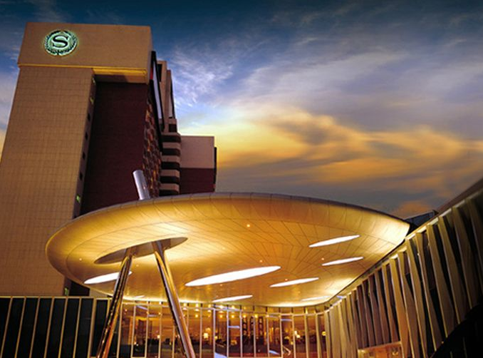

Address: 21 Gwangjang-Dong, Gwangjin-Gu, Seoul, Korea
Phone: +82-2-2022-0059 (cite “ITU-T” as group name)
Fax: +82-2-2022-0567 (indicate “ITU-T” as group name)
Reservation Manager: HyeJung Kwon (Ms.)
Email: hjkwon@walkerhill.co.kr (indicate “ITU-T” as group name)
Website: http://www.walkerhill.co.kr (Korean/English/Japanese available)

Hotels
* Sheraton Grande Walkerhill & W Hotel (conference venue)
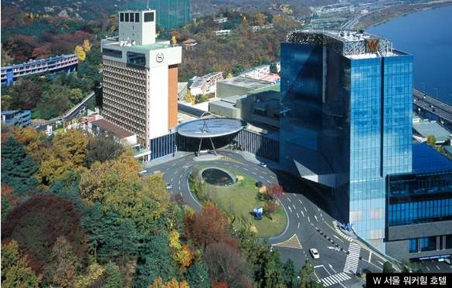
Grande Walkerhill & W Hotel is a global lifestyle brand. Offering its guests with new, memorable, and lasting experiences, comfortable meeting spaces, and good location, it is the perfect venue for the conference. The hotel even gave us special room rates for our meetings.
In the picture, left side is the Grande Walkerhill hotel and right side is the W hotel. The conference center is between the Grande Walkerhill and the W Hotel

HanKang Hotel
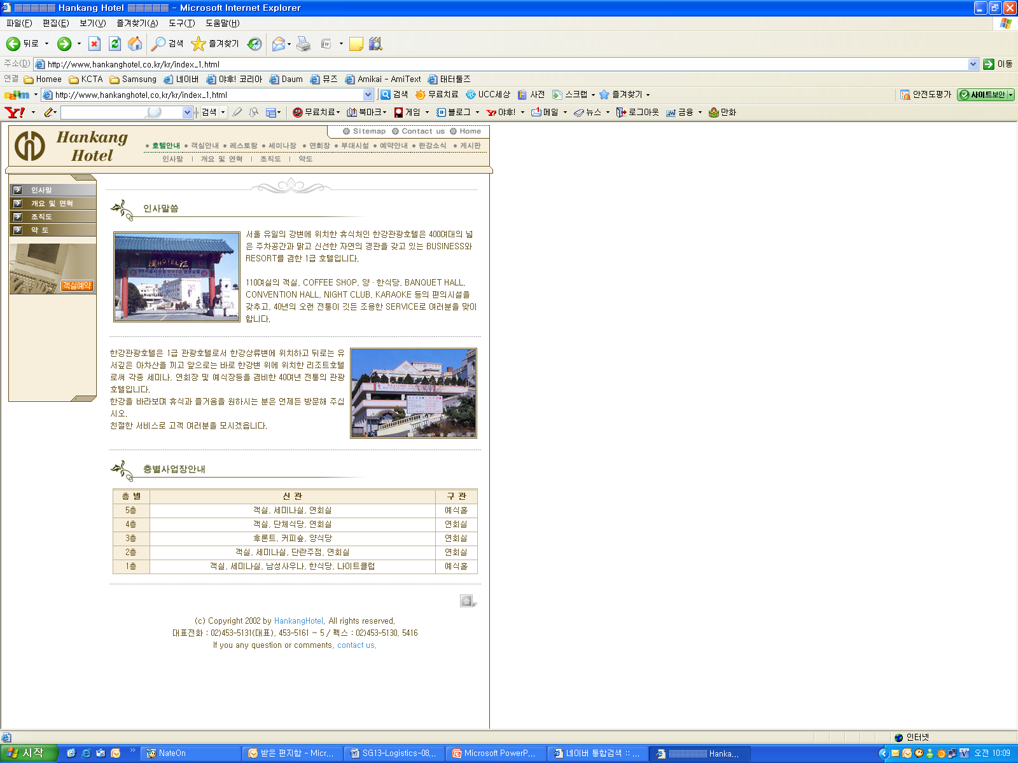
Located on the riverside in Seoul, Hankang Hotel has been providing outstanding service based on 38 years of colorful tradition.

Contact: Park Dea Up
Email: hankang@hankanghotel.co.kr
Tel.: +82-2-53-5131
Fax: +82-2-453-5130
http://www.hankanghotel.co.kr

DongSeoul Hotel
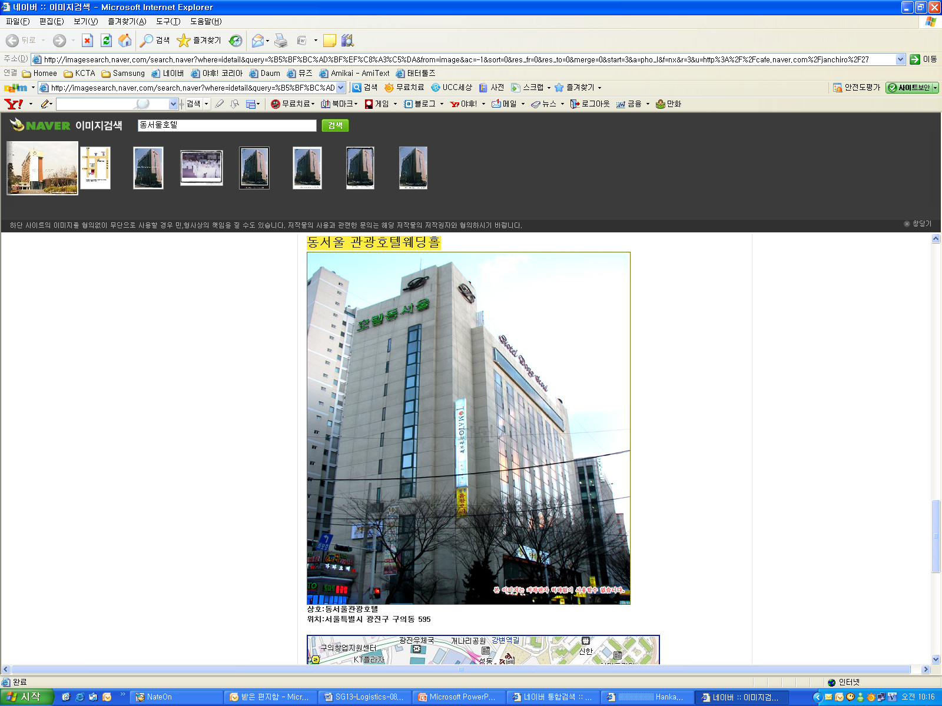
DongSeoul Hotel is very accessible through several means of transportation. Touring Seoul is very easy.

Contact: Kim Nam Young
Email: rotate76@nate.com
Tel.: +82-2-2049-6704
Fax: +82-2-455-6311
http://www.idshotel.co.kr/

Hotel | Room | Rate
Sheraton Grande Walkerhill Hotel  (★★★★★) | Douglas | KRW 111,000
Sheraton Grande Walkerhill Hotel  (★★★★★) | Main Deluxe | KRW 144,300
Sheraton Grande Walkerhill Hotel  (★★★★★) | Club Deluxe | KRW 238,650
W Hotel  (★★★★★★) | Wonderful | KRW 199,800
W Hotel  (★★★★★★) | Spectacular | KRW 222,000
Hankang Hotel (★★★) | Standard | KRW 111,000
DongSeoul Hotel (★★★) | Standard | KRW 80,000
The Sheraton Grand Walkerhill hotel and the W Hotel are recommended by the host organization. And another recommended hotels are the Hankang Hotel and the Dongseoul Hotel. (See registration form in Annex 4)
- Korea has blocked 250 rooms at Sheraton Grande Walkerhill Hotel for the ITU-T NGN-GSI and related events. Since hotel rooms shall be assigned on a first-come, first-served basis, early reservation is recommended.
- To guarantee your reservation, your credit card information is necessary in making a one-night deposit. The total hotel fees shall be charged directly by the hotel upon check-out.
- The hotel should be informed of any and all changes or cancellations regarding room reservation via email or fax.
- Any changes or cancellations regarding room reservation should be informed by e-mail or faxed to the hotel.
- Korea has blocked maximum 50 rooms at the Hankang Hotel which is 1 km apart from the Sheraton Grand Walkerhill Hotel and the DongSeoul Hotel which is 3km apart from the Sheraton Grand Walkerhill Hotel. The quality of those hotels is lower than that of the Sheraton Grand Walkerhill Hotel. Reservation of this hotel can be used same registration form and contact point in Annex 4.

Floor Information(Conference Center)
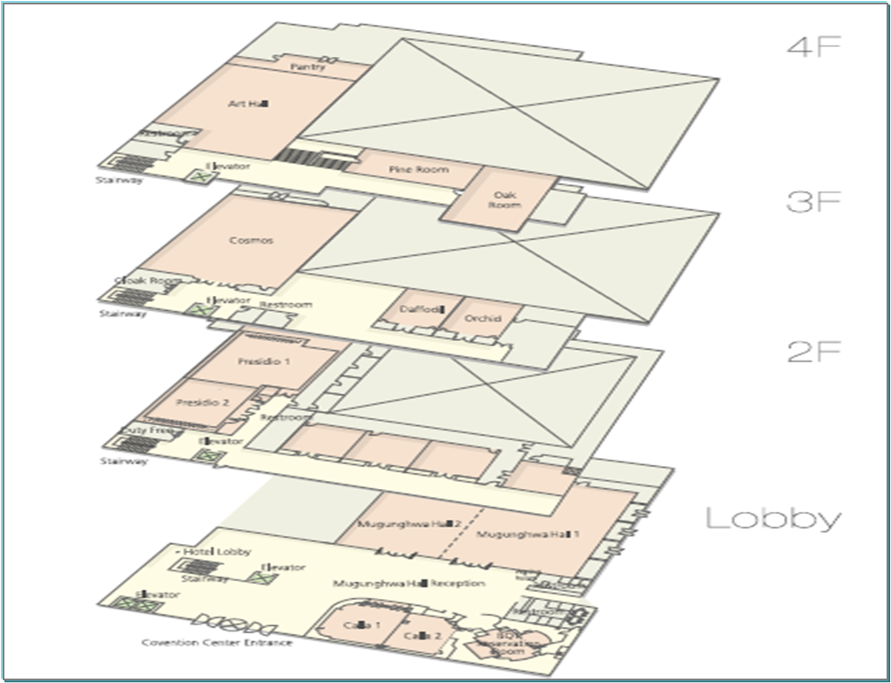
- ITU-T Secretariat: Calla 1
- Session Venue: Mugunghwa Hall 1,2(1F)
Presidio 1, 2/2-A1, A2, B1, B2, B3 (2F)
Daffodil/Orchid/Cosmos (3F)
Pine Room/Oak Room/Art center (4F)
Grand Hall 1, 2, 3, 4 (B1)
- Registration Desk (1F)
- Chairman’s Room: 3F in the Hotel
- Vice Chairman’s Room: Calla 2
Lobby (B1, 4 rooms)
Lobby (1F, 2 rooms)

2F (7 rooms) 3F (3 rooms)

4F (3 rooms)
Travel Information
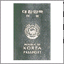
Visa
Any foreign visitor wishing to enter Korea must have a valid passport. Tourists may visit Korea for 15 days without a visa, although proof of confirmed round trip air reservation is required. Note, however, that some countries need visas to enter the Republic of Korea. For more information, visit the website of the Ministry of Foreign Affairs and Trade at www.mofat.go.kr.

Currency and Exchange
The Korean currency unit is WON (indicated as ￦). Bank notes come in ￦10,000, ￦5,000, and ￦1,000 bills, and coin denominations are ￦500, ￦100, ￦50, and ￦10. As of August 2007, USD 1 is equivalent to about ￦930. Money can be exchanged at Incheon International Airport, banks, and hotels.
http://www.keb.co.kr/IBS/english/fx/rate/average/index.jsp

Weather
The weather in January is usually cold. The average temperature is -2.8~4.1°C (37~39.4°F). For more detailed climate information, visit the website of the Korea Meteorological Administration at http://www.kma.go.kr/intro.html
Electricity
The standard supply is 220 volts with AC/60 cycles. Outlets for 220 volts are available at the hotels.
The following outlets are compatible with those available in Korea:
a) “Europlug,” which is described in CEE 7/16
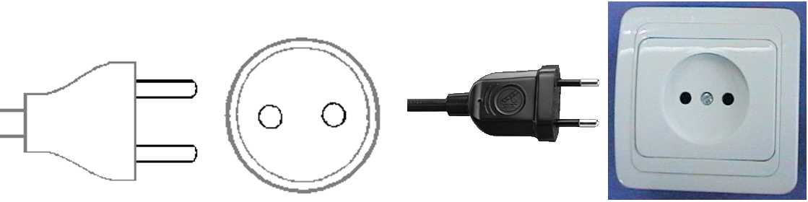
b) This plug is similar to those illustrated above, except that it is round and with the addition of two grounding clips on the side of the plug.
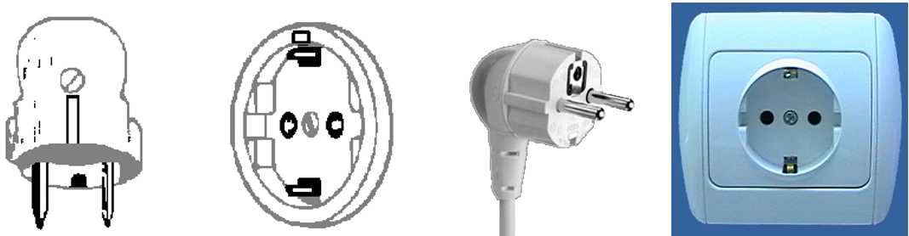

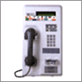
Telephone Calls
A local 3-minute call costs ￦70. To make an international call, dial the international dialing code (001, 002, or 00700) followed by the country code, area code, and local telephone number. You may also rent a cellular phone at Incheon International Airport.
Emergencies
Police--------------------------------112
Fire Department--------------------119
Medical Emergencies ------------ 1339
Business Hours
Government offices are open from Monday to Friday from 09:00 to 18:00.
Most private businesses are open from 08:30 to 10:00 and are closed in the evening. Banks are an exception; their business hours are from 09:30 to 16:30 on weekdays. They are closed during the weekends.
Foreign diplomatic missions in Seoul generally maintain strict business hours including lunch. They are usually open from 09:00 to 17:00 on weekdays and closed on Saturdays and Sundays.
Major department stores are usually open from 10:30 to 20:00 including Sundays, although smaller shops tend to open earlier and close later every day of the week.
Automated Teller Machines (ATM) for Foreign Travelers
Travelers who carry internationally recognized credit cards can get cash advances in Korean won at the Automated Teller Machines (ATMs) installed at airports, major hotels, department stores, subway stations, and tourist attractions.
Tipping
Tipping is not a traditional Korea custom. A 10% service charge is added to your bill at all tourist hotels (3~10% at some big restaurants).
Tax
Value-added tax (VAT) is levied on most goods and services at a standard rate of 10% and included in the retail price. In tourist hotels, this 10% tax is applied to meals and other services and is added to the bill.
Mail
Domestic postal rates are ￦190 for a letter weighing up to 25g, ￦1,490 for a registered letter weighing no more than 25g, and ￦1,500 or ￦2,000 for a package weighing up to 2kg. A postcard costs ￦160.
■ Korea post: www.koreapost.go.kr
Newspaper, TV, and Radio
There are three English dailies: the Korea Times, Korea Herald, and International Herald Tribune Joongang Daily. They are available in most newsstands and in most hotel gift shops.
Korea has five TV networks, all of which broadcast in Korean (KBS1, KBS2, MBC, SBS, and EBS). Aside from the national broadcasting networks, there are also many cable TV channels specializing in various fields of programming including news, movies, entertainment, sports, etc. As a special English channel produced in Korea (cable channel #50), Arirang TV features programs on politics, economy, community, and culture. It provides insight to and aids in the understanding of all things Korean through popular TV serial dramas with English subtitles. Some 90 hotels in Korea offer Arirang TV on cable or satellite.

Korea and Korean Tourism
For more information on Korea and tours, visit the following websites:
http://www.kois.go.kr
http://www.tour2korea.com
Local time
GMT + 9 hours (same as Tokyo time)
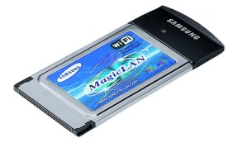
Computer Networking
Each meeting room will be equipped with wireless access (wireless LAN, supports IEEE802.11b & g, 2.4GHz band) to the Internet. Those who wish to have wireless access must be equipped with the necessary hardware and correctly configured PC.
Airport
The nearest airport is Incheon International Airport.
Transportation (from Incheon International Airport to Sheraton Grande Walkerhill Hotel)
- The distance from the airport to Sheraton Grande Walkerhill Hotel is about 70km. A KAL Limousine Bus will get you to the hotel in about 1 ½ hours.
- Only Korean currency (Won) can be used for all means of transportation.
- We strongly recommend that you take a KAL Limousine Bus.
(1) KAL Limousine Bus
- Goes directly from Incheon International Airport to Sheraton Grande Walkerhill Hotel
- Affordable means of transportation
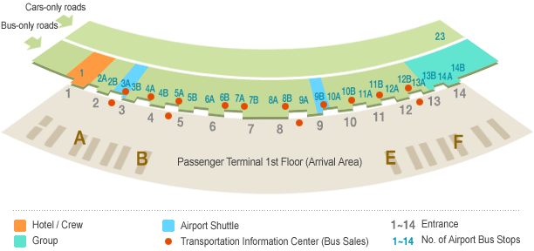
- Price: KRW 13,000 (approximately USD 13.98)
- Traveling time: Depending on the traffic, you can get to Sheraton Grande Walkerhill Hotel in about 90 minutes.
- Departure interval: Approximately 20-30 minutes
- Bus station number 4-B, 11-A Exit
- Bound for Jamsil (Incheon International Airport→ Lotte World→ Dong Seoul Bus Terminal → Kwangnaru Subway Station→ Walkerhill)
- Purchasing a ticket: You may purchase a ticket at the Transportation Information Counter located at exits 2, 4, 9, and 13 on the passenger terminal arrival floor.
- Contact: KAL Limousine Headquarters (02-2667-0386)
Incheon International Airport Information (1577-2600)
- Timetable: From the airport to Sheraton Grande Walkerhill Hotel
04:50 | 05:10 | 05:30 | 05:50 | 06:12 | 06:30 | 06:52
07:10 | 07:30 | 07:50 | 08:10 | 08:30 | 08:50 | 09:10
09:30 | 09:50 | 10:10 | 10:30 | 10:50 | 11:10 | 11:30
11:50 | 12:12 | 12:25 | 12:45 | 12:57 | 13:10 | 13:30
13:30 | 13:50 | 14:10 | 14:30 | 14:50 | 15:12 | 15:30
15:50 | 16:12 | 16:30 | 16:50 | 17:10 | 17:25 | 17:40
17:55 | 18:10 | 18:30 | 18:45 | 19:00 | 19:10 | 19:30
19:50 | 20:10 | 20:30 | 20:50 | 21:10 | 21:30 | 21:55
22:10 | 22:35

(2)Taxi
- Taxi stands are located at the passenger terminal arrival floor (1st floor) between platforms
4D and 8C
- Taxi rates: -Standard taxi: KRW 60,000-70,000 (approximately USD 64.5 ~75.26)
-Deluxe taxi: KRW 90,000 (approximately USD 96.78)
* Passengers shoulder the expressway fees (KRW 6,900, one way).
- Traveling time: Approximately 60 minutes, 90 minutes in case of heavy traffic
- The rates were estimated based on the assumption that there is no traffic; actual rates may vary, however.
- No reservations are necessary.
- If you plan to take a taxi, please show the following note to the taxi driver:

쉐라톤 워커힐 호텔에 데려다 주세요.
(Please take me to Sheraton Grande Walkerhill Hotel.)

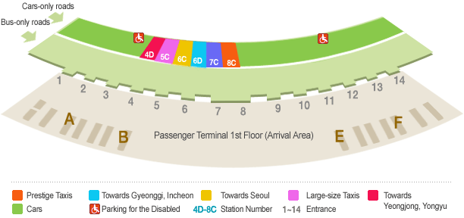

Fee Structure for Incheon International Airport Taxis
Section |  | Basic Fee |  | Platform Number |  | Remarks
Standard
taxi
Standard  taxi |  | KRW 1,900 (Seoul) |  | 18 |  | 24:00 ~ 04:00; additional 20% late night premium  Receipt issuance and translation provided as basic services
Deluxe taxi |  | KRW 4,500 |  | 21 |  | Car phone service/No late night premium fee  Receipt issuance and translation provided as basic services  No late night premium fee

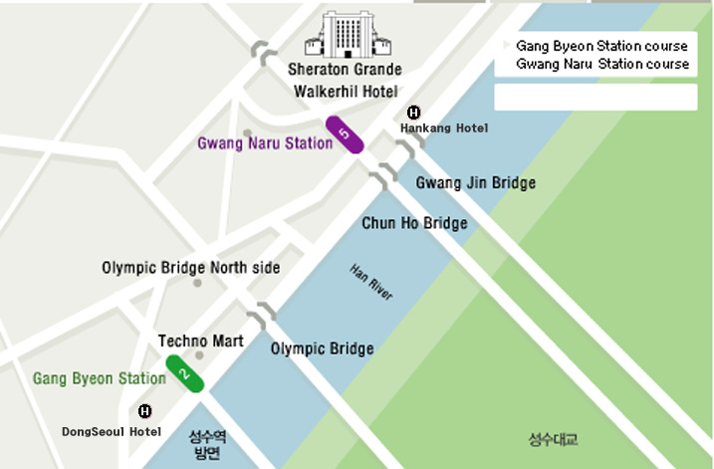
Shuttle Bus :
Sheraton Grande Walkerhill Hotel (Conference Venue)
Sheraton Grande Walkerhill Hotel Shuttle Bus is stop by Gwang Naru Station and Gang Byeon Station for free.
* Gang Byeon Station course:
Time schedule: 06:00 a.m~11:20 p.m (every 20mins), duration time is 10 min to 20 min.
* Gwang Naru Station Course
Time schedule: 06:10 a.m.~11:10p.m. (every 20mins), duration time is 5 min to 15 min.

Hankang Hotel to Sheraton Grande Walkerhill Hotel
Shuttle bus | Taxi | By walking
10 min | 5 min | 25 min
* Time table of the shuttle bus will be provided upon check-in.
Dongseoul Hotel to Sheraton Grande Walkerhill Hotel
Taxi | By walking
7 min | 30 min
* Dongseoul hotel is not providing a shuttle bus, but Gang Byeon Station is 5 minutes by walk. You can take Sheraton Grande Walkerhill Hotel shuttle bus at Gang Byeon Station.

Internet Service at Sheraton Grande Walkerhill Hotel
Sheraton Grande Walkerhill Hotel provides high-speed Internet service to guests who are using laptops (Plug & Play System). Simply plug the Internet connection line into the plug jack. Payments for Internet use will be automatically added to your room.
In addition, Sheraton Grande Walkerhill Hotel provides a laptop rental service for free. Only it is charge to Internet Access fee about KRW 24,200 (Incl. VAT, for 24hrs). Please inquire when making a reservation or upon arrival at the check-in counter. This service will be charged separately from your room bills.

Tourist Office
Paradise Walkerhill Office
Tel.: +82-2-450-4834
Fax: +82-2-455-2121

Hotel Reservation and Cancellation
Reservation requests should be received no later than 31 December 2007. Hotel rooms must be guaranteed using a credit card. For cancellations, the reservation must be canceled 3 days prior to the arrival date to avoid paying a “no-show” charge. Rooms shall be assigned on a first-come, first-served basis. Room availability and rate after December 31, 2007 may not be guaranteed.

Map of Sheraton Grande Walkerhill Hotel
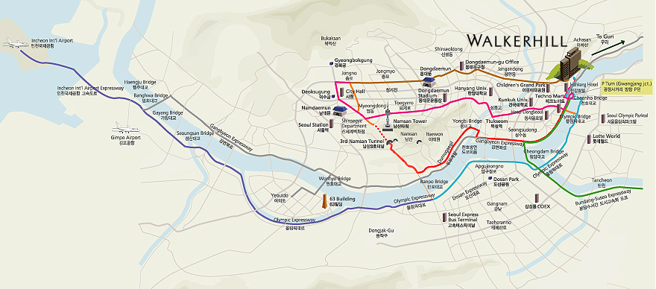

Map of the Seoul Subway
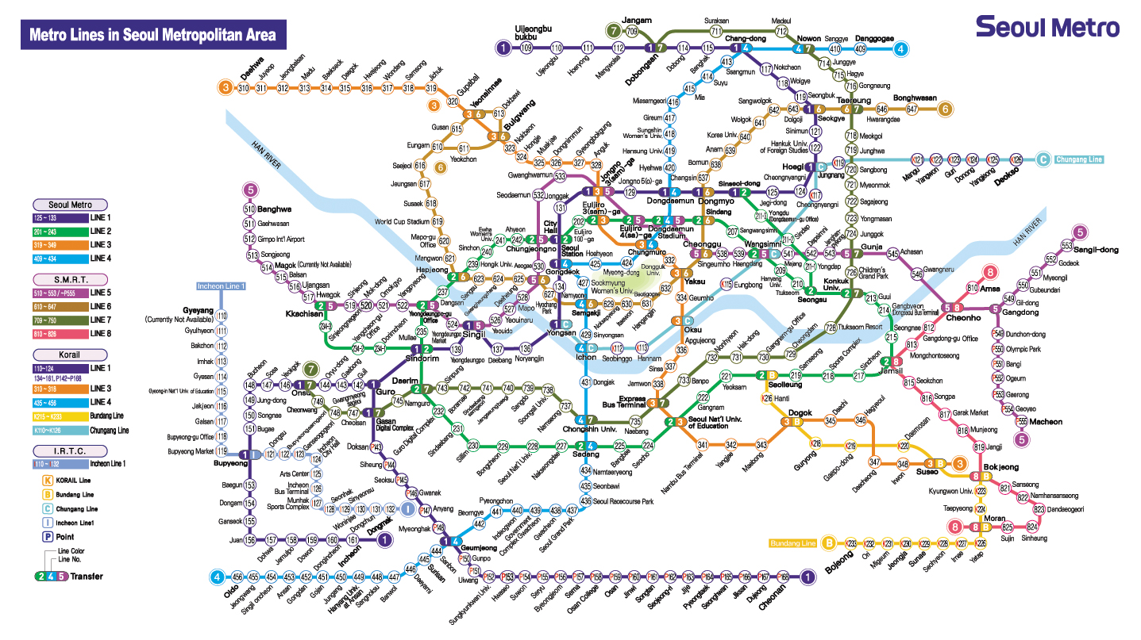
- Seoul subway map download
  - English version : http://211.54.2.50/eng/map_english.zip
  - Chinese version : http://211.54.2.50/eng/map_china.zip
  - Japanese version : http://211.54.2.50/eng/map_japan.zip

About Korea & Seoul

Korea
Korea boasts of 5,000 years’ history, in the course of which a unique culture blossomed. Modern Korea is a nation that has rebuilt itself from the ruins of the Korean War, achieving an economic miracle in a span of 50 years. The Korean peninsula extends southward from the eastern end of the Asian continent; it is approximately 1,000 km long and 216 km wide at its narrowest point.
Seoul
Seoul is a city of contrasts. From palaces that are several centuries old to high-tech skyscrapers made of steel and glass, from ancient texts dating back to a couple of millennia to the fastest broadband Internet access in the world, Seoul is a place where the old and new coexist in harmony. With one
foot in the past and another in the future, Seoul is a city that never ceases to amaze. It is also the center of the so-called “Korean Wave” sweeping Asia. With Korean dramas, film, and music reaching a wider audience abroad, more and more visitors are coming to Seoul to experience first-hand the city’s rich culture and avail themselves of its outstanding cultural facilities.Due to the division of the nation and proximity of DMZ with North Korea (only an hour’s drive away), however, some may consider Seoul to be a somewhat risky place to visit. Notwithstanding foreign news reports, nothing could be further from the truth; in fact, Seoul is one of the safest places in the world for foreign travelers with its low crime rate, hospitable people, state-of-the-art medical facilities, and capable police and security authorities. Seoul’s security situation has never been better.
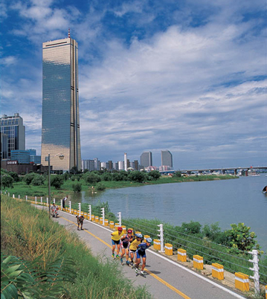

Attractions
* N Tower
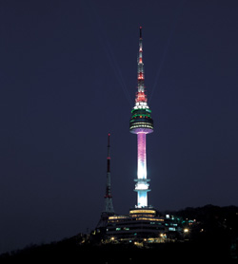
Located on top of Namsan Mountain, this place affords the finest views of Seoul. Since it was opened to the public in 1980, it has been a very popular place for relaxation among Seoul citizens. A lighting show is held every night at the N Seoul tower from 5 PM to 11 PM, featuring various color presentations. As one of the must-see attractions when visiting Seoul, the lighting show of the N Seoul tower is very impressive.
* COEX
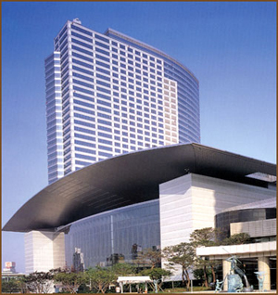
Touted as Seoul’s very own World Trade Center that includes a convention center, the COEX building houses an exhibition hall and a mall. It is the place to be for international conferences and cultural and art events. The COEX mall features many other leisure places such as Aquarium, Megabox Movie Theater, Kimchi field museum, event court, and food court. In particular, Aquarium has more than 40,000 fish from 600 species and dozens of large sharks. You will also see spectacular Kimchi displays and have the opportunity to learn Kimchi recipes and techniques in preparing Kimchi. If you participated in one of the international or art events before, you have probably been to this place already. Countless people visit here daily for various reasons. It is especially very crowded during weekends and holidays.

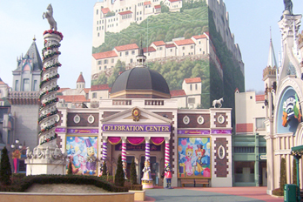
* Lotte World

The Lotte World complex is a theme park bonanza that boasts of both shopping and entertainment facilities. In particular, the Folk Museum gives a glimpse of Korea’s colorful 5000-year history. The indoor grounds of Lotte World are teeming with specialty boutiques and toy stores that will delight children of all ages, with the large, prestigious Lotte Department Store on one end of the mall and Lotte Mart as the bargain hunters’ haven on the other. Lotte World remains a popular shopping and leisure destination for parents with small children.

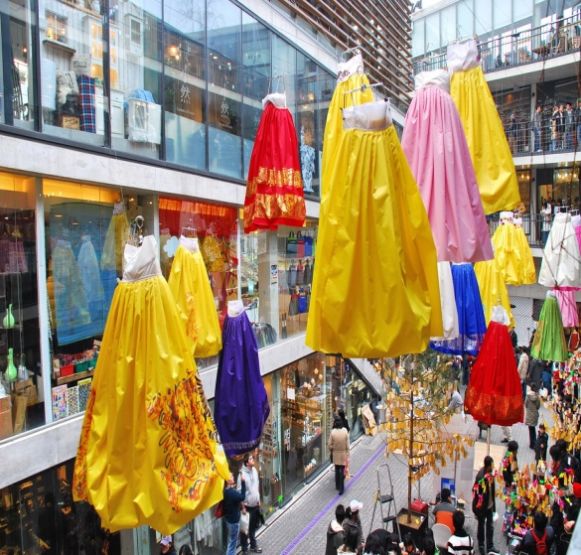
As the largest market featuring traditional Korean art and products, Insadong is the ideal place for visitors who want to experience the true character of Korea and its subtle, enduring beauty. Upon arriving in Insadong, you will immediately be drawn to the small alleys lined with numerous tiny and spacious shops and galleries such as antique shops, Korean stationery stores, frame shops, handicraft shops, pottery and porcelain shops, bookstores and painting studios, and art supply stores. The restaurants and cafes in the area serve traditional food and teas. A shuttle bus service linking galleries in different parts of Seoul has recently started operating between Insadong and Pyeongchangdong.
* Insadong

ANNEX 4
(to Revision 1 to TSB Collective letter 9/11)

HOTEL RESERVATION FORM
Please fill out this form and send it to the hotel **contact person
by fax or email no later than 31 December 2007.

Family name: …………………………..……… First name: ………………………………………
Organization: ……………………………..…… Country: ………………………………………….
Telephone: ………………………………...…… Fax: ………………………………………………
Email: …………………………………….……
Check-in date: ………………………………… Check-out date: …………………………………
No. of days of stay: ………… Days Number of persons: ………… Person

Hotel | Room Rate |  |  | **Contact Person | Remarks
Sheraton Grand Walkerhill Hotel | Douglas | Double bed ( )  Twin bed ( ) | KRW 111,000 | HyeJung Kwon  hjkwon@walkerhill.co.kr  Tel: +82-2-2022-0059  Fax: +82-2-2022-0567 | Breakfast is not included  except Club Deluxe room  Breakfast : KRW24,200 per person
Sheraton Grand Walkerhill Hotel | Main Deluxe | Double bed ( )  Twin bed ( ) | KRW 144,300
Sheraton Grand Walkerhill Hotel | * Club Deluxe | Double bed ( )  Twin bed ( ) | KRW 238,650
W Hotel | Wonderful | Double bed ( )  Twin bed ( ) | KRW 199,800
W Hotel | Spectacular | Double bed ( )  Twin bed ( ) | KRW 222,000
Hankang Hotel | Standard | Double bed ( )  Twin bed ( ) | KRW 111,000 | Park DeaUp  hankang@hankanghotel.co.kr  Tel: +82-2-53-5131  Fax: +82-2-453-5130 | Breakfast is not included  *Breakfast : KRW18,000 per person
Dongseoul  Hotel | Standard | Double bed ( )  Twin bed ( ) | KRW  80,000 | Kim NamYoung  rotate76@nate.com  Tel: +82-2-2049-6704  Fax: +82-2-455-6311 | Breakfast is not included  *Breakfast :KRW8,000 per person
* 10% VAT will be charged (only to Korean)
* All rates are quoted in KRW (Korean Won). The exchange rate for US Dollar is subject to change.
* This room rate is specially discounted for the ITU-T Meetings.
* The Club Deluxe Room rate includes breakfast for 2 persons.
* Hotel rooms must be guaranteed using a credit card; for cancellations, any reservation must be canceled 3 days before the arrival date to avoid paying a “no-show” charge.

Please encircle one of the following:
VISA, MASTERCARD, AMERICAN EXPRESS, DINERS CLUB, etc.

Credit card no.: ………………………………..…… Expiry date: …………………………………
Name of cardholder: ………………………………………………………………………………

Signature: …………………………………………………………………………………
ANNEX 5
(to Revision 1 to TSB Collective letter 9/11)

Request for Letter of Invitation for VISA Issuance to
Participate in the ITU-T events in Seoul, Korea (Republic of),
14 - 25 January 2008
Please return this form to Mr. Youngjae Kim no later than 7 December 2007 for the processing of a formal invitation letter if required.
(Email: ngn-gsi@tta.or.kr; office phone: +82-31-724-0195; fax: +82-31-724-0119)

Family name
Given name
Date of birth (yyyy/mm/dd)
Gender
Company (individual member)
Nationality
Passport number
Mailing address
(with postal code)
Expected arrival date
Expected departure date
Tel.
Fax.
Email

ANNEX 6
(to Revision 1 to TSB Collective letter 9/11)
ITU-TSB | ITU-T events in Seoul, Korea (Republic of),  14-25 January 2008
REGISTRATION FORM
To be returned to TSB by fax (+41 22 730 5853) or e-mail (tsbreg@itu.int) by 14 December 2007

Mr Mrs Ms Miss |  |  |  | _______________________________________________  Country
____________________________________________  Family name |  |  |  | ______________________________________________  Name of Administration of Member State*
____________________________________________  First name |  |  |  | ______________________________________________  Name of Sector Member / Associate / other
Full address of administration or organization:
______________________________________________ |  |  | Tel: _____________________________________________
______________________________________________ |  |  | Fax: _____________________________________________
______________________________________________ |  |  | E-mail: __________________________________________
*For delegates of Member States: Function at the meeting (for study group meetings only) |  |  |  | Hotel or other address in Seoul
SG 11 SG 13 SG 19 |  |  |  | Hotel: __________________________________________
(C) Head of delegation |  |  |  | Address: ________________________________________
(CA) Deputy head of delegation |  |  |  | ___________________________________________
(D) Delegate |  |  |  | Tel: ____________________________________________
I will participate in the following :

 | NGN-GSI
SG 11 | SG 13 | SG 19 | JCA-NGN | IPTV-GSI | JCA-IPTV | SG 16 Rapporteur  Groups | JCA-NID | IdM*
* Joint Rapporteur Groups on identity management; and, if agreed by TSAG IdM GSI event and JCA-IdM

Important Note:
Paper copy of study groups plenary (PLEN) temporary documents will be provided only upon request.

I need paper copies of PLEN temporary documents posted on or after 11 January 2008 for : | SG 11 | SG 13
If explicitly requested, a full set of meeting documents may be obtained from the secretariat.
Date: ___________________________ | Signature: ______________________________________

