2007年11月28日，日内瓦
国 际 电 信 联 盟
电信标准化局

文号： | 电信标准化局第9/11号集体函修订1
电话：  传真：  电子  邮件： | +41 22 730 5866  +41 22 730 5853  tsbsg11@itu.int | 致国际电联成员国各主管部门、ITU-T部门成员和参加第11研究组工作的ITU-T部门准成员

事由： | 第11研究组会议  2008年1月16-23日，韩国首尔

尊敬的先生/女士：
1 我谨通知您，应第11研究组主席要求并经我同意和第11研究组会议（2007年4月23-27日，日内瓦）批准，第11研究组（信令的要求及协议）将应韩国信息和通信部的盛情邀请，自2008年1月16日至23日在韩国首尔召开会议。
第一天的会议将于09:30开始。与会代表的注册工作从08:30开始。与会代表亦可从2008年1月13日（星期日）开始注册（星期日16:00至18:00）。有关会议厅安排的具体信息将在会场的电视屏幕上显示。
2 该会议的讨论将根据现行有关规定进行。
3 经第11研究组主席Yukio Hiramatsu先生（日本）同意起草的议程草案见本函附件1。
4.1 经第11研究组主席同意起草的时间表草案见本函附件2。
4.2 特提请贵方注意计划在NGN-GSI（2008年1月14-25日）大主题下进行的协调工作，ITU-T将在此期间举行其它活动。电信标准化局第174号通函将概要介绍此期举行的这些其它活动。
5 有关会议的其它信息见本函附件3。
6 根据第A.1号建议（2006年）的条款，有关该研究组工作的文稿应提交电信标准化
局（TSB）。电信标准化局在2008年1月6日之前收到的文稿将发布在第11研究组的网站上。按照现行规定，可以应要求翻译在会议开始至少两个月前收到的文稿。

欢迎与会代表以11研究组主页提供的网上提交表或电子邮件的方式向以下地址提交文稿：tsbsg11@itu.int。详尽指南见ITU-T网站。

我们大力提倡您使用已制作出的一套新模版，它们既能够使ITU-T文件的格式保持一致，又可以方便文件制作、提高效率。这些模版可以在ITU-T每个研究组网页中的“指南、工具和模版”（http://www.itu.int/ITU-T/studygroups/templates/index.html）处找到。
为了解决与文稿有关的问题，请在文稿上注明联系人的姓名、传真和电话号码以及电子邮件地址。因此，务请在所有文件的封页注明这些细节。
7 为了便于电信标准化局进行文件制作和会议组织方面的必要安排，我希望您能通过信函、传真（号码：+41 22 730 5853）或电子邮件（tsbreg@itu.int）的方式尽早、但不迟于2007年12月14日将代表贵主管部门、部门成员、部门准成员、区域性和/或国际组织或其它实体出席会议的人员名单发至我处。同时，希望各主管部门注明其代表团团长（如果有副团长，亦盼一并注明）的姓名。填妥的附件6中的报名表（每位与会代表一份）应附于上述名单后。
8 事先通过报名表要求得到纸质文件的实际到会的与会代表，将仅收到2008年1月11日至会议结束时公布在ITU-T网站上的全体会议临时文件。
9 每个会议厅均配有无线上网设施，希望使用这些设施的代表必须具备相应的计算机硬件并正确配置自己的计算机。
10 本函附件4中有一份宾馆确认单，供参考。
11 希望入境韩国的外国来访者必须拥有有效护照，旅游者可以免签证在韩国逗留15天，但需出示经确认的来回程机票预定证据。然而某些国家的公民需获得签证才能入境韩国。欲了解有关签证的更多信息，请访问“外交和贸易部”的下列网站：www.mofat.go.kr。本函附件5提供协助代表办理签证的韩方联系人及联络方式。
顺致敬意！

电信标准化局主任
马尔科姆·琼森

附件：6件
ANNEX 1
(to Revision 1 to TSB Collective letter 9/11)
Draft Agenda for the plenary meetings of Study Group 11
(Seoul, 16 – 23 January 2008)

Wednesday 16 January 2008 Study Group 11 Opening Plenary: 0930 am
1 Introduction
2 Approval of the meeting agenda for the opening SG11 plenary
3 Chairman/Rapporteur positions and changes, if any
4 Highlights of Interim/Rapporteurs meetings
5 Approval of the work plan for this SG11 meeting
6.1 Allocation of documents
6.2 Allocation of IPTV related documents:
Traffic management (Q.5/11 (lead))
IPTV Network Control (Q.1/11, Q.3/11, Q.7/11 (lead))
IPTV Multicast Framework (Q.1/11, Q.2/11 (lead))
IPTV Related Protocols (Q.1/11 (lead), Q.2/11)
7 Recommendations matters
7.1 TAP
7.2 AAP
7.2.1 Four consented Recommendations from the SG11 April 2007 meeting:
- LC announced in the AAP Circular 59 of 16 May 2007:
1. Q.115.0 (12/02) Corr. 1:
approved (announced in AAP 63 of 16 June 2007);
2. Q.3303.0 (Q.rcp3.0):
comments resolved (September 2007);
AR (announced in the AAP 69 of 16 October 2007);
3. Q.3303.1 (Q.rcp3.1 (Rw)), COPS Alternative:
approved (announced in AAP 65 of 16 August 2007);
4. Q.3303.2 (Q.rcp3.2 (Rw)), H.248 Alternative:
approved (announced in AAP 65 of 16 August 2007);
    - Working Party 2/11 consented 3 Recommendations (21 September 2007):
LC announced AAP 68 (1 October 2007)
1. Q.3300 (formerly Q.rcp0);
2. Q.3304.1 (formerly Q.rcp4.1 (Rc));
3. Q.3304.2 (formerly Q.rcp4.2);
7.2.3 Working Party 3/11 consented 3 Recommendations (21 September 2007):
LC announced AAP 68 (1 October 2007)
1. Q.3201;
2. Q. 3901 (formerly Q. tt3);
3. Q.3902 (formerly Q.tt4);
8 New/Revised Questions
9 SG11 Coordination
10 Any other business for opening plenary meeting
10.1 Liaison Statements
10.2 Other documents
10.3 Working Party updates for SG11 Work Programme (schedule of deliverables)
10.4 Work Plan (sessions) for next meeting

Wednesday 23 January 2008 Study Group 11 Closing Plenary: 1430 pm

11 Closing Plenary
12 Draft Recommendations for SG11 consideration
12.1 Draft Recommendations for Decision/Approval
12.1.1 TAP (WTSA-04 Res. 1)
12.1.2 AAP (WTSA-04 Rec. A.8.)
12.2 Draft Recommendations for Determination (TAP, WTSA-04 Res.1)
13 Draft Recommendations for Consent (WTSA-04 Rec. A.8)
14 Supplements
15 Deletion of Recommendation(s)
16 Implementor’s Guide
17 New/Revised Questions
18 Proposed Rapporteurs meeting and interim WP meetings
18.1 Interim WP meetings
18.2 Rapporteurs meetings
19 External liaison statements proposed by Working Parties and SG11 coordination
20 Reports of WPs, SG11 Coordination and ad-hoc activities
21 Working Party updates work programme of SG11
22 Any other business for the closing plenary
22.1 NGN-JCA
22.2 Meeting dates for the next meeting
22.3 Draft structure for next meeting
22.4 Draft Work plan for next meeting
22.5 Contributions to the next meeting
22.6 IPTV related matters
23 Closing of the meeting.
ANNEX 2
(to Revision 1 to TSB Collective letter 9/11)
Draft SG11 meeting plan: Seoul, 16 – 23 January 2008

 | Wednesday 16 |  |  |  | Thursday 17 |  |  |  | Friday 18 |  |  |  | Monday 21 |  |  |  | Tuesday 22 |  |  |  | Wednesday 23
Sessions | 1 | 2 | 3 | 4 | 1 | 2 | 3 | 4 | 1 | 2 | 3 | 4 | 1 | 2 | 3 | 4 | 1 | 2 | 3 | 4 | 1 | 2 |  | 3 |  | 4
SG11 Plenary | X* |  |  |  |  |  |  |  |  |  |  |  |  |  |  |  |  |  |  |  |  |  |  | X |  | X
WP1 |  | X |  |  |  |  |  |  |  |  |  |  |  |  |  |  | X2
Q1/11 |  |  | X | X |  |  | X | X
Q2/11 |  |  |  |  | X | X
WP2 |  |  |  | X1 |  |  |  |  |  |  |  |  |  |  |  |  |  |  | X  3
Q3/11 |  |  |  |  | X  4 | X | X | X | X  5 |  | X | X | X  5 | X | X | X | X | X
Q4/11 |  |  |  |  | X | X |  |  | X  5 |  |  |  | X  5 |  |  |  | X
Q5/11 |  |  |  |  | X | X | X | X | X  5 |  | X | X | X  5 | X | X | X | X | X
WP3 |  |  | X1 |  |  |  |  |  |  |  |  |  |  |  |  |  |  | X2,3
Q6/11 |  |  |  | X
Q7/11 |  |  |  |  | X | X | X | X | X |  | X | X  9
Q8/11 |  |  |  |  |  |  |  |  |  |  |  |  | X | X | X | X
SG11 New/Rev Qs. |  |  |  | 6 |  |  |  |  |  |  |  |  |  | X
SG11- NGN Coord.
SG11 Security Coord.
SG11 Q.708 Coord.
SG11 Manag.  NOTE: 7 |  |  |  |  |  |  |  |  |  |  |  |  |  | 8

Time slots: 1: 0900 – 1030 2: 1100-1230 3: 1400-1530 4: 1600-1730
(*) SG11 Opening plenary: starts at 0930 AM
1 WP 2/11 opening plenary will start as soon as WP 3/11 opening finishes.
2 WP 3/11 closing plenary will start as soon as WP 1/11 closing plenary finishes.
3 WP 2/11 closing plenary will start as soon as WP 3/11 closing plenary finishes.
4 Q.3/11 starts after Q.2/11 has closed.
5 Joint Q.3/11, 4/11 and 5/11 on IEPS/TDR/EW issues (and others of common interest as needed).
On Monday 21st Jan. Q.3/11 and 5/11 may meet (editing sessions) separately.
6 SG11 New/Revised Questions 18.30- 20.30
7. SG11 management: 15 January 2007: 14:30 – 16:30
8. SG11 management: 13:00 – 14:00
9. Joint 7/11 and 15/13.
ANNEX 3
(to Revision 1 to TSB Collective letter 9/11)

GENERAL INFORMATION
ITU-T events in Seoul, Korea (Republic of),
14 - 25 January 2008
Venue Information

Venue
Sheraton Grande Walkerhill Hotel Convention Center

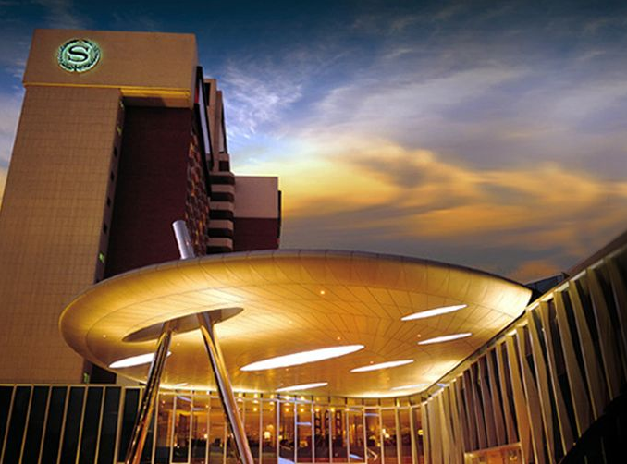

Address: 21 Gwangjang-Dong, Gwangjin-Gu, Seoul, Korea
Phone: +82-2-2022-0059 (cite “ITU-T” as group name)
Fax: +82-2-2022-0567 (indicate “ITU-T” as group name)
Reservation Manager: HyeJung Kwon (Ms.)
Email: hjkwon@walkerhill.co.kr (indicate “ITU-T” as group name)
Website: http://www.walkerhill.co.kr (Korean/English/Japanese available)

Hotels
* Sheraton Grande Walkerhill & W Hotel (conference venue)
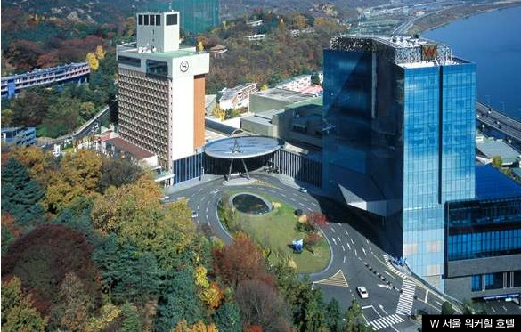
Grande Walkerhill & W Hotel is a global lifestyle brand. Offering its guests with new, memorable, and lasting experiences, comfortable meeting spaces, and good location, it is the perfect venue for the conference. The hotel even gave us special room rates for our meetings.
In the picture, left side is the Grande Walkerhill hotel and right side is the W hotel. The conference center is between the Grande Walkerhill and the W Hotel

HanKang Hotel
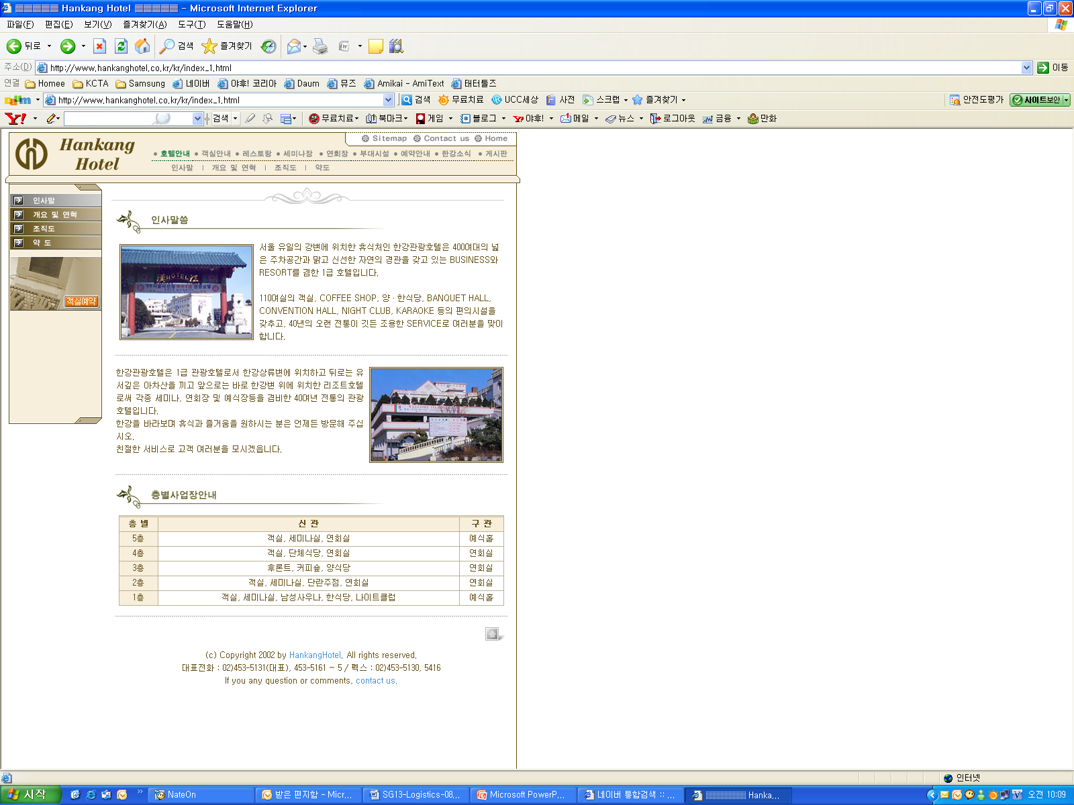
Located on the riverside in Seoul, Hankang Hotel has been providing outstanding service based on 38 years of colorful tradition.

Contact: Park Dea Up
Email: hankang@hankanghotel.co.kr
Tel.: +82-2-53-5131
Fax: +82-2-453-5130
http://www.hankanghotel.co.kr

DongSeoul Hotel
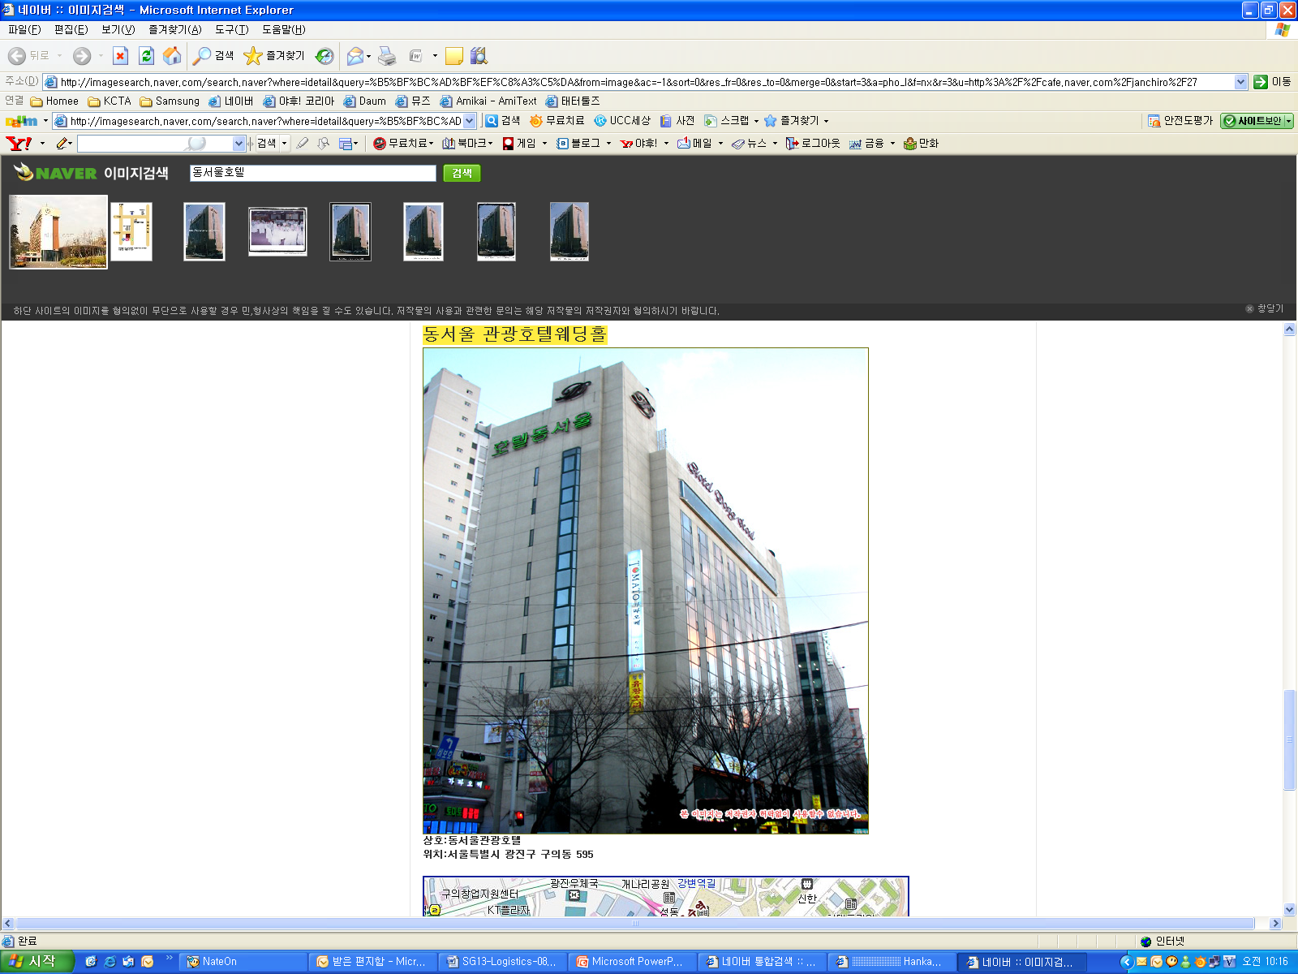
DongSeoul Hotel is very accessible through several means of transportation. Touring Seoul is very easy.

Contact: Kim Nam Young
Email: rotate76@nate.com
Tel.: +82-2-2049-6704
Fax: +82-2-455-6311
http://www.idshotel.co.kr/

Hotel | Room | Rate
Sheraton Grande Walkerhill Hotel  (★★★★★) | Douglas | KRW 111,000
Sheraton Grande Walkerhill Hotel  (★★★★★) | Main Deluxe | KRW 144,300
Sheraton Grande Walkerhill Hotel  (★★★★★) | Club Deluxe | KRW 238,650
W Hotel  (★★★★★★) | Wonderful | KRW 199,800
W Hotel  (★★★★★★) | Spectacular | KRW 222,000
Hankang Hotel (★★★) | Standard | KRW 111,000
DongSeoul Hotel (★★★) | Standard | KRW 80,000
The Sheraton Grand Walkerhill hotel and the W Hotel are recommended by the host organization. And another recommended hotels are the Hankang Hotel and the Dongseoul Hotel. (See registration form in Annex 4)
- Korea has blocked 250 rooms at Sheraton Grande Walkerhill Hotel for the ITU-T NGN-GSI and related events. Since hotel rooms shall be assigned on a first-come, first-served basis, early reservation is recommended.
- To guarantee your reservation, your credit card information is necessary in making a one-night deposit. The total hotel fees shall be charged directly by the hotel upon check-out.
- The hotel should be informed of any and all changes or cancellations regarding room reservation via email or fax.
- Any changes or cancellations regarding room reservation should be informed by e-mail or faxed to the hotel.
- Korea has blocked maximum 50 rooms at the Hankang Hotel which is 1 km apart from the Sheraton Grand Walkerhill Hotel and the DongSeoul Hotel which is 3km apart from the Sheraton Grand Walkerhill Hotel. The quality of those hotels is lower than that of the Sheraton Grand Walkerhill Hotel. Reservation of this hotel can be used same registration form and contact point in Annex 4.

Floor Information(Conference Center)
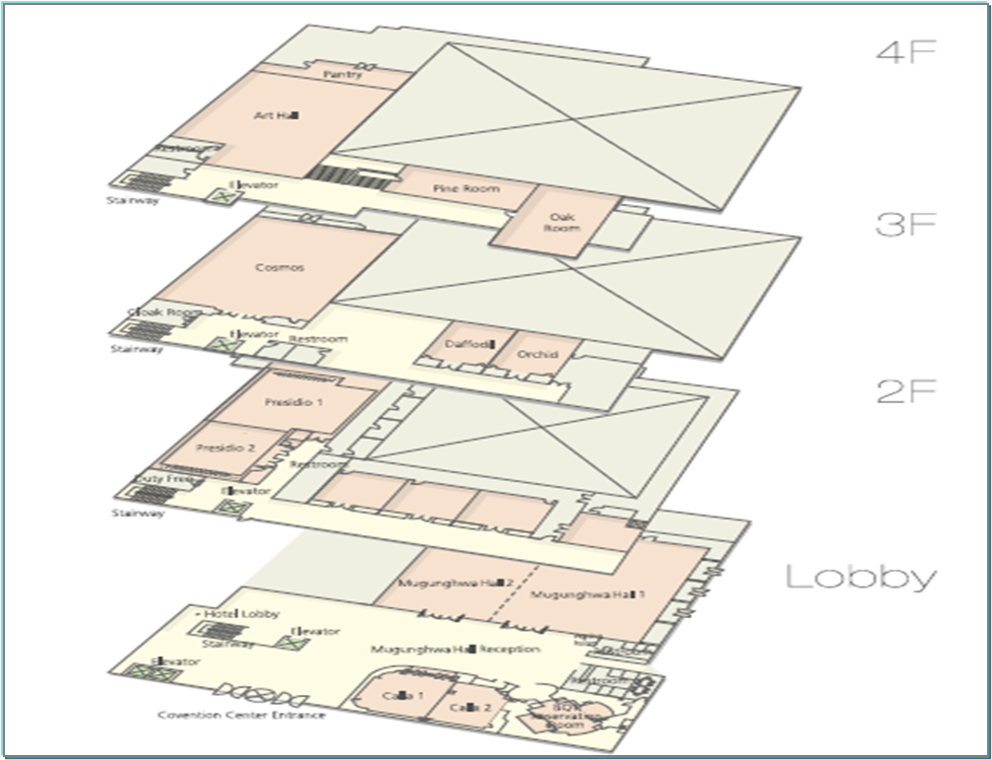
- ITU-T Secretariat: Calla 1
- Session Venue: Mugunghwa Hall 1,2(1F)
Presidio 1, 2/2-A1, A2, B1, B2, B3 (2F)
Daffodil/Orchid/Cosmos (3F)
Pine Room/Oak Room/Art center (4F)
Grand Hall 1, 2, 3, 4 (B1)
- Registration Desk (1F)
- Chairman’s Room: 3F in the Hotel
- Vice Chairman’s Room: Calla 2

Lobby (B1, 4 rooms)
Lobby (1F, 2 rooms)
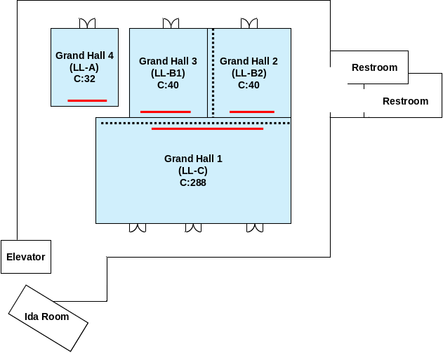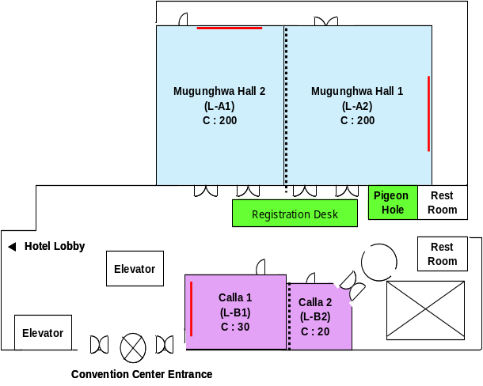

2F (7 rooms) 3F (3 rooms)

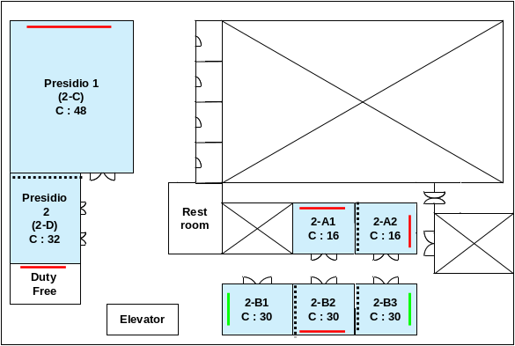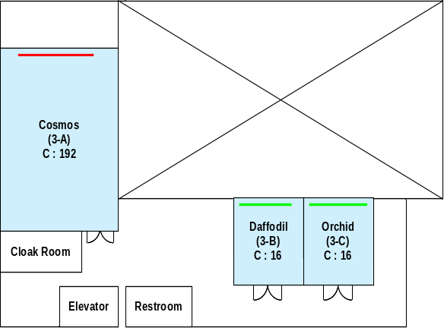

4F (3 rooms)

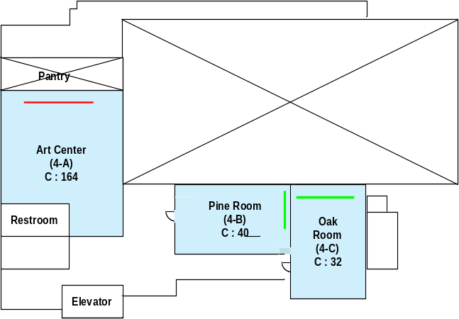
Travel Information
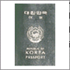
Visa
Any foreign visitor wishing to enter Korea must have a valid passport. Tourists may visit Korea for 15 days without a visa, although proof of confirmed round trip air reservation is required. Note, however, that some countries need visas to enter the Republic of Korea. For more information, visit the website of the Ministry of Foreign Affairs and Trade at www.mofat.go.kr.

Currency and Exchange
The Korean currency unit is WON (indicated as ￦). Bank notes come in ￦10,000, ￦5,000, and ￦1,000 bills, and coin denominations are ￦500, ￦100, ￦50, and ￦10. As of August 2007, USD 1 is equivalent to about ￦930. Money can be exchanged at Incheon International Airport, banks, and hotels.
http://www.keb.co.kr/IBS/english/fx/rate/average/index.jsp

Weather
The weather in January is usually cold. The average temperature is -2.8~4.1°C (37~39.4°F). For more detailed climate information, visit the website of the Korea Meteorological Administration at http://www.kma.go.kr/intro.html

Electricity
The standard supply is 220 volts with AC/60 cycles. Outlets for 220 volts are available at the hotels.

The following outlets are compatible with those available in Korea:

a) “Europlug,” which is described in CEE 7/16
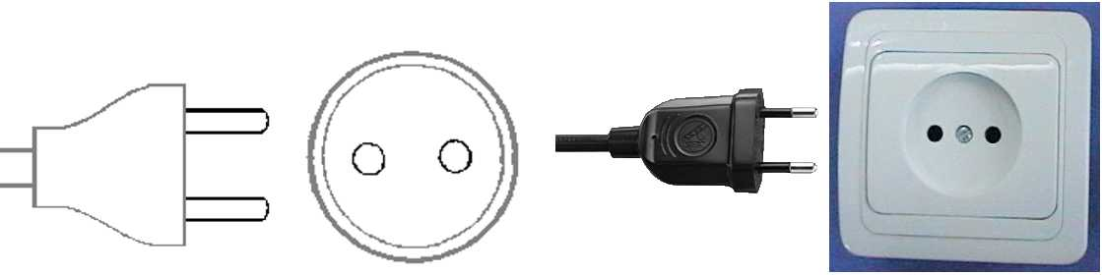
b) This plug is similar to those illustrated above, except that it is round and with the addition of two grounding clips on the side of the plug.
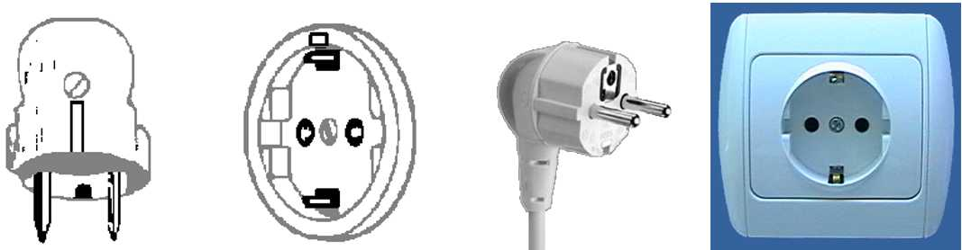

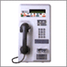
Telephone Calls
A local 3-minute call costs ￦70. To make an international call, dial the international dialing code (001, 002, or 00700) followed by the country code, area code, and local telephone number. You may also rent a cellular phone at Incheon International Airport.
Emergencies
Police--------------------------------112
Fire Department--------------------119
Medical Emergencies ------------ 1339

Business Hours
Government offices are open from Monday to Friday from 09:00 to 18:00.
Most private businesses are open from 08:30 to 10:00 and are closed in the evening. Banks are an exception; their business hours are from 09:30 to 16:30 on weekdays. They are closed during the weekends.
Foreign diplomatic missions in Seoul generally maintain strict business hours including lunch. They are usually open from 09:00 to 17:00 on weekdays and closed on Saturdays and Sundays.
Major department stores are usually open from 10:30 to 20:00 including Sundays, although smaller shops tend to open earlier and close later every day of the week.

Automated Teller Machines (ATM) for Foreign Travelers
Travelers who carry internationally recognized credit cards can get cash advances in Korean won at the Automated Teller Machines (ATMs) installed at airports, major hotels, department stores, subway stations, and tourist attractions.

Tipping
Tipping is not a traditional Korea custom. A 10% service charge is added to your bill at all tourist hotels (3~10% at some big restaurants).

Tax
Value-added tax (VAT) is levied on most goods and services at a standard rate of 10% and included in the retail price. In tourist hotels, this 10% tax is applied to meals and other services and is added to the bill.

Mail
Domestic postal rates are ￦190 for a letter weighing up to 25g, ￦1,490 for a registered letter weighing no more than 25g, and ￦1,500 or ￦2,000 for a package weighing up to 2kg. A postcard costs ￦160.
■ Korea post: www.koreapost.go.kr

Newspaper, TV, and Radio
There are three English dailies: the Korea Times, Korea Herald, and International Herald Tribune Joongang Daily. They are available in most newsstands and in most hotel gift shops.
Korea has five TV networks, all of which broadcast in Korean (KBS1, KBS2, MBC, SBS, and EBS). Aside from the national broadcasting networks, there are also many cable TV channels specializing in various fields of programming including news, movies, entertainment, sports, etc. As a special English channel produced in Korea (cable channel #50), Arirang TV features programs on politics, economy, community, and culture. It provides insight to and aids in the understanding of all things Korean through popular TV serial dramas with English subtitles. Some 90 hotels in Korea offer Arirang TV on cable or satellite.

Korea and Korean Tourism
For more information on Korea and tours, visit the following websites:
http://www.kois.go.kr
http://www.tour2korea.com

Local time
GMT + 9 hours (same as Tokyo time)

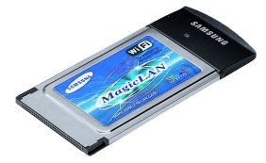
Computer Networking
Each meeting room will be equipped with wireless access (wireless LAN, supports IEEE802.11b & g, 2.4GHz band) to the Internet. Those who wish to have wireless access must be equipped with the necessary hardware and correctly configured PC.

Airport
The nearest airport is Incheon International Airport.

Transportation (from Incheon International Airport to Sheraton Grande Walkerhill Hotel)

- The distance from the airport to Sheraton Grande Walkerhill Hotel is about 70km. A KAL Limousine Bus will get you to the hotel in about 1 ½ hours.
- Only Korean currency (Won) can be used for all means of transportation.
- We strongly recommend that you take a KAL Limousine Bus.

(1) KAL Limousine Bus
- Goes directly from Incheon International Airport to Sheraton Grande Walkerhill Hotel
- Affordable means of transportation
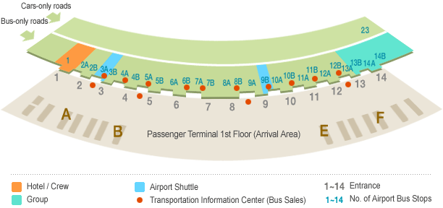
- Price: KRW 13,000 (approximately USD 13.98)
- Traveling time: Depending on the traffic, you can get to Sheraton Grande Walkerhill Hotel in about 90 minutes.
- Departure interval: Approximately 20-30 minutes
- Bus station number 4-B, 11-A Exit
- Bound for Jamsil (Incheon International Airport→ Lotte World→ Dong Seoul Bus Terminal → Kwangnaru Subway Station→ Walkerhill)
- Purchasing a ticket: You may purchase a ticket at the Transportation Information Counter located at exits 2, 4, 9, and 13 on the passenger terminal arrival floor.
- Contact: KAL Limousine Headquarters (02-2667-0386)
Incheon International Airport Information (1577-2600)
- Timetable: From the airport to Sheraton Grande Walkerhill Hotel
04:50 | 05:10 | 05:30 | 05:50 | 06:12 | 06:30 | 06:52
07:10 | 07:30 | 07:50 | 08:10 | 08:30 | 08:50 | 09:10
09:30 | 09:50 | 10:10 | 10:30 | 10:50 | 11:10 | 11:30
11:50 | 12:12 | 12:25 | 12:45 | 12:57 | 13:10 | 13:30
13:30 | 13:50 | 14:10 | 14:30 | 14:50 | 15:12 | 15:30
15:50 | 16:12 | 16:30 | 16:50 | 17:10 | 17:25 | 17:40
17:55 | 18:10 | 18:30 | 18:45 | 19:00 | 19:10 | 19:30
19:50 | 20:10 | 20:30 | 20:50 | 21:10 | 21:30 | 21:55
22:10 | 22:35

(2)Taxi
- Taxi stands are located at the passenger terminal arrival floor (1st floor) between platforms
4D and 8C
- Taxi rates: -Standard taxi: KRW 60,000-70,000 (approximately USD 64.5 ~75.26)
-Deluxe taxi: KRW 90,000 (approximately USD 96.78)
* Passengers shoulder the expressway fees (KRW 6,900, one way).
- Traveling time: Approximately 60 minutes, 90 minutes in case of heavy traffic
- The rates were estimated based on the assumption that there is no traffic; actual rates may vary, however.
- No reservations are necessary.
- If you plan to take a taxi, please show the following note to the taxi driver:

쉐라톤 워커힐 호텔에 데려다 주세요.
(Please take me to Sheraton Grande Walkerhill Hotel.)

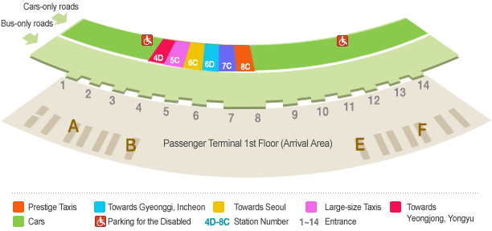

Fee Structure for Incheon International Airport Taxis
Section |  | Basic Fee |  | Platform Number |  | Remarks
Standard
taxi
Standard  taxi |  | KRW 1,900 (Seoul) |  | 18 |  | 24:00 ~ 04:00; additional 20% late night premium  Receipt issuance and translation provided as basic services
Deluxe taxi |  | KRW 4,500 |  | 21 |  | Car phone service/No late night premium fee  Receipt issuance and translation provided as basic services  No late night premium fee

Shuttle Bus :
Sheraton Grande Walkerhill Hotel (Conference Venue)
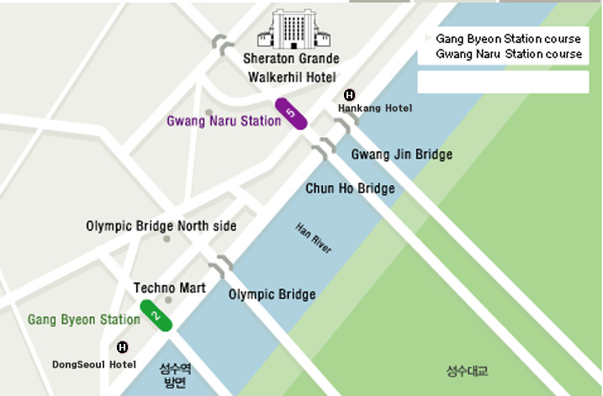
Sheraton Grande Walkerhill Hotel Shuttle Bus is stop by Gwang Naru Station and Gang Byeon Station for free.
* Gang Byeon Station course:
Time schedule: 06:00 a.m~11:20 p.m (every 20mins), duration time is 10 min to 20 min.
* Gwang Naru Station Course
Time schedule: 06:10 a.m.~11:10p.m. (every 20mins), duration time is 5 min to 15 min.
Hankang Hotel to Sheraton Grande Walkerhill Hotel
Shuttle bus | Taxi | By walking
10 min | 5 min | 25 min
* Time table of the shuttle bus will be provided upon check-in.
Dongseoul Hotel to Sheraton Grande Walkerhill Hotel
Taxi | By walking
7 min | 30 min
* Dongseoul hotel is not providing a shuttle bus, but Gang Byeon Station is 5 minutes by walk. You can take Sheraton Grande Walkerhill Hotel shuttle bus at Gang Byeon Station.

Internet Service at Sheraton Grande Walkerhill Hotel
Sheraton Grande Walkerhill Hotel provides high-speed Internet service to guests who are using laptops (Plug & Play System). Simply plug the Internet connection line into the plug jack. Payments for Internet use will be automatically added to your room.
In addition, Sheraton Grande Walkerhill Hotel provides a laptop rental service for free. Only it is charge to Internet Access fee about KRW 24,200 (Incl. VAT, for 24hrs). Please inquire when making a reservation or upon arrival at the check-in counter. This service will be charged separately from your room bills.
Tourist Office
Paradise Walkerhill Office
Tel.: +82-2-450-4834
Fax: +82-2-455-2121

Hotel Reservation and Cancellation
Reservation requests should be received no later than 31 December 2007. Hotel rooms must be guaranteed using a credit card. For cancellations, the reservation must be canceled 3 days prior to the arrival date to avoid paying a “no-show” charge. Rooms shall be assigned on a first-come, first-served basis. Room availability and rate after December 31, 2007 may not be guaranteed.

Map of Sheraton Grande Walkerhill Hotel
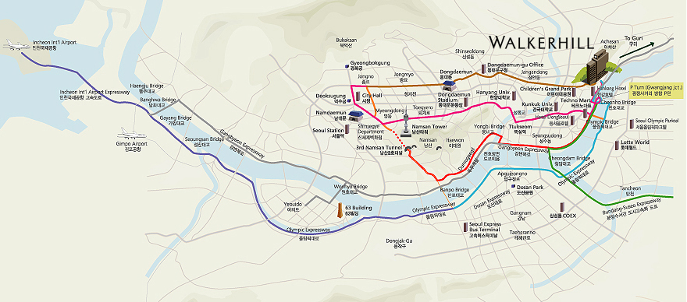

Map of the Seoul Subway
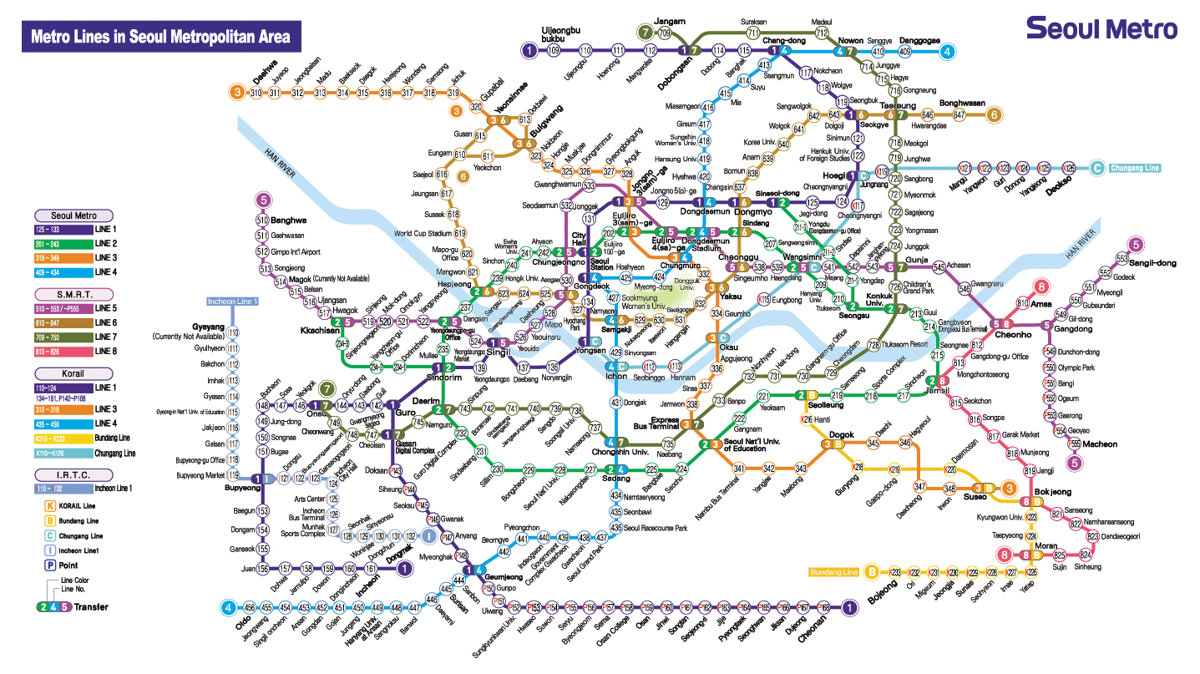
- Seoul subway map download
  - English version : http://211.54.2.50/eng/map_english.zip
  - Chinese version : http://211.54.2.50/eng/map_china.zip
  - Japanese version : http://211.54.2.50/eng/map_japan.zip

About Korea & Seoul

Korea
Korea boasts of 5,000 years’ history, in the course of which a unique culture blossomed. Modern Korea is a nation that has rebuilt itself from the ruins of the Korean War, achieving an economic miracle in a span of 50 years. The Korean peninsula extends southward from the eastern end of the Asian continent; it is approximately 1,000 km long and 216 km wide at its narrowest point.

Seoul
Seoul is a city of contrasts. From palaces that are several centuries old to high-tech skyscrapers made of steel and glass, from ancient texts dating back to a couple of millennia to the fastest broadband Internet access in the world, Seoul is a place where the old and new coexist in harmony. With one
foot in the past and another in the future, Seoul is a city that never ceases to amaze.
It is also the center of the so-called “Korean Wave” sweeping Asia. With Korean dramas, film, and music reaching a wider audience abroad, more and more visitors are coming to Seoul to experience first-hand the city’s rich culture and avail themselves of its outstanding cultural facilities.
Due to the division of the nation and proximity of DMZ with North Korea (only an hour’s drive away), however, some may consider Seoul to be a somewhat risky place to visit. Notwithstanding foreign news reports, nothing could be further from the truth; in fact, Seoul is one of the safest places in the world for foreign travelers with its low crime rate, hospitable people, state-of-the-art medical facilities, and capable police and security authorities. Seoul’s security situation has never been better.
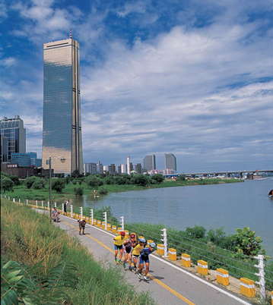

Attractions
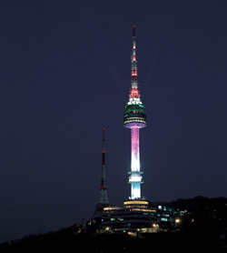
Located on top of Namsan Mountain, this place affords the finest views of Seoul. Since it was opened to the public in 1980, it has been a very popular place for relaxation among Seoul citizens. A lighting show is held every night at the N Seoul tower from 5 PM to 11 PM, featuring various color presentations. As one of the must-see attractions when visiting Seoul, the lighting show of the N Seoul tower is very impressive.
* N Tower
* COEX
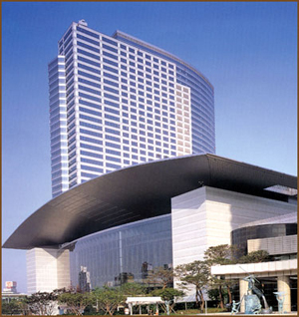
Touted as Seoul’s very own World Trade Center that includes a convention center, the COEX building houses an exhibition hall and a mall. It is the place to be for international conferences and cultural and art events. The COEX mall features many other leisure places such as Aquarium, Megabox Movie Theater, Kimchi field museum, event court, and food court. In particular, Aquarium has more than 40,000 fish from 600 species and dozens of large sharks. You will also see spectacular Kimchi displays and have the opportunity to learn Kimchi recipes and techniques in preparing Kimchi. If you participated in one of the international or art events before, you have probably been to this place already. Countless people visit here daily for various reasons. It is especially very crowded during weekends and holidays.

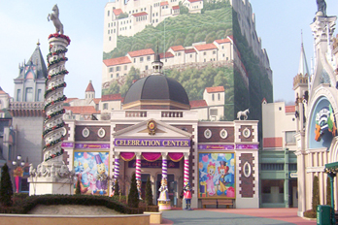

The Lotte World complex is a theme park bonanza that boasts of both shopping and entertainment facilities. In particular, the Folk Museum gives a glimpse of Korea’s colorful 5000-year history. The indoor grounds of Lotte World are teeming with specialty boutiques and toy stores that will delight children of all ages, with the large, prestigious Lotte Department Store on one end of the mall and Lotte Mart as the bargain hunters’ haven on the other. Lotte World remains a popular shopping and leisure destination for parents with small children.
* Lotte World

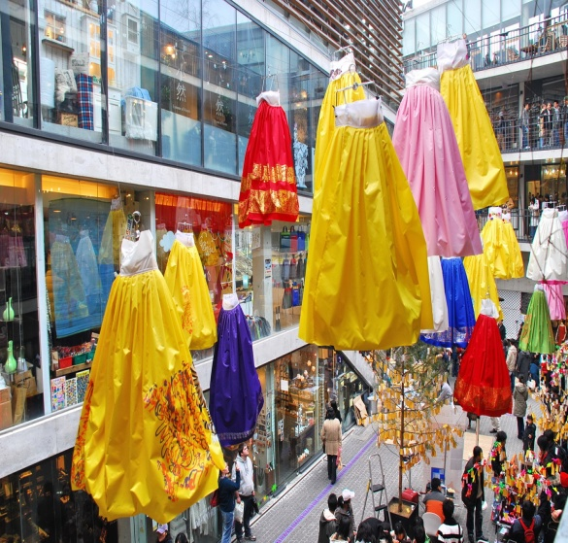
As the largest market featuring traditional Korean art and products, Insadong is the ideal place for visitors who want to experience the true character of Korea and its subtle, enduring beauty. Upon arriving in Insadong, you will immediately be drawn to the small alleys lined with numerous tiny and spacious shops and galleries such as antique shops, Korean stationery stores, frame shops, handicraft shops, pottery and porcelain shops, bookstores and painting studios, and art supply stores. The restaurants and cafes in the area serve traditional food and teas. A shuttle bus service linking galleries in different parts of Seoul has recently started operating between Insadong and Pyeongchangdong.
* Insadong

ANNEX 4
(to Revision 1 to TSB Collective letter 9/11)

HOTEL RESERVATION FORM
Please fill out this form and send it to the hotel **contact person
by fax or email no later than 31 December 2007.

Family name: …………………………..……… First name: ………………………………………
Organization: ……………………………..…… Country: ………………………………………….
Telephone: ………………………………...…… Fax: ………………………………………………
Email: …………………………………….……
Check-in date: ………………………………… Check-out date: …………………………………
No. of days of stay: ………… Days Number of persons: ………… Person

Hotel | Room Rate |  |  | **Contact Person | Remarks
Sheraton Grand Walkerhill Hotel | Douglas | Double bed ( )  Twin bed ( ) | KRW 111,000 | HyeJung Kwon  hjkwon@walkerhill.co.kr  Tel: +82-2-2022-0059  Fax: +82-2-2022-0567 | Breakfast is not included  except Club Deluxe room  Breakfast : KRW24,200 per person
Sheraton Grand Walkerhill Hotel | Main Deluxe | Double bed ( )  Twin bed ( ) | KRW 144,300
Sheraton Grand Walkerhill Hotel | * Club Deluxe | Double bed ( )  Twin bed ( ) | KRW 238,650
W Hotel | Wonderful | Double bed ( )  Twin bed ( ) | KRW 199,800
W Hotel | Spectacular | Double bed ( )  Twin bed ( ) | KRW 222,000
Hankang Hotel | Standard | Double bed ( )  Twin bed ( ) | KRW 111,000 | Park DeaUp  hankang@hankanghotel.co.kr  Tel: +82-2-53-5131  Fax: +82-2-453-5130 | Breakfast is not included  *Breakfast : KRW18,000 per person
Dongseoul  Hotel | Standard | Double bed ( )  Twin bed ( ) | KRW  80,000 | Kim NamYoung  rotate76@nate.com  Tel: +82-2-2049-6704  Fax: +82-2-455-6311 | Breakfast is not included  *Breakfast :KRW8,000 per person
* 10% VAT will be charged (only to Korean)
* All rates are quoted in KRW (Korean Won). The exchange rate for US Dollar is subject to change.
* This room rate is specially discounted for the ITU-T Meetings.
* The Club Deluxe Room rate includes breakfast for 2 persons.
* Hotel rooms must be guaranteed using a credit card; for cancellations, any reservation must be canceled 3 days before the arrival date to avoid paying a “no-show” charge.

Please encircle one of the following:
VISA, MASTERCARD, AMERICAN EXPRESS, DINERS CLUB, etc.

Credit card no.: ………………………………..…… Expiry date: …………………………………
Name of cardholder: ………………………………………………………………………………

Signature: …………………………………………………………………………………

ANNEX 5
(to Revision 1 to TSB Collective letter 9/11)

Request for Letter of Invitation for VISA Issuance to
Participate in the ITU-T events in Seoul, Korea (Republic of),
14 - 25 January 2008
Please return this form to Mr. Youngjae Kim no later than 7 December 2007 for the processing of a formal invitation letter if required.
(Email: ngn-gsi@tta.or.kr; office phone: +82-31-724-0195; fax: +82-31-724-0119)

Family name
Given name
Date of birth (yyyy/mm/dd)
Gender
Company (individual member)
Nationality
Passport number
Mailing address
(with postal code)
Expected arrival date
Expected departure date
Tel.
Fax.
Email

ANNEX 6
(to Revision 1 to TSB Collective letter 9/11)
ITU-TSB | ITU-T events in Seoul, Korea (Republic of),  14-25 January 2008
REGISTRATION FORM
To be returned to TSB by fax (+41 22 730 5853) or e-mail (tsbreg@itu.int) by 14 December 2007

Mr Mrs Ms Miss |  |  |  |  | _______________________________________________  Country
____________________________________________  Family name |  |  |  |  | ______________________________________________  Name of Administration of Member State*
____________________________________________  First name |  |  |  |  | ______________________________________________  Name of Sector Member / Associate / other
Full address of administration or organization:
______________________________________________ |  |  |  | Tel: _____________________________________________
______________________________________________ |  |  |  | Fax: _____________________________________________
______________________________________________ |  |  |  | E-mail: __________________________________________
*For delegates of Member States: Function at the meeting (for study group meetings only) |  |  |  |  | Hotel or other address in Seoul
SG 11 SG 13 SG 19 |  |  |  |  | Hotel: __________________________________________
(C) Head of delegation |  |  |  |  | Address: ________________________________________
(CA) Deputy head of delegation |  |  |  |  | ___________________________________________
(D) Delegate |  |  |  |  | Tel: ____________________________________________
I will participate in the following :
 | NGN-GSI
SG 11 | SG 13 | SG 19 | JCA-NGN | IPTV-GSI | JCA-IPTV | SG 16 Rapporteur  Groups | JCA-NID | IdM*
* Joint Rapporteur Groups on identity management; and, if agreed by TSAG IdM GSI event and JCA-IdM

Important Note:
Paper copy of study groups plenary (PLEN) temporary documents will be provided only upon request.
I need paper copies of PLEN temporary documents posted on or after 11 January 2008 for : | SG 11 | SG 13

If explicitly requested, a full set of meeting documents may be obtained from the secretariat.
Date: ___________________________ | Signature: ______________________________________

