Genève, le 28 novembre 2007
UNION INTERNATIONALE DES TÉLÉCOMMUNICATIONS  Bureau de la normalisation  des télécommunications | 

Réf: | Révision 1 à la  Lettre collective TSB 8/19
Tél.: | +41 22 730 5126
Fax:  E-mail: | +41 22 730 5853  tsbsg19@itu.int | - Aux administrations des Etats Membres de l'Union, aux Membres du Secteur UIT-T et aux Associés de l'UIT-T participant aux travaux de la Commission d'études 19

Objet: | Réunion de la Commission d'études 19  Séoul (République de Corée)  17-24 janvier 2008

Madame, Monsieur,
1 Conformément au calendrier des réunions de l'UIT-T (voir la Circulaire TSB 158), j'ai l'honneur de vous informer que la Commission d'études 19 (Réseaux de télécommunication mobiles) se réunira à Séoul (République de Corée), du 17 au 24 janvier 2008 inclus, à l'aimable invitation du Ministère de l'information et de la communication de la République de Corée.
La réunion s'ouvrira à 9 h 30 le premier jour. L'enregistrement des participants débutera à 8 h 30. Les participants peuvent également se faire enregistrer à partir du dimanche 13 janvier 2008 (entre 16 heures et 18 heures le dimanche). Les précisions relatives aux salles de réunion seront affichées sur place.
2 Les débats se dérouleront conformément aux décisions prises compte tenu des dispositions en vigueur.
3 Le projet d'ordre du jour, établi en accord avec le Président de la Commission d'études 19 (M. John Visser, Canada), figure dans l'Annexe 1 ci-après.
4.1 Le projet de calendrier, établi en accord avec le Président de la Commission d'études 19 (M. John Visser, Canada), figure dans l'Annexe 2 ci-après.
4.2 Nous attirons votre attention sur les travaux coordonnés qui sont prévus dans le cadre de l'initiative NGN-GSI (14-25 janvier 2008). Veuillez noter que d'autres manifestations de l'UIT-T auront lieu durant cette période, comme cela sera indiqué en détail dans la Circulaire TSB 174.
5 On trouvera un complément d'information sur la réunion dans l'Annexe 3.
6 Conformément aux dispositions de la Recommandation A.1 (2006), les contributions aux travaux de la Commission d'études doivent être soumises au Bureau de la normalisation des télécommunications (TSB). Les contributions reçues par le TSB le 6 janvier 2008 au plus tard
seront postées sur le site web de la Commission d'études 19. Les contributions reçues deux mois au moins avant le début de la réunion pourront être traduites, si nécessaire, conformément aux dispositions en vigueur.
Les participants sont invités à soumettre les contributions à l'aide du formulaire de soumission disponible sur la page d'accueil du site web de la Commission d'études 19, ou par courrier électronique à l'adresse suivante: tsbsg19@itu.int. Vous trouverez des instructions détaillées sur le site web de l'UIT-T.
Nous vous engageons vivement à utiliser l'ensemble de gabarits (templates) qui a été mis au point afin d'harmoniser la présentation des documents de l'UIT-T, ce qui facilitera la production des documents et la rendra donc plus efficace. Ces gabarits sont accessibles sur la page web de chaque commission d'études de l'UIT-T, sous "Guides, Tools and Templates"(http://www.itu.int/ITU-T/studygroups/templates/index.html et http://www.itu.int/ITU-T/studygroups/com19/edh/sg19template.doc).
En vue de régler toutes questions éventuelles au sujet des contributions, le nom de la personne à contacter à ce sujet, ses numéros de fax et de téléphone ainsi que son adresse électronique (e-mail) doivent figurer sur les contributions. Je vous prie donc de bien vouloir fournir ces renseignements sur la page de couverture de tous les documents.
7 Afin de permettre au TSB de prendre les dispositions nécessaires concernant la documentation et l'organisation de la réunion, je vous saurais gré de bien vouloir me faire parvenir par lettre, par fax (N° +41 22 730 5853) ou par courrier électronique (tsbreg@itu.int), dès que possible et au plus tard le 14 décembre 2007, la liste des personnes qui représenteront votre Administration, Membre de Secteur, Associé, organisation régionale et/ou internationale ou autre entité. Les administrations sont invitées à indiquer également le nom du Chef de délégation (et du Chef adjoint, le cas échéant). Vous trouverez, dans l'Annexe 6, le formulaire de participation qu'il faudra remplir, à raison d'un exemplaire par participant, et joindre à la liste mentionnée ci-dessus.
8 Veuillez noter qu'il s'agit d'une réunion sans document papier.
9 Toutes les salles de réunion seront équipées d'un accès sans fil à l'Internet. Les personnes souhaitant utiliser cet accès doivent disposer du matériel nécessaire et d'un ordinateur correctement configuré.
10 A toutes fins utiles, vous trouverez un formulaire de confirmation d'hôtel dans l'Annexe 4.
11 Pour entrer en Corée, tous les étrangers doivent être un possession d'un passeport valide. Les touristes peuvent séjourner en Corée pendant 15 jours sans visa, mais doivent présenter la confirmation de la réservation de leur billet d'avion aller-retour. Toutefois, les ressortissants de certains pays ont besoin d'un visa pour entrer en République de Corée. Pour de plus amples renseignements, veuillez vous adresser au Ministère des affaires étrangères et du commerce (www.mofat.go.kr). Les délégués ayant besoin d'aide concernant l'obtention d'un visa peuvent s'adresser à la personne dont le nom et les coordonnées sont indiqués dans l'Annexe 5.
Veuillez agréer, Madame, Monsieur, l'assurance de ma considération distinguée.

Malcolm Johnson
Directeur du Bureau de la
normalisation des télécommunications
Annexes: 6
ANNEX 1
(to Revision 1 to TSB Collective letter 8/19)
Draft agenda ITU-T SG19 meeting
Seoul, Korea (Republic of), 17-24 January 2008

- Opening of the plenary session
- Welcome by SG 19 Chairman
- Chairman’s comments and key objectives for this meeting
- Approval of agenda
- Brief reports of interim meetings
  - Questions 5/19 and 6/13 E-Meeting (11 – 15 June 2007)
  - Q.4/19 correspondence group on drafting second Edition of Handbook on deployment of IMT-2000 systems (June – November 2007)
  - Questions 2/19 and 6/13 E-Meeting (29 June – 5 July 2007)
  - Q.1/19 E-Meeting (11 – 29 June 2007)
  - Q.1/19 E-Meeting (27 August – 7 September 2007)
  - Questions 2/19, 5/19, 6/13 Joint Rapporteurs meeting at NGN GSI event (Geneva, 11 – 21 September 2007)
5.7 SG 19 one session meeting (Geneva, 21 September 2007, PM)
5.8 Q.1/19 E-Meeting (29 October – 9 November 2007)
5.9 Questions 2/19 and 6/13 E-meeting (21 – 26 November 2007)
6. Related activities
6.1 ITU-T NGN GSI event (Geneva, 11- 21 September 2007)
6.2 ITU-T WPs 1/13, 2/13, 3/13, 4/13 and WP 2/11, WP3/11 (Geneva, 21 September 2007)
6.3 ITU-T NGN GSI event (Seoul, Korea, 14 – 25 January 2008)
6.4 Others as identified
7. Information on other events of interest
7.1 Focus Group on IPTV (Bled, Slovenia, 7 – 11 May 2007)
7.2 ITU-R WP 8F Workshop on IMT-Advanced (Kyoto, Japan, 22 May 2007)
7.3 ITU-R WP 8F meeting (Kyoto, Japan, 23 – 31 May 2007)
7.4 ITU-T Workshop “Satellites in NGN?” (Montreal, Canada, 13 July 2007)
7.5 Focus Group on IPTV (Geneva, 23 – 31 July 2007)
7.6 ITU-R WP 8F meeting (Seoul, Korea, 29 – 31 August 2007)
7.7 Council 2007 (Geneva, 4 – 14 September 2007)
7.8 ITU-T Workshop “Multimedia in NGN” (Geneva, 10 – 11 September 2007)
7.9 Focus Group "From/In/To Cars Communication" (Nürnberg, Germany, 12 September 2007)
7.10 Focus Group on IPTV (Tokyo, Japan, 15 – 19 October 2007)
7.11 Radiocommunication Assembly 2007 (Geneva, 15 – 19 October 2007)
7.12 World Radiocommunication Conference 2007 (Geneva, 22 October – 16 November 2007)
7.13 ITU-BDT Regional Seminar on Broadband Wireless Access (BWA) for CIS, CEE and Baltic Countries (Moscow, Russia, 26-29 November 2007)
7.14 Focus Group "From/In/To Cars Communication" (Aachen, Germany, 27 November 2007)
7.15 ITU TSB Director’s IPR Ad Hoc (Geneva, 27 – 28 November 2007)
7.16 SG Chairmen’s meeting (Geneva, 29 – 30 November 2007)
7.17 TSAG meeting (Geneva, 3 – 7 December 2007)
7.18 Last meting of Focus Group on IPTV (Qawra, St Paul's Bay, Malta, 11 – 18 December 2007)
7.19 Others as identified
8. Organization of the work
8.1 Working methods
8.2 Appointment of Rapporteurs, Editors and Coordinators as required
8.3 Preparations for WTSA-08
8.4 Others as identified
9. Approval of Meeting Work Plan
10. Document allocation
11. Meetings of Individual Questions
12. Examination and approval of the reports of the Questions
12.1 Consent of Recommendations in accordance with the rules of Recommendation A.8
12.2 Endorsement of 2nd edition of Handbook on deployment of IMT-2000 Systems
12.3 Approval of a proposed set of Questions for study in the next Study Period
12.4 Examination / approval of Outgoing Liaison statements
13. Future activities
14. Miscellaneous / Any Other Business
15. Closure of the Meeting

ANNEX 2
(to Revision 1 to TSB Collective letter 8/19)
Draft timetable for Study Group 19
Seoul, Korea (Republic of), 17-24 January 2008
SG19 Activity | Wed, 16 Jan |  |  |  | Thu, 17 Jan |  |  |  | Fri, 18 Jan |  |  |  | Sat,  19 Jan | Sun,  20 Jan |  |  | Mon, 21 Jan |  |  |  | Tue, 22 Jan |  |  |  | Wed, 23 Jan |  |  |  | Thu,  24 Jan
Session | 1,2 | 3 | 4 | E | 1 | 2 | 3 | 4 | 1 | 2 | 3 | 4 |  |  | 4 |  | 1 | 2 | 3 | 4 | 1 | 2 | 3 | 4 | 1 | 2 | 3 | 4 | 1 | 2
Mgmt Team |  |  | X³ |  |  |  |  |  |  |  |  |  |  |  |  |  |  |  |  |  |  |  |  |  |  |  | X³
SG19 Plenary |  |  |  |  | X |  |  |  |  |  |  |  |  |  |  |  |  |  |  |  |  |  |  |  |  |  |  |  | X⁴ | X
Q.1/19 |  |  |  |  |  |  |  |  |  |  |  |  |  |  |  |  | X |  | X |  |  | X | X | X |  |  |  | X
FMC¹ |  |  |  |  |  | X | X | X | X |  | X | X
MM² |  |  |  |  |  |  |  |  |  |  |  |  |  |  |  |  |  |  | X | X |  | X | X |  | X | X
MM & FMC |  |  |  |  |  |  |  |  |  |  |  |  |  |  |  |  |  |  |  |  |  |  |  |  |  |  | X
MM, FMC & Q.29/16 |  |  |  |  |  |  |  |  |  |  |  |  |  |  |  |  |  | X
Q.3/19 |  |  |  |  |  |  |  |  |  |  |  |  |  |  |  |  |  |  |  |  |  |  |  | X |  | X
Q.4/19 |  |  |  |  |  |  |  |  |  |  |  |  |  |  |  |  |  |  |  | X |  |  |  |  | X |  |  | X⁵
Q.2/19 & Q.2/13, Q.6/13 |  |  |  | X⁶
Q.2/19, Q.6/13, Q.3/13 |  |  |  |  |  |  |  |  |  |  |  |  |  |  |  | X⁷
SG 19 Futures |  |  |  |  |  |  |  |  |  |  |  |  |  |  |  |  |  |  |  |  | X⁸
Notes:
1. FMC is the joint activity on Fixed-Mobile Convergence involving Qs.5/19 and 6/13.
2. MM is the joint activity on Mobility Management involving Qs.2/19 and 6/13.
3. The SG19 Management Team will meet 1600-1730 on Wednesday, 16 January, to prepare for the opening plenary, and will also meet 1330-1400 on Wednesday, 23 January, to review issues and progress, and prepare for the closing plenary.
4. Recommendations to be considered for AAP Consent or TAP Determination, and Supplements to be considered for approval, must be provided to the TSB in sufficient time that they can be posted and be available to all delegates by 0900 Thursday. Question reports should be made available by this time as well, but as a second priority.
5. This session of Q.4/19 will follow that allocated to Q.1/19 and is to provide an opportunity for Q.4/19 to work with participants in Q.3/19 following their last session in support of the work of Q.4/19.
6. Joint Q.2/13, Q.6/13 and Q.2/19 evening session to review the Q.2/13 work on Y.MPLS-mob, to be confirmed.
7. Session on mobility management.
8. This is a session on SG 19 future and Questions.
9. TSR sessions are planned for Friday, 18 January, session 2, and Wednesday, 23 January, in the evening. Please refer to TSB Circular 158.
10. IPTV-GSI TSR will take place on Tuesday, 15 January. JCA-IPTV is planned for Monday, 21 January, evening session. JCA-NGN is planned for Tuesday, 22 January, sessions 3 and 4.

ANNEX 3
(to Revision 1 to TSB Collective letter 8/19)

GENERAL INFORMATION
ITU-T events in Seoul, Korea (Republic of)
14-25 January 2008

Venue Information

Venue
Sheraton Grande Walkerhill Hotel Convention Center

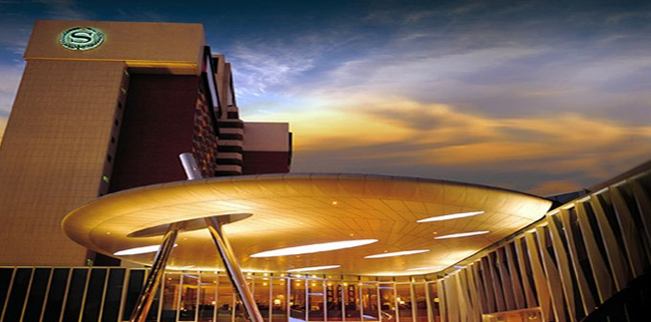

Address: 21 Gwangjang-Dong, Gwangjin-Gu, Seoul, Korea
Phone: +82-2-2022-0059 (cite “ITU-T” as group name)
Fax: +82-2-2022-0567 (indicate “ITU-T” as group name)
Reservation Manager: HyeJung Kwon (Ms.)
Email: hjkwon@walkerhill.co.kr (indicate “ITU-T” as group name)
Website: http://www.walkerhill.co.kr (Korean/English/Japanese available)

Hotels
* Sheraton Grande Walkerhill & W Hotel (conference venue)
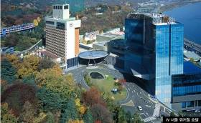
Grande Walkerhill & W Hotel is a global lifestyle brand. Offering its guests with new, memorable, and lasting experiences, comfortable meeting spaces, and good location, it is the perfect venue for the conference. The hotel even gave us special room rates for our meetings.
In the picture, left side is the Grande Walkerhill hotel and right side is the W hotel. The conference center is between the Grande Walkerhill and the W Hotel

HanKang Hotel
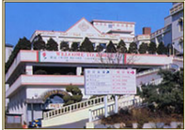
Located on the riverside in Seoul, Hankang Hotel has been providing outstanding service based on 38 years of colorful tradition.

Contact: Park Dea Up
Email: hankang@hankanghotel.co.kr
Tel.: +82-2-53-5131
Fax: +82-2-453-5130
http://www.hankanghotel.co.kr

DongSeoul Hotel
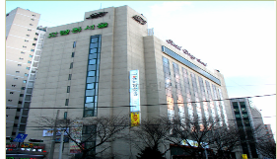
DongSeoul Hotel is very accessible through several means of transportation. Touring Seoul is very easy.

Contact: Kim Nam Young
Email: rotate76@nate.com
Tel.: +82-2-2049-6704
Fax: +82-2-455-6311
http://www.idshotel.co.kr/

Hotel | Room | Rate
Sheraton Grande Walkerhill Hotel  (★★★★★) | Douglas | KRW 111,000
Sheraton Grande Walkerhill Hotel  (★★★★★) | Main Deluxe | KRW 144,300
Sheraton Grande Walkerhill Hotel  (★★★★★) | Club Deluxe | KRW 238,650
W Hotel  (★★★★★★) | Wonderful | KRW 199,800
W Hotel  (★★★★★★) | Spectacular | KRW 222,000
Hankang Hotel (★★★) | Standard | KRW 111,000
DongSeoul Hotel (★★★) | Standard | KRW 80,000
The Sheraton Grand Walkerhill hotel and the W Hotel are recommended by the host organization. And another recommended hotels are the Hankang Hotel and the Dongseoul Hotel. (See registration form in Annex 4)
- Korea has blocked 250 rooms at Sheraton Grande Walkerhill Hotel for the ITU-T events. Since hotel rooms shall be assigned on a first-come, first-served basis, early reservation is recommended.
- To guarantee your reservation, your credit card information is necessary in making a one-night deposit. The total hotel fees shall be charged directly by the hotel upon check-out.
- The hotel should be informed of any and all changes or cancellations regarding room reservation via email or fax.
- Any changes or cancellations regarding room reservation should be informed by e-mail or faxed to the hotel.
- Korea has blocked maximum 50 rooms at the Hankang Hotel which is 1 km apart from the Sheraton Grand Walkerhill Hotel and the DongSeoul Hotel which is 3km apart from the Sheraton Grand Walkerhill Hotel. The quality of those hotels is lower than that of the Sheraton Grand Walkerhill Hotel. Reservation of this hotel can be used same registration form and contact point in Annex 4.

Floor Information(Conference Center)
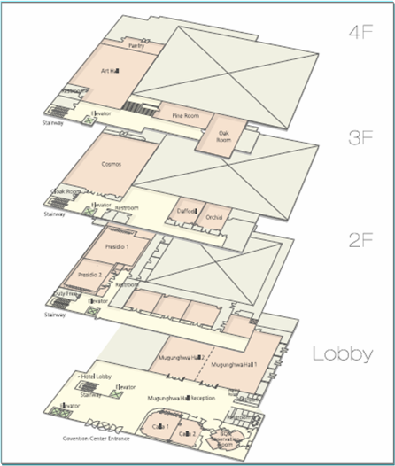
- ITU-T Secretariat: Calla 1
- Session Venue: Mugunghwa Hall 1,2(1F)
Presidio 1, 2/2-A1, A2, B1, B2, B3 (2F)
Daffodil/Orchid/Cosmos (3F)
Pine Room/Oak Room/Art center (4F)
Grand Hall 1, 2, 3, 4 (B1)
- Registration Desk (1F)
- Chairman’s Room: 3F in the Hotel
- Vice Chairman’s Room: Calla 2

Lobby (B1, 4 rooms)
Lobby (1F, 2 rooms)
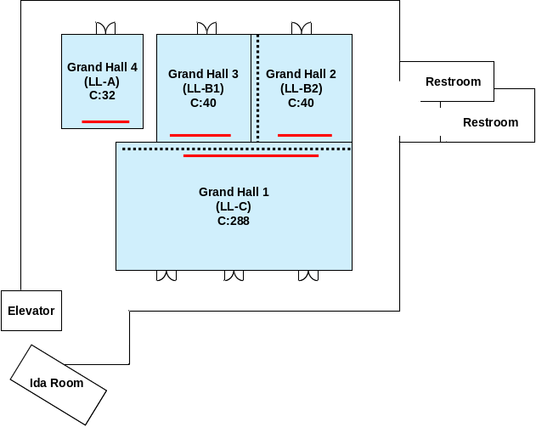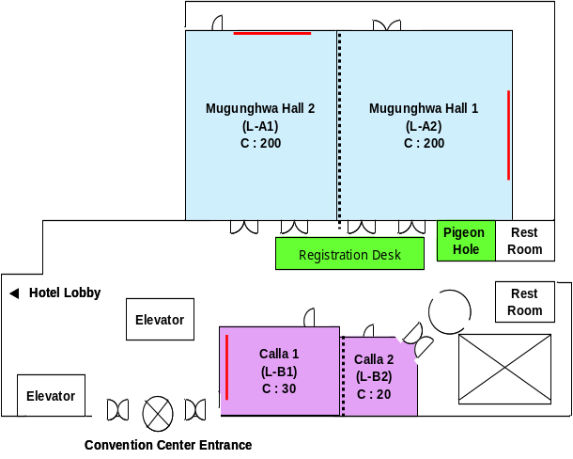

2F (7 rooms) 3F (3 rooms)

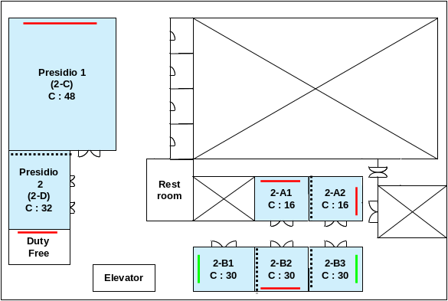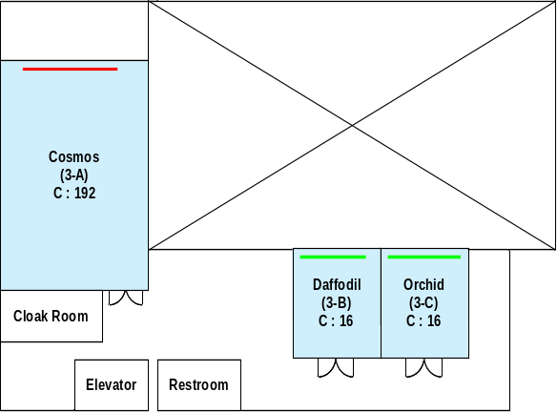

4F (3 rooms)

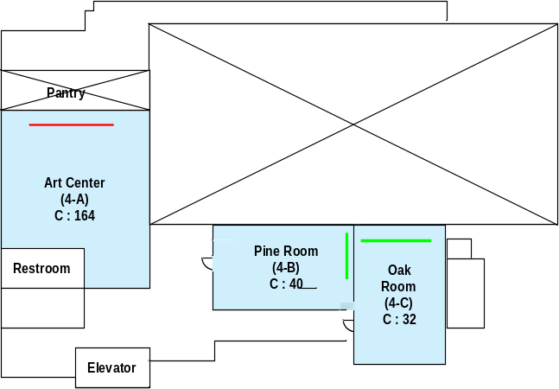
Travel Information
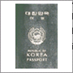
Visa
Any foreign visitor wishing to enter Korea must have a valid passport. Tourists may visit Korea for 15 days without a visa, although proof of confirmed round trip air reservation is required. Note, however, that some countries need visas to enter the Republic of Korea. For more information, visit the website of the Ministry of Foreign Affairs and Trade at www.mofat.go.kr.

Currency and Exchange
The Korean currency unit is WON (indicated as ￦). Bank notes come in ￦10,000, ￦5,000, and ￦1,000 bills, and coin denominations are ￦500, ￦100, ￦50, and ￦10. As of August 2007, USD 1 is equivalent to about ￦930. Money can be exchanged at Incheon International Airport, banks, and hotels.
http://www.keb.co.kr/IBS/english/fx/rate/average/index.jsp

Weather
The weather in January is usually cold. The average temperature is -2.8~4.1°C (37~39.4°F). For more detailed climate information, visit the website of the Korea Meteorological Administration at http://www.kma.go.kr/intro.html

Electricity
The standard supply is 220 volts with AC/60 cycles. Outlets for 220 volts are available at the hotels.

The following outlets are compatible with those available in Korea:

a) “Europlug,” which is described in CEE 7/16
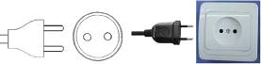
b) This plug is similar to those illustrated above, except that it is round and with the addition of two grounding clips on the side of the plug.


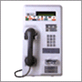
Telephone Calls
A local 3-minute call costs ￦70. To make an international call, dial the international dialing code (001, 002, or 00700) followed by the country code, area code, and local telephone number. You may also rent a cellular phone at Incheon International Airport.
Emergencies
Police 112
Fire Department 119
Medical Emergencies 1339

Business Hours
Government offices are open from Monday to Friday from 09:00 to 18:00.
Most private businesses are open from 08:30 to 10:00 and are closed in the evening. Banks are an exception; their business hours are from 09:30 to 16:30 on weekdays. They are closed during the weekends.
Foreign diplomatic missions in Seoul generally maintain strict business hours including lunch. They are usually open from 09:00 to 17:00 on weekdays and closed on Saturdays and Sundays.
Major department stores are usually open from 10:30 to 20:00 including Sundays, although smaller shops tend to open earlier and close later every day of the week.

Automated Teller Machines (ATM) for Foreign Travelers
Travelers who carry internationally recognized credit cards can get cash advances in Korean won at the Automated Teller Machines (ATMs) installed at airports, major hotels, department stores, subway stations, and tourist attractions.

Tipping
Tipping is not a traditional Korea custom. A 10% service charge is added to your bill at all tourist hotels (3~10% at some big restaurants).

Tax
Value-added tax (VAT) is levied on most goods and services at a standard rate of 10% and included in the retail price. In tourist hotels, this 10% tax is applied to meals and other services and is added to the bill.

Mail
Domestic postal rates are ￦190 for a letter weighing up to 25g, ￦1,490 for a registered letter weighing no more than 25g, and ￦1,500 or ￦2,000 for a package weighing up to 2kg. A postcard costs ￦160.
■ Korea post: www.koreapost.go.kr

Newspaper, TV, and Radio
There are three English dailies: the Korea Times, Korea Herald, and International Herald Tribune Joongang Daily. They are available in most newsstands and in most hotel gift shops.
Korea has five TV networks, all of which broadcast in Korean (KBS1, KBS2, MBC, SBS, and EBS). Aside from the national broadcasting networks, there are also many cable TV channels specializing in various fields of programming including news, movies, entertainment, sports, etc. As a special English channel produced in Korea (cable channel #50), Arirang TV features programs on politics, economy, community, and culture. It provides insight to and aids in the understanding of all things Korean through popular TV serial dramas with English subtitles. Some 90 hotels in Korea offer Arirang TV on cable or satellite.

Korea and Korean Tourism
For more information on Korea and tours, visit the following websites:
http://www.kois.go.kr
http://www.tour2korea.com

Local time
GMT + 9 hours (same as Tokyo time)

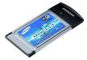
Computer Networking
Each meeting room will be equipped with wireless access (wireless LAN, supports IEEE802.11b & g, 2.4GHz band) to the Internet. Those who wish to have wireless access must be equipped with the necessary hardware and correctly configured PC.

Airport
The nearest airport is Incheon International Airport.

Transportation (from Incheon International Airport to Sheraton Grande Walkerhill Hotel)

- The distance from the airport to Sheraton Grande Walkerhill Hotel is about 70km. A KAL Limousine Bus will get you to the hotel in about 1 ½ hours.
- Only Korean currency (Won) can be used for all means of transportation.
- We strongly recommend that you take a KAL Limousine Bus.

(1) KAL Limousine Bus
- Goes directly from Incheon International Airport to Sheraton Grande Walkerhill Hotel
- Affordable means of transportation
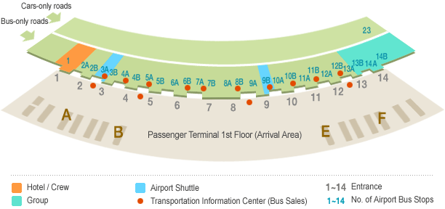
- Price: KRW 13,000 (approximately USD 13.98)
- Traveling time: Depending on the traffic, you can get to Sheraton Grande Walkerhill Hotel in about 90 minutes.
- Departure interval: Approximately 20-30 minutes
- Bus station number 4-B, 11-A Exit
- Bound for Jamsil (Incheon International Airport→ Lotte World→ Dong Seoul Bus Terminal → Kwangnaru Subway Station→ Walkerhill)
- Purchasing a ticket: You may purchase a ticket at the Transportation Information Counter located at exits 2, 4, 9, and 13 on the passenger terminal arrival floor.
- Contact: KAL Limousine Headquarters (02-2667-0386)
Incheon International Airport Information (1577-2600)
- Timetable: From the airport to Sheraton Grande Walkerhill Hotel
04:50 | 05:10 | 05:30 | 05:50 | 06:12 | 06:30 | 06:52
07:10 | 07:30 | 07:50 | 08:10 | 08:30 | 08:50 | 09:10
09:30 | 09:50 | 10:10 | 10:30 | 10:50 | 11:10 | 11:30
11:50 | 12:12 | 12:25 | 12:45 | 12:57 | 13:10 | 13:30
13:30 | 13:50 | 14:10 | 14:30 | 14:50 | 15:12 | 15:30
15:50 | 16:12 | 16:30 | 16:50 | 17:10 | 17:25 | 17:40
17:55 | 18:10 | 18:30 | 18:45 | 19:00 | 19:10 | 19:30
19:50 | 20:10 | 20:30 | 20:50 | 21:10 | 21:30 | 21:55
22:10 | 22:35

(2)Taxi
- Taxi stands are located at the passenger terminal arrival floor (1st floor) between platforms
4D and 8C
- Taxi rates: -Standard taxi: KRW 60,000-70,000 (approximately USD 64.5 ~75.26)
-Deluxe taxi: KRW 90,000 (approximately USD 96.78)
* Passengers shoulder the expressway fees (KRW 6,900, one way).
- Traveling time: Approximately 60 minutes, 90 minutes in case of heavy traffic
- The rates were estimated based on the assumption that there is no traffic; actual rates may vary, however.
- No reservations are necessary.
- If you plan to take a taxi, please show the following note to the taxi driver:

쉐라톤 워커힐 호텔에 데려다 주세요.
(Please take me to Sheraton Grande Walkerhill Hotel.)

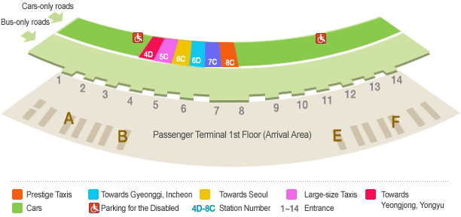

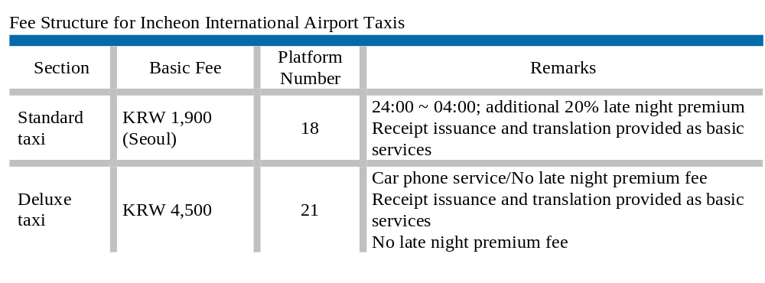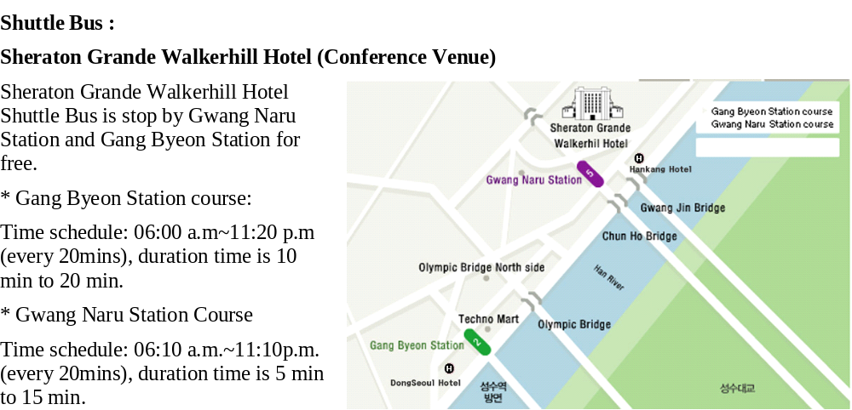
Hankang Hotel to Sheraton Grande Walkerhill Hotel
Shuttle bus | Taxi | By walking
10 min | 5 min | 25 min
* Time table of the shuttle bus will be provided upon check-in.

Dongseoul Hotel to Sheraton Grande Walkerhill Hotel
Taxi | By walking
7 min | 30 min
* Dongseoul hotel is not providing a shuttle bus, but Gang Byeon Station is 5 minutes by walk. You can take Sheraton Grande Walkerhill Hotel shuttle bus at Gang Byeon Station.

Internet Service at Sheraton Grande Walkerhill Hotel
Sheraton Grande Walkerhill Hotel provides high-speed Internet service to guests who are using laptops (Plug & Play System). Simply plug the Internet connection line into the plug jack. Payments for Internet use will be automatically added to your room.
In addition, Sheraton Grande Walkerhill Hotel provides a laptop rental service for free. Only it is charge to Internet Access fee about KRW 24,200 (Incl. VAT, for 24hrs). Please inquire when making a reservation or upon arrival at the check-in counter. This service will be charged separately from your room bills.

Tourist Office
Paradise Walkerhill Office
Tel.: +82-2-450-4834
Fax: +82-2-455-2121

Hotel Reservation and Cancellation
Reservation requests should be received no later than 31 December 2007. Hotel rooms must be guaranteed using a credit card. For cancellations, the reservation must be canceled 3 days prior to the arrival date to avoid paying a “no-show” charge. Rooms shall be assigned on a first-come, first-served basis. Room availability and rate after December 31, 2007 may not be guaranteed.

Map of Sheraton Grande Walkerhill Hotel
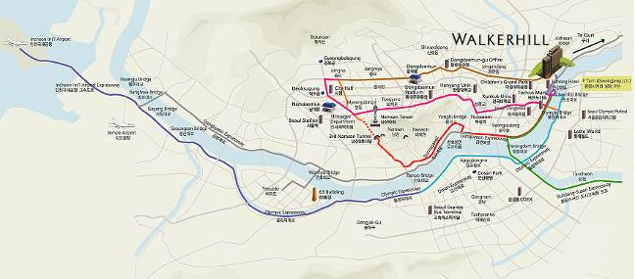

Map of the Seoul Subway
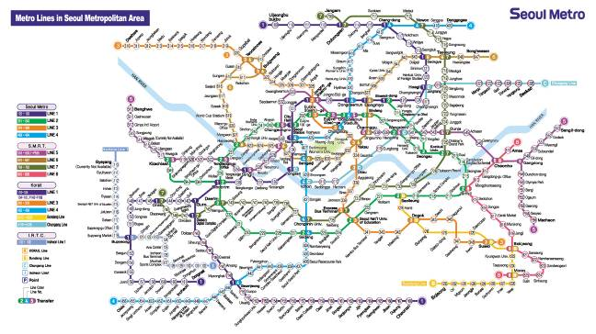
- Seoul subway map download
  - English version : http://211.54.2.50/eng/map_english.zip
  - Chinese version : http://211.54.2.50/eng/map_china.zip
  - Japanese version : http://211.54.2.50/eng/map_japan.zip

About Korea & Seoul

Korea
Korea boasts of 5,000 years’ history, in the course of which a unique culture blossomed. Modern Korea is a nation that has rebuilt itself from the ruins of the Korean War, achieving an economic miracle in a span of 50 years. The Korean peninsula extends southward from the eastern end of the Asian continent; it is approximately 1,000 km long and 216 km wide at its narrowest point.

Seoul
Seoul is a city of contrasts. From palaces that are several centuries old to high-tech skyscrapers made of steel and glass, from ancient texts dating back to a couple of millennia to the fastest broadband Internet access in the world, Seoul is a place where the old and new coexist in harmony. With one foot in the past and another in the future, Seoul is a city that never ceases to amaze.
It is also the center of the so-called “Korean Wave” sweeping Asia. With Korean dramas, film, and music reaching a wider audience abroad, more and more visitors are coming to Seoul to experience first-hand the city’s rich culture and avail themselves of its outstanding cultural facilities.
Due to the division of the nation and proximity of DMZ with North Korea (only an hour’s drive away), however, some may consider Seoul to be a somewhat risky place to visit. Notwithstanding foreign news reports, nothing could be further from the truth; in fact, Seoul is one of the safest places in the world for foreign travelers with its low crime rate, hospitable people, state-of-the-art medical facilities, and capable police and security authorities. Seoul’s security situation has never been better.

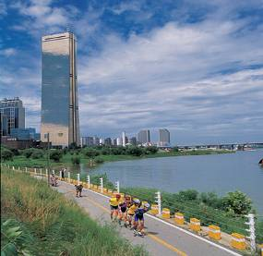

Attractions
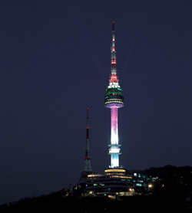
Located on top of Namsan Mountain, this place affords the finest views of Seoul. Since it was opened to the public in 1980, it has been a very popular place for relaxation among Seoul citizens. A lighting show is held every night at the N Seoul tower from 5 PM to 11 PM, featuring various color presentations. As one of the must-see attractions when visiting Seoul, the lighting show of the N Seoul tower is very impressive.
* N Tower
* COEX
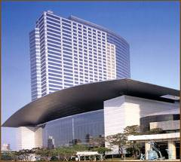
Touted as Seoul’s very own World Trade Center that includes a convention center, the COEX building houses an exhibition hall and a mall. It is the place to be for international conferences and cultural and art events. The COEX mall features many other leisure places such as Aquarium, Megabox Movie Theater, Kimchi field museum, event court, and food court. In particular, Aquarium has more than 40,000 fish from 600 species and dozens of large sharks. You will also see spectacular Kimchi displays and have the opportunity to learn Kimchi recipes and techniques in preparing Kimchi. If you participated in one of the international or art events before, you have probably been to this place already. Countless people visit here daily for various reasons. It is especially very crowded during weekends and holidays.

The Lotte World complex is a theme park bonanza that boasts of both shopping and entertainment facilities. In particular, the Folk Museum gives a glimpse of Korea’s colorful 5000-year history. The indoor grounds of Lotte World are teeming with specialty boutiques and toy stores that will delight children of all ages, with the large, prestigious Lotte Department Store on one end of the mall and Lotte Mart as the bargain hunters’ haven on the other. Lotte World remains a popular shopping and leisure destination for parents with small children.
* Lotte World
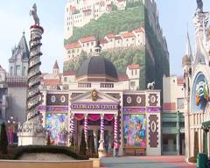

* Insadong
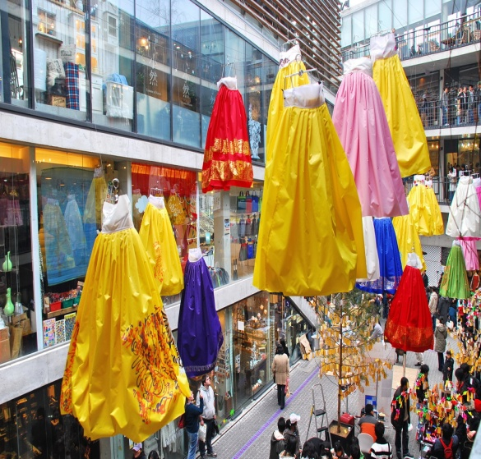
As the largest market featuring traditional Korean art and products, Insadong is the ideal place for visitors who want to experience the true character of Korea and its subtle, enduring beauty. Upon arriving in Insadong, you will immediately be drawn to the small alleys lined with numerous tiny and spacious shops and galleries such as antique shops, Korean stationery stores, frame shops, handicraft shops, pottery and porcelain shops, bookstores and painting studios, and art supply stores. The restaurants and cafes in the area serve traditional food and teas. A shuttle bus service linking galleries in different parts of Seoul has recently started operating between Insadong and Pyeongchangdong.
ANNEX 4
(to Revision 1 to TSB Collective letter 8/19)

HOTEL RESERVATION FORM
Please fill out this form and send it to the hotel **contact person
by fax or email no later than 31 December 2007.

Family name: …………………………..……… First name: ………………………………………
Organization: ……………………………..…… Country: …………………………………………
Telephone: ………………………………...…… Fax: ………………………………………………
Email: …………………………………….……
Check-in date: ………………………………… Check-out date: …………………………………
No. of days of stay: ………… Days Number of persons: ………… Person

Hotel | Room Rate |  |  | **Contact Person | Remarks
Sheraton Grand Walkerhill Hotel | Douglas | Double bed ( )  Twin bed ( ) | KRW 111,000 | HyeJung Kwon  hjkwon@walkerhill.co.kr  Tel: +82-2-2022-0059  Fax: +82-2-2022-0567 | Breakfast is not included  except Club Deluxe room  Breakfast : KRW24,200 per person
Sheraton Grand Walkerhill Hotel | Main Deluxe | Double bed ( )  Twin bed ( ) | KRW 144,300
Sheraton Grand Walkerhill Hotel | * Club Deluxe | Double bed ( )  Twin bed ( ) | KRW 238,650
W Hotel | Wonderful | Double bed ( )  Twin bed ( ) | KRW 199,800
W Hotel | Spectacular | Double bed ( )  Twin bed ( ) | KRW 222,000
Hankang Hotel | Standard | Double bed ( )  Twin bed ( ) | KRW 111,000 | Park DeaUp  hankang@hankanghotel.co.kr  Tel: +82-2-53-5131  Fax: +82-2-453-5130 | Breakfast is not included  *Breakfast : KRW18,000 per person
Dongseoul  Hotel | Standard | Double bed ( )  Twin bed ( ) | KRW  80,000 | Kim NamYoung  rotate76@nate.com  Tel: +82-2-2049-6704  Fax: +82-2-455-6311 | Breakfast is not included  *Breakfast :KRW8,000 per person
* 10% VAT will be charged (only to Korean)
* All rates are quoted in KRW (Korean Won). The exchange rate for US Dollar is subject to change.
* This room rate is specially discounted for the ITU-T Meetings.
* The Club Deluxe Room rate includes breakfast for 2 persons.
* Hotel rooms must be guaranteed using a credit card; for cancellations, any reservation must be canceled 3 days before the arrival date to avoid paying a “no-show” charge.

Please encircle one of the following:
VISA, MASTERCARD, AMERICAN EXPRESS, DINERS CLUB, etc.

Credit card no.: ………………………………..…… Expiry date: ………………………………………
Name of cardholder: ……………………………………………………………………………………
Signature: ………………………………………………………………………………............
ANNEX 5
(to Revision 1 to TSB Collective letter 8/19)

Request for Letter of Invitation for Visa Issuance to
Participate in the ITU-T events in Seoul, Korea (Republic of),
14-25 January 2008

Please return this form to Mr. Youngjae Kim no later than 7 December 2007 for the processing of a formal invitation letter if required.
(Email: ngn-gsi@tta.or.kr; office phone: +82-31-724-0195; fax: +82-31-724-0119)

Family name
Given name
Date of birth (yyyy/mm/dd)
Gender
Company (individual member)
Nationality
Passport number
Mailing address
(with postal code)
Expected arrival date
Expected departure date
Tel.
Fax.
Email

ANNEX 6
(to Revision 1 to TSB Collective letter 8/19)
ITU-TSB | ITU-T events in Seoul, Korea (Republic of)  14-25 January 2008
REGISTRATION FORM
To be returned to TSB by fax (+41 22 730 5853) or e-mail (tsbreg@itu.int) by 14 December 2007
Mr Mrs Ms Miss |  |  |  |  |  | _______________________________________________  Country
____________________________________________  Family name |  |  |  |  |  | ______________________________________________  Name of Administration of Member State*
____________________________________________  First name |  |  |  |  |  | ______________________________________________  Name of Sector Member / Associate / other
Full address of administration or organization:
______________________________________________ |  |  |  |  | Tel: _____________________________________________
______________________________________________ |  |  |  |  | Fax: _____________________________________________
______________________________________________ |  |  |  |  | E-mail: __________________________________________
*For delegates of Member States: Function at the meeting (for study group meetings only) |  |  |  |  |  | Hotel or other address in Seoul
SG 11 SG 13 SG 19 |  |  |  |  |  | Hotel: __________________________________________
(C) Head of delegation |  |  |  |  |  | Address: ________________________________________
(CA) Deputy head of delegation |  |  |  |  |  | ___________________________________________
(D) Delegate |  |  |  |  |  | Tel: ____________________________________________
I will participate in the following :
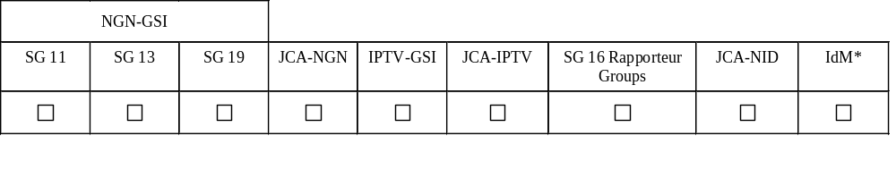* Joint Rapporteur Groups on identity management; and, if agreed by TSAG IdM-GSI event and JCA-IdM
Important Note:
Paper copy of study group plenary (PLEN) temporary documents will be provided only upon request.

If explicitly requested, a full set of meeting documents may be obtained from the secretariat
Date: ___________________________ |  | Signature: ______________________________________

