2005年1月28日，日内瓦
国 际 电 信 联 盟
电信标准化局

文号: | 电信标准化局第19号通函  TSB Workshops/X.Y.
电话:  传真:  电子  邮件: | +41 22 730 6206  +41 22 730 5853  tsbworkshops@itu.int | - 致国际电联会员国各主管部门；  - 致ITU-T各部门成员；  - 致ITU-T研究组正副主席；  - 致ITU-T 部门准成员；  抄送：  - 电信发展局主任；  - 无线电通信局主任

事由: | 下一代网络（NGN）讲习班  2005年3月14-15日，大韩民国济州岛

尊敬的先生/女士,
1 受韩国政府的诚挚邀请，我谨通知您下一代网络（NGN）技术讲习班将自2005年3月14日至15日在大韩民国济州岛的乐天酒店（Lotte Hotel）举行。在讲习班结束后的2005年3月16日至22日，在同一地点还将召开下一代网络焦点组（FGNGN）的第五次会议。有关FGNGN第五次会议的更多信息见http://www.itu.int/itu-t/ngn/fgngn网址。
讲习班将于09:00时开始。有关会议厅安排的具体信息将在会议地点入口处的电视屏幕上显示。
2 会议将只用英文进行。
3 愿参加此工作的国际电联会员国、部门成员和部门准成员以及国际电联会员国的任何个人均可与会。这里所指的“个人”亦包括作为国际、区域和国家组织成员的个人。讲习班不收取任何费用，但亦不发放与会补贴。
4 讲习班的初步议程表见附件 1 。
5 有关讲习班的其他具体信息见附件 2 。
6 关于讲习班的信息可查询ITU-T的下列网址：http://www.itu.int/ITU-T/worksem/ngntech/index.html。
7 为方便您与会，附件3附上一份酒店预订表。请在不迟于2005年3月4日前将预订请求发回。
8 为便于电信标准化局就讲习班的组织做出必要安排，希望您能通过传真(号码: +41 22 730 5853)、电子邮件 (tsbreg@itu.int)或 http://www.itu.int/ITU-T/worksem/ngntech/registration.html 网址以在线形式向电信标准化局尽早（但不迟于2005年3月6日）寄出附件4所附的报名表（每位与会者一份）。
9 我们在此谨提醒您，一些国家的公民需要获得签证才能入境韩国并在此逗留。签证必须向驻贵国的韩国代表机构（使馆或领事馆）申请和领取。如贵国没有此类机构，则请向驻离贵国最近的国家的此类机构申请并领取。
为赴韩国需要提供邀请函和/或签证辅助函的与会者请与下列先生联系：
韩国信息通讯技术协会（TTA）
Youngjae Kim先生
电话：+82 31 724 0195
传真：+82 31 724 0119
电子邮件：fgngn@tta.or.kr

顺致敬意！

赵厚麟
电信标准化局主任
附件：4件
ANNEX 1
(to TSB Circular 19)

Advance Program NGN Technical Workshop
14 – 15 March 2005
Lotte Hotel, Jeju Island, Korea (Republic of)
Kindly note that the detailed program for this workshop will be available at:
http://www.itu.int/ITU-T/worksem/ngntech/index.html

14 March 2005 (Monday)
08:00 – 09:00 Registration
Opening Session
Keynote 1 BcN Deployment Strategies in Korea
Keynote 2 FGNGN Activities

Session I: NGN Framework and Architecture
Session II: NGN Services
Session III: Group Discussions 1

15 March 2005 (Tuesday)
Keynote 3 The Octave Project: Beyond Broadband Business

Session IV: NGN Applications
Session V: NGN Technology I
Session VI: NGN Technology II
Session VII: Group Discussions 2

Closing Session

ANNEX 2
(to TSB Circular 19)

PRACTICAL INFORMATION

NGN Technical Workshop
(Jeju, Korea, 14 – 15 March 2005)

Meeting Venue
JEJU Lotte Hotel
2812-4, Saekdal-dong, Seogwipo City
Jeju -do, South Korea 697-130
Phone: (82)(2)759-7051~4 (Seoul Office) (Please quote group name 'ITU-T')
Fax: (82)(2)779-1353(Seoul Office) (Please quote group name 'ITU-T')
Sales Executive : JW Park
Email: jwparka@hotellotte.co.kr (Please quote group name 'ITU-T')
Home Page: http://www.hotellotte.co.kr

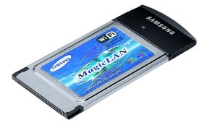
Computer Networking
Each meeting room will be equipped with wireless access (Wireless LAN, supporting IEEE802.11b, 2.4GHz band) to the Internet. Those who wish to use the wireless access must be equipped with the necessary hardware and correctly configured PC.

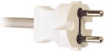
Electricity & Voltage

Jeju Lotte Hotel is equipped with V220 electricity outlets only (the shape of plug is the same as in France), but a transformer for V110 is also available upon request.
Airport
The closest airport is the Jeju International Airport

Transportation
(From Jeju International Airport to Jeju Lotte Hotel)
* Only Korean currency (Won) can be used for all transportation.

1. Limousine Bus
For visitor’s convenience, Samyoung Limousine bus is in service between the Jeju Lotte Hotel and the Jeju Airport
- Operation Hour: Everyday 06:20 – 22:00 (15minutes interval – A 50minutes ride from the Airport)
- Charge: 3,900 Korean Won (approximately 3.9 USD)

2. Taxi
It costs approximately 35,000 Korean Won (approximately 35 USD) from Jeju Airport to Jeju Lotte Hotel.

3. Rental car Information
Kumho Rent a car
Tel: +82-64-738-8101

We recommend that you take public transportation.

Map of Jeju island
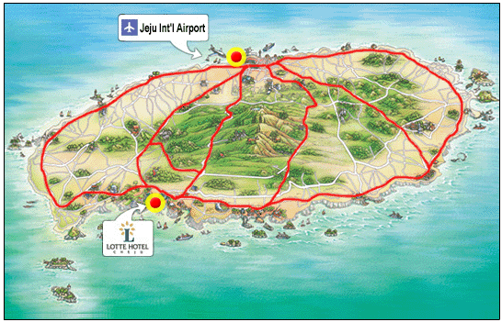

Hotel Information
1. Jeju Lotte Hotel
Address: 2812-4, Saekdal-dong, Seogwipo City, Jeju -do, South Korea 697-130
Phone: (82)(2)759-7051~4 (Seoul Office) Fax: (82)(2)779-1353(Seoul Office)
Home Page: http://www.hotellotte.co.kr
Category: 5 Star
There are 500 rooms equipped with cable TV, internet access, air conditioner, hairdryer, bath, telephone, voice mail, radio, alarm clock, in-house movie, writing desk and mini bar. The Hotel offers coffee/tea facilities and parking.
2. Hana Hotel
Address: 2812-2 sackkdaldong(Chung Mun Tourist Area), Seokkwipo, Cheju
Phone: +82-64-738-7001~2 FAX : +82-64-738-7000
Home Page: http://www.hotelhana.co.kr/
Category: 4 Star
There are 86 guest rooms equipped with color TV, air conditioner, telephone, radio, alarm clock, and mini bar, writing desk. The Hotel offers coffee/tea facilities and parking. The distance to Jeju Lotte Hotel is about 2 minutes on foot.

3. Hankook(Korea) Condominium
Home Page: http://www.koreacondo.co.kr
Home Page: http://www.koreacondo.co.kr/branch/branch_jeju_s.asp
Category: 4 Star
There are 216 apartments equipped with color TV, air conditioner, telephone, radio, alarm clock, and mini bar, writing desk. Each apartment accommodates up to 5 people with cooking facility. The distance to Jeju Lotte Hotel is about 2 minutes on foot.

Hotel Reservation and Cancellation
Reservation requests should be received no later than 4 March 2005. You are kindly requested to make use of the indicated hotel and the attractive rate offered. No other hotel room blocks have been reserved. Should you wish to seek other accommodation, please see: http://dir.yahoo.com/Regional/Countries/Korea__South/Provinces/Jeju_do/Travel_and_Transportation/Lodging/.
Hotel rooms must be guaranteed against a credit card and the reservation must be cancelled 3 days prior to arrival day to avoid a “no-show” charge.

Map of nearby Hotels
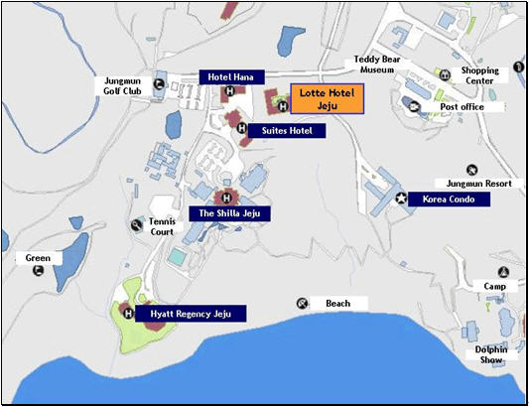
Passports and Visas
Most visitors with confirmed outbound tickets may stay up to fifteen days without visas. However, this does not apply to certain nationalities. Please check with your travel agent, Korean embassy or Korean consulate in your country in advance of your trip. Participants who need an invitation letter and/or visa-supporting letter for entering into Korea are strongly advised to contact the following person:
Mr. Youngjae Kim, TTA
Tel: +82 31 724 0195
Fax: +82 31 724 0119
Email: fgngn@tta.or.kr
The 18 Countries that need VISA: Cuba, Macedonia, Palestine, China, Mongolia, Philippine, Vietnam, Nepal, Sri Lanca, and India. Chinese nationals with more than five people to a group with a sightseeing purpose do not require visa. For further information, contact your local Korean Embassy or visit the website at http://www.mofat.go.kr/en/visa/e_visa.mof
About the Place
Jeju island is located at the southwest of Korean peninsula. The island is somewhat warmer than Seoul and has excellent beach resorts. It is favored with nature, clean water, fresh air and blessed climate. Jeju island’s total area is 1,845㎢. It is the smallest Province of Korea. The land is flat and oval-shaped but with Mt. Halla at center of the Island, contour lines draw concentric circles, letting the cultivated lands spread on the seacoast. Hilly areas of 200-300m above the sea level are gently sloped but most of them are idle land or meadows.
Jeju Island is a place favored by many honeymooners because of it’s weather, resorts, and beautiful surroundings. Also, Jeju Island has all the ingredients for an attractive convention or incentive tour site. For detailed information about Jeju, please find at http://www.jeju.go.kr
Climate & Clothing
The climate of Jeju during meeting may be a little bit cool. The temperature is around 13 degrees Celsius during March. For more detailed climate information, please contact the Korea Meteorological Administration (http://www.kma.go.kr/ema/eindex.htm )
Currency
Korea’s currency is called the won. Coins come in denominations of W 10, W 50, W 100, and W 500 and notes come in denominations of W 1,000, W 5,000, and W 10,000. The exchange rate fluctuates daily, dependent on international foreign exchange rates. Foreign currencies and traveler’s cheques can be exchanged at banks, airports, international ferry terminals and hotels.
* Current exchange rate: W1,039 / 1 USD ( as of 14 Jan 2005)
Credit Cards
Credit cards (Visa, American Express, Diners Club, Master Card and etc.) are accepted in almost all places such as major hotels, and major restaurants.
Korea & Korean Tourism
Please visit the following Websites for more information on Korea and possible tours:
http://www.kois.go.kr and http://www.visitkorea.or.kr/
Local time
GMT + 9 hours.
ANNEX 3
(to TSB Circular 19)

HOTEL RESERVATION FORM
To be sent to:
Fax: +82 2 779 1353
E-mail: jwparka@hotellotte.co.kr
This form should be send not later than 4 March 2005.
- I will participate in the NGN Workshop (14-15 March 2005)
- I will participate in the ITU-T Focus Group NGN Meeting (16-22 March 2005)

Family Name: …………………………..……… First Name: ………………………………………
Organization: ……………………………..…… Country: ………………………………………….
Telephone: ………………………………...…… Fax: ………………………………………………
E-mail: …………………………………….……
Check in date: ………………………………… Check out date: …………………………………
Room Nights: ………… Days Number of people: ………… Person

Hotel | Room |  | Fare
Hotel |  |  | Fare for mountain view | Fare for ocean view
Jeju Lotte Hotel | W/O breakfast  (for 1 or 2 person) | Single bed ( )  Double bed ( )  Twin bed ( ) | ( ) US $135 | ( ) US $195
Jeju Lotte Hotel | With breakfast  (for 1 person) | Single bed ( )  Double bed ( )  Twin bed ( ) | ( ) US $155 | ( ) US $215
Jeju Lotte Hotel | With breakfast  (for 2 person) | Double bed ( )  Twin bed ( ) | ( ) US $178 | ( ) US $238
Hana Hotel | With breakfast | Single bed | ( ) US $70 | -
Hana Hotel | With breakfast | Double/Twin bed | ( ) US $80 | -
Hankook Condominium | 1 to 5 person in one apartment  (two rooms and one bed in each apartment) |  | ( ) US $66 | -
* Please choose only one type of room and fare
* All tax included
Please circle one credit card from the following:
VISA, MASTER CARD, AMERICAN EXPRESS, DINERS CLUB
Credit Card No: ………………………………..…… Expire date: …………………………………
Name of the card holder: ………………………………………………………………………………
Signature: …………………………………………………………………………………

ANNEX 4
(to TSB Circular 19)

ITU-TSB | NGN Technical Workshop  Jeju Island, Korea (Republic of), 14-15 March 2005
REGISTRATION FORM
To be returned to TSB (Fax: +41 22 730 5853 / tsbreg@itu.int) by 6 March 2005

Mr. Mrs. Ms. Miss |  |  |  | Administration of ITU Member State
____________________________________________  Family Name |  |  |  | ITU Sector Member
 |  |  |  | ITU Associate
____________________________________________  First Name |  |  |  | ITU Associate
 |  |  |  | Non-Member
Name and complete address of Administration or Organization:
______________________________________________ |  |  | Tel: _____________________________________________
______________________________________________
______________________________________________ |  |  | Fax :_____________________________________________
_________________________________________ |  |  | E-mail : _________________________________________
NOTE:
REGISTRATION FOR THE 5TH FGNGN MEETING (16 - 22 March 2005) IS TO BE DONE SEPARATELY VIA THE ONLINE FORM AVAILABLE AT: http://www.itu.int/itu-t/ngn/fgngn

Hotel :
________________________________________________ |  |  | Tel. : _______________________________________
Date: ___________________________ | Signature: ______________________________________

