Женева, 17 февраля 2006 года
Международный союз электросвязи  Бюро стандартизации  электросвязи | 
Осн.: | Циркуляр 72 БСЭ  NGN-GSI/TK | – Администрациям Государств – Членов Союза
Тел.:  Факс: | +41 22 730 5126  +41 22 730 5853 | – Администрациям Государств – Членов Союза
Эл. почта: | tsbngngsi@itu.int | Копии:  - Членам Сектора МСЭ-Т  - Ассоциированным членам МСЭ-Т  - Председателям и заместителям председателей исследовательских комиссий МСЭ-Т  - Директору Бюро развития электросвязи  - Директору Бюро радиосвязи

Предмет: | Мероприятие ГИС-СПП и собрания групп Докладчиков по транспортным сетям  22−27 апреля 2006 года, Кобе, Япония

Уважаемая госпожа,
Уважаемый господин,
1 Имею честь сообщить вам, что в дополнение к предварительному собранию в рамках
ГИС-СПП (Глобальной инициативы по стандартизации сетей последующих поколений), объявленному в Циркуляре 47 БСЭ, и согласно решениям, принятым на собраниях ИК11, ИК13 и ИК19, состоявшихся в январе 2006 года, и в соответствии со стратегией усиления работы в области СПП в МСЭ-Т путем проведения собраний групп Докладчиков, максимально приближенных по времени и месту, следующее мероприятие в рамках ГИС-СПП и собрания групп Докладчиков по транспортным сетям по любезному приглашению компании "The ITU Association of Japan, Inc." состоятся в Международном центре конференций Кобе (ICCK) в Кобе (Япония) с 22 по 27 апреля 2006 года включительно.
Это мероприятие увязано с семинаром-практикумом МСЭ-Т "СПП и их транспортные сети", который состоится в том же самом месте. Вся информация, относящаяся к этому семинару-практикуму, содержится в Циркуляре 60 БСЭ.
2 Открытие совместных собраний Докладчиков, включающих мероприятие в рамках ГИС-СПП и собрания групп Докладчиков по транспортным сетям, состоится в первый день его работы в 09 час. 00 мин. Подробная информация, касающаяся залов заседаний, будет размещена на Web-сайте ГИС-СПП и на экранах в ICCK.
3 Выступления и обсуждение будут проходить на английском языке.
4 Приглашения с предлагаемой повесткой дня будут направлены Докладчиками обычным способом.
5 Проект повестки дня этого мероприятия вместе с некоторыми логистическими договоренностями для этой серии собраний, достигнутыми заинтересованными Докладчиками и председателями, приведены в Приложении 1 к настоящему документу.
6 С обновленной информацией, касающейся данного мероприятия, можно будет ознакомиться на Web-сайте ГИС-СПП МСЭ-Т по следующему адресу: http://www.itu.int/ITU-T/ngn/index.phtml.
В Приложении 2 дана практическая информация об организации собрания, предоставленная принимающей организацией.
7 Для вашего удобства в Приложении 3 содержится форма для бронирования гостиницы.
8 С тем чтобы принимающая организация и БСЭ могли предпринять необходимые действия в отношении проведения этого мероприятия, мы были бы признательны вам за предварительную регистрацию путем направления в БСЭ до 11 апреля должным образом заполненной регистрационной формы (по одной на каждого участника), которая содержится в Приложении 4. Онлайновая регистрационная форма будет также размещена на Web-сайте ГИС-СПП.
9 Напоминаем, что для въезда в Японию и пребывания там гражданам определенных стран необходима виза. Визу следует запрашивать и получать в учреждении (посольстве или консульстве), представляющем Японию в вашей стране, или, если в вашей стране такое учреждение отсутствует, − в ближайшем к стране выезда.
Участникам, которым необходимо получить пригласительное письмо и/или письмо с визовой поддержкой для въезда в Японию, рекомендуется обратиться к представителям семинара-практикума в Японии, подробная информация о которых приводится ниже:
Ms Hideyo Banishky или Mr Akihito Yamamoto

Technical Department

The ITU Association of Japan, Inc.

3rd floor Kanda KS Building,

1-8-6 Kaji-cho, Chiyoda-ku, Tokyo 101-0032, Japan

Тел.: +81 3 5207 5722

Факс: +81 3 5207 5731

Эл. почта: hideyo@ituaj.jp
С уважением,
Х. Чжао
Директор Бюро
стандартизации электросвязи
Приложения: 5

ANNEX 1
(to TSB Circular 72)
ITU-T NGN-GSI and Rapporteur’s Groups on Transport Networks Time Allocation

Sat |  | 22 Apr |  | Sun |  | 23 Apr |  | Mon |  | 24 Apr |  | Tues |  | 25 Apr |  | Wed |  | 26 Apr |  | Thu |  | 27 Apr
AM |  | PM |  | AM |  | PM |  | AM |  | PM |  | AM |  | PM |  | AM |  | PM |  | AM |  | PM
1) | 1) | Q3/13 | Q3/13 |  |  |  |  | 2) | 2) | Q3/13 | Q3/13 | Q3/13 | Q3/13 | Q3/13 | Q3/13 | Q3/13 | Q3/13 | Q3/13 | Q3/13 | Q3/13 | Q3/13 | Q3/13 | TSR
Q15  /13 | Q15  /13 | Q15  /13 | Q15  /13 |  |  |  |  | Q9/13 | Q9/13 | Q15  /13 | Q15  /13 | Q9/13 | Q9/13 | Q15  /13 | Q15  /13 | Q15  /13 | Q15  /13 | Q9/13 | Q9/13 | Q9/13 | Q9/13 | Q15  /13 | TSR
Q7/13 | Q7/13 | Q7/13 | Q7/13 |  |  |  |  | Q1/13 | Q1/13 | Q7/13 | Q7/13 | Q7/13 | Q7/13 | Q7/13 | Q7/13 | Q1/13 | Q1/13 | Q7/13 | Q7/13 | Q7/13 | Q7/13 | Q7/13 | TSR
Q8/13 | Q8/13 | Q2/13 | Q2/13 |  |  |  |  | 3) | 3) | Q2/13 | Q2/13 | Q2/13 | Q2/13 | Q2/13 | Q2/13 | Q8/13 | Q8/13 | Q2/13 | Q2/13 | Q2/13 | Q2/13 | Q2/13 | TSR
Q1/13 | Q1/13 | Q1/13 | Q1/13 |  |  |  |  | FMC | FMC | MM | MM | FMC | FMC | MM | MM | FMC | FMC | MM | MM | 5) | FMC&MM | FMC&MM | TSR
Q4/13 | Q4/13 | Q4/13 | Q4/13 |  |  |  |  | Q4/13 | Q4/13 | 4) | 4) | Q4/13 | Q4/13 | Q4/13 | Q4/13 | Q4/13 | Q4/13 | Q4/13 | Q4/13 | Q4/13 | Q4/13 | Q4/13 | TSR
 |  |  |  |  |  |  |  | Q1+2/11 | Q1+2/11 | Q1+2/11 | Q1+2/11 | Q5/11 | Q5/11 | Q5/11 | Q5/11 | Q5/11 | Q5/11 | Q7+2/11 | Q7/11 | Q7/11 | Q7/11 | Q7/11 | TSR
 |  |  |  |  |  |  |  |  |  | Q3/11 | Q7/11 | Q3/11 | Q3/11 | Q3/11 | Q3/11 | Q3/11 | Q3/11 | Q3/11 | Q3/11 | Q3/11 | Q3/11 | Q3/11 | TSR
Ether | Ether | Ether | Ether |  |  |  |  | Ether | Ether | Ether | Ether | Ether | Ether | Ether | Ether | Ether | Ether | Ether | Ether | Ether | Ether | Ether | Ether
ASON | ASON | ASON | ASON |  |  |  |  | ASON | ASON | ASON | ASON | ASON | ASON | ASON | ASON | ASON | ASON | ASON | ASON | ASON | ASON | ASON | ASON
Legend
TSR: NGN-GSI Technical and Strategy Review Activity | Note 4 : Joint Q4/13 + Q5/11
FMC: Joint Q6/13+Q5/19 | Note 5 : Joint MM, FMC and Q9/13 on Mobile IPv6
MM: Joint Q6/13+Q2/19 | Ether: Ethernet and MPLS - Qs 9/15, 12/15 and Q.5/13
Note 1: Require(Q2/13)+Architecture(Q3/13) + IPv6(Q9/13) + FMC | ASON: Transport Management and ASON - Qs 14/15, 9/15 (joint with
Note 2 : Joint Q3/13 + Q7/13 | Q9/15 as needed for Element Management topics) and 12/15 (joint with
Note 3 : Joint Q2/13 + Q8/13 | Q12/15 as needed for ASON topics)
Experts from SGs 12 and 16 are planning to join the groups of their interest

Some arrangements for the NGN GSI meeting

- The meetings will be run paperless. No paper copies will be distributed. Contributions will be available on SGs IFAs as usual for Rapporteur’s meetings.
- To support the paperless meeting a new web page for the Kobe meetings will be linked at the NGN GSI web (http://www.itu.int/ITU-T/ngn/index.phtml). Besides all the information about the coming NGN GSI event in Kobe, it will list all the contributions received for this meeting. Contributions will be numbered according to the following scheme: Kobe-Q.xx/yy-zzz, where xx stands for number of Question, yy stands for SG 11, 13 or 19 number and zzz is sequential document number for the particular Question. Document number in the list will be linked to the whole document text (located at corresponding SG IFA under the filename Kobe-Qxx-yy-zzz).
- Contributions to the meeting should be sent to the Rapporteur according to normal procedure AND Cc-ed to Tatiana Kurakova (tatiana.kurakova@itu.int).
- Deadline for submission of contributions is set to be received by 14 April, midnight, Geneva time
- Meeting logistics will be coordinated by Tatiana Kurakova who will provide the interface to the hosting organization.
Mrs Kurakova’s contact details are as follows:
Tatiana Kurakova
TSB/ITU
Place des Nations
CH-1211 Geneva 20
Switzerland
Tel: +41 22 730 5126
Fax: +41 22 730 5853
Emails: tsbngngsi@itu.int
tatiana.kurakova@itu.int

- Any requests for information on meeting should be sent to Tatiana Kurakova, TSB coordinator for NGN GSI. She will then consult the Rapporteurs concerned.

ANNEX 2
(to TSB Circular 72)

Practical Information
- Venue
The International Conference Center Kobe Tel: +81 78 302 5200
6-9-1 Minatojima-nakamachi, Chuo-ku, Fax:+81 78 302 6485
Kobe 650-0046, Japan
For detailed information about International Conference Center Kobe (ICCK), please see:
http://www.kcva.or.jp/kcc/icck/e-index.html
- Access to the ICCK
Please see Attachment 1 to Annex 2 for details. Some changes in the operation of public transportation in Kobe are expected when a new domestic airport opens in Kobe in February 2006. Access information will be updated when new information is available.
3. Hotels
3.1 Hotel list
A total of about 300 rooms in 6 hotels around the ICCK have been blocked for the participants at preferential rates for participants. The preferential rates will start on 1 December 2005 and be cut off on 31 March 2006. These hotels are listed in Attachment 2 to Annex 2 and a map indicating their location is also attached.
3.2 Hotel reservations
Participants wishing to make reservations should contact the hotel directly by using the reservation form in Attachment 3 to Annex 2.
4. General information on Japan and Kobe
4.1 Electrical appliances
Japan operates on 100 volts for electrical appliances. The frequency is 60 Hz in western Japan including Kobe and Osaka (50 Hz in eastern Japan including Tokyo). The type of power outlet/connector used in Japan is A type which is two parallel pronged type.
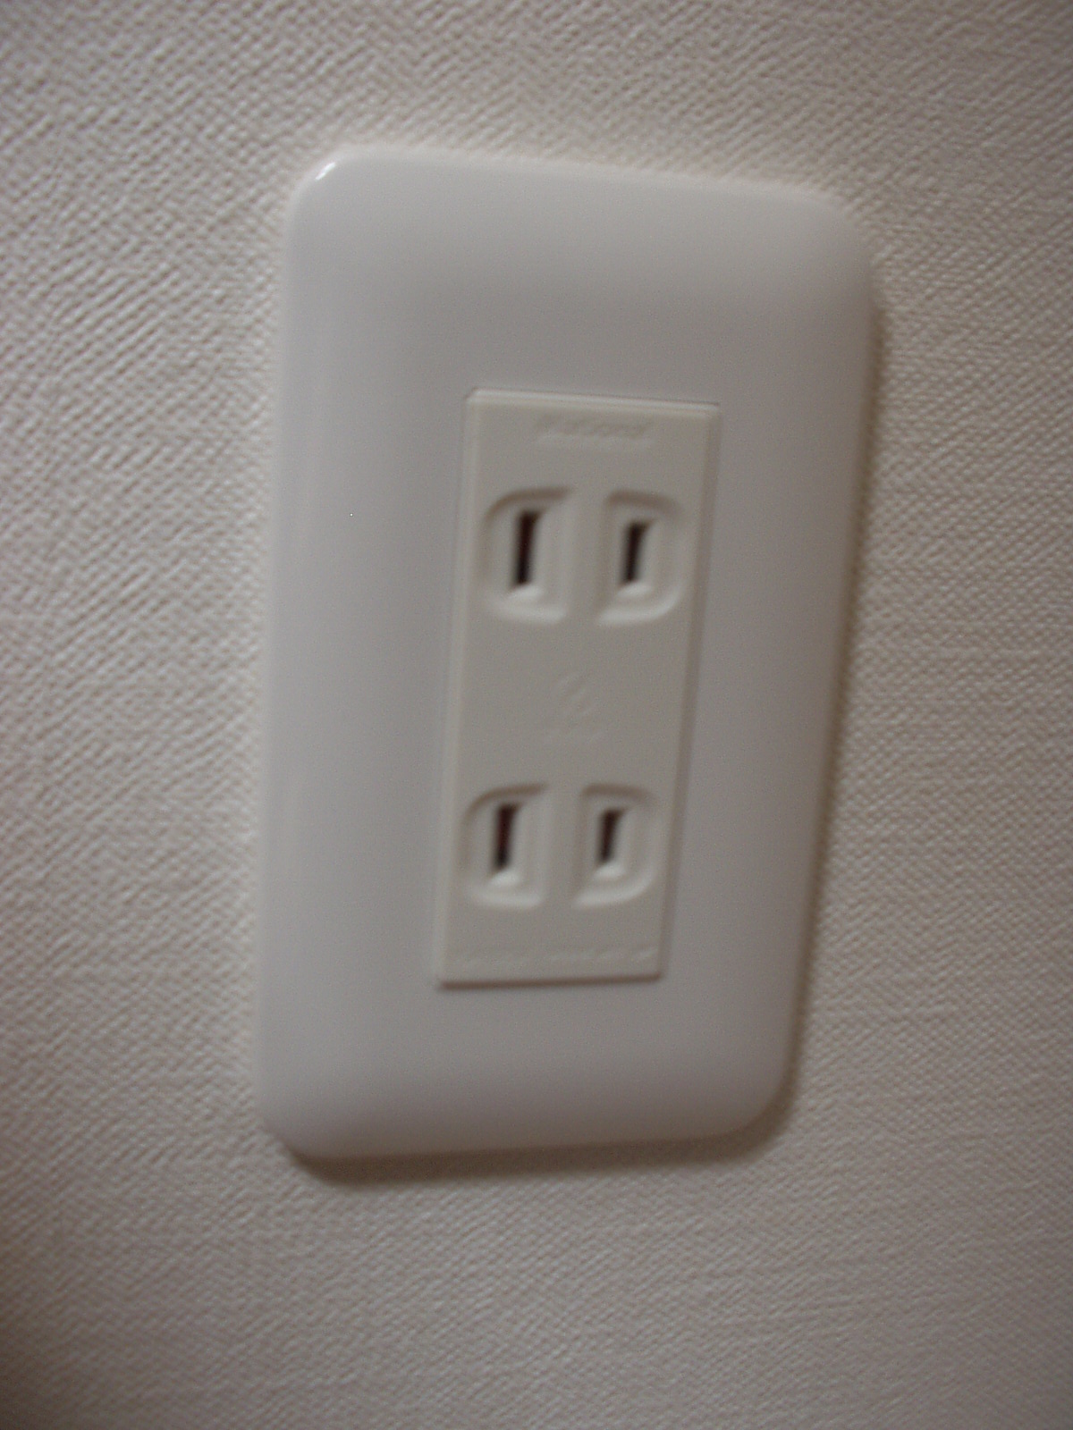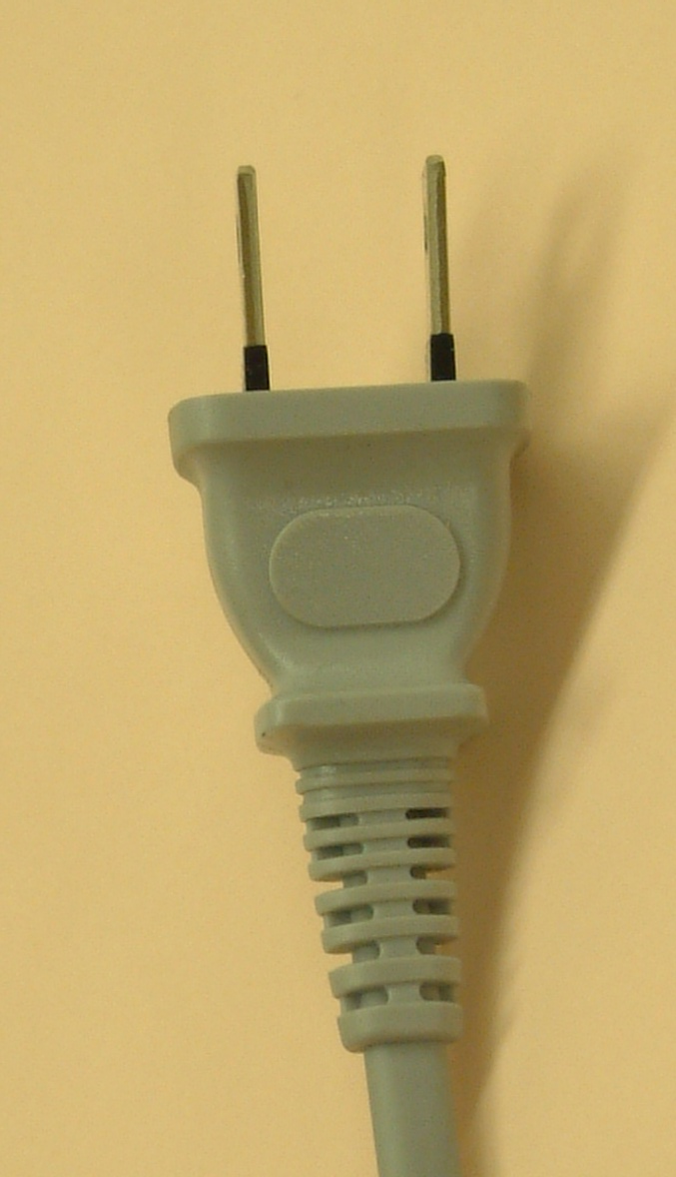
If your appliances operate on a different voltage, please bring your own transformers.
  - Passports and Visas
All foreign visitors entering Japan must have a valid passport. Participants who require a visa should, well in advance, apply for a visa to a Japanese consulate or diplomatic mission in their respective country prior to departure. Participants are also advised to contact their local travel agents or carriers. For more information please visit the web site of the Ministry of Foreign affairs of Japan at: http://www.mofa.go.jp/j_info/visit/visa/index.html.
Participants who need an invitation letter and/or a visa supporting letter for entering Japan are advised to get in touch with the contact person in Japan as indicated in item 7 below.
  - Currency exchange
Only Japanese Yen is accepted at stores and restaurants. Major foreign currencies may be exchanged to Yen at foreign exchange banks and other authorized money exchangers on presentation of your passport. A few local banks’ branches where currency may be exchanged are available around Sannomiya Station.
  - Exchange rates
Online spot exchange rates are shown at: http://www.btm.co.jp/gdocs/kinri/list_j/kinri/kawase.htm. Exchange rate as of 1 December 2005.
US Dollar 1 | 116.77
Euro 1 Euro | 133.68

  - Tipping

Tipping is not necessary.
  - Climate
The climate of Kobe in spring is comparatively dry with clear blue skies. Average temperature during the season is;
March | April | May
8.9 C (48.02 F) | 14.7 C (58.46 F) | 19.2 C (66.56 F)

  - City of Kobe
Kobe is a port city with a history of 1,300 years and is now one of the biggest international port cities in Japan, which attracts many people from both home and abroad. The blessing in Kobe is its beautiful mountains and seaside. In downtown, you will see a unique combination of modern and classic, Japanese and exotic cultures. Kobe is the leading city of top mode, fashion and trend. Kobe is also known for its excellent cuisine, especially the Kobe Beef, confectionery, and people’s hospitality. For more information, please visit the following Web site: http://feel-kobe.jp/english/index.html .
5. Using laptop PC at the meetings7
This meeting will be paper-less. Therefore participants are strongly recommended to bring their laptops. Wireless LAN will be provided in all meeting rooms. Please bring with you your card.
6. Excursion
NGN Japan Host Committee is kindly inviting the participants of the Workshop and NGN GSI event and Rapporteurs groups on transport networks to a free week-end excursion around the Kobe area.
- Himeji castle one day tour, 23.04, 8:30 – 13:30 (http://whc.unesco.org/en/list/661)
Kobe Portopia Hotel → Himeji Castle and Ko-ko En Garden (Japanese Garden) → Lunch →
Maiko (view of Awaji Great Suspension bridge) → Kobe Portopia Hotel
- Arima Hot Spring one day tour, 23.04, 8:30 – 15:00
(http://www.kcva.or.jp/e-convention/index.html)
Kobe Portopia Hotel → Arima hot spring (bath and lunch) → Rokko Garden Terace →
→ Kobe Portopia Hotel
*Note: Tour No. 2 has a seating capacity of 40. Tour will be cancelled in case of insufficient applications.
If you wish to join the excursion, please refer to Annex 5, fill in the registration form for excursion and send it to JTB (Japan Travel Bureau), whose contact details appear at the bottom of the registration form.
Please note that, registration to the excursion is necessary in addition to the registration to the Workshop/Rapporteurs meetings.
7. Contact persons
If you have any questions, please contact:
Ms. Hideyo Banishky or Mr. Akihito Yamamoto
Technical Department, ITU Association of Japan, Inc.
3rd floor Kanda KS Building, 1-8-6 Kaji-cho, Chiyoda-ku, Tokyo 101-0032, Japan
Tel: +81 3 5207 5722 Fax: +81 3 5207 5731
e-mail: hideyo@ituaj.jp
8. Support
This workshop and Rapporteur meetings are kindly supported by the Ministry of Internal Affairs and Communications of Japan, and sponsored by; Nippon Telegraph and Telephone Corporation, FUJITSU LIMITED, Hitachi, Ltd., KDDI Corporation, MITSUBISHI ELECTRIC CORPORATION, NEC Corporation, Oki Electric Industry Co., Ltd., Motorola Japan Ltd., SOFTBANK Group, Softfront, Matsushita Electric Industrial Co., Ltd. (Panasonic), ACCA Networks Co., Ltd., COMMUNICATION LINE PRODUCTS ASSOCIATION OF JAPAN, eAccess Ltd., Ericsson AB, Fuji Xerox Co., Ltd., Japan Cable Television Engineering Association, Japan Cable & Telecommunications Association, NTT Comware Corporation, Support Center for Advanced Telecommunications Technology Research Foundation, The ITU Association of Japan, Inc., The Telecommunication Technology Committee, TOSHIBA CORPORATION and Vodafone.

ATTACHMENT 1 TO ANNEX 2
(to TSB Circular 72)

ACCESS to International Conference Center Kobe

By domestic flight
Fare: \19,100
Travel time: 70 min.
Departure: 3 flights a day
NARITA INT. AIRPORT
KANSAI INT. AIRPORT
By JR limited express train, NARITA EXPRESS
Fare: \2,940
Travel time: 96 min.
Departure time: 7:42 – 21:43
(30 min intervals)

By limousine bus
Fare: \1,800
Travel time: 65 – 75 min.
Departure time: 6:30 – 23:20
(20 min. intervals)

KOBE AIRPORT
((Domestic flight only)
To be opened in Feb 2006
TOKYO STATION
OSAKA INT. AIRPORT

(ITAMI)

By JR bullet train, HIKARI
Fare: \14,270
Travel time: 195min
Departure time: 6:36 – 20:30
(60 min. intervals)

By limousine bus
Fare: \1,020
Travel time: 40 min
Departure time:
From North Terminal:7:50 – 21:15
From South Terminal:7:45 – 21:10
(20 min. intervals)
By JR bullet train, NOZOMI
Fare: \14,670
Travel time: 173 min
Departure time: 6:00 – 20:30
(30 min. intervals)

SHINKOBE STATION

By Subway
Fare: \200
Travel time: 5 min
Departure time:5:26–0:00
(7 min intervals)

SANNOMIYA STATION

By Port Liner
(Shimin Hiroba Sta.)
Fare: \240
Further information will
be provided later
By Port Liner
(Shimin Hiroba Sta.)
Fare: \240
Further information will be provided later

INTERNATIONAL CONFERENCE CENTER KOBE (ICCK)
Attachment 2 to ANNEX 2 HOTEL LIST (20-27 April 2006, Kobe)
No | Hotel Name | Single Room  with Bath |  | Twin Room with Bath |  |  | ACCESS to ICCK | Address  Phone / Fax / e-mail / home page
No | Hotel Name | Rate*1 | Size  (m²⁾) | Single Use Rate*1 | Twin Use Rate*1 | Size  (m²⁾) | ACCESS to ICCK | Address  Phone / Fax / e-mail / home page
1 | Portopia Hotel | ￥11,550  (￥9,550) ^{*2} | 22.4 | ￥17,850  (￥15,850) | ￥21,000  (￥17,000) | 27.4 | ･3 min walk to ICCK  ･Every 20 min, free shuttle bus runs from Shinkobe Station and Sannomiya Sation to portopia hotel. | 10-1,6 Chome, Minatojima Nakamachi, Chuo-ku, Kobe  TEL: +81-78-302-1111 FAX: +81-78-302-6877  reservation@portopia.co.jp  (www.portopia.co.jp/en/index.html）
2 | Quality Hotel Kobe (no rooms on 4/26, 27) | ￥7,500  (￥6,500) | 20 | ￥8,500  (￥7,500) | ￥13,000  (￥11,000) | 28 | ･3 min walk to ICCK | 1,6 Chome, Minatojima Nakamachi, Chuo-ku, Kobe  TEL: +81-78-303 5555 FAX:+81-78-303-5560  info@choice-hotels.jp (www.choicehotels.com/ires/en-EN/hotel/JP044)
3 | Hotel Pearl City Kobe | ￥9,975  (￥8,925) | 19 | ￥12,600  (￥11,550) | ￥16,800  (￥14,700) | 20 | ･5 min walk to ICCK | 5-1, 7 Chome, Minatojima Nakamachi, Chuo-ku, Kobe  TEL: +81-78-303 0100 FAX:+81-78-303-0211  kobe@pearlcity.co.jp  (www.pearlcity.co.jp/kobe/English/jindex.hml)
4 | Kobe Tokyu Inn | ￥9,000  (￥8,000) | 15 | ￥12,000  (￥11,000) | ￥16,000  (￥14,000) | 18.4 | ･3 min walk to Sannomiya Sta and 10 min ride (Portliner) to ICCK | 6-1-5, Kumoidori, Chuo-ku, Kobe  TEL: +81-78-291 0109 FAX:+81-78-221-2917  kobe109@gold.ocn.ne.jp  (www.tokyuhotels.co.jp/en/TI/TI_KOBE/index.html)
5 | Sannomiya Terminal Hotel | ￥8,946  (￥8,316) | 15 | ￥14,212  (￥13,582) | ￥21,702  (￥16,354) | 23 | ･10min ride(Portliner) to ICCK | 1-2, 8-chome kumoidori, Chuo-ku,Kobe  TEL: +81-78-291-0001 FAX:+81-78-291-0020  info@sth-hotel.co.jp  (www.sth-hotel.co.jp/e-index.html)
6 | ShinKobe  Oriental Hotel | ￥11,550  (￥10,500) | 15 | ￥15,750  (￥14,700) | ￥18,900  (￥16,800) | 22 | ･1min walk to Shin-Kobe Bullet train Station  ･20min ride (Subway & Portliner) to ICCK | 1-chomekitano-cho,chuo-ku,Kobe  TEL: +81-78-291-1188 FAX:+81-78-291-1154  yoyaku@orientalhotel.co.jp  (www.orientalhotel.co.jp/e/index.htm)
Notes: *1: Room rates are the preferential ones for the NGN-WS & NGN-GSI meetings in Kobe. Room rates include 10% service charge, 5% tax and breakfast. *2: Room rate in parentheses is without breakfast. **An early reservation is desirable to book a convenient room. ***Positions of each hotel are indicated on attached Hotel MAP.JPG.
Map of Hotels in Kobe
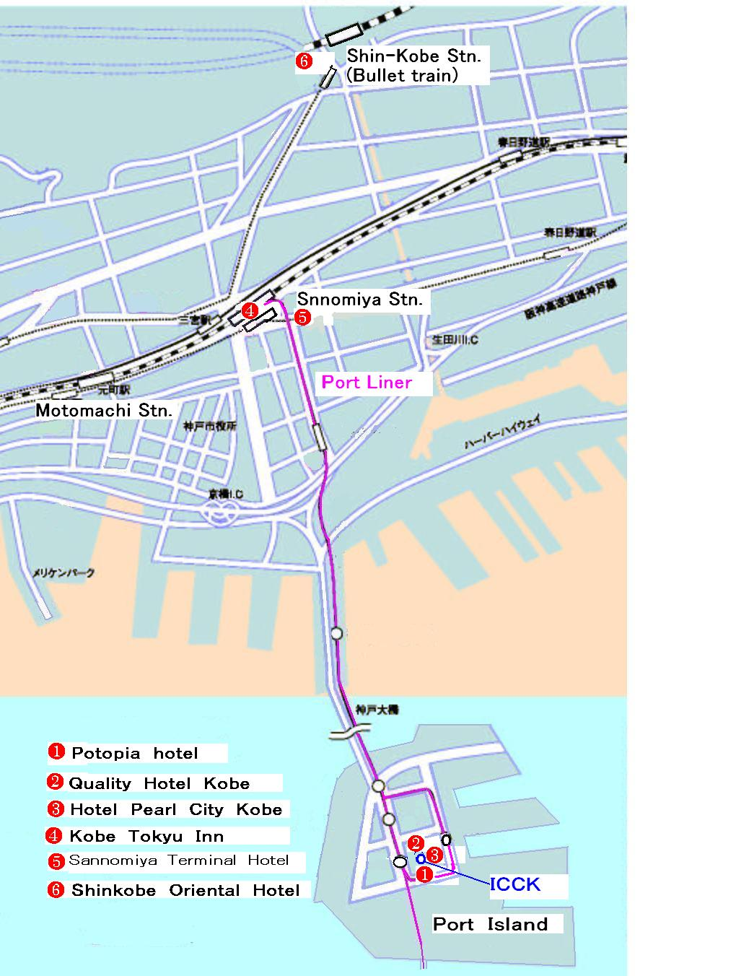

ANNEX 3
(to TSB Circular 72)
HOTEL RESERVATION FORM
for NGN-GSI and Rapporteur’s groups on Transport Networks
(Kobe, 20 – 27 April, 2006)
Please complete and return this form to one of the hotels below as your preference:
Portopia Hotel: reservation@portopia.co.jp Quality Hotel Kobe: info@choice-hotels.jp
Hotel Pearl City Kobe: kobe@pearlcity.co.jp Kobe Tokyu Inn: kobe109@gold.ocn.ne.jp
Sannomiya Terminal Hotel: info@sth-hotel.co.jp ShinKobe Oriental Hotel: yoyaku@orientalhotel.co.jp
Refer to the attachment2, each home page or hotel for details

(Please type or print in block letters and check appropriate items.)
NAME: □ Mr. □ Ms.
Last name First name

ORGANIZATION:

ADDRESS: □ Office □ Home _________________

Postal code_ Country
Phone: Fax:

Name of Accompanying Person(s), if any:
□ Mr □ Ms. Last name First name
Flight Schedule: Arriving at (airport) on (date) by (flight number)

HOTEL ACCOMMODATION
Hotel Name | Room Type | Period of stay
 | Single: | Check In:
 | Twin (single use): | Check Out:
 | Twin (twin use): | Nights:

REMITTANCE
- Cash
- □ Credit card: □ VISA □ MasterCard □ Diners Club □ AMEX □ Other ( )
Card number:
Name of card holder: Expiration date: / /
Authorized signature:

ANNEX 4
(to TSB Circular 72)

Registration Form
ITU-T NGN-GSI event (Joint Rapporteur’s Meetings) and Rapporteur’s groups on Transport networks
22–27 April 2006, Kobe, Japan

Please fill in this form and send it by 11 April 2006 to:  (beyond this date you will be registered on site) | E-Mail: tsbreg@itu.int  Fax: + 41 22 730 5853

Title: | Ms. Mr
Last Name:
First Name:
Company:
Mailing address:
Country:
Telephone:
Fax:
Email Address:
I participate in  NGN GSI:  Rapporteur’s group(s)  Rapporteur’s groups on Transport Networks:  - Ethernet and MPLS  - Transport Management and ASON | Q.1/13 Q.2/13 Q.3/13 Q.4/13 Q.6/13 Q.7/13 Q.8/13 Q.9/13 Q.15/13  Q.1/11 Q.2/11 Q.3/11 Q.5/11 Q.7/11 Q.2/19 Q.5/19  Q.5/13, Q.9/15 and Q.12/15  Q.14/15
Hotel of your stay
(optional)
I join excursion on  Sunday, 23 April  (deadline for registration - 15 April) | Himeji castle tour Arima Onsen Hot Spring tour  (please refer to clause 6 of Annex 2, page 7 for more information on this social event)

ANNEX 5
(to TSB Circular 72)
FAX：+81-6-6263-0717

Excursion Registration Form
ITU-T NGN-GSI event and Rapporteur’s groups on Transport networks

Please check one of boxes:
Application

□ I apply to ① Himeji Tour on 23rd April for ( ) person(s).
□ I apply to ② Arima Onsen hot spring tour on 23rd April for ( ) person(s).

Name: | Company's name
Confirmation sheet will be sent to: ☐ Office ☐ Home
Address:

Postal code: Country:

Phone # Fax # E-mail address:

Accompanying Person’s Name:

Name of Hotel (you stay in Japan)

Check-in date Check-out date

JTB Corp. Event & Convention Sales Dept. Western Japan Regional Headquarters
“ITU-T Workshop on NGN and its Transport Networks”

JTB Bldg. (7F), 2-1-25, Kyutaro-Machi, Chuo-ku, Osaka, 541-0056 Japan
Phone: +81-6-6260-5060 Fax: +81-6-6263-0717
Email: westec_op6@jtb.jp Office hours: 9:30 - 17:30, Mon - Fri.

_________________

