Geneva, 2 November 2007
INTERNATIONAL TELECOMMUNICATION UNION
Telecommunication
Standardization Bureau

Ref: | TSB Circular 175 | - To Administrations of Member States of the Union;  - To ITU-T Sector Members;  - To ITU-T Associates
Tel:  Fax:  E-mail: | +41 22 730 5851  +41 22 730 5853  standards@itu.int | Copy:  - To the Chairmen and Vice-Chairmen of  ITU- T Study Groups;  - To the Director of the Telecommunication Development Bureau;  - To the Director of the Radiocommunication Bureau  - To ISO Secretary General;  - To IEC General Secretary

Subject: | Questionnaire on Standards Management Training Programme
Dear Sir/Madam,
The World Standards Cooperation (WSC) consisting of ITU, ISO and IEC, in its commitment to promote and harmonize international standards, organized two courses for managers within their membership organizations in October 2004 and April 2005. Given their success, the WSC plans to organize a further course in 2008.
ITU members are invited to complete the questionnaire in Annex 1 hereto, indicating whether they would be interested in participating in a similar course in 2008. Interested parties are kindly requested to return their replies preferably before 15 December 2007 to Mr. Paolo Rosa, Head of the Workshops and Promotion Division (e-mail: standards@itu.int - fax: +41 22 730 5853).
The agenda of the last course held in April 2005 is attached in Annex 2 hereto as a reminder.
Yours faithfully,
Malcolm Johnson
Director of the Telecommunication
Standardization Bureau
Annexes: 2
ANNEX 1
(to TSB Circular 175)

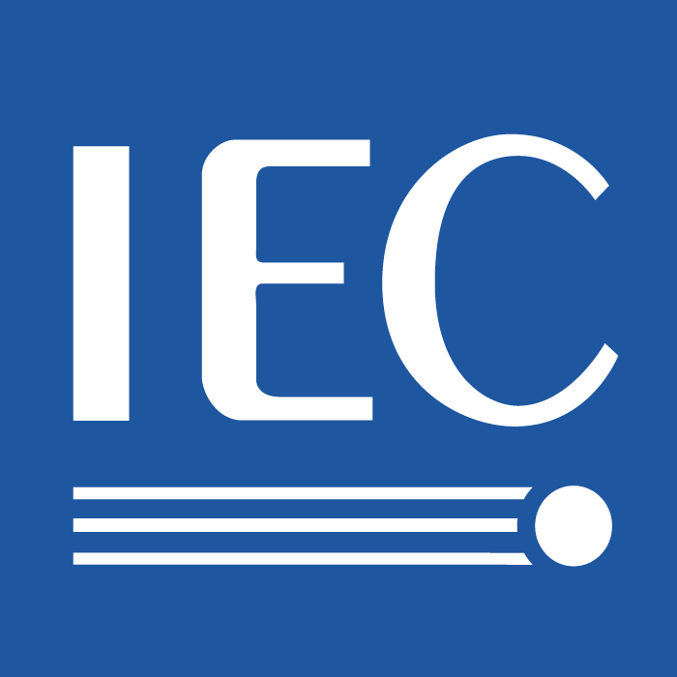 | 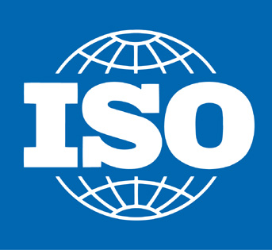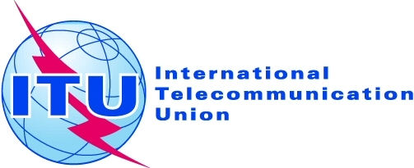

Standards Management Training Courses

Under the auspices of WSC (World Standards Cooperation), IEC, ISO and ITU have organized two series of courses for managers of their members. Theses courses took place in October 2004 and April 2005. The courses lasted for 5 days and the agenda for the second course is attached as a reminder.

The courses were intended for managers of the members of IEC, ISO and ITU, in particular those members with officers in the technical work. They were intended to prepare these managers for their participation in the future development of the international standardization community and provide them with a detailed insight into the business of international standardization. They explained the role of standards in trade and commerce, the operation of standards organizations, both at the national and international level and provided plenty of opportunity for the participants to exchange experiences.

The members of IEC, ISO and ITU are invited to fill in the following questionnaire, to indicate interest in a further course for those who have not taken part in the previous courses.

Name of member body:

My organization would be interested in taking part in a Standards Management Training Course:
Yes No

I would like to send ____ participant(s) to the course.
Organization | Name | Position | E-mail

The following time periods would be most suitable:
March 2008
April 2008
May 2008
September 2008

Other suggestions (including topics for inclusion in the programme):

Please return this page only of the questionnaire as appropriate to:
Jack Sheldon  IEC Central Office  E-mail: jrs@iec.ch  Fax: +41 22 919 0300 | Daniele Gerundino  ISO Central Secretariat  E-mail: gerundino@iso.org  Fax: +41 22 733 3430 | Paolo Rosa  ITU  E-mail: Paolo.Rosa@itu.int  Fax: +41 22 730 5853
ANNEX 2
(to TSB Circular 175)

Agenda of the Course held in April 2005

Day 1, Monday – April 11, 2005
8:30 Registration at Conference Centre of Varembé, 7- 9 Rue de Varembé, Geneva (CCV), conference room C
9:00 – 12:30 What are International Standards?

9:00 – 10:30 Session Chairman –

- Definitions
- History
- Position today

IEC –
ITU –
11:00 – 12:30 Session Chairman –
Why are International Standards Essential?

      - International Standards benefits
      - Regulation

ISO –
12:30 – 14:00 Lunch

14:00 – 17:30 How are International Standards used?
Session Chairman –

      - As specifications –
      - Conformity assessment –
      - ISO’s view on CA/CASCO –
19:30 – 21:30 Welcome Cocktail –

Day 2, Tuesday – April 12, 2005
9:00 – 12:30 How are International Standards used? (continued)
Session Chairman –

- ISO’s view on regional Agreements (Vienna Agreement) –
- Regional and international agreements –
- Strategic role of standardization –
- Case study – WTO conflict resolution –
12:30 – 14:00 Lunch
14:00 – 17:30 How are International Standards made?
Session Chairman –

- Fundamentals –
- IPR issues –
- Standards development – general (initiation, development, distribution and maintenance) –

Day 3, Wednesday – April 13, 2005
9:00 – 12:00 How do International Standards bodies function?
Session Chairman –
9:00 – 10:30
- IEC technical management
- ISO technical management –
- ITU technical management –

Session Chairman –
11:00 – 12:30
- IEC Marketing and Communications –
- ISO Marketing and Communications –
- ITU Marketing and Communications –
12:00 – 13:30 Lunch

13:30 – 17:30 Standards in action –
Day 4, Thursday – April 14, 2005
9:00 – 12:30 How do International Standards bodies function?
Session Chairman –
9:00 – 10:30
- IEC standards development –
- ISO standards development –
- ITU standards development –
11:00 – 12:30
Session Chairman –

- IEC IT tools and services –
- ISO IT tools and services –
- ITU IT tools and services –

12:30 – 14:00 Lunch
14:00 – 17:30 How do International Standards bodies function?
(three break out sessions by organization)

ISO | ITU | IEC
Session Chairman –  - ISO Members and related issues  - ISO Governance Bodies, Policy Development Committees (CASCO, COPOLCO, DEVCO),  CASCO –  COPOLCO –  DEVCO –  - ISO Technical work | Session Chairman –  - ITU-T within the context of ITU and communication strategy  - Organization of the work - study groups and other groups  - Electronic working methods | Session Chairman –  - IEC management structure and governance  - Technical committees  - AC ACET, Liaisons  - Strategic role of information technology in Central Office

19:30 – 21:00 Cocktail

Day 5, Friday – April 15, 2005
9:00 – 12 :30 How do International Standards bodies function?
(three break out sessions by organization)

ISO | ITU | IEC
Session Chairman –  - Role of the ISO Central Secretariat: overview  - Support to Standards Development  - Support to Developing Countries  - Marketing and promotion of ISO standards  - ISO e-services | Session Chairman –  - Products and services (website etc.)  - Development and approval processes  - Special Projects and study topics | Session Chairman –  - Advisory Committees (except ACET), Sector Boards  - Function of the Central Office  - Marketing and selling Electrotechnical standards  - IEC reaches out to developing nations

12:30 – 14:00 Lunch

14:00 – 16:30 Conclusions (at CCV, conference room C)

- The future
- Feedback
- Final summary, discussion

_______________

If a further course is organized, the programme will be updated, taking into account the experience from the previous sessions, including the feedback from the participants and the suggestions made in the responses to this questionnaire.

